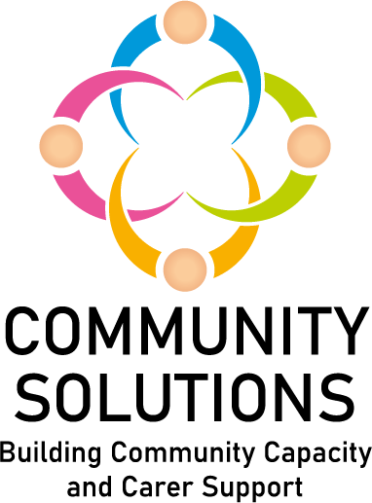

Support in the Right Direction
Impact and Learning Report - 2019-2024

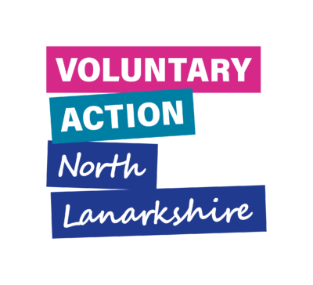
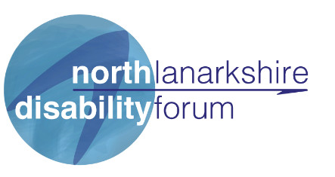

Contents
1. Introduction – Page 3
2. SiRD in North Lanarkshire – Page 8
3. Summary of Reach and Impact – Page 9
4. Summary of Activity – Page 11
5. Summary of Outcomes – Page 12
6. Learning – Page 19
7. Future Plans – Page 20
Appendices – Page 21
Appendix A - Case Studies – Page 21
A.1 Equals Advocacy – Year Five Case Study
A.2 North Lanarkshire Disability Forum – Year Five Case Study

Appendix B – Summary of Reach - Page 24
Appendix C – Summary of Referral Routes – Page 25
Appendix D – NLDF SDS Contact Record Master Sheet – Page 27

*A supplementary report is available with a year by year summary of the funding.
1. Introduction
1.1 Purpose
This report provides an overview of the work and achievements of the Support in the Right Direction (SiRD) project in North Lanarkshire from 2019-2024, including a summary of activity and impact.
1.2 Fund Phases

Phase | Funding Amount  North Lanarkshire Disability Forum (£) | Funding Amount – Equals Advocacy (£)
2019-2020 | 65,000 | 14,054
2020-2021 | 67,984 | 14,054
2021-2022 | 82,770 | 14,054
2022-2023 | 85,899 | 14,054
2023-2024 | 89,113 | 16,838
TOTAL | 390,766 | 73,054

1.3 Background to Support in the Right Direction
The Scottish Government funds a national ‘Support in the Right Direction’ programme which aims to empower people and carers receiving social care support and services to be equal partners in their care where they have real choice and control over their lives, including:
- Decisions about where they live and the services they receive
- Participation in fulfilling activities and their community
- Employment, if appropriate

This is usually referred to as ‘self-directed support’ (SDS).

The national SIRD Fund is managed by Inspiring Scotland on behalf of the Scottish Government. 30 organisations across the 32 local authority areas in Scotland are funded to deliver SIRD projects.

1.4 Evaluation and Monitoring
The Fund’s approach to evaluation, learning, and improvement is informed by Inspiring Scotland’s Self-Directed Support Improvement Plan. Funded projects are required to capture and share with Inspiring Scotland key information on the following:
- Type of support provided – activities
- Numbers of unique individuals supported – reach
- The difference this support made to those receiving support – outcomes.

Funded projects, NLDF and Equals Advocacy, submit six and twelve monthly evaluation and monitoring forms to VANL, who collate the two and submit this to Inspiring Scotland as one return for North Lanarkshire.

1.4.1 Programme Outcomes
The SIRD Programme aims to contribute to five outcomes, which are listed below. These outcomes were developed when the fund was launched in 2018. They focus on the difference having independent support makes to people and carers as they navigate planning and implementing the social care support they need to live a good life.
Outcome 1: People and carers are better prepared, confident to engage and contribute meaningfully to social care assessments and reviews.
Outcome 2: People and carers feel more informed, listened to, less stressed.
Outcome 3: People and carers can creatively and flexibly plan to achieve personal outcomes including accessing community assets.
Outcome 4: People and carers have increased skills so are better able to manage social care packages.
Outcome 5: People and carers have increased knowledge and understanding of self-directed support principles and options for social care.

1.5 Logic Model
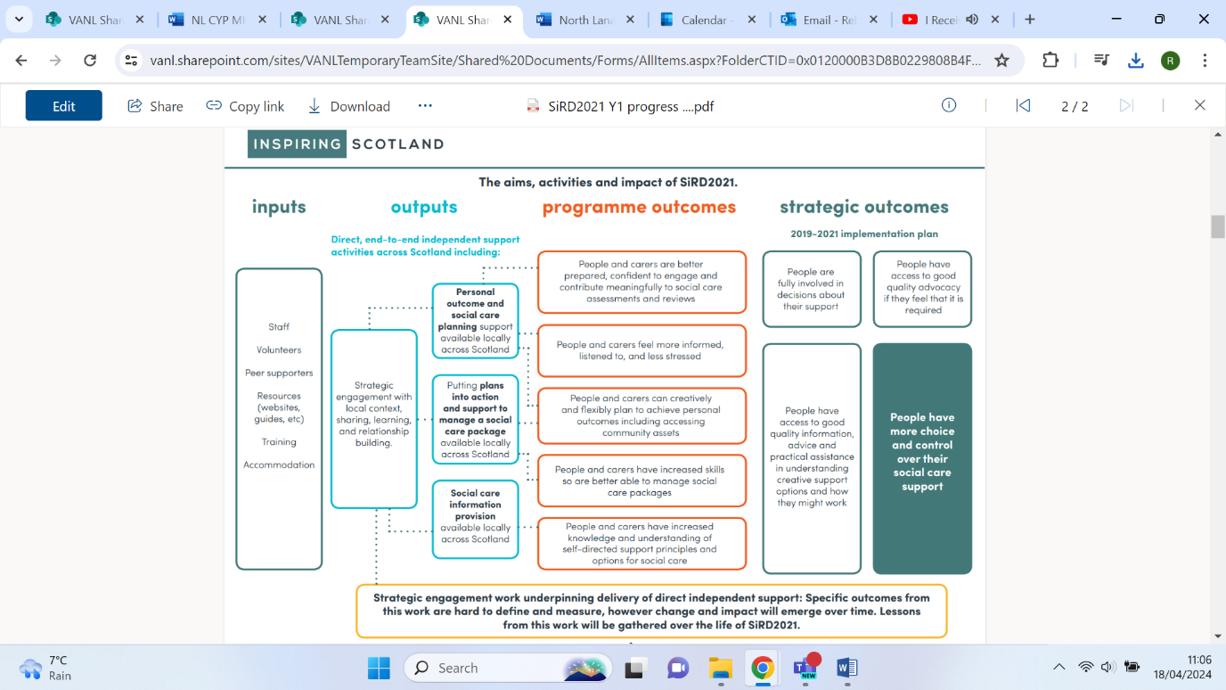
The logic model below was prepared by Inspiring Scotland to explain the SIRD project’s aims, activities, and impact.
2. SiRD in North Lanarkshire
Voluntary Action North Lanarkshire (VANL) manages the SiRD fund for North Lanarkshire, and has distributed this funding through the Community Solutions Programme to two Community and Voluntary Sector (CVS) organisations:
- Equals Advocacy
- North Lanarkshire Disability Forum (NLDF)
2.1 Equals Advocacy
The SiRD project has funded a dedicated part-time advocacy worker within Equals Advocacy since January 2019, who has helped people to identify what outcomes they would like to achieve without necessarily opting for SDS, and ensuring that they have considered existing support services. Where appropriate, Equals Advocacy referred individuals onto the NLDF Community Connectors to access support offered by a Community and Voluntary Sector (CVS) organisation.

2.2 North Lanarkshire Disability Forum
NLDF are the host for the largest part of the project. NLDF has hosted two Community Connectors since 2019, who are responsible for:
- Raising awareness of SDS throughout North Lanarkshire
- Supporting those who are not yet eligible for an individual social care budget by linking them to key supports
As the Project has developed, NLDF are also responsible for:
- Convening and supporting quarterly SDS Network meetings.

- Influencing the refresh of the North Lanarkshire SDS strategy by participating in the training subgroup, marketing & public engagement subgroup and other relevant working groups.

- Providing bespoke training and education programmes to people receiving or eligible for SDS, to ensure that they know what it should look like and what it includes e.g. community, signposting, financial support, sitter services, etc.

- Providing individuals, CVS organisations and statutory partners with guidance on the latest SDS Legislation.

- Collecting information and evidence on issues around SDS processes including the directed self-assessment process, the application process and the review process based on peoples lived experience and the journeys they have experienced.

- Creating online interactive information about the SDS process, speaking to those who use it gathering good experiences and experiences that highlight where improvements can be made, helping people to tell their stories through case studies and testimonies.

- Developing and delivering 12 SDS awareness sessions to individuals, CVS organisations or statutory partners over the coming year.

- Identifying any gaps in the provision of community supports, highlighting them through the SDS Network and with the six Community Solutions Locality Hosts to inform small grant awards through the Locality Activity Fund.

- Promoting the use of the ALISS (A Local Information Service for Scotland) on-line service directory to encourage CVS organisations to upload up to date and relevant information about the support they provide, so this can be accessed by individuals requiring support and organisations providing support.

3. Summary of Reach and Impact
3.1 Total Reach – 2019-2024
Below is a summary of reach from 2019-24. See Appendix B for a full breakdown by year.
3.2 Reach by Year – 2019-2024
4. Summary of Activity
Below is a summary of the key activities delivered through the SiRD programme. See the supplementary report for more information on all activities.
5. Summary of Outcomes
Below is a summary of the outcomes reported by individuals from 2020-2024. Equals Advocacy collected information on outcomes by monitoring referrals and outcomes for service users through the SIRD advocacy work stream. NLDF collected this information using their Contact Record Master sheet (see Appendix D). Outcomes 4 was not reported on.

4.1 Outcome 1
Outcome 1 was reported on from 2022-24.
4.2 Outcome 2
4.2.1 Outcome 2 – 2020-22
The following indicators were reported for Outcome 2 from 2020-22.
4.2.2 Outcome 2 – 2022-24
The indicators for outcome 2 were changed in 2022. The following outcomes were reported during 2022-24.
4.3 Outcome 3
4.3.1 Outcome 3 – 2020-22
The following indicators were reported for Outcome 3 from 2020-22.

4.3.1 Outcome 3 – 2022-24
The indicators for outcome 2 were changed in 2022. The following outcomes were reported during 2022-24.
4.4 Outcome 5
The following indicators were reported for Outcome 35 from 2020-23. Outcome 5 was not reported on in 2023-24.
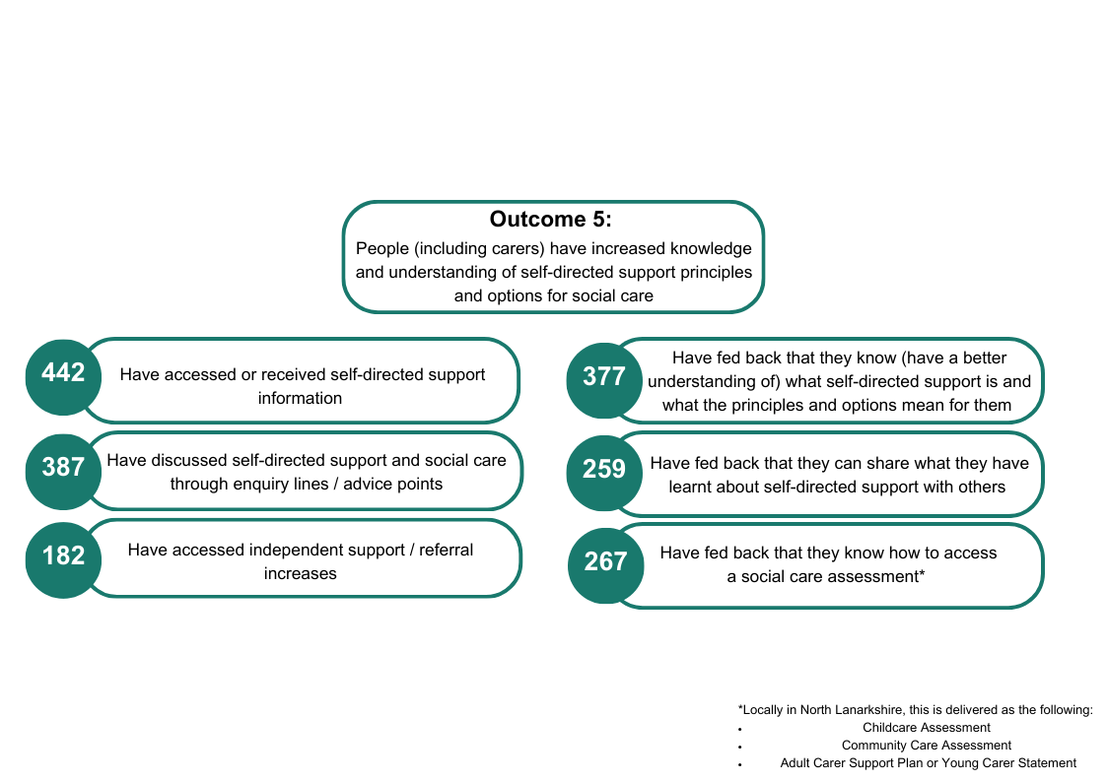

6. Learning
NLDF and Equals Advocacy provided feedback on their learning, and their main reflections on their projects in the six- and twelve-monthly evaluation forms.
‘Demand has been high, we have been successfully keeping as many people as independent for as long as possible. We have been champions for supported people in NL and will continue to fly the flag of SDS moving forward.’
– NLDF

‘People still mix up SDS with an individual budget. This is more about language being used within all sectors. This is something we try to flag up when we can.’
- NLDF

‘We have noted an increase in health and social care partners interested in our model of work, and we hope this will go some way in making what we have sustainable and integrated into statutory services.’
– NLDF

‘Funding is an ongoing challenge, we have not been successful in this fund moving forward so we will be looking at other ways of keeping our model of work on the Governments agenda in other ways such as campaigning, consultation and awareness raising on the projects we have.’
– NLDF
‘There are real pressures across health and social care around recruitment and retention of staff. Some of the challenges facing this process is the difficulty of recruiting staff to deliver SDS services in the community. Despite these barriers, there is still an ongoing commitment from all partners to allow older people to live independently, the life they want ensuring choice and control for older people in North Lanarkshire’
– Equals Advocacy
7. Future Plans

8. Appendices
Appendix A - Case Studies
A.1 Equals Advocacy – Year Five Case Study
Background
An individual (called an advocacy partner [AP]) was referred to Equals Advocacy’s service by social work, to support them during the ASP (Adult Support and Protection) process to ensure their views were heard and that their rights were safeguarded, promoted, and upheld.
The following issues were identified as required areas of support:
- Navigating the ASP process and self-neglect
- Alcohol addiction and harm reduction
- Respite
- Condition of housing requiring a deep clean
Intervention
An advocate from Equals Advocacy met regularly with AP, within their own home and a care home setting. The advocate attended all ASP meetings representing AP’s views, whilst safeguarding, promoting, and upholding their rights. The advocate ensured that AP’s views were heard in their ongoing ASP process, that any interventions were centred on AP, and supported AP to make informed choices throughout the process.
The AP accepted a 4-week period of respite within a Care Home, to be supported to safely reduce their alcohol consumption and to have regular nutritious meals. The period of respite also allowed for a deep clean of the individuals’ home to be completed, to ensure that it was of a reasonable, habitable standard before their return home.
The AP was returned to their home, as per their wish, with an SDS budget and a private provider delivering their required care, including their basic care needs and social supports.
Outcome
As a result of the intervention, the AP was able to:
- Return to a safe and habitable home, improving their confidence and wellbeing, and supporting them to feel more in control and that they have a choice
- Engage with the private provider to improve their social inclusion, and reduce isolation and loneliness
- Remain at home with support for longer, delaying the need for more complex support and supporting them to remain independent
- Become medication compliant due to being abstinent from alcohol, and now enjoys regular, nutritious meals improving both their health and wellbeing
A.2 North Lanarkshire Disability Forum – Year Five Case Study
Background
L has a high level of care needs, and is very vulnerable. The housing L is in is unsuitable for his needs. L was referred to NLDF experiencing a number of issues including:
- Mobility issues which make it difficult to get around his flat, and struggle to reach the toilet
- Memory and mobility issues making it difficult and dangerous for him to cook, as he knocks things over, forgets about things cooking, and cannot hold a cup due to tremors resulting in weight loss
- Sleeping on the couch which tires him out due to his difficulty getting upstairs
- Being unable to wash regularly as he cannot get in and out of the shower
- Being physically unable to do housework, and his house is in disarray
- Forgetting to take medication and struggling to go and collect medication
- Lack of suitable clothing

A GP link worker had already made a referral to social work, but L was unable to respond as he is dyslexic, does not read his letters and missed the letter the worker had sent.
.
Intervention
NLDF staff were able to arrange the following support for L over an eight month period:
- Called social work to re-refer L and advised that this was urgent due to his high care needs. Within two days, social work completed the referral passed this onto a senior manager
- Supported L with writing an application for housing. Staff wrote a letter of support for the application, collected a doctor’s support letter, and sent this
- Collected a parcel from the food bank, along with clothing and bedding and delivered this to L
- Arranged for future food bank parcels to be collected for L as required and delivered food shopping
- Arranged a meeting with social work to attend L’s home to assess his needs. Social work made a referral to the Tackling Poverty team to assess where his money is going, and applied for a crisis loan. It was agreed suitable housing is necessary for L and adaptations to his current home would not be enough to ensure quality of life
- L required encouragement and support as he was reluctant to deal with agencies like social work
- A support letter was written for pension credits to confirm L can no longer work
- Shopping was provided for L
- Referrals were made to the Wee Mobile Food Bank and Trussell trust
- Arranged a fire safety check which identified safety concerns, which social work were made aware of
- Arranged for the council to fix his kitchen and living room flooring
- Arranged weekly welfare checks due to L’s mental health, unsafe housing, and low income
- Arranged a blue badge
- When L was offered new housing, staff visited the potential new home and videoed it for L to see

Outcome
Due to NLDF staff’s support, L has been able to access:
- An improved living situation
- A blue badge
- A home care package to support his safety
- Food banks with a welfare referral to address income
- Links with statutory supports including Housing, Occupational Therapy, and Social Work

Appendix B – Summary of Reach
Year | Individuals provided focussed support | Cared for people supported through case work | Carers supported through case work | People supported with general independent support activities
Year 2 (2020-21) | 68 | 55 | 13 | 119
Year 3 (2021-22) | 106 | 81 | 25 | 428
Year 4 (2022-23) | 131 | 52 | 3 | 167
Year 5 (2023-24) | 137 | 129 | 34 | 106
TOTAL | 442 | 317 | 75 | 820

Appendix C – Summary of Referral Routes
672 individuals reported on the referral route taken into the SiRD programme. The most common referral route was through Local Authority, with 207 reported referrals.
Referral Routes | Number of Referrals
 | Year 1 (2019-20) | Year 2 (2020-21) | Year 3 (2021-22) | Year 4 (2022-23) | Year 5 (2023-24) | TOTAL
Local authority | 44 | 15 | 46 | 43 | 59 | 207
Schools | 5 | 0 | 38 | 5 | 2 | 50
Other CVS organisations | 34 | 29 | 37 | 14 | 43 | 157
Self-referrals | 32 | 5 | 27 | 23 | 44 | 131
Carers | 5 | 2 | 23 | 11 | 15 | 56
Adverts | 5 | 0 | 1 | 3 | 0 | 9
Other | 8 | 10 | 28 | 16 | 0 | 62

Appendix D – NLDF SDS Contact Record Master Sheet
Contact Information

Name

Address

Email

Phone

Date of Birth

First contact date

How did you find out about us?

Who is the supported person?

Getting to know you

What we talked about

How much do you know about SDS?

What is the person looking to achieve?

How will we stay in touch?

Do you know about Adult Carers Support Plan or Young Carers Statement?

In receipt of formal support?

Info about disability etc

Referrals to other orgs?

Social work information

Advocacy explained and offered?

What information was given about SDS and how have you supported the person to understand SDS?

Engagement Record
Date | contact | What we talked about | Any outcomes to update? – see below

Outcomes
Outcome 2: People (including carers) feel more informed, listened to, less stressed. | have been supported through community connections and advocacy work
 | have fed back that they have been able to express what matters to them
 | have fed back that they feel their preferences have been considered
 | have fed back that they understand the process for accessing social care and feel more informed
 | have fed back that they have had the opportunity to share their views, ask questions
 | have fed back that they have received information about different local options
 | have fed back that they are happy with how their support is being manged
 | have fed back that they understand different coping and management strategies

Outcome 3: People (including carers) can creatively and flexibly plan to achieve personal outcomes including accessing community assets | have been supported with personal outcome planning
 | have been supported with alternative uses of their budget
 | have been signposted to other relevant community-based services, support or resources
 | have fed back that they feel they have more (or have maintained) their independence
 | have fed back that they feel more engaged or part of their community
 | have fed back that they are trying new things (have joined new groups)
 | who are doing different things with their budgets (as opposed to traditional services)

Outcome 5: People (including carers) have increased knowledge and understanding of self-directed support principles and options for social care | have accessed or received self-directed support information
 | have discussed self-directed support and social care through enquiry lines / advice points
 | have accessed independent support / referral increases
 | have fed back that they know (have a better understanding of) what self-directed support is and what the principles and options mean for them
 | have fed back that they can share what they have learnt about self-directed support with others
 | have fed back that they know how to access a social care assessment

Was the situation resolved?
Date:

What was the outcome?

Any feedback for us?

How long did we support the person /family?

[Document ends]

Information from Year 1 (2019-2020) is not included as it was not collected until Year 2.

