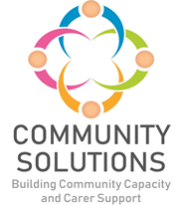

**Children, Young People, and Families Community Mental Health and Wellbeing Fund**

**Supplementary Impact and Learning Report –**

**Phase Four (2023-24)**

**Phase X (20XX-XX) - Impact and Learning Report**



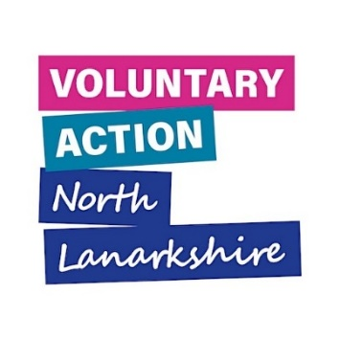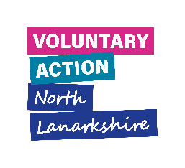



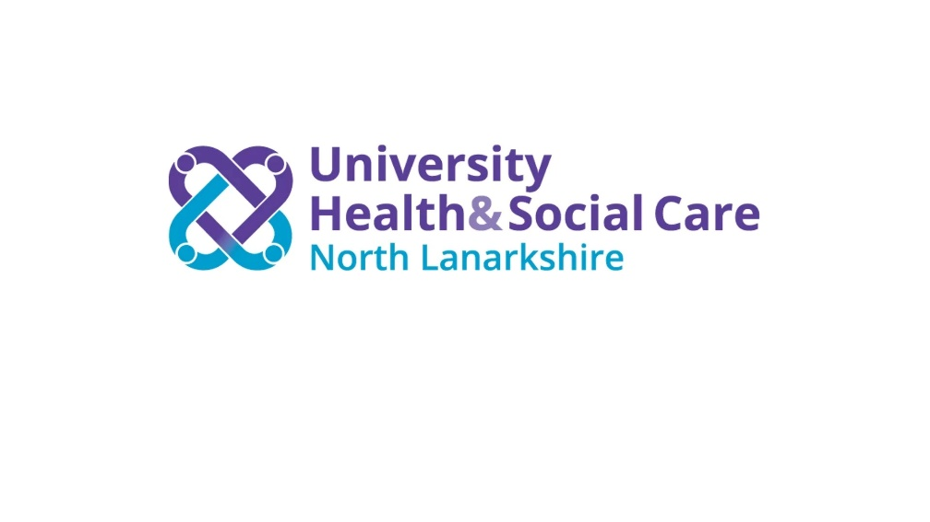

# Contents

1. Introduction – Page 3
2. Summary of All Funded Projects – Page 4
3. Case Studies – Page 37

**1. Introduction**

The purpose of this report is to supplement the North Lanarkshire (NL) Community and Voluntary Sector (CVS) Children and Young People Community Mental Health and Wellbeing Fund Impact and Learning report for Phase 4 (covering 2023-24). The full report includes an overview and background of the fund, and a summary of achievements, reach and impact data, whereas this shorter, supplementary report provides additional information about all projects funded through Phase Three of the fund. This report provides a summary of the following for each funded project:

* The project aims
* The service/activity provided
* The school clusters the project was delivered in
* The project reach
* The evaluation method used to measure outcomes
* The achieved project outcomes and [SHANARRI](https://www.gov.scot/policies/girfec/wellbeing-indicators-shanarri/) indicators
* The learning from each project

This report also includes case studies from three funded projects, and a diagram summarising the types of supports provided in Phase Four.

The following projects were funded during Phase Four, however, some could not deliver their projects during the delivery period covered by this report. This project has agreed with Voluntary Action North Lanarkshire (VANL) staff to deliver their project and report to VANL in the 24-25 period:

* Action for Children – Family Support and Wellbeing
* The Miracle Foundation – Exam Stress Support sessions

**2. Summary of All Funded Projects**

This section presents a project-by-project summary of the projects funded through Phase Four.

**Bazooka Arts – Therapeutic Arts Programme**



**Aim –** To support young people’s mental health and wellbeing through therapeutic arts

**Service/Activity –** Therapeutic Art workshops

**Reach –** 11 primary school pupils, 9 secondary school pupils, 7 families

**Delivery Cluster(s) –** St Ambrose and St Andrews

**Evaluation Method**

* Observation
* Young people’s feedback

**Outcomes**

This project has:

* Provided P6/7 and S1 pupils with transition support through a 6-week therapeutic arts programme, including drama on topics such as hopes for the future, making dream catchers, and creating cyanotype prints
* Created a film of a drama workshop presented by 6 young people
* Provided 8 additional sessions for pupils in need of individual therapeutic support
* Made artwork focused on identity, positive affirmations, and hopes and dreams for the future

**Learning**

* To involve young people’s families, the project was supposed to include an in person sharing event. Due to family circumstances, the young people suggested to film a drama workshop instead to share with friends and family, which they were able to take the lead on
* The project would like to further explore the long-term impact of young people taking on the role of facilitators in sharing arts activity with friends and family
* The project found it difficult to engage young people who were not attending school

**Circle – Young People’s Service**

**Aim –** To support care experienced young people to strengthen their health and wellbeing

**Service/Activity –** Weekly 1:1 support and small group work over three months

**Reach –** 11 care experienced secondary school pupils, 9 families

**Delivery Cluster(s) –** Cardinal Newman High

**Evaluation Method**

* 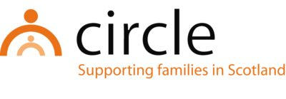Support plans developed with young people and families, aligned to SHANARRI wellbeing indicators
* Quarterly reviews of Family Wellbeing Strengthening Assessment undertaken with children/young people and families
* Feedback from children, young people and families and schools

**Outcomes**

This project has:

* Delivered sessions promoting life skills such as cooking, arts and crafts, and exploring further learning and development opportunities
* Established trusting relationships between the project’s Young People’s Worker and the young people
* Strengthened the young people’s resilience and their relationships with peers, families and the wider community

**Learning**

* This project is working on further embedding a children’s human rights approach, ensuring a strong focus on care experienced young people whose rights are most at risk
* A challenge is maintaining ongoing support for young people with limited and sometimes unpredictable funding. The organisation endeavour to maintain support by identifying additional funding sources and signposting to relevant and appropriate supports

**Circle – Whole family, trauma recovery and early intervention support**

**Aim –** To support children, young people and their families who have additional support needs, are experiencing poor mental health and wellbeing, have experienced trauma, and/or require parental or whole family support

**Service/Activity –** 1:1 and group work with children and families

**Reach –** 9 families comprising of 14 parents/carers and 11 children and young people

**Delivery Cluster(s) –** Caldervale High

**Evaluation Method**

* Support plans developed with young people and families, aligned to SHANARRI wellbeing indicators
* Quarterly reviews of Family Wellbeing Strengthening Assessment undertaken with young people and families 
* Feedback from children, young people and families, and schools

**Outcomes**

This project has:

* Provided opportunities for children, young people, and their families to strengthen relationships, recognise and understand their experiences, build self-confidence, and improve their resilience
* Provided guidance and support to parents and carers including on housing, financial inclusion, and understanding of their child’s additional support needs

**Learning**

* The project identified the need for support for young people and families who are either impacted by a diagnosis or waiting on a diagnosis of a neurodivergent condition. This led to Circle increasing their knowledge in supporting neurodivergent people
* The project has increased the organisation’s awareness of community-based resources and shared these with families
* The project supported one young person who had limited attendance at school and experienced sustained anxiety. The Family Outreach Worker established a relationship with the child which was informed by their perspective and needs, including the child’s concern for the parent who had experienced long term illness. Through this support the child’s worry and anxiety lessened, and they are now tentatively exploring with schoolteachers what the transition to school could look like. *Read more about this in section 3.1*

**Glenboig Development Trust – Without Walls**



**Aim –** To support an engaging learning environment for every child and increase families’ knowledge of coping mechanisms to ensure ongoing learning at home

**Service/Activity –** Individual and small group activity

**Reach –** 15 primary school pupils, 8 secondary school pupils, of which 2 young carers and 2 care experienced CYP, 15 families

**Delivery Cluster(s) –** Airdrie Academy

**Evaluation Method**

* School reports
* Observations
* Comments from young people
* Outcome star

**Outcomes**

This project has:

* Supported 23 young people across three 9-week periods
* Supported one family to engage with the Tackling Poverty team, resulting in a £300 increase to their monthly income
* Linked a kinship carer with Nurture Scotland who helped him reassess his eligibility to carer benefits

**Learning**

* The project found that as a third sector agency they are more able to engage with parents in a relaxed method and gain their trust

**Health and Wellness Hub – Stress Buster Programme**



**Aim –** To support young people to learn about mindfulness for self-care

**Service/Activity –** 12-week programme to learn about mindfulness and prepare a lesson for incoming first years

**Reach –** 56 primary school pupils, 38 secondary school pupils

**Delivery Cluster(s) –** Chryston High, Kilsyth Academy, St Margaret’s, Our Lady’s High

**Evaluation Method**

* School staff feedback
* Verbal and written pupil feedback
* Conversations with external staff at transition sessions

**Outcomes**

This project has:

* Delivered 8 introduction to mindfulness lessons, 3 sessions in which young people created a lesson themselves, and 16 sessions supporting delivery of the lessons at transition days (per cluster)
* Increased young people’s confidence and ability to self-manage moods and anxieties

**Learning**

* In multiple clusters there was a delay in the start of the programme. The involvement of cluster leads helped ensure the sessions were arranged in time. Delays were accommodated in several different ways, including delaying the delivery of the lessons for the transition days until after the school holidays, and increasing the number of sessions per week
* During the project, male students delivered a wellbeing session to the incoming S1 classes, despite feedback that it was unusual to see male students take the lead in mental health activities. The project hopes this will encourage other young men to take part in this activity in the future

**The Holding Space – Joining the Dots**

**Aim –** To help young people understand the connection between their emotions, thoughts and behaviours

**Service/Activity –** 8-week programme including therapeutic art, pet therapy, nurture by nature, yoga, cooking lessons, mental health support, development of coping strategies

**Reach –** 24 primary school pupils, 5 secondary school pupils

**Delivery Cluster(s) –** Greenfaulds High, St Maurice’s High**,** Coatbridge High, We Aspire

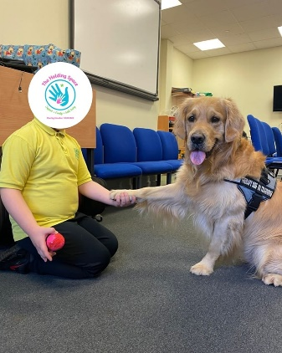**Evaluation Method**

* Verbal evaluation with children and young people
* End of project evaluation form
* Conversations with teaching staff

**Outcomes**

This project has:

* Built solid relationships between the young people and the practitioners
* Allowed young people to talk about their emotions and increased self-regulation with the tools and techniques delivered within the project

**Learning**

* The project found that 8 weeks was not long enough, and young people fed back that they would like to attend more. In response to this, the Holding Space has now increased their program with options of 12 and 16 weeks, and created a program for out of school hours
* Through conversations across schools, the project identified issues and barriers young people are facing, including social media. The project was adapted to include discussions about social media and what tools young people can use to cope with the negative side of social media
* A challenge was getting permission from schools to allow Tommy the pet therapy dog to enter the school building. Evaluation forms helped show that Tommy is a vital part of the project, and as a result he was allowed in schools

**Home Start GNNL – Home-Start schools project**

**Aim –** To support family confidence and wellbeing and increase young people’s school attendance and engagement

**Service/Activity –** Weekly 1:1 support sessions in the family home for P1-3 pupils and their families

**Reach –** 9 children and 8 families

**Delivery Cluster(s) –** Cardinal Newman High

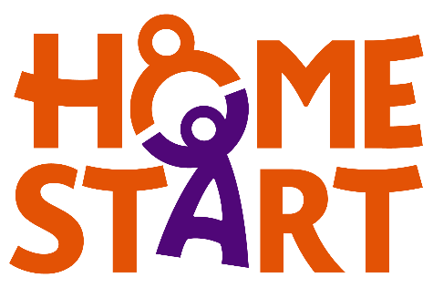

**Evaluation Method**

* Verbal and written feedback from school staff and CIIL
* Reviews with young people and their parents
* Needs assessment using scoring system, evaluated every 12 weeks

**Outcomes**

This project has:

* Led to increased motivation for some young people to attend school and engage positively in learning
* Improved communication and relationships between families and school
* Increased vulnerable families’ resilience by supporting families through promoting parent-child engagement, developing nurturing relationships, caregiver support, signposting and stress reduction

**Learning**

* The project supported a mum and P1 son. The family support worker (FSW) supported Mum in meetings with school staff. The young person was removed from class sessions and given 1:1 support daily. The FSW also connected the family with other charities. Mum now reports an improvement in the relationship with her son and feels more supported by the school. The young person’s sleep has improved and there is a plan to integrate him back into the classroom in a phased approach. *Read more about this in section 3.2*
* This work started as a pilot two years ago. Referrals from other schools shows the success and need for this work

**HOPE for Autism – Anxiety Related School Absence**

**Aim –** To support autistic children who may be vulnerable to anxiety related school absence

**Service/Activity –** Visits to schools to support sensory and communicative environment, coffee and chat drop-in for parents, s2 group activity on alternate weeks, P6/7 transition group on alternate weeks

**Reach –** 10 primary school pupils, 4 secondary school pupils, 10 families

**Delivery Cluster(s) –** Airdrie Academy

**Evaluation Method**

* Case study notes
* Observations
* Conversations with parents/carers, young people and education staff before and after support period

**Outcomes**

This project has:

* Supported young people who were absent from school to understand autism in a positive way and understand their own needs better
* Fostered a community among families, providing a space for families to connect and support each other
* Allowed young people involved in the S2 and P6/7 groups to begin to open up and engage in positive conversations about autism

**Learning**

* An unexpected outcome of the project has been the opportunity to provide additional support to the vulnerable parents of the participating families
* A challenge has been to arrange dates with the schools. The project would have benefited from more information about the young people before the project started as it would allow for more planning before starting

**HOPE for Autism – Community Transition Group**

**Aim –** Increase school attendance, enhance the wellbeing of children and their families, building confidence in parents/carers to engage in public outings with their children, build peer support between families

**Service/Activity –** 9-week programme. Group sessions complemented by various trips and social activities

**Reach –** 24 primary school pupils and their 24 families

**Delivery Cluster(s) –** Airdrie Academy

**Evaluation Method**

* Case study notes
* Observations
* Conversations with parents/carers, young people and education staff before and after support period

**Outcomes**

This project has:

* Fostered a community among families, providing a space for families to connect and support each other
* Led to education staff feeling reassured and appreciative of HOPE for Autism’s suggestions

**Learning**

* The staff team found that being involved in a number of different projects across several clusters has allowed them to get a fuller picture of the challenges that young people, families and education face and how they can bridge the gap
* A story used to support transition was so well-received that another teacher requested one for another young person
* The project created an online form to collate feedback, but schools and parents tended not to complete this after the support ended. The project will use paper surveys in the future that can be completed at the time

**HOPE for Autism – Personalised Intensive Support**

**Aim –** Increase comfort of pupils in education environment by developing an understanding of the young person’s sensory, emotional, and communication needs and recommend and implement strategies

**Service/Activity –** 3 visits to the class to observe/play/interact with the child or young person. Telephone conversations with families

**Reach –** 29 primary school pupils, 1 secondary school pupil, and their 30 families

**Delivery Cluster(s) –** Our Lady’s High, Kilsyth Academy, Chryston High

**Evaluation Method**

* Case study notes
* Observations
* Conversations with parents/carers, young people and education staff before and after support period

**Outcomes**

This project has:

* Created personalised support packages to support understanding of the child’s sensory needs and communication strategies
* Introduced positive visuals to support the child to understand what they had to do throughout their day
* Supported a child with transition to P2
* Increased pupils’ independence and ability to attend school trips and the family learning centre
* Helped families feeling more confident and positive

**Learning**

* This and other funded HOPE for Autism projects prompted the development of a suite of resources that can be used to support other people in the future
* The needs for this project were greater than initially thought and the project had to be flexible to suit them
* This project has created more longer-term support for the families, which HOPE indicated might create pressure on staff

**“Your work empowers parents like myself to advocate for our children and collaborate with schools to create a truly inclusive learning environment”**

**Parent involved in HOPE for Autism Personalised Intensive Support**

**HOPE for Autism – Neurobears**



**Aim –** To support young autistic people aged 8-14 to explore what their autism means to them and give them the language to help describe and understand their autism

**Service/Activity –** Series of videos and activities in the child’s workbook

**Reach –** 14 primary school pupils, 9 family

**Delivery Cluster(s) –** Cumbernauld Academy, Our Lady’s High

**Evaluation Method**

* Case study notes
* Reflective conversations
* Observations

**Outcomes**

This project has:

* Supported parents and young people to confidently talk about autism, using shared language and experiences
* Increased the young person’s and parents’ understanding of what autism means to them, increasing their self-confidence
* Increased parents’ confidence in supporting their child

**Learning**

* An unexpected outcome of this project was that the breaks that were introduced for the young person actually benefited the parents as they could ask questions when their child was out of the room
* This project took place in school with school staff as the supportive adult for the young people. In the future the project would like to explore the option of taking place outwith school with parents as the supportive adult

**HOPE for Autism – Autism Family Support**

**Aim –** To support parents with their child transitioning between (nursery and) schools and increase knowledge and understanding of their child’s communication style and strategies

**Service/Activity –** Three 1-hour sessions with parents/carers and a member of the HOPE team for intensive support. This included pre or post diagnostic support, support with play, communication, transitions or emotions

**Reach –** 20 primary school pupils and their families

**Delivery Cluster(s) –** Our Lady’s High, Kilsyth Academy

**Evaluation Method**

* Case study notes
* Reflective conversations
* Observations

**Outcomes**

This project has:

* Supported a parent to work with the school to develop positive ways to prepare their child for school who was previously too distressed
* Developed customised visuals to bridge the gap in communication between teacher and student, which the teacher said had made a “massive difference”
* Improved relationships between parents and schools, and increased families’ awareness of where to access further support

**Learning**

* The projects have emphasised the need for whole family support, for collaboration with education and the need to be flexible to the needs of those involved
* The project supported a family whose relationship with the nursery had broken down. The project helped bridge the gap and improved the relationship. The family are receiving ongoing support
* The project supported a family of a young person transitioning to high school. The project developed a communication passport for the taxi driver taking the young person to school, which minimised parents’ concerns and anxiety

**HOPE for Autism – Family Training**

**Aim –** To increase families’ knowledge on autism and discussion of strategies to support the child, chance to support network

**Service/Activity –** 8 hours of training/support provided by 2 autistic trainers who have autistic children

**Reach –** 14 primary school pupils and their families

**Delivery Cluster(s) –** Our Lady’s High



**Evaluation Method**

* Case study notes
* Reflective conversations
* Observations

**Outcomes**

This project has:

* Fostered a budding community among families, providing a space for parents, particularly vulnerable ones, to connect and support each other.
* Increased parents’ understanding of their child

**Learning**

* An unexpected outcome from this project has been that siblings also benefited from the support to understand autism
* The project was invited along to a school event afterwards to raise awareness of autism
* The project feels that education seem more understanding of the role that the Community and Voluntary sector can play and the impactful services they can provide

* Increased parents’ confidence to take their child out more

**Lanarkshire Community Food and Health Partnership – Come Dine With Us**

**Aim –** To encourage healthy food habits and cooking skills in families, while strengthening family relationships and decreasing food insecurity

**Service/Activity –** A programme of fortnightly distributed food bags with “cook along” recipes to help families produce healthy and low-cost meals

**Reach –** 5 secondary school pupils and their families

**Delivery Cluster(s) –** Airdrie Academy

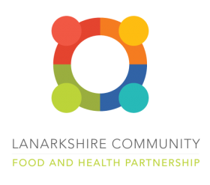

**Evaluation Method**

* Verbal feedback

**Outcomes**

This project has:

* Given out 15 food bags, including pictorial recipe cards with portion costs, and ingredients
* Shared additional recipe videos on YouTube

**Learning**

* A secondary outcome of this project, was that by receiving ingredients for family sized recipes, the families had additional food support that reduced their exposure to food insecurity throughout the 6-week duration of the project
* Collaboration between the cluster lead and LCFHP allowed them to create this project around the need for support that the cluster lead had identified
* The cluster lead had originally identified a need for one pupil and their family. Through collaboration with LCFHP and shaping of the project, an additional 4 families were supported

**LANDED Peer Education Service – Harm Reduction Workshops**

**Aim –** To provide factual and relevant information to young people in relation to a range of risk-taking behaviours

**Service/Activity –** 5 workshops

**Reach –** 6 secondary school pupils

**Delivery Cluster(s) –** Cardinal Newman High

**Evaluation Method**

* Education staff observations

**Outcomes**

This project has:

* Increased young people’s knowledge of the risks associated with substance use and where to seek support within their local communities
* Increased young people’s knowledge of the risks associated with smoking and vaping and where to seek support in relation to quit attempts
* Made young people more aware of the signs of controlling and coercive behaviours within relationships

**Learning**

* A challenge in this project has been to link the sessions together as the same young people did not attend all sessions.
* The project found that the young people were initially reluctant to take part in the sessions. They felt they were being singled out, as these young people were selected by the school based on previous behaviours and concerns. Once the session began, they realised LANDED’s approach was different from other organisations and they participated fully

**Made4UInML2 – School employability**

**Aim –** To support young people with life skills, focusing on employability skills, team building, confidence building, money management and focused group and one to one support

**Service/Activity –** Small group sessions

**Reach –** 7 secondary school pupils

**Delivery Cluster(s) –** Clyde Valley High

**Evaluation Method**

* Evaluation forms

**Outcomes**

This project has:

* Increased young people’s confidence
* Developed young people’s team building and social skills
* Motivated young people to have a larger input into the sessions, creating a youth led environment

**Learning**

* The project faced challenges with regular attendance of the young people
* The project had to be flexible with rooms during the examination period and will be more aware of this in the future

**Make and Create Arts – Positive Creations**

**Aim –** To use art activities to encourage students to explore mindfulness and express their feelings and emotions creatively

**Service/Activity –** Small group sessions focussing on different creative activities

**Reach –** 201 primary school pupils, 35 secondary school pupils

**Delivery Cluster(s) –** Airdrie Academy, St Ambrose High, St Andrew’s High, St Margaret’s High



**Evaluation Method**

* Evaluation forms
* Observations

**Outcomes**

This project has:

* Helped students feel more positive and increase their confidence and skills.
* Helped students to see themselves in a positive light, be proud of themselves, share their positivity with others

**Learning**

* The project supported a young person who went from not speaking during the first session to actively initiating conversations with others in the class and the tutors
* The project supported two boys who were not interested in the activities. The tutors took the time to discuss with them what they were interested in, and the following week the tutor brought in materials for them to make a boardgame. This led to a significant difference in the young people’s excitement and attitudes toward the project and the rest of the class
* The project supported a girl who couldn’t speak English. With the encouragement of the tutor the student was able to complete all the activities at the same pace as her classmates

**Young person involved in Make and Create Arts Positive Creations**

**One girl told the tutors “I feel happy and joyful like a butterfly” when she knows she will be attending one of the sessions**

**Make and Create Arts – Positive Families**



**Aim –** To explore ways families can work together and enjoy spending time creating together

**Service/Activity –** Small group sessions focussing on different creative activities

**Reach –** 21 (pre)primary school pupils, 12 secondary school pupils and their 33 families

**Delivery Cluster(s) –** Airdrie Academy

**Evaluation Method**

* Evaluation forms
* Observations

**Outcomes**

This project has:

* Increased parent and carers’ confidence in being able to work with their child
* Improved parent and carers’ mental health

**Learning**

* Part of this project worked with a pre-school ASN group. It was a challenge for the young students to engage with the first session. The tutors worked with the nursery staff to learn more about the young people participating and their motivators to allow them to prepare sessions that would engage the young people and allow them to get the most out of the sessions. This collaboration enabled them to provide bespoke solutions which greatly benefited the young people

**The Miracle Foundation – One to One Art and Play Therapy**

**Aim –** To provide a confidential space for children and young people to explore their feelings around Bereavement and Trauma

**Service/Activity –** 50-minute art sessions within a 10-week period in the presence of a therapist

**Reach –** 46 primary school pupils, 8 secondary school pupils of which 11 care experienced CYP

**Delivery Cluster(s) –** St Maurice’s High, Greenfaulds High, Kilsyth Academy, We Aspire

**Evaluation Method**

* Facilitator observations, GIRFEC wellbeing webs and evaluation forms
* Individual case summaries

**Outcomes**

This project has:

* Built therapeutic relationships between the young person and the art therapist
* Provided a space for young people to express their emotions freely and develop new strategies for managing stress and adversity
* Engaged young people who demonstrated attendance issues as school to be involved in all sessions of the art therapy programme

**Learning**

* Some young people had higher needs than expected, highlighting the need for a personalised approach to support
* The project supported a young person who experienced the sudden loss of their father. The project helped them express and recognise their emotions
* The project supported a young person who had experienced loss and expressed a fear of death. Through the project, they were able to identify distress triggers and discuss physical and emotional responses, and showed an increased sense of safety and health

**The Miracle Foundation – ‘Encouraging Growth & Resilience’ Mental Health Workshops**

**Aim –** To create a safe space for children and young people to talk about their own mental health and wellbeing, and shared experiences

**Service/Activity –** Workshop on an introduction to mental health, followed by sessions shaped by what is important to the children and young people. Topic options included: Anxiety, Stress, Self-Harm, Suicide, Bereavement, Trauma, Bullying

**Reach –** 116 primary school pupils, 46 secondary school pupils, of which 31 care-experienced CYP

**Delivery Cluster(s) –** St Margaret’s High, Kilsyth Academy, Our Lady’s High, Coatbridge High, Calderhead High

**Evaluation Method**

* Pre-, mid and post-intervention assessment tools
* GIRFEC wellbeing webs and facilitator evaluation forms
* Questionnaires

**Outcomes**

This project has:

* Engaged young people who had previously demonstrated school attendance issues to attend all five sessions, and improved attendance rates

**Learning**

* The partnership between the Miracle Foundation, cluster leads, and head teachers allowed the project to tailor support to young people’s individual wellbeing needs, showing the power of collaborative efforts in addressing complex challenges
* The project had to be flexible and adaptable to manage the challenge of navigating the schools’ timetables and space availability. These challenges will inform the project’s approach in the future

**One Parent Families Scotland – Creating Connections**

**Aim –** To support single parents to engage with appropriate services including GP, Primary Mental health team, social work, education, housing, trauma support and financial support

**Service/Activity –** 1:1 and group family support, including home visits

**Reach –** 2 primary school pupils, 5 secondary school pupils and their 7 families

**Delivery Cluster(s) –** Bellshill Academy

**Evaluation Method**

* Verbal feedback
* Questionnaires
* “My Life and Me” assessments

**Outcomes**

This project has:

* Increased single parents’ awareness of additional support services and confidence in approaching them
* Enabled parents and their children to feel more connected within their local community
* Increased income and financial gains for families

**Learning**

* The project initially was slow to start, but meetings with the cluster leads resolved this and referrals increased

**OutLET – SOARing Outdoors Small Group Support**

**Aim –** To support young people facing challenges engaging in the classroom through hands-on experiences in a natural setting

**Service/Activity –** 8-10 weekly two-hour sessions in a woodland space within the cluster area

**Reach –** 37 primary school pupils, 12 secondary school pupils, of which 3 (known) care experienced CYP and 2 young carers

**Delivery Cluster(s) –** Coatbridge High, Cumbernauld Academy, Clyde Valley High, Dalziel High, Bellshill Academy

**Evaluation Method**

* 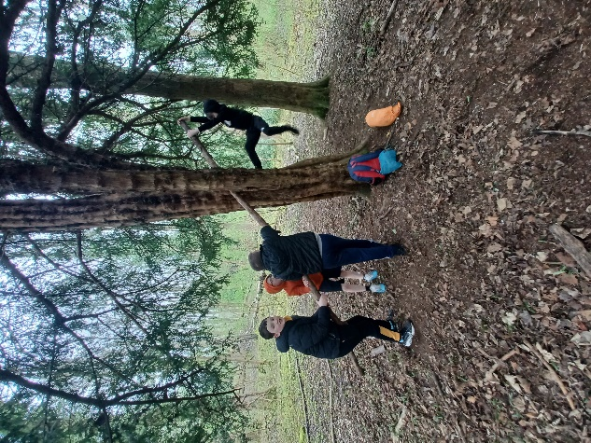Weekly reflections and observations from staff
* Verbal feedback from young people, parents and teachers
* Photographs documenting the sessions

**Outcomes**

This project has:

* Supported young people to gain skills in resilience and emotional regulation and to foster better social connections with peers
* Increased some young people’s attendance - especially on the day of the programme
* Led to 100% of young people who attended reporting enjoying their time outdoors with staff
* Developed young people’s outdoor skills such as building and extinguishing fires, identifying plants, whittling, and tree climbing

**Learning**

* An unexpected observation was that a couple of young people did not see an increase in physical activity. The project assumed they must normally be quite physical and saw the time as a space to relax more than run and play
* The project supported a young person who has attended OutLET sessions for a few terms. The young person initially was reactive and struggled to regulate emotions. During the sessions he has become more confident in a group setting and is building trust in his peers. He particularly enjoys working with tools and helping to light the fire. *Read more about this in 3.4*
* Several end of programme case studies highlight young people’s enjoyment of interacting with the outdoors, playing in mud, seeing animals, feeling the wind and rain on their face, and feeling calmed by having more space and freedom

**OutLET – SOARing Outdoors Individual Support**

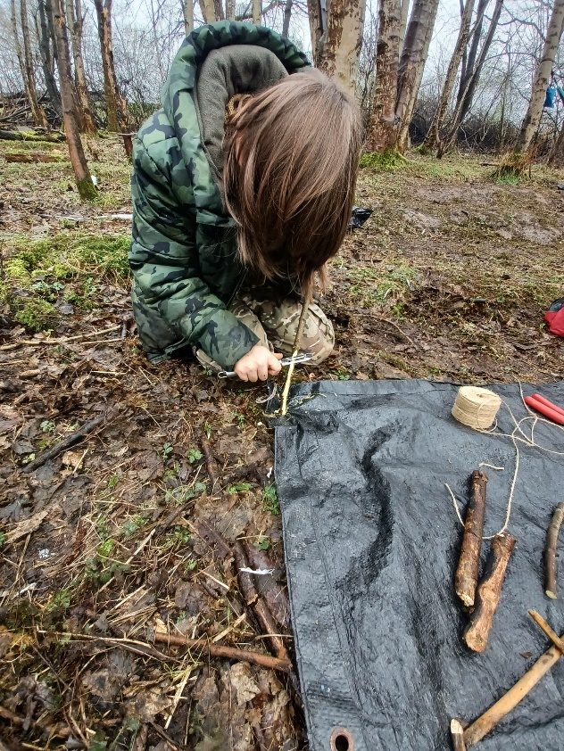

**Aim –** To support young people facing challenges in thriving within the classroom through hands-on experiences in a natural setting

**Service/Activity –** 8 weekly two-hour sessions in a woodland space within the cluster area

**Reach –** 1 primary school pupil, 3 secondary school pupils

**Delivery Cluster(s) –** Coatbridge High, We Aspire, Cumbernauld Academy

**Evaluation Method**

* Weekly reflections and observations from staff
* Verbal feedback from young people, parents and teachers
* Photographs documenting the sessions

**Outcomes**

This project has:

* Increased young people’s school attendance of the outdoor sessions
* Increased young people’s resilience, confidence and ability to communicate their needs

**Learning**

* The project has been tricky due to one of the young people running away during sessions, which has led to tense relationships between the young person and school staff. Despite struggling to engage with the programme sometimes, the project has helped him build confidence
* Another challenge can be the significant needs of the young people and families. For example, a young person’s parent would often call of her child’s sessions. When the young person was able to attend he worked well
* In one of the clusters this project was initially planned as a small group, but was changed to individual support due to the needs of the young person

**OutLET – Youth and Community Ranger**

**Aim –** To support students facing challenges in thriving within the classroom through hands-on experiences in a natural setting

**Service/Activity –** Individual and small group support

**Reach –** 33 primary school pupils, 12 secondary school pupils

**Delivery Cluster(s) –** St Maurice’s High

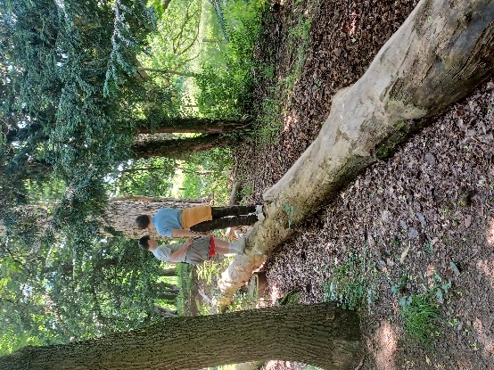**Evaluation Method**

* Weekly reflections and observations from staff
* Verbal feedback from participants, parents and teachers
* Photographs documenting the sessions

**Outcomes**

This project has:

* Increased young people’s school attendance, especially on outdoor days
* Developed strong relationships between young people and the Community Ranger, which allowed them to discuss difficult subjects
* Increased young people’s self confidence and ability to work with peers
* Led to young people saying they felt more relaxed outdoors and were able to cope with their emotions better

**Learning**

* The project was able to support more young people than initially expected
* A challenge with this project has been transport of the young people to the woodland. The schools had to transport the young people using taxis which led to normal issues such as late pickups and overall costs for the cluster
* The project would like to increase the time with the young people in the future to allow for stronger relationships to build
* The woodland that was used was also occasionally used by other schools and groups, which made the space more crowded and made it more difficult to meet the needs of some young people

**Parent Action for Safe Play – Play Champ Programme**

**Aim –** To support Primary 6-7 pupils to develop their skills and knowledge on how to facilitate play opportunities for young people and peers, and continue to champion play and support activities within their school

**Service/Activity –** 8 weekly 1-hour sessions in groups of 12 young people

**Reach –** 148 primary school pupils

**Delivery Cluster(s) –** Cumbernauld Academy

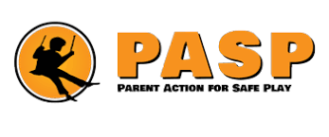**Evaluation Method**

* Observations
* Recording forms
* Children and teacher feedback

**Outcomes**

This project has:

* Increased young people’s self-confidence and communication skills. 85% of young people reported having a more positive view of themselves. 82% of young people feel they have increased their listening skills and feel more confident talking to others.
* Supported young people to facilitate play opportunities to P1 children within their school
* Supported young people’s wellbeing through play
* Increased young people’s physical activity levels during school hours

**Learning**

* On one occasion, due to a misunderstanding of the project, staff had to work with twice as many young people as expected. Staff did decide to continue to work with the larger group so that no one was turned away but felt this does not allow the programme to run to its full potential
* Another challenge was that sometimes the indoor space allocated did not provide enough space for physical activity. This was resolved on most occasions, but in the future more communication might be required to prevent this

**Parent Action for Safe Play – Active Play Programme**

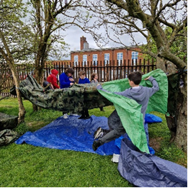

**Aim –** To increase young people’s confidence to explore and participate in play opportunities that support essential skill development and help increase physical activity levels during school

**Service/Activity –** 5-10 weekly 1-hour sessions of semi-structured games and activities, delivered in outdoor green space

**Reach –** 180 primary school pupils

**Delivery Cluster(s) –** St Ambrose High, Calderhead High

**Evaluation Method**

* Feedback from young people and teachers
* Staff observations
* Case studies

**Outcomes**

This project has:

* Delivered 80 hours of Active Play sessions for 180 young people to develop their ability, balance and coordination through physical activities. 100% of young people developed at least one fundamental movement skill
* Increased young people’s confidence. 79% of young people stated they felt more confident either socially or physically

**Learning**

* The project supported a young person who does not usually participate in physical activities and PE. He attended 4 of 5 sessions and fed back he thoroughly enjoyed the sessions and made sure he attended school on these days
* The project supported a group of boys from P5-7, some of whom were quiet and lacked confidence. By the end of the project all boys seemed to have formed a bond and worked well together. *Read more about this in section 3.5*
* The project supported a group of young people from P1-3 with additional support needs. Staff engaged with the teacher to adapt the project. The group was split in two to allow staff more time with each child, and activities were changed to lower intensity to focus on fostering creative play, teaching patience and resilience. Staff noticed an increase in confidence and felt they could make an even bigger impact if the project had been longer

**Ponies Help Children – Equine Assisted Learning**

**Aim –** To build self-esteem, reducing anxiety, building resilience and improving mental health

**Service/Activity –** 7 sessions of equine therapy per pupil

**Reach –** 10 primary school pupils, 2 secondary school pupils

**Delivery Cluster(s) –** Clyde Valley High, Caldervale High, Cumbernauld Academy

**Evaluation Method**

* Feedback forms completed regularly throughout the project
* Feedback from parents, carers and teachers

**Outcomes**

This project has:

* Increased school attendance
* Improved young people’s concentration, collaboration and regulate their behaviour
* Reduced young people’s anxiety

**Learning**

* The project supported a young person who struggled with regulating emotions. The pony reflected their behaviour. The project helped the person find coping techniques that improved both the young person’s and the pony’s behaviour
* One young person fed back that it was beneficial for her to be in a calm and understanding environment and she looked forward to school when she was attending the project
* The two secondary school pupils reported improvements in their social wellbeing, emotional wellbeing, and ability to regulate behaviour

**Reeltime Music – Music and Media Workshops**

**Aim –** To engage disenfranchised young people and develop their skills creatively, socially and personally and to help the young people make more informed decisions in future when dealing with their own mental health and wellbeing

**Service/Activity –** Creative workshops and thinking activities around different aspects of mental health

**Reach –** 75 primary school pupils, 24 secondary school pupils

**Delivery Cluster(s) –** Airdrie, St Margaret’s, St Ambrose, St Andrews, We Aspire

**Evaluation Method**

* Evaluation surveys
* Staff observations

**Outcomes**

This project has:

* Supported young people in creating music, music videos, trying instruments and group performances.
* Increased pupils’ understanding of mental health. For example, 84% of pupils who completed surveys felt they have a better understanding of how to be aware of and improve their mental health. 78% felt they have a better idea of who to contact if they have a mental health question, problem or crisis

**Learning**

* In the future the project would like to increase the time in sessions to cover more depth of detail and support further skills development
* The project saw a decrease in attendance, partly due to the background of the pupils (vulnerable, disengaging with school) and partly due to the timing of the project clashing with end of term activities

**Young person involved in Reeltime Music Music Workshops**

**“I got to play the drums for the first time. It was really fun and it helped me get comfortable with them. It has also helped me with team work. Sometimes working with others can be a hassle but now I am better at it”**

**Social Track – Shredability and Wheeled Sports Sessions**



**Aim –** To **s**upport the development of cycling skills and emotional and mental wellbeing of young people who struggle to engage with school

**Service/Activity –** Cycling skills, led rides and bike maintenance sessions

**Reach –** 1 primary school pupil

**Delivery Cluster(s) –** Clyde Valley High, St Margaret’s High, We Aspire

**Evaluation Method**

* Observation
* School attendance

**Outcomes**

This project has:

* Increased a young person’s school attendance, and ability to stay in school longer
* Increased the young person’s desire to take part in activities and increase their motivation to learn

**Learning**

* The project supported a young person struggling with home life and help them not experience statutory care. The project was made aware of violent behaviour that others had experienced. The coaches did not experience this at all during the sessions
* A challenge has been flight risk, as people prefer to cycle off campus. Getting other programs involved has helped overcome this issue and work has progressed. Flight risk was a difficult thing to manage as young people prefer to cycle off campus. This look like the issues have been overcome as work has progressed but this took planning and other programs being involved

**VIP-Pass Community Project – Creative Transitions Project**

**Aim –** Improving young people’s emotional, physical and mental health and wellbeing and increase confidence and self-esteem

**Service/Activity –** Group and 1:1 sessions involving horse-riding, gardening, health and beauty, musical theatre, Sonny & Me, yoga, Chefs on the Move, and web design

**Reach –** 440 primary school pupils, 74 secondary school pupils

**Delivery Cluster(s) –** St Margaret’s High, Greenfaulds High, Cardinal Newman High, Brannock High

**Evaluation Method**

* Case studies
* Observations
* Teacher feedback
* Pre-, mid- and post-evaluation forms

**Outcomes**

This project has:

* Involved all pupils in the development of each activity
* Given pupils something to enjoy and look forward to, and given them a sense of belonging and worth
* Increase young people’s confidence and willingness to engage in other school activities

**Learning**

* The project supported a person with Tourette’s syndrome to take part in a musical theatre activity. To start they were very anxious but as the program progressed became part of the group and seemed calmer and engaged with others in the group
* The project supported a person living with trauma due to family bereavement to take part in 1-1 horse-riding sessions. They connected with the coach and the horses. School and family reported that their aggression to siblings had reduced
* The project supported a selective mute taking part in 1:1 gardening sessions. At the start they were eager to learn without verbal communication. By the end of the block they were having conversations with the coach and are now on occasions communicating at school

**3. Case studies**

This section outlines six case studies from projects funded in Phase Four. These case studies are illustrative of the range of great work that has been done by all organisations, across all clusters, and have been selected to highlight the variety of services provided.

**3.1 Circle – Whole family, trauma recovery and early intervention support**

**Background**

One child awaiting a neurodevelopment assessment had limited attendance at school and whilst flexible options were offered the young person experienced sustained anxiety and nonattendance. The young person’s parent communicated that her young person’s anxiety would impact on her ability to establish a relationship with the Family Outreach Worker (FOW) and was unsure whether she would actively meet with the FOW at home or in the community given her anxiety in social settings.

**Intervention**

The FOW established a relationship with the young person that was informed by the young person’s perspective and her needs. Through meeting at home with the young person and the parent the FOW understood that the parent had experienced a long-term illness which created increased worry, concern and anxiety for the young person. This had a direct impact on the young person’s anxiety in not being able to be at home and close to her parent throughout the extended period of poor health. In engaging in open communication, offering reassurance for the young person regarding parent’s health and wellbeing, the young person’s worry and anxiety lessened.

Throughout the period of support the young person met with the FOW weekly (unable to meet twice due to being unwell) attending favourite spaces including pet stores, coffee shops and latterly therapeutic interventions (animals).

**Outcome**

The young person’s anxiety regarding their parent’s health and wellbeing lessened. The young person has now tentatively met schoolteachers and is exploring what the transition can and could look like to improve and strengthen her attendance and attainment at school.

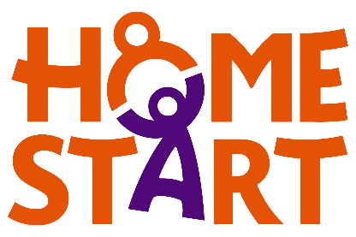**3.2 Home Start GNNL – Home-Start schools project**

**Background**

A Mum and her Primary 1 son (C) were referred to Family Support Worker (FSW) for help to support with school settlement and engagement. C was disengaging from school and refusing to follow rules. Mum was getting phone calls on an almost daily basis asking her to collect C from school due to his disruptive behaviour.

**Intervention**

The FSW supported Mum along to a multi-agency meeting to discuss C’s behaviour. Mum explained how stressful she was finding the phone calls and said she had considered giving up her job because of it. Also present were the educational psychologist and CIIL along with an additional support needs teacher. During the meeting the educational psychologist recommended that C was removed from class lessons and given 1:1 supervision daily.

Shortly after this meeting the family had to be rehomed due to threats and violence from a neighbour. They are now settling into their new home and FSW has secured an early-years grant from Save The Children to assist with furnishing their new home. FSW also referred to Sleep Scotland for advice on sleep problems the family were experiencing at home.

FSW has provided practical and emotional support to Mum during this time and will continue to support further with her son’s school journey as she explores possible pathways for his education.

**Outcome**

Mum now reports that the frequent phone calls have stopped and she is no longer considering giving up her job. At present there is a plan to integrate C back into the classroom in a phased approach and reassess the situation after the February school break. Mum has requested a referral to CAMHS. Mum reports an improvement in relationship and feeling more supported by the school since Home-Start involvement and C1’s sleep has improved since the involvement of Sleep Scotland which has had a positive effect on the morning routine before school.

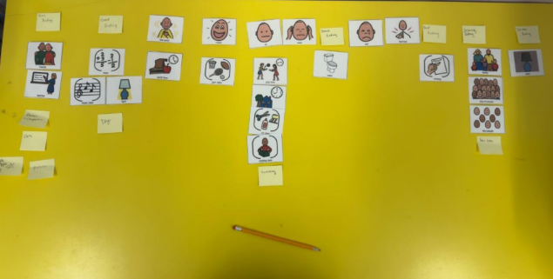**3.3 HOPE for Autism – Personalised Intensive Support**

**Background**

Hope for Autism supported a young autistic person (B) in primary school by developing an understanding of his sensory, emotional and communication needs, and recommending and implementing strategies in collaboration with him and his teacher.

**Intervention**

The block spanned 3 visits. In the first session, HOPE for Autism did a consultation with B’s teacher, where she explained the ins and outs of B’s day, as well as his strengths and areas where he would benefit from additional support. They also completed a talking mats style activity with B to establish a profile of his support needs. This was very successful and B’s teacher asked for an adapted version of the activity to continue this conversation with B in the classroom.

In the second session, B completed an activity sorting his interests and needs into different sections (good, bad etc.). B asked if he could include “alternate story endings” from the game Roblox to talk about his emotions. HOPE for Autism completed a sensory profile using a language and interest-based approach and converted this into a Communication Passport for B to aid in transitions and when interacting with new people within the school.

In the third and final visit, B completed an updated version of the talking mats. He said he was very proud of himself for having done the activity and is looking forward to using it again in the future to communicate. He also completed another activity talking about the future. Based on the visits, HOPE wrote a personalised Support Summary stating goals, strategies, successful approached and summaries of the visits.

**Outcome**

B has made incredible progress. B’s teacher’s classroom is a safe and positive place for him and his classmates. He has started to really integrate into the class, and is even welcoming visitors into his classroom, where in the part this has been more challenging. The number of people he can be around is increasing, which is a massive jump from his past where he had been very isolated. Adjusting to a new routine has been a good learning experience for B. He has also been able to eat his lunch in the hall, is able to better regulate his emotions, and is constantly pushing himself to attain new goals like playing outside. These are all massive achievements, and with the school’s support HOPE sees avenues for more growth in the future.

**3.4 OutLET – Youth and Community Ranger** 

**Background**

OutlET delivered a programme of outdoor learning and play sessions for a group of up to 6 young people. The group comprised 6 young people, some of whom had met previously and others who were completely new to the programme. One of the young people (OD) had attended the OutLET sessions for a few terms already. Initially, he was reactive and prone to hitting out. He also struggled with sharing and regulating his emotions when things didn’t go his way.

**Intervention**

The young people learnt how to prepare, build and extinguish fires safely, we have explored the site extensively and identified different trees and plants. They built dens, learned how to put up hammocks, climbed trees, used tools to whittle, batten and saw wood. They also used imaginative play and had numerous adventures in the stream and every muddy puddle.

**Outcome**

The dynamic of the group shifted and changed from week to week as there were often absences and it took a few weeks for the boys to bond and become more comfortable with one another. By the end, however, there was a significant shift in how well they were getting on and sharing with one another. Friendships were beginning to form and everyone seemed more at ease. Over the past several sessions across multiple terms OD has made significant progress. He has learned to assess situations and consider his responses. He can be wary of others and often likes to do his own thing, but he has become more confident in a group setting and is really starting to develop his social skills and make friends. He can also share things now, having built trust with his peers.

OD very much thrives being outdoors and exploring through all of his senses. He particularly enjoys spending time working with tools and helping to light the fire. Overall the young people very much embraced their natural surroundings.

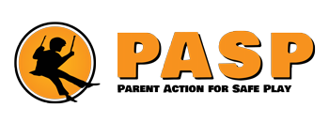**3.5 Parent Action for Safe Play – Active Play**

**Background**

PASP worked with a group of 13 boys from P5, 6 and 7, some of whom were quiet and lacked confidence and others who did not. Due to the age, stage of development and nature of the group the key aims were to help develop friendships and confidence.

One of the boys attending, (T) told us he does not usually participate in any physical activities and does not attend P.E, he stated that he would go to the library during this time to read or draw.

**Intervention**

The programme focussed on Active Play and was adapted to incorporate a wide range of team building activities including den building, tug of war etc. Young people were split into groups incorporating a range of abilities to encourage them to engage and support one another.

**Outcome**

Den building really helped with communication and problem solving together and games such as tug of war allowed young people who normally don’t enjoy traditional games (as most focus on speed and agility) to find something they are good at. By the end of the programme all boys seemed to form a bond and work well together. Those who were very confident took a step back to allow those who initially were not, to shine. PASP say it was a pleasure to work with this group and visualise such positive outcomes in such a short period of time.

T attended 4 of 5 sessions and fed back that he thoroughly enjoyed his sessions with us and made sure he attended school on these days. His mother expressed his enthusiasm throughout the duration of the programme.

Staff adapted the active play programme to suit the children attending our sessions to enable all outcomes to be reached, we do know that with being given some background information on the children attending prior to the programme gives us better knowledge on what is required. This is something we will be advocating for in future.

**3.6 The Miracle Foundation – One to One Art and Play Therapy**

**Background**

Young person B initially presented with a low attendance rate and frequently reported feeling anxious at school, particularly in response to loud noises and crowded environments. B was also worried about the possibility of being reprimanded or getting into trouble. B initially scored low on the SHANARRI indicators for feeling included, achieving, and being active.

**Intervention**

B attended 1:1 Art therapy sessions, creating art in presence of a therapist. It took a few sessions for B to settle in and open up, but they gradually began to show enthusiasm for the sessions and expressed themselves more freely. B and the therapist worked on strategies to help B manage their feelings of being overwhelmed or worried, and identified people he could speak with in these situations.

**Outcome**

B’s SHANARRI scores improved by the end of the program. B’s attendance also improved significantly over the course of the sessions, and they took great pride in this achievement. The Miracle Foundation and B celebrated the success and discussed how it was positively impacting his learning. B would benefit from continued support within the school to help B manage sensitivity to noise and they worries about getting into trouble or making mistakes. In the final session, B reflected that they had enjoyed the sessions and was sad they were ending. B mentioned that the sessions had helped them feel more comfortable coming to school, particularly on Thursdays, which they used to worry about.

[end of document]