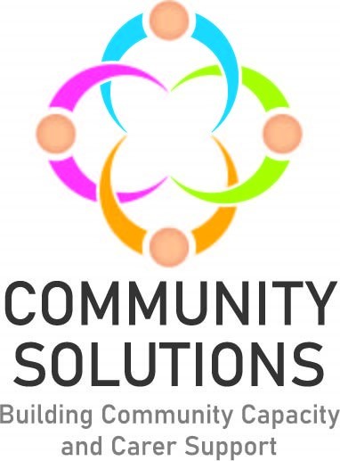

**North Lanarkshire Children, Young People & Families Mental Health & Wellbeing Fund**

**Impact and Learning Supplementary Report – Phase Three 2022-23**

**Contents**

1. Introduction – Page 3
2. Summary of All Funded Projects – Page 4
3. Case Studies – Page 24
4. Summary of Support Types – Page 27

**1. Introduction**

The purpose of this report is to supplement the North Lanarkshire (NL) Community and Voluntary Sector (CVS) Children and Young People Community Mental Health and Wellbeing Fund Impact and Learning report for Phase 3 (covering 2022-23). The full report includes an overview and background of the fund, and a summary of achievements, reach and impact data, whereas this shorter, supplementary report provides additional information about all projects funded through Phase Three of the fund. This report provides a summary of the following for each funded project:

* The project aims
* The service/activity provided
* The school clusters the project was delivered in
* The project reach
* The evaluation method used to measure outcomes
* The achieved project outcomes and [SHANARRI](https://www.gov.scot/policies/girfec/wellbeing-indicators-shanarri/) indicators
* The learning from each project

This report also includes case studies from three funded projects, and a diagram summarising the types of supports provided in Phase Three.

The following projects were funded during Phase Three, however, some could not deliver their projects during the delivery period covered by this report. Those projects have agreed with Voluntary Action North Lanarkshire (VANL) staff to deliver their projects and report to VANL in late 2023:

* Circle – Whole Family Support Service
* Lanarkshire Community Food and Health Partnership – The Nurture Project
* Volunteering Matters – North Lanarkshire Youth Befriending Project

**2. Summary of All Funded Projects**

This section presents a project-by-project summary of the projects funded through Phase Three.

**Action for Children – Young Carers Primary School Awareness Programme**

**Aim –** To raise awareness of Action for Children’s Young Carers service, and support the current and future identification of young carers within schools

**Service/Activity –** 66 classroom-based awareness and information sessions for pupils and staff to raise awareness and identify young carers

**Reach –** 200 primary school and two secondary school pupils, 60 families, and 12 young carers

**Delivery Cluster(s) –** St Margaret’s

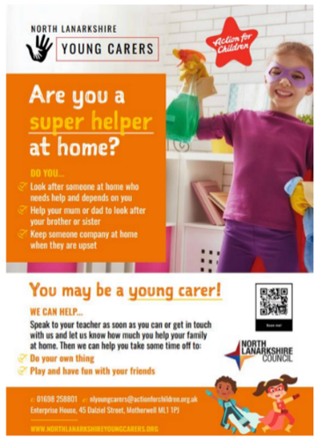**Evaluation Method**

* Written feedback from pupils
* Feedback from teaching staff
* Referrals to the service
* Attendance figures

**Outcomes**

This project has:

* Delivered 36 in-class information sessions and presentations to primary school pupils
* Delivered 30 information sessions and presentations to school teaching and support staff
* Been supported by two peer support mentors (secondary school pupils who were young carers) who supported the information sessions

**Learning**

* In the future, the project will involve more peer support mentors as the young carers felt valued and were able to support the primary school pupils
* The project typically preferred to deliver multiple sessions in small groups. However, some schools preferred a one-off presentation to a larger group
* The number of referrals after the sessions to their service has shown that there is increased awareness of the service and what it does

**Bazooka Arts – Group Therapeutic Arts Programme**

**Aim –** To support children and young people’s mental health and wellbeing through therapeutic arts

**Service/Activity –** 93 therapeutic arts workshops

**Reach –** 30 primary school pupils

**Delivery Cluster(s) –** St Margaret’s, St Ambrose, St Andrew’s, Coltness, and St Aidan’s, Calderhead

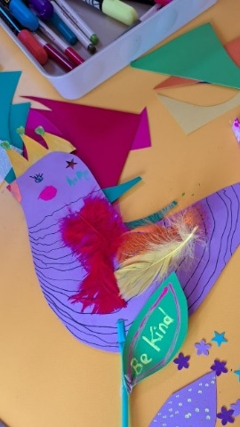

**Evaluation Method**

* Evaluation survey
* Verbal feedback

**Outcomes**

This project has:

* Delivered 93 therapeutic arts workshops using play, imagination, movement, and creative techniques
* Engaged children in activities including creating cyanotypes, dreamcatchers, and silk painting
* Focused on providing relaxation, building confidence and resilience, and increasing social interaction for children who had suffered bereavement, had low confidence and self-esteem, and who can find social interactions and the classroom environment challenging

**Learning**

* The survey highlighted:
  + 100% felt the sessions resulted in an increase in confidence
  + 100% felt the sessions improved mental health and wellbeing
* The project felt that the children would have benefitted from and wanted longer sessions. Longer sessions would give them the opportunity for the children to build more trusting, positive relationships with each other and with staff
* The project would like to have more family involvement in the future

**Home Start – Practical Steps Towards Change**

**Aim –** To provide emotional support, friendship and practical help to parents and carers of children at the P1-P3 stage who are experiencing difficulties engaging or re-engaging with their primary school

**Service/Activity –** 1-to-1 support for families

**Reach –** Six children and their families

**Delivery Cluster(s) -** Bellshill

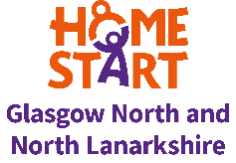**Evaluation Method**

* Weekly reviews with families
* School attendance
* Staff observations
* Verbal feedback

**Outcomes**

This project has:

* Offered six children and their families weekly 1-to-1 support through home visits and telephone calls, offering practical and emotional support and signposting to other agencies
* Held five trips including to the science centre, the PlayTalkRead bus, Summerlee Heritage Park, Strathclyde Park, and Blair Drummond Safari Park
* Provided 2 families with trauma-informed parenting training

**Learning**

* The project supported one pupil who was a non-attender to re-engage with school. Her attendance rate percentage is now in the high 90’s. The relationship between the family and their school has also improved and they now work together to support the child to engage fully with the curriculum. The child is also now attending the school’s summer club during the school holidays.
* Going forward with the project, the organisation will ensure that any new schools who submit referrals understand the role of the family support worker and what support they provide, and what the expectations are on the school before starting support

**Hope for Autism – Support for School Transitions**

**Aim –** To support children with autism in early primary education with their transition into school

**Service/Activity –** 10 weekly face-to-face support sessions with the child and their family

**Reach –** Six children and 11 parents/carers

**Delivery Cluster(s) –** Airdrie Academy

**Evaluation Method**

* Staff observations
* Verbal feedback from parents/carers
* Thumbs-up scale with children (good, middle, bad)

**Outcomes**

This project has:

* Offered children a safe space during 10 weekly support sessions to interact with their peers
* Allowed parents/carers to seek advice about their child
* Facilitated conversations between parents, allowing them to share experiences
* Hosted a day trip to Glasgow Science Centre and Almond Valley in Livingston, hosted social gatherings in a soft play area, and a celebratory end-of-project party

**Learning**

* In future, the project would plan an initial meeting with the parents/caregivers and staff without the children, to allow them to establish a stronger relationship prior to the project. They would also hold separate sessions for children in nursey and children already in primary school, rather than a mixed age group
* Some families invited did not participate. The project extended another invitation when the group planned to visit a soft play area, and one family took up this offer

**Hope for Autism – HOPE for Autism’s Lunch Time Club**

**Aim –** To support the emotional wellbeing of autistic young people and provide them with a safe space during lunch time

**Service/Activity –** Lunch club for autistic young people

**Reach –** Six secondary school pupils

**Delivery Cluster(s) –** Kilsyth



**Evaluation Method**

* School staff feedback
* Verbal feedback
* Attendance

**Outcomes**

This project has:

* Delivered 12 weekly lunch time club sessions with autistic young people, giving them the space to relax, interact with others, and discuss topics like what being autistic means to them, aspects of being autistic, their worries and stresses at school, and their sexuality and gender identity
* Gave young people access to sensory stimulation items and tools, bringing them comfort and allowing them to decompress

**Learning**

* The project reported that multiple staff members made them aware that several pupils involved in the lunch club asked if they would be returning. The young people also expressed interest in the project running again next term
* Since the lunch club has ended, a parent of a pupil who attended has contacted the organisation to sign up for a membership.
* The project offered the young people sticky notes, sheets of paper and pens as an alternative way to communicate without any pressure. However, they found the young people were comfortable enough with the facilitators that they did not use them

**Lanarkshire Community Food and Health Partnership – Big Chef Little Chef**

**Aim –** To provide a space for parents and child to bond, whilst also gaining practical cooking skills and learning about nutrition

**Service/Activity –** Parent and child practical cooking sessions and nutrition

**Reach –** 136 primary school pupils and their parent/carer

**Delivery Cluster(s) -** Coatbridge, St Maurice, St Ambrose, St Andrews

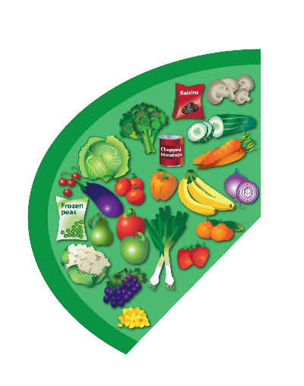

**Evaluation Method**

* Pre- and post-course survey
* Verbal feedback

**Outcomes**

This project has:

* Delivered 82 weekly, two-hour workshops where parents/carers and children cook together and learn about nutrition
* Taught recipes including overnight oats, filled wraps, cheese and vegetable omelette, and pitta bread pizzas
* Taught nutrition topics such as the Eatwell Guide, health snacking, sugar intake, fussy eating advice
* Delivered activities such as exotic fruit tasting, healthy snack tasting, and a sugary cereal quiz

**Learning**

* Some courses were four weeks and others were six. The nutritionist found that six weeks was a more effective course length as participants got longer to make a bigger range of different recipes, and more time to practice their skills
* There was one cluster with some pupils with additional support needs which was challenging. The nutritionist was able to work with their parents/carers to adapt the course by keeping instructions short and quick

**Lanarkshire Community Food and Health Partnership – Come Dine with Me**

**Aim –** To encourage families to cook healthier meals from scratch together

**Service/Activity –** At home, weekly family cooking sessions

**Reach –** 49 primary and 29 secondary school pupils and their families

**Delivery Cluster(s) –** Airdrie Academy and Caldervale

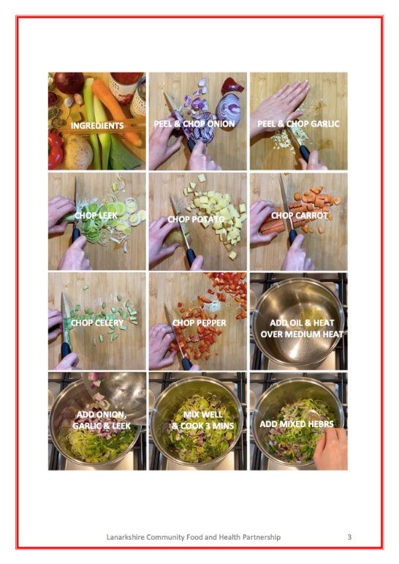

**Evaluation Method**

* Pre- and post-online surveys

**Outcomes**

This project has:

* Delivered 22 weekly sessions where families were provided a food bag containing a pictorial step-by-step recipe and ingredients
* Instructed families to cook the provided recipes together at home
* Provided each family with a bag of fruit on a weekly basis

**Learning**

* The project found it difficult to gather responses to their surveys, especially the post-delivery survey as the activities were delivered at home. The project will explore new ways of collecting data with teachers in the future
* The project is considering making it a requirement for families to take a picture of the finished meal to monitor their engagement and to be able to share with others to motivate families

**Lanarkshire Community Food and Health Partnership – Cooking Club**

**Aim –** To teach young people about nutrition and give them practical cooking skills

**Service/Activity –** Eight-week healthy cooking and nutritional education course

**Reach –** 26 secondary school pupils

**Delivery Cluster(s) –** Braidhurst, Chryston, Kilsyth



**Evaluation Method**

* Pre- and post-course survey
* Verbal feedback

**Outcomes**

This project has:

* Delivered 44 practical cooking sessions focused on easy-to-make budget meals and teaching the importance of eating five a day, healthy snacking, sugar intake, and the Eatwell Guide

**Learning**

* The project felt that being able to communicate with the school effectively was important. In the future, the project would like to communicate with the school to ensure that the school has the capacity to work with them
* The project found that the time provided for the session was too short to provide the demonstration, cook the meal, clean up, and teach the nutrition information. In one cluster, the session was cutting into pupil’s break-time. To avoid this, the nutritionist leading the course would try to talk about nutrition as much as possible during the demonstration and cooking to save time whilst still delivering the information
* Pupil’s feedback suggested that making and trying new foods and meals was their favourite part

**Make and Create Arts – Positive Creations**

**Aim –** To improve children and young people’s school attendance, mental health and wellbeing, resilience and confidence, and reduce anxiety

**Service/Activity –** Creative sessions focused on positive mental health

**Reach –** 230 primary and 24 secondary school pupils

**Delivery Cluster(s) –** St Ambrose, St Andrew’s, Caldervale



**Evaluation Method**

* Verbal feedback
* Written feedback form

**Outcomes**

This project has:

* Delivered 84 creative workshop sessions creating a new craft each week that could be tailored to the young person’s interests, to improve their mental health and wellbeing, build resilience, and reduce anxiety around attending school

**Learning**

* One cluster was supposed to follow the organisation’s ‘Creative Families’ project (see below). However, very few parents from this cluster attended the sessions, so the project decided to deliver the Positive Creations project with children only
* Strike action meant that some sessions had to be rescheduled
* At the end of the project, young people fed back that they felt they had learned new skills, felt more confident in their skills and abilities, and felt more comfortable working on their own and as part of a team

**Make and Create Arts – Creative Families**

**Aim –** To improve children and young people’s school attendance, mental health and wellbeing, resilience and confidence, and reduce anxiety

**Service/Activity –** Creative family workshops for pupils disengaged with school or who are not attending

**Reach –** 24 primary school pupils, 12 parents/carers

**Delivery Cluster(s) –** Airdrie Academy



**Evaluation Method**

* Verbal feedback
* Written feedback form

**Outcomes**

This project has:

* Delivered two blocks of six weekly workshops in eight schools, each week focusing on a different creative craft activity completed by the child and their parent/carer
* Taught children and their families the benefits of attending school regularly and building bonds with peers

**Learning**

* The teachers fed back that there was a noticeable difference in children’s behaviour and attitude after attending the workshops
* One student was unable to attend with a parent and instead had a member of school staff attend with him or he worked alone. This highlighted to the project that it was important for children to have a parent/carer be involved to get the most out of the experience, as parents would encourage their child and their communication improved

**One Parent Families Scotland – Creating Connections**

**Aim –** To support parents facing challenges with their health and wellbeing to improve their family wellbeing

**Service/Activity –** Programme of scheduled support activities for single-parent families

**Reach –** 105 single parents and 154 children

**Delivery Cluster(s) -** Greenfaulds, Our Lady's High Cumbernauld, Cumbernauld Academy, Braidhurst



**Evaluation Method**

* Verbal feedback
* Written questionnaire

**Outcomes**

This project has:

* Delivered a programme of support for single-parent families to alleviate circumstances of poverty, make single parents feel more included, and improve their family wellbeing by providing access to the right support at the right time
* Provided 262 1-to-1 support sessions with parents including face-to-face, telephone, virtual, text, and walk and talk support
* Provided 168 in-person group support sessions
* Provided crisis support on 103 occasions
* Provided single parents with access to the organisation’s single parent hub in Cumbernauld for weekly drop-ins

**Learning**

* The project identified that the parents referred to the project were most commonly facing significant challenges with their health and wellbeing, their children’s health, crisis support, managing family finances, and low levels of confidence, self-worth, and self-esteem
* The project found that more parents needed and wanted 1-to-1 support rather than group support. The project was able to adapt their service to focus more on 1-to-1 family support and crisis support. They were able to provide a weekly drop-in hub for parents to attend, and they were able to provide peer mentor training sessions to a smaller group of single parents

**OutLET Play – SOARing Outdoors**

**Aim –** To support young people who have experienced significant trauma and are struggling to engage with school through nature

**Service/Activity –** Weekly, individual, small group, and group outdoor learning-and-support sessions

**Reach –** 39 primary and seven secondary school pupils

**Delivery Cluster(s) –** Brannock and Taylor, Clyde Valley, Greenfaulds, Kilsyth, Dalziel, Our Lady’s High Cumbernauld

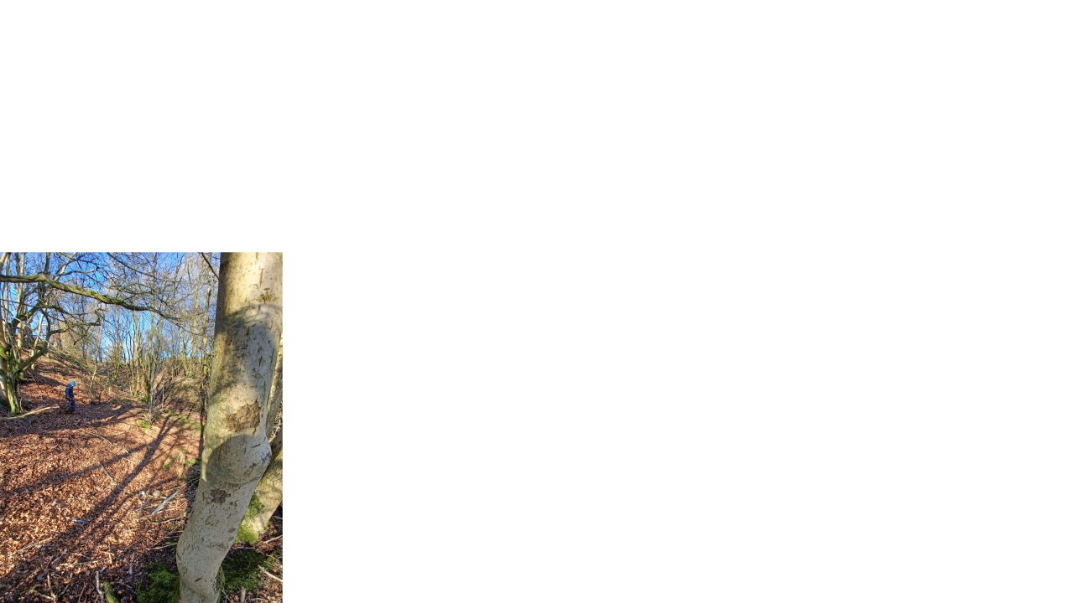

**Evaluation Method**

* Observations
* Attendance
* Verbal feedback

**Outcomes**

This project has:

* Delivered 50 two-hour small group sessions in a local woodlands area, which engaged young people in sensory seeking activities and allowed them to play freely whilst working through their emotions
* Delivered 85 one-to-one sessions*
* Delivered 59 larger group sessions

*The total number of sessions is higher than the number of school pupils supported as they can attend more than one individual or group session

**Learning**

* The project felt the 1-to-1 sessions were very successful, as a strong relationship was built between the young people and the facilitator. This enabled the young people to talk about their worries and difficulties with school
* A challenge the project faced was that school staff were sometimes unavailable to accompany young people at the sessions. To accommodate this, the project adjusted their procedures so other responsible adults could accompany them
* For future programmes, the project would consider asking the school to take responsibility for transporting the young people to the session

**OutLET Play – Wild Passport**

**Aim –** To support young people who have experienced significant trauma and are struggling to engage with school through nature

**Service/Activity –** Weekly, individual outdoor support sessions

**Reach –** Seven primary school and four secondary school pupils

**Delivery Cluster(s) –** Brannock and Taylor

**Evaluation Method**

* School staff feedback
* Verbal feedback
* Facilitator observations

**Outcomes**

This project has:

* Delivered a block of six weekly outdoor learning and support sessions with 13 children and young people who have experienced significant trauma. This focused on giving children the space to experience their emotions and build resilience
* Provided self-directed activities in nature led by the children and young people
* Been delivered by highly trained staff with a specific understanding of the effects of developmental trauma on children

**Learning**

* There was an opportunity for children aged 10+ to gain a Forest and Outdoor Learning Award, however, the children who attended did not attend regularly enough to achieve this

**PASP – Play Champion Programme**

**Aim –** To increase young people’s activity levels during school hours to support their cognitive, physical, and mental health and wellbeing

**Service/Activity –** Eight-week play and leadership workshops

**Reach –** 482 primary school pupils

**Delivery Cluster(s) –** Greenfaulds, Cumbernauld Academy, St Maurice

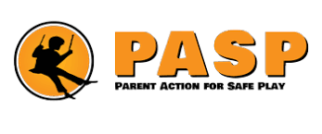

**Evaluation Method**

* Staff observations
* Written feedback and questionnaire

**Outcomes**

This project has:

* Delivered 35 eight-week workshop programmes which focused on leadership skills, group work to improve their confidence and self-esteem, understanding of risk benefits, play types, and the health and wellbeing benefits of play
* Taught 482 young people how to facilitate free-play opportunities with or without equipment, which they then demonstrated in a session with P1 pupils

**Learning**

* The project identified that some pupils struggled with the written work aspect of the workshops. The project was able to adapt the programme to suit this. In future, the project will prompt this from school staff and Cluster Improvement Integration Leads (CIILs) so they can prepare
* The project felt the young people would have benefitted more from delivering the session to the P1 pupils at an earlier stage
* The questionnaire showed that 100% of children felt they had a positive overall experience

**Reeltime Music – Creative Project using Music and Media**

**Aim –** To enable young people to speak about their mental health issues whilst learning creative skills

**Service/Activity –** Weekly music and creative media workshops

**Reach –** 15 primary and 74 secondary school pupils

**Delivery Cluster(s) –** Caldervale, Airdrie Academy, Kilsyth, Our Lady’s High Cumbernauld and Motherwell

**Evaluation Method**

* Verbal feedback from school staff
* End-of-project written questionnaire

**Outcomes**

This project has:

* Delivered 79 workshop sessions focusing on recording music, trying instruments, group performances, creating music videos, and original music compositions
* Provided young people with information about available mental health supports and a safe space to talk about their problems

**Learning**

* The project experienced some difficulties such as inconsistent attendance, struggles with social anxiety, and lack of interest in music. However, they knew to expect these issues from experience, and found ways to work around them as the project moved forward. For example, facilitators worked with the young people to decide on the content of each activity, and put them in charge of the sessions which increased the likelihood they would attend. They also built in activities that which allow the young people to get to know one another to reduce feelings of social anxiety

**Social Track - Empowering Young People Through Action Sports**

**Aim –** To re-engage young people with school and promote positive mental health strategies through action sports

**Service/Activity –** Bespoke group coaching in BMX, scooters, and skateboards

**Reach –** 87 primary school and 20 secondary school pupils

**Delivery Cluster(s) –** Clyde Valley and Calderhead



**Evaluation Method**

* Verbal feedback
* Observation

**Outcomes**

This project has:

* Supported young people by providing bespoke small-group group coaching based on young people’s skill level in BMX, scooters, and skateboards
* Focused on positive goal-setting and learning to fail and try again
* Taught young people to build and fix bikes

**Learning**

* The project found that the BMX bikes was the most popular option for the young people, so they have invested funding in more bikes for future projects
* The project observed that the peer support element of the project was valuable to the young people and made them feel included

**The Health and Wellness Hub – Emotional Wellbeing in Schools**

**Aim –** To support young people and their families to manage their stress and anxiety

**Service/Activity –** Stress and anxiety management courses (mindfulness and fitness activities)

**Reach –** 323 primary and 102 secondary school pupils, and 36 families

**Delivery Cluster(s) -** St Margaret's, Chryston, Airdrie Academy, Braidhurst, Dalziel, Caldervale

**Evaluation Method**

* Pre- and post-questionnaire

**Outcomes**

This project has:

* Delivered 215 mindfulness sessions with young people which taught them about mindfulness practice, discussed the concepts related to mindfulness, and prepared the young people to deliver their own mindfulness sessions to peers
* Delivered nine fitness sessions including yoga
* Supported 36 family members to be involved in the mindfulness sessions

**Learning**

* The project is considering producing an information flyer about the courses and what the children are doing to encourage others to attend
* There were teaching strikes which caused some sessions to be cancelled or rescheduled. The project found that this sometimes caused a break in the continuity of the sessions for the children. To combat this, the project held a refresher session rather than continuing on with the course progression

**The Miracle Foundation – Encouraging Growth and Resilience**

**Aim –** To support young people to feel empowered and aware of mental health and wellbeing issues

**Service/Activity –** Two mental health workshop blocks in two schools

**Reach –** 78 primary school pupils and 39 secondary school pupils

**Delivery Cluster(s) –** Coltness, Airdrie Academy, Coatbridge, St Maurice, Kilsyth, Our Lady’s Cumbernauld, Caldervale, St Aidan’s



**Evaluation Method**

* Facilitator observations
* Pre- and post-questionnaires
* [Wellbeing Web](https://lx.iriss.org.uk/content/girfec-wellbeing-web.html)

**Outcomes**

This project has:

* Delivered 40 sessions of a mental health focused workshop each week for five weeks, where the group chose the topic for the final three sessions including topics such as bereavement, trauma, bullying, stress, anxiety, suicide, and self-harm
* Taught young people techniques to overcome stress such as breathing techniques, stretching exercises, mindfulness techniques, and making friendships and connections
* Provided a safe space for young people to talk about issues important to them

**Learning**

* The project found that having a direct line of communication between the project staff and teaching staff of the children attending the programme was vital for the success of the project
* Young people were often late to the workshops as they did not remember week to week
* The project tried to mix pupils from two schools in one group. They found this could cause issues around getting feedback as the facilitator had to call the second school for feedback, which was challenging as the teacher and facilitator didn’t know each other

**The Miracle Foundation – Supporting Children and Young People’s Mental Health**

**Aim –** To support young people to manage the stress and anxiety related to transitioning to high school

**Service/Activity –** Workshops targeted at supporting P7 pupils with the transition to high school

**Reach –** 70 primary school pupils

**Delivery Cluster(s) -** Caldervale, St Maurice, Coatbridge, Airdrie Academy, Greenfaulds



**Evaluation Method**

* [Wellbeing Web](https://lx.iriss.org.uk/content/girfec-wellbeing-web.html)
* [Psychlops](http://www.psychlops.org.uk/about)
* Verbal feedback

**Outcomes**

This project has:

* Delivered 30 90-minute workshop sessions over five or 10 weeks targeted at supporting young people with the transition to high school
* Provided young people with a safe space to work through the stress and anxieties they had in relation to going to high school, and taught them how to deal with feelings of loss with leaving primary school, and techniques to build resilience and confidence

**Learning**

* The young people asked if the project could follow up with them once they had transitioned to high school, which they were able to do. The organisation is looking at ways to implement this going forward for all school transitions workshops
* The project held both five-week and 10-week programmes, and found that the 10-week programmes were more beneficial in establishing a long-term, positive relationship between the facilitator and the young people
* One cluster had young people from two primary schools in the same group. This was initially difficult as they did not know each other, however, over time the children developed friendships

**VIP Arts and Sports Academy – Creative Me! Wellbeing Programme**

**Aim –** To re-engage young people with school whilst also improving their confidence, self-esteem, and physical, emotional, and mental wellbeing

**Service/Activity –** An activity programme delivered by specialist coaches, including yoga, cookery, musical theatre, and other activities

**Reach –** 348 primary and 32 secondary school pupils

**Delivery Cluster(s) –** Bellshill



**Evaluation Method**

* Verbal feedback
* Written feedback
* Goal-setting and performance review

**Outcomes**

This project has:

* Delivered 20 yoga sessions with P4 to P7 pupils focusing on de-stressing
* Delivered 40 cookery sessions with P4 to P7 pupils focusing on eating healthy and making better food choices
* Hosted a gardening project with P4 to P7 pupils, led by S3 pupils, teaching horticultural skills and encouraging time outdoors
* Delivered five musical theatre sessions, where each school produced a showcase at the end of the block for their peers and teachers
* Taken five pupils from P4 to S3 horse riding, to teach them to care for the horse and for the therapeutic benefit to reduce stress and anxiety

**Learning**

* Sometimes children did not always turn up for activities due to difficult personal circumstances. To overcome this, the project set up a system with the head teachers so other children could attend when allocated children couldn’t attend
* The project found it was important to involve the young people at each stage of development of each activity, as this gave them a sense of self-worth and allowed them to communicate their needs and wishes

**3. Case Studies**

This section outlines three case studies from projects funded in Phase Three. These case studies are illustrative of the range of great work that has been done by all organisations, across all clusters, and have been selected to highlight the variety of services provided.

**3.1 Home-Start**

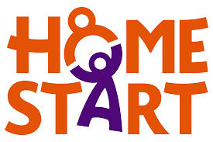**Background**

A referral was made by the head teacher to provide support to the family of a P3 girl (Child A) who was having difficulty re-engaging with school following lockdown. The family had been referred to a neurodevelopmental pathway and were being supported by a pediatrician, but felt misunderstood by the school. The parents felt unsupported by the school, and the relationship between the school and the family was becoming fractured. The parents reported that Child A would refuse to go to school and could be very anxious. Child A could often manage to contain her anxiety when she was at school, but would break down at home after school. She was also struggling to sleep and could stay awake for up to three days at a time.

**Intervention**

Home-Start’s Family Support Worker supported the family to attend a meeting with the head teacher, who explained different strategies he had implemented to support Child A in school, such as allowing her to arrive late and leave early, and visiting the family home. The head teacher and the family discussed the challenging environmental issues Child A faced and discussed pathways for going forward. Following the meeting, the head teacher made a referral for Child A to occupational therapy and provided a supporting letter to housing. Child A’s mother has submitted a placing request to a school with an ASN support base.

**Outcome**

The parents have reported an improvement in their daughter’s attendance and in their relationship with the school since Home-Start’s involvement. Child A’s attendance is now in the high 90’s percentage. The family had an upcoming placing request hearing, however, the family were reconsidering this due to the improvement in Child A resulting from their engagement with Home-Start.

Home-Start also signposted the family to other services to support their other two children. They have also supported the family with a referral to the Fuel Bank Foundation when their energy bills increased due to their children being off school unwell during a particularly cold spell of weather.

**3.2 Outlet Play**

**Background**

J was not attending school and was finding it difficult to engage as he had fallen behind in school, was struggling to cope in a classroom setting, and had become isolated from his peers. He was lacking self-confidence and struggled with being separated from his mum. However, he had a clear love of being outdoors, he was adventurous and very active.

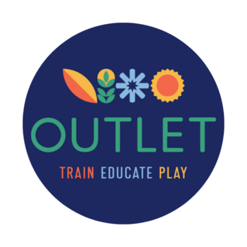**Intervention**

J first met with the group leader from [OutLET](https://outlet.scot/) at his school with his mum present, to allow them to get to know each other and discuss what things he would like to do at the sessions. J was very enthusiastic and keen to show the group leader around the school grounds and where he plays. J had a taster session where, together with the group leader, he put up a hammock and tried to light cotton wool with the striker. He enjoyed the taster and said he was looking forward to the sessions.

J was offered 12 sessions of outdoor activities and was able to attend five. The sessions were held in a piece of woodland close to the school, where they set up a base. Unfortunately, J missed a lot of sessions, although when he did come the group leader felt he maximised his experience. J showed an interest in building fires and making things out of sticks. He also enjoyed putting up swings and started to build a den.

**Outcome**

After the first few sessions, J was less keen to go back to the base, and instead preferred to walk around and spot wildlife. J found it easier to engage when on the move, and began to open up more to the group leader and accept other people’s ideas. The group leader found that – if the leader met him halfway – he would take part on his own terms. For example, he didn’t want to collect litter with the litter pickers, but would squish cans for the group leader. He wouldn’t carry the kit, but he became an expert at every stage of building, lighting, and extinguishing a fire. The group leader was able to adapt the activities to suit J.

The group leader reported that J began to trust them more and was less focused on his mum by the end of the sessions. J was able to chat with the leader. The leader advised that for his next steps, his love of nature and being outdoors should be considered. J told the leader that he has a place at an ASN school where his needs will be supported and seemed excited about this.

**4. Summary of Support Types Offered in Phase Three**

Below is a summary of the types of supports provided in the Airdrie Academy cluster to meet the needs of their children, young people, and families identified by their CIIL. This is illustrative of the wide variety of supports offered within each cluster.

[document ends]