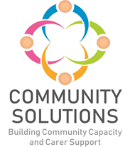

**Children, Young People, and Families Community Mental Health and Wellbeing Fund**

**Impact and Learning Report - Phase Four (2023-24)**

**Phase X (20XX-XX) - Impact and Learning Report**



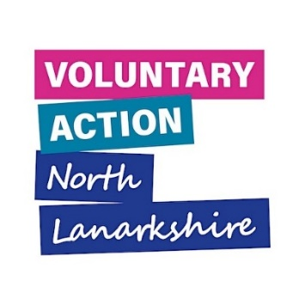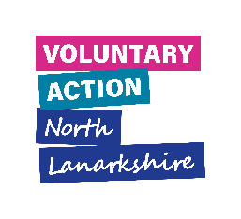



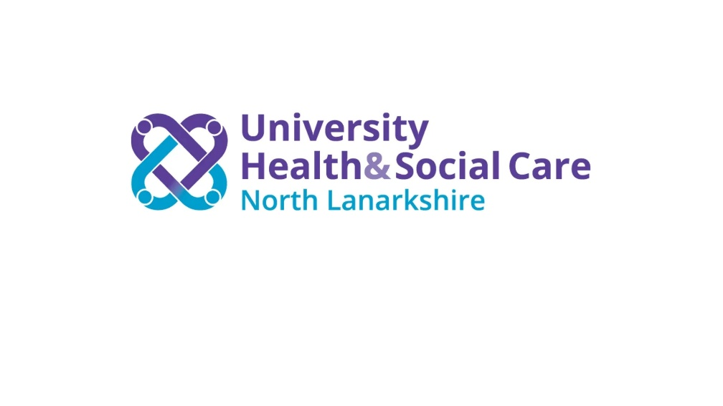

# Contents

1. Introduction to Fund – Page 3

2. Overview of Phase Four – Page 10

2.1 Funded Projects and Children, Young People, and Families (CYPF) Supported – Page 10

2.2 Summary of Children, Young People and Families Supported – Page 11

2.3 Summary of Children, Young People and Families Supported by Cluster – Page 12

2.4 Summary of Feedback on Impact on Children, Young People, and Families – Page 18

2.5 Summary of Children and Young People’s Outcomes Reported – Page 19

3. Overview of Supports Delivered – Page 21

4. Learning from Phase Four – Page 23

5. Future Phases – Page 31

**Appendices**

Appendix A: Highlights from Six Funded Projects* – Page 33

Appendix B: Summary of All Funded Projects – Page 40

*A complementary report with more information on all funded projects is available.

# 1. Introduction

**1.1 Purpose**

The purpose of this report is to share the impact and learning from projects funded in Phase Four of the **North Lanarkshire Children, Young People and Families Community Mental Health and Wellbeing (CYP) Fund**. The Impact and Learning report for Phase One, Two and Three are [available here](https://www.communitysolutionsnl.org.uk/children-young-people-and-families-mental-health-and-wellbeing-fund/). Learning from Phase One-Three informed Phase Four. A complementary report providing summaries of all funded projects in Phase Four is also available.

**1.2. Fund Phases**

Phase One was a rapid pilot to develop and test the approach. Given the success of the fund, additional funding was agreed for Phase Two-Four. Phase Four completes in summer 2024. Phase Five has been agreed in principle.

|  |  |  |  |
| --- | --- | --- | --- |
| Phase | Date | Total Custodian Funding | Total Funding Per Year |
| Phase One | Jan 21-Mar 21 | £100,000 | £100,000 |
| Phase Two | Sept 21-Mar 22 | £276,600 | £364,600 |
| Phase Three | May 22-Apr 23 | £465,000 | £516,344 (includes Phase Two underspend of £56,588) |
| Phase Four | May 23-Apr 24 | £449,650 | £502,650 |
|  | **TOTAL** | **£1,291,250** | **£1,483,594** |

**1.3 Aim**

Our **North Lanarkshire Children and Young People Community Mental Health and Wellbeing** Fund supports local delivery of the Scottish Government Children and Young People Mental Health and Wellbeing Framework, the North Lanarkshire Children’s Services Plan, and Lanarkshire Mental Health Strategy.

**1.4 Outcomes**

To improve children and young people’s mental health and wellbeing, with reference to the national [‘SHANARRI’](https://www.gov.scot/policies/girfec/wellbeing-indicators-shanarri/) framework. (See outcomes section below.)

**1.5 Objectives**

1.5.1 Increase North Lanarkshire Community and Voluntary Sector (CVS) capacity to support children and young people’s mental health and wellbeing in their local community.

1.5.2 Demonstrate the contribution of the North Lanarkshire CVS to improving children and young people’s mental health and wellbeing.

1.5.3 Improve collaboration between schools and the community and voluntary sector.

**1.6 Fund Logic Model**

The [‘logic model’](https://evaluationsupportscotland.org.uk/resources/ess-support-guide-1c-developing-a-logic-model/) diagram below summarises the fund’s:

* Investment and other inputs
* Funded projects
* Beneficiaries
* Types of activities delivered
* Difference made (i.e., outcomes)

**Figure One: North Lanarkshire Children and Young People Mental Health and Wellbeing Fund Logic Model**

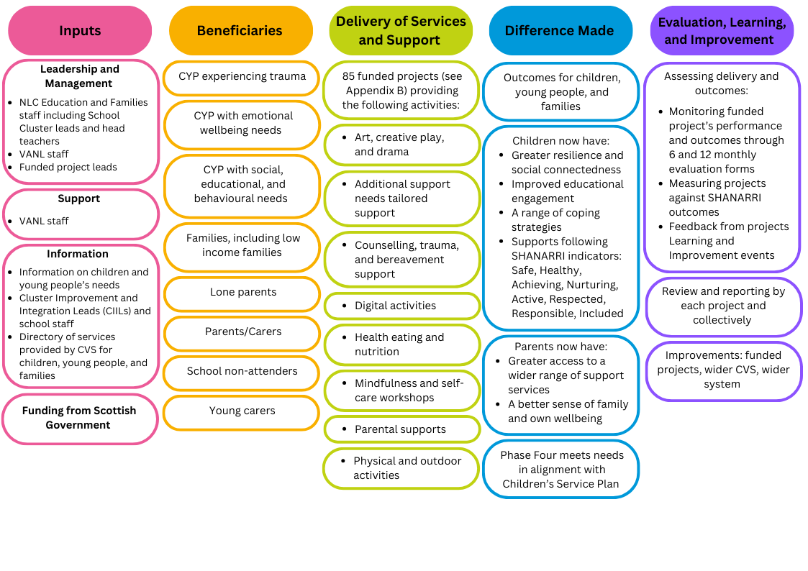

**1.7 Funding and Fund Management**

**1.7.1** Funding for this initiative is provided by the Scottish Government to the North Lanarkshire Council (NLC), which is then transferred to Voluntary Action North Lanarkshire (VANL) to manage distribution through the Community Solutions Programme - working in partnership with NLC Education and Families colleagues and CVS organisations. Decisions about local funding priorities are taken by the North Lanarkshire school clusters[1], which commission CVS organisations to provide mental health and wellbeing support for their children and young people. VANL facilitates liaison between the school clusters and the CVS; manages award payments and supports evaluation and reporting.

**1.7.2** VANL supports this fund as part of the wider Community Solutions Programme, which VANL hosts and manages on behalf of [University Health and Social Care North Lanarkshire.](https://hscnl.org.uk/)

**1.7.3** **Funding Awards Process**

**1.7.3.1 Process for Identifying Needs and Agreeing Funding Awards**

School Cluster Improvement Integration Leads (CIILs) work alongside school staff to identify local priorities to support children and young people’s mental health, informed by a needs analysis and with a ‘solution-focussed’ approach. CVS organisations are then invited to submit applications to deliver support which address identified priorities. Decisions on funding are taken by each school cluster team, which are made up of CIILs and head teachers.

Please see Appendix B for a full list of funded CVS projects for Phase Four.

**1.8 Evaluation, Learning and Improvement**

**1.8.1 Approach**

The Fund’s approach to evaluation, learning, and improvement is guided by the [Community Solutions Performance Management, Evaluation, Learning, and Improvement Framework](https://www.communitysolutionsnl.org.uk/pmeli-framework/). The framework sets out the Community Solutions Programme’s approach to performance management, evaluation, learning, and improvement to support funded projects and the programme as a whole. The framework also sets out standardised measures and relevant supports to help funded projects make the most of their findings.

In line with the framework, funded CVS organisations are required to assess the reach and impact/outcomes of their work, and capture and share learning to inform improvements to their service or activities, and where possible to other funded projects, the wider CVS, and the Health and Social Care system. Using the framework, VANL staff support funded projects to undertake ongoing evaluation to facilitate learning and improvement during and at the end of project delivery.

**1.8.2 Performance Data and Method**

Funded projects are required to capture and share with VANL key information on the following:

* Type of support provided – activities
* Numbers of unique individuals supported – reach
* The difference this support made to those receiving support – outcomes.

Funded projects are also asked to measure their project outcomes using ‘SHANARRI’ indicators, which are widely used nationally and locally to measure outcomes as part of the Getting It Right For Every Child (GIRFEC) approach. The initials of the SHANARRI set out the following aspirations for every child and young person:

Safe

Healthy

Achieving

Nurtured

Active

Respected

Responsible

Included

Funded projects collect this data at points prior to, during, and post project delivery using a range of different methods including:

* Written surveys; online or via the phone
* Verbal feedback
* Observations
* Self-assessment methods such as the [Warwick Edinburgh Mental Wellbeing Scale](https://warwick.ac.uk/fac/sci/med/research/platform/wemwbs/) and progress tracker worksheets

Funded projects use this data to complete evaluation forms which are submitted to VANL at the six- and twelve-month mark of the projects.

VANL also hosts two Learning and Improvement events for representatives from funded projects and from school clusters for each phase. The purpose of these events is to collect feedback from funded projects on their experience of the fund. This feedback informs the delivery of future fund phases and service delivery for projects.Data from evaluation forms and Learning and Improvement events is used to prepare Impact and Learning reports for each phase.

**1.9 Policy Context**

**1.9.1 Scottish Government’s Community Mental Health and Wellbeing Supports and Services Framework**

The Scottish Government’s[Community Mental Health and Wellbeing Supports and Services Framework](https://www.gov.scot/publications/community-mental-health-wellbeing-supports-services-framework/) guides development and delivery of local support and services for children and young people’s mental health and emotional wellbeing, with this fund investing in the CVS to provide community-based support.



**Figure Two:** **Scottish Government Children and Young People’s Mental Health and Wellbeing Model**

The aim of the Government’s framework is that: “Every child and young person in Scotland will be able to access local community services which support and improve their mental health and emotional wellbeing. Every child and young person and their families or carers will get the help they need, when they need it, from people with the right knowledge, skills, and experience to support them.  This will be available in the form of easily accessible support close to their home, education, employment, or community.”

**1.9.2 North Lanarkshire Children’s Services Partnership and Plan**

The [North Lanarkshire Children’s Services Partnership](https://www.northlanarkshire.gov.uk/social-care-and-health/children-and-families/childrens-service-plan) brings together public bodies, youth representation, and CVS organisations to deliver services and supports that improve outcomes for children, young people, and families.

“The North Lanarkshire Children’s Services Plan brings together our thinking about how we best deliver services and supports for children, young people and families in North Lanarkshire and outlines what we want to collectively achieve. The focus of the Children’s Services Plan is on the shared priorities that partners identify and work together to achieve. The partnership publishes a Children’s Services Plan every three years, and a yearly report which provides an overview of the progress made during the first year of the Children’s Services Plan 2023-26 and the context in which the ambitions of the plan have progressed.”

Cross-sector strategic planning and operational support for children and young people’s mental health and wellbeing services and support across North Lanarkshire is facilitated through a sub-group of the Children’s Services Partnership which also supports [delivery of Lanarkshire’s Mental Health Strategy.](https://www.nhslanarkshire.scot.nhs.uk/strategies/mental-health-wellbeing-2019-24/)

# Many thanks to the funded projects and CIILs who provided information and to the VANL staff who prepared this report. 2. Overview of Phase Four: Reach and Outcome

**2.1 Figure Three: CVS Organisations - Funded Projects and Children, Young People, and Families Supported**

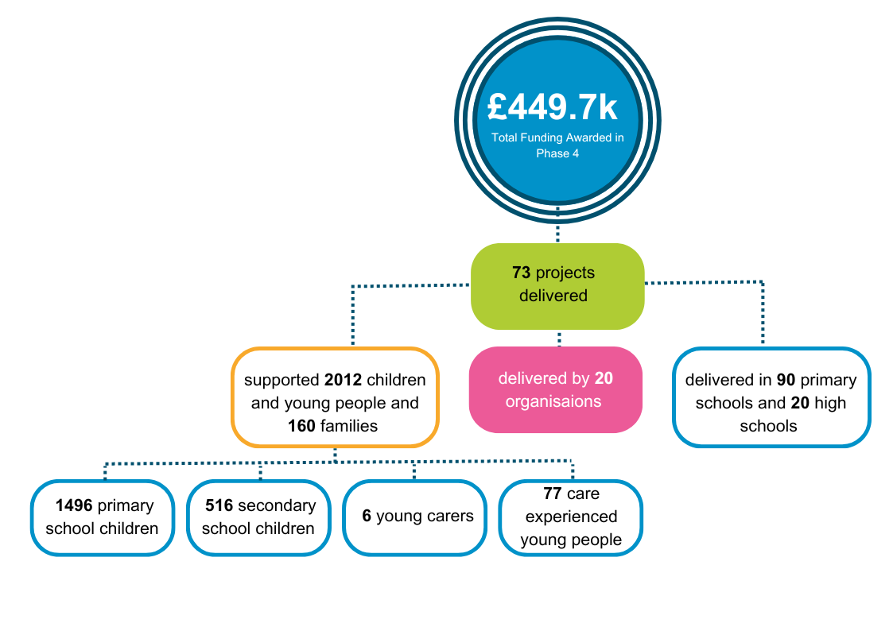

**2.2 Figure Four: CIILs - Children, Young People, and Families Supported**

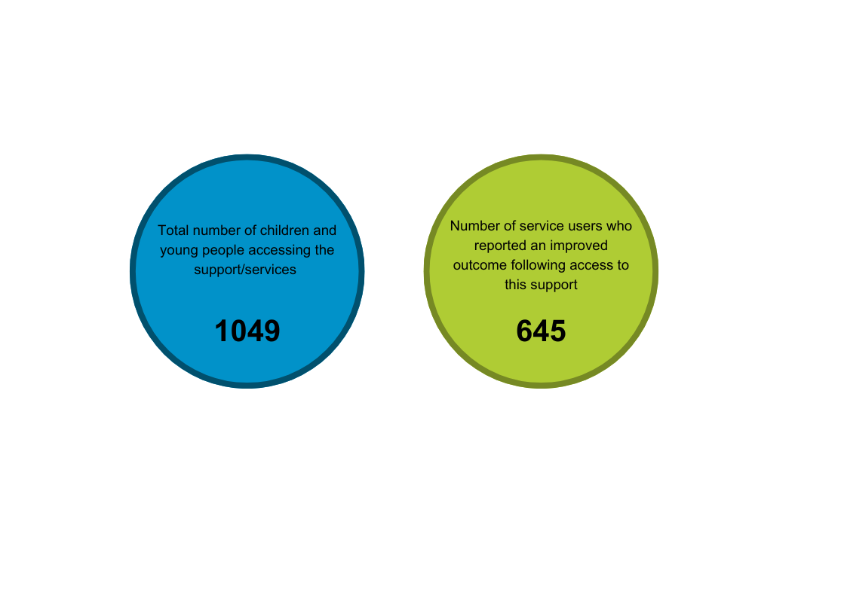

There is a disparity between the number of children and young people supported reported by CIILs versus the CVS organisations. Due to CIILs changing clusters, not all evaluation and monitoring forms were received from each cluster which may explain some of the difference. Feedback from the Learning and Improvement event also highlighted that some CIILs were using estimations of how many young people were supported in the progress report. VANL staff will further investigate with CIILs and the organisations how this information is being collected and offer guidance on using actual figures.

**2.3 Figure Five: CVS Organisations - Summary of CYPF Supported**

**2.4 Figures 5.1 to 5.22: Number of CYPF Supported by School Cluster**

The number of unique children, young people, and families supported is not available for the following, as their projects have been delayed until 2024-25:

* Braidhurst High
* Coltness High
* St Aidan’s High

**2.5 Figure Six: CVS Organisations - Summary of Feedback on Impact on Children, Young People, and Families**

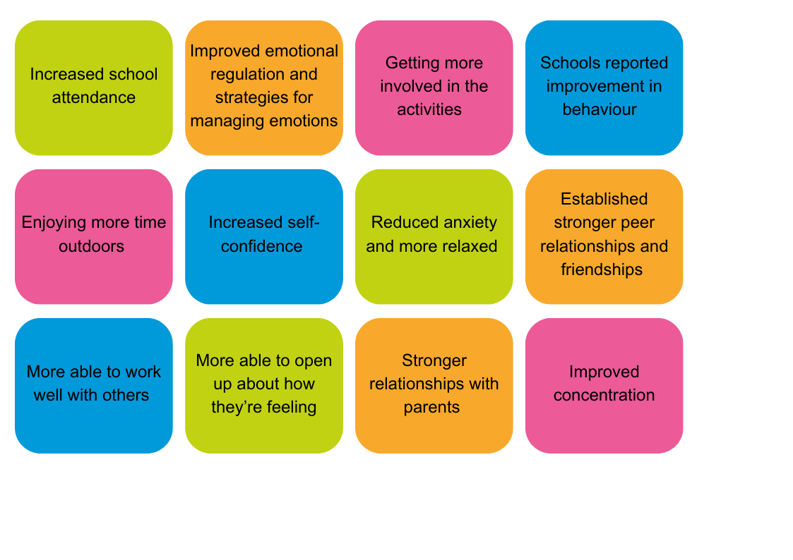

**2.6 Figure Seven: Summary of Children and Young People’s Outcomes Reported - SHANARRI Outcomes**

Below are the total number of children and young people who reported against each SHANARRI outcome. This information is collected by funded projects using self-assessment from the children and young people their projects support, using methods such as:

* Verbal feedback from children and young people
* Written pre-and post-support surveys and evaluation forms
* GIRFEC Wellbeing Web
* Weekly reflections and recording sheets

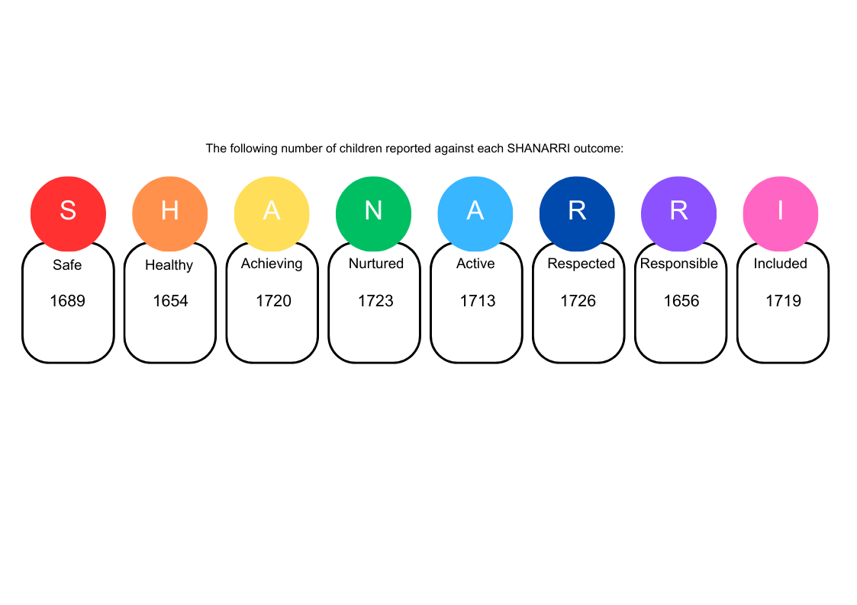

The majority of funded projects (85%) reported that the project met the desired outcomes. One funded project reported that they did not meet the desired outcomes, as the planned project was not working for the group of young people due to timing conflicts. The organisation has offered alternatives to address the needs of the young people and are having ongoing discussions with the CIIL.

**3. Overview of Supports Delivered for this Period**

**3.1 Type of Support Delivered**

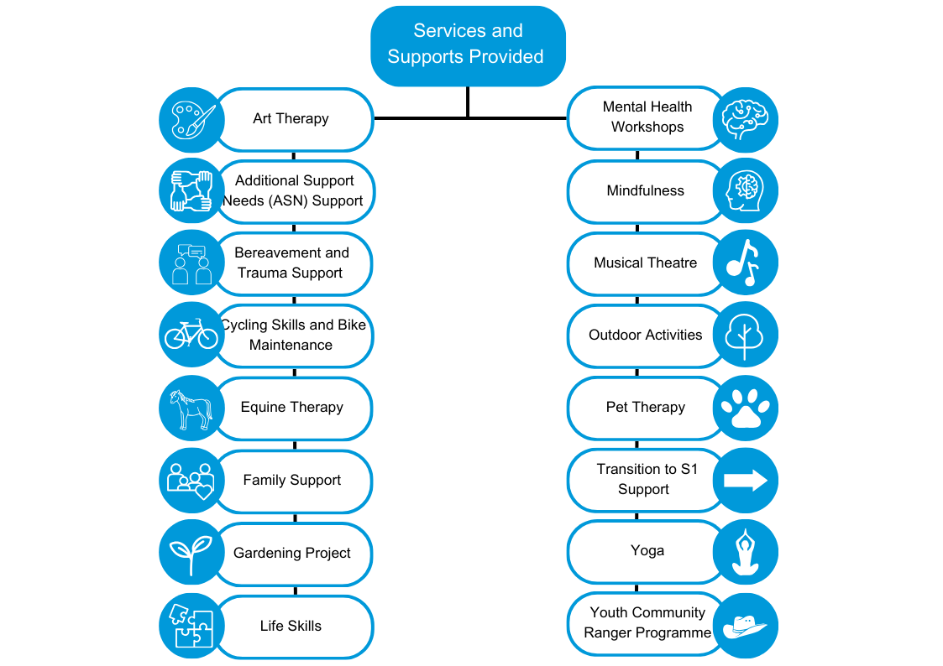

**3.2 CVS Organisations - Location of Support**

Funded projects reported on where and when supports took place. The majority of supports (50%) took place within a school building, and during the school day (66%).

The interim report also highlighted that most projects delivered up until January 2024 took place in a school building (43%) or community based (43%), and during the school day (82%). As the Scottish Government has advised that where possible, most interventions should be based in the community, VANL staff discussed this with funded projects and identified the following challenges:

* It is challenging for projects to find appropriate community-based venues
* It can be difficult to get parents to attend projects in community settings
* Transport to community buildings isn’t available
* Sometimes the young person would prefer to meet within the school
* Projects felt that working in the community made sense for some projects more than others

**3.3 CIILs - Areas of Support Targeted with Intervention**

The following areas of support were targeted by CIILs with the interventions delivered by CVS organisations.

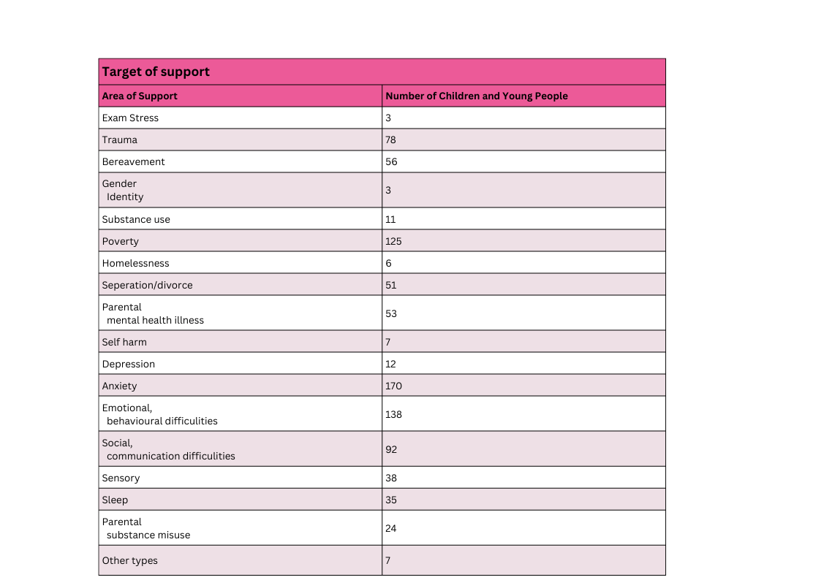

**4. Learning from Phase Four**

**4.1 Phase Four Learning and Improvement Event**

VANL hosted a Learning and Improvement event in February 2024 for CIILs and funded organisations. The purpose of the events was to:

* Facilitate open discussion to promote and support learning and improvements to collaboration and management of the fund and current and future services
* Focus on solutions to identified challenges
* Inform planning for Phase Five

The event structure involved a group discussion using the following prompts for CIILs:

* How has this fund improved your knowledge of the local CVS?
* As the allocation of the fund has been behind schedule, is there anything stopping you from allocating funding e.g. time constraints, and how can we help with this?
* As advised by the Scottish Government, interventions should take place within the community. Where this is not happening, why? Is there anything you need in place to enable this?
* There are some disparities between figures reported by CIILs and CVS organisations. How are you reporting, and are schools supporting you with this?

The event used the following prompts for funded projects:

* After our previous L&I event, we made a number of changes e.g. the second contact within schools. Are any challenges you have faced, and what changes would benefit you to improve this?
* As advised by the Scottish Government, interventions should take place within the community. Where this is not happening, why? Is there anything you need in place to enable this?
* As the application forms have now changed to sign off forms, the information included in applications become briefer, is there something preventing you from including more information?

Feedback from these discussions was analysed by VANL staff, with a summary of key themes presented below.

**4.1.1 CIIL Feedback**

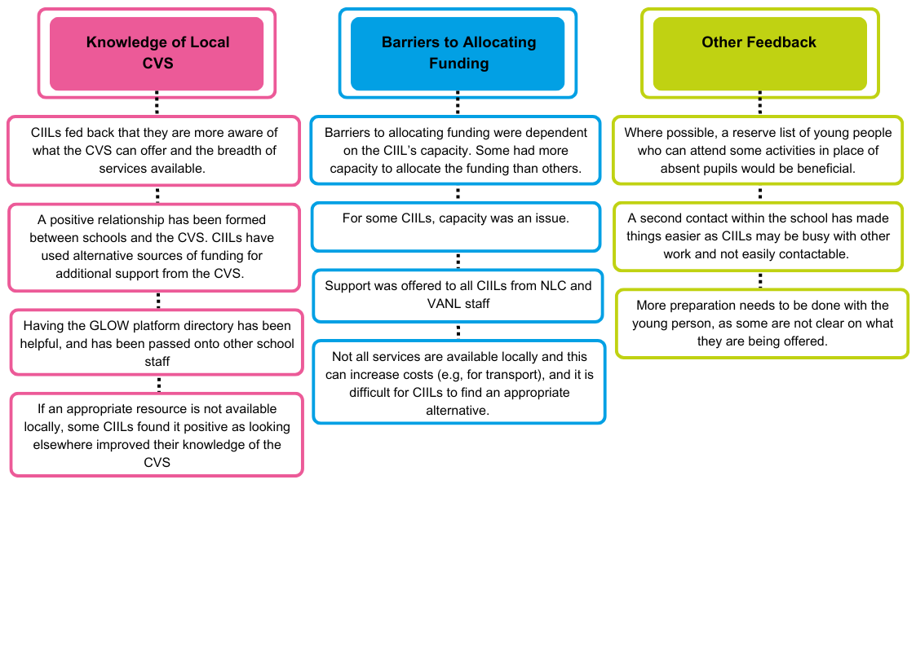

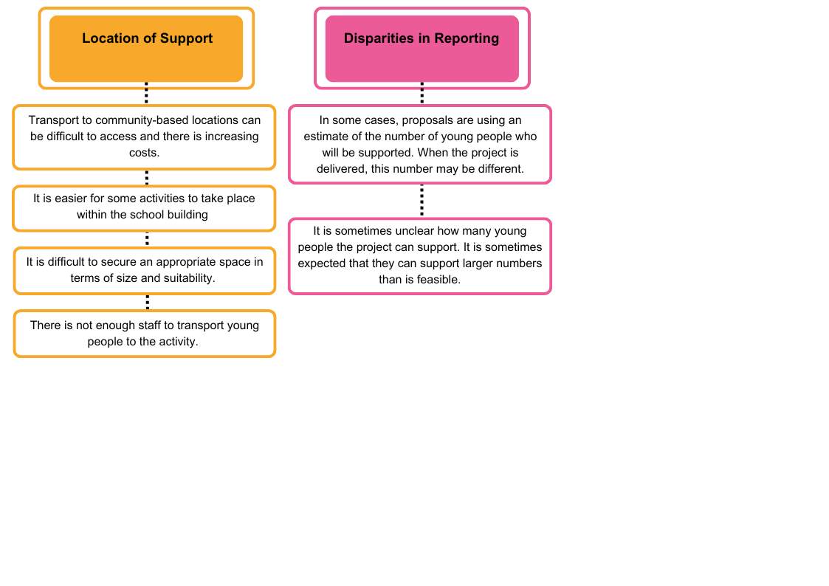

**4.1.2 Funded Project Feedback**

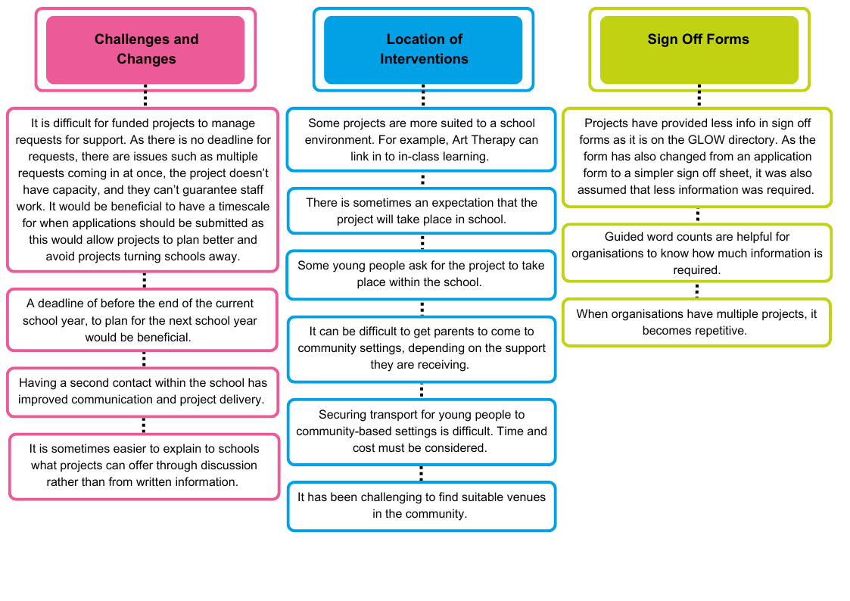

From this feedback, common themes suggested by both CIILs and funded projects are:

* Communication between the CIILs, school staff, and funded projects should be improved to clarify how many children can attend a project, what is being offered, and any important dates in the school calendar
* There is a lack of appropriate community venues and accessing suitable venues is difficult due to availability of travel, staff and cost
* Some projects are better suited to the school environment
* A reserve list of young people who can attend projects in place of absent pupils would benefit CIILs and funded projects
* A second contact within the school improves communication, but this is not being done in all schools/with all projects
* What is being offered should be more clearly communicated to young people and their families/carers

**4.2 Unexpected Positive Outcomes**

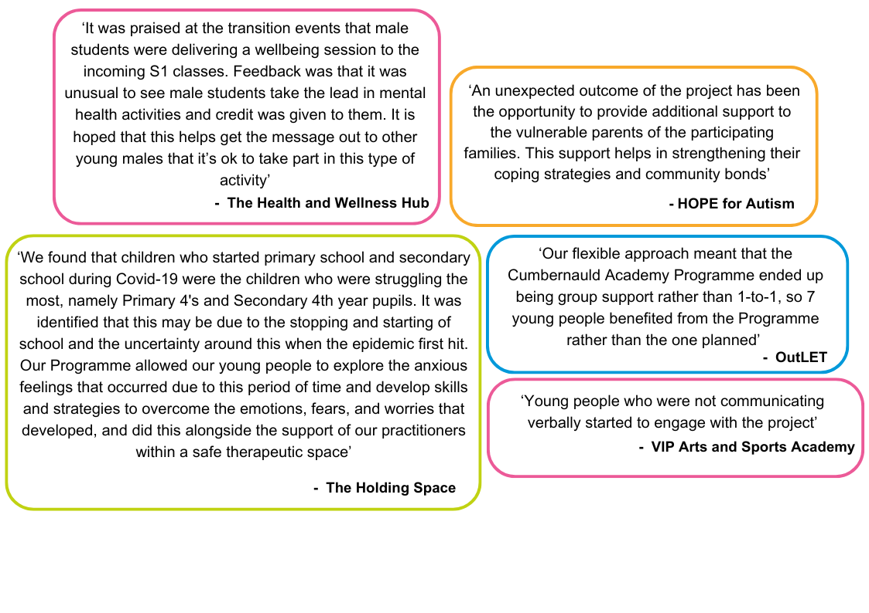

**4.3 Feedback on Challenges**

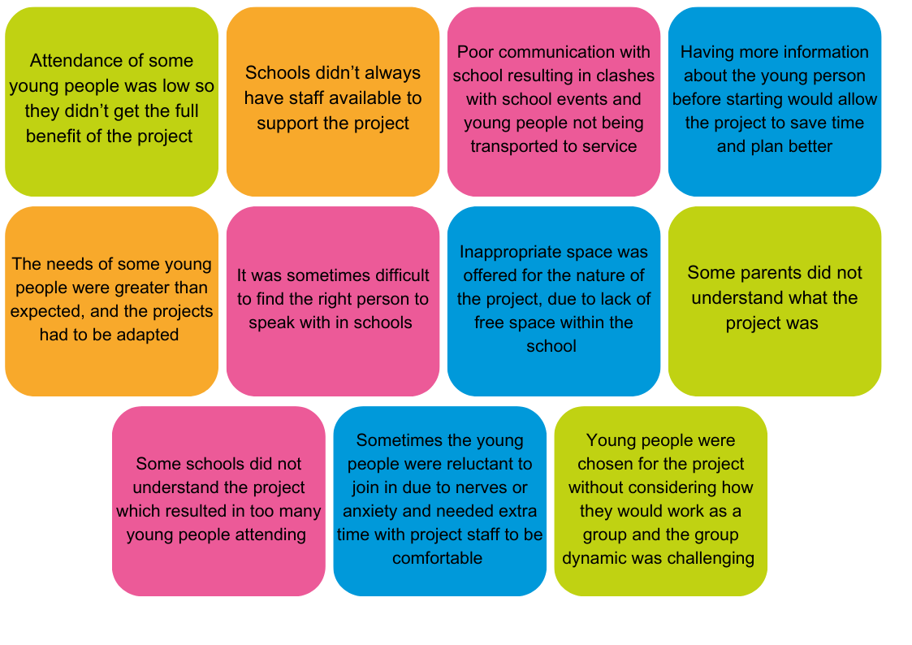Funded projects reported the following challenges in project delivery:

Funded projects also reported that challenges were mitigated when the following was done:

* They met with the CIIL prior to the project starting
* They had a consistent contact within the school
* A system was set up so that other young people could attend the project in place of those who didn’t show up
* They worked with the school in partnership throughout the project

**5. Future Phases**

**5.1 Phase Five**

The plan for Phase Five is as follows:

|  |  |
| --- | --- |
| Action | Date |
| Application Launch | May 2024, December-January 2025 |
| Funding Panel Dates | June 2024, January 2025 |
| Award Letters Issued | July 2024, September 2024, January 2025 |
| Projects Delivered | August 2024-June 2025 |
| Mid-phase Evaluation Report | January 2025 |
| End-of-phase Evaluation Report | June 2025 |
| Total Custodian Funding | £416,000 |

**5.2 New Funding Allocation Process**

The interim learning summarised in the Phase Four Progress Report highlighted issues with the funding allocation process. A panel-type approach was proposed and piloted from January 2024-June 2024, to support allocation of funding awards. Due to the success of the pilot, this approach will be used in Phase Five.

The new funding allocation process for Phase Five is as follows:

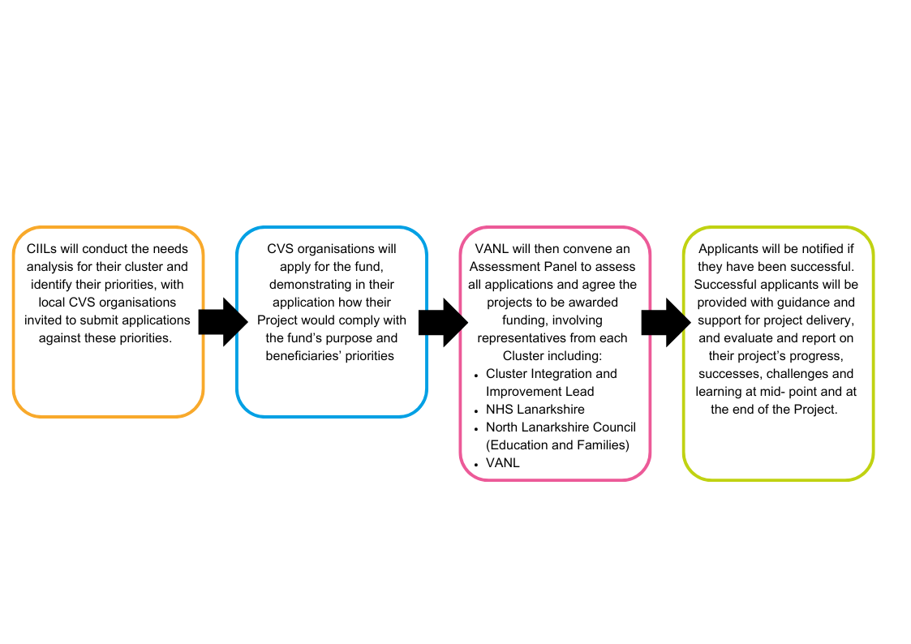

**Appendices**

**Appendix A – Highlights from Six Funded Projects**

**Bazooka Arts – Therapeutic Arts Programme**



**Aim –** To support young people’s mental health and wellbeing through therapeutic arts

**Service/Activity –** Therapeutic Art workshops

**Reach –** 11 primary school pupils, 9 secondary school pupils, 7 families

**Delivery Cluster(s) –** St Ambrose and St Andrews

**Evaluation Method**

* Observation
* Young people’s feedback

**Outcomes**

This project has:

* Provided P6/7 and S1 pupils with transition support through a 6-week therapeutic arts programme, including drama on topics such as hopes for the future, making dream catchers, and creating cyanotype prints
* Created a film of a drama workshop presented by 6 young people
* Provided 8 additional sessions for pupils in need of individual therapeutic support
* Made artwork focused on identity, positive affirmations, and hopes and dreams for the future

**Learning**

* To involve young people’s families, the project was supposed to include an in person sharing event. Due to family circumstances, the young people suggested to film a drama workshop instead to share with friends and family, which they were able to take the lead on
* The project would like to further explore the long-term impact of young people taking on the role of facilitators in sharing arts activity with friends and family
* The project found it difficult to engage young people who were not attending school

**The Holding Space – Joining the Dots**

**Aim –** To help young people understand the connection between their emotions, thoughts and behaviours

**Service/Activity –** 8-week programme including therapeutic art, pet therapy, nurture by nature, yoga, cooking lessons, mental health support, development of coping strategies

**Reach –** 24 primary school pupils, 5 secondary school pupils

**Delivery Cluster(s) –** Our Lady’s High Cumbernauld, We Aspire

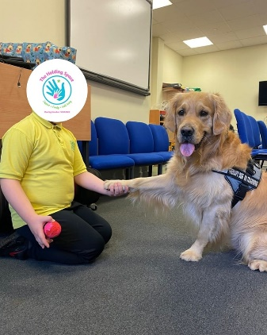**Evaluation Method**

* Verbal evaluation with children and young people
* End of project evaluation form
* Conversations with teaching staff

**Outcomes**

This project has:

* Built solid relationships between the young people and the practitioners
* Allowed young people to talk about their emotions and increased self-regulation with the tools and techniques delivered within the project

**Learning**

* The project found that 8 weeks was not long enough, and young people fed back that they would like to attend more. In response to this, the Holding Space has now increased their program with options of 12 and 16 weeks, and created a program for out of school hours
* Through conversations across schools, the project identified issues and barriers young people are facing, including social media. The project was adapted to include discussions about social media and what tools young people can use to cope with the negative side of social media
* A challenge was getting permission from schools to allow Tommy the pet therapy dog to enter the school building. Evaluation forms helped show that Tommy is a vital part of the project, and as a result he was allowed in schools

**HOPE for Autism – Community Transition Group**

**Aim –** Increase school attendance, enhance the wellbeing of children and their families, building confidence in parents/carers to engage in public outings with their children, build peer support between families

**Service/Activity –** 9-week programme. Group sessions complemented by various trips and social activities

**Reach –** 24 primary school pupils, 10 primary school pupils and their 24 families

**Delivery Cluster(s) –** Our Lady’s High, Airdrie Academy

**Evaluation Method**

* Case study notes
* Observations
* Conversations with parents/carers, young people and education staff before and after support period

**Outcomes**

This project has:

* Fostered a community among families, providing a space for families to connect and support each other
* Led to education staff feeling reassured and appreciative of HOPE for Autism’s suggestions

**Learning**

* The staff team found that being involved in a number of different projects across several clusters has allowed them to get a fuller picture of the challenges that young people, families and education face and how they can bridge the gap
* A story used to support transition was so well-received that another teacher requested one for another young person
* The project created an online form to collate feedback, but schools and parents tended not to complete this after the support ended. The project will use paper surveys in the future that can be completed at the time

**The Miracle Foundation – One to One Art and Play Therapy**

**Aim –** To provide a confidential space for children and young people to explore their feelings around Bereavement and Trauma

**Service/Activity –** 50-minute art sessions within a 10-week period in the presence of a therapist

**Reach –** 46 primary school pupils, 8 secondary school pupils of which 11 care experienced CYP

**Delivery Cluster(s) –** St Maurice’s High, Greenfaulds High, Our Lady’s High, Kilsyth Academy, We Aspire

**Evaluation Method**

* Facilitator observations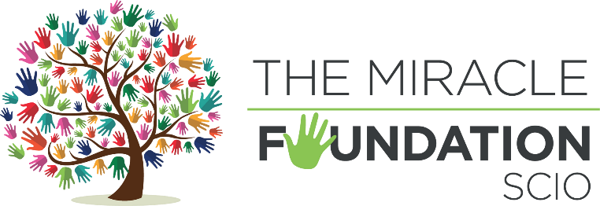, GIRFEC wellbeing webs and evaluation forms
* Individual case summaries

**Outcomes**

This project has:

* Built therapeutic relationships between the young person and the art therapist
* Provided a space for young people to express their emotions freely and develop new strategies for managing stress and adversity
* Engaged young people who demonstrated attendance issues as school to be involved in all sessions of the art therapy programme

**Learning**

* Some young people had higher needs than expected, highlighting the need for a personalised approach to support
* The project supported a young person who experienced the sudden loss of their father. The project helped them express and recognise their emotions
* The project supported a young person who had experienced loss and expressed a fear of death. Through the project, they were able to identify distress triggers and discuss physical and emotional responses, and showed an increased sense of safety and health

**OutLET – Youth and Community Ranger**

**Aim –** To support students facing challenges in thriving within the classroom through hands-on experiences in a natural setting

**Service/Activity –** Individual and small group support

**Reach –** 33 primary school pupils, 12 secondary school pupils

**Delivery Cluster(s) –** St Maurice’s High

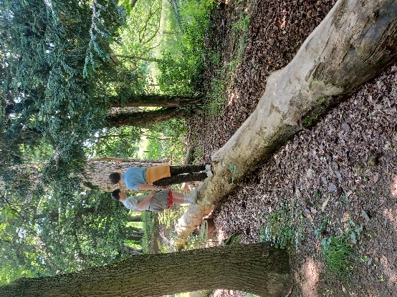**Evaluation Method**

* Weekly reflections and observations from staff
* Verbal feedback from participants, parents and teachers
* Photographs documenting the sessions

**Outcomes**

This project has:

* Increased young people’s school attendance, especially on outdoor days
* Developed strong relationships between young people and the Community Ranger, which allowed them to discuss difficult subjects
* Increased young people’s self confidence and ability to work with peers
* Led to young people saying they felt more relaxed outdoors and were able to cope with their emotions better

**Learning**

* The project was able to support more young people than initially expected
* A challenge with this project has been transport of the young people to the woodland. The schools had to transport the young people using taxis which led to normal issues such as late pickups and overall costs for the cluster
* The project would like to increase the time with the young people in the future to allow for stronger relationships to build
* The woodland that was used was also occasionally used by other schools and groups, which made the space more crowded and made it more difficult to meet the needs of some young people

**Parent Action for Safe Play – Play Champ Programme**

**Aim –** To support Primary 6-7 pupils to develop their skills and knowledge on how to facilitate play opportunities for young people and peers, and continue to champion play and support activities within their school

**Service/Activity –** 8 weekly 1-hour sessions in groups of 12 young people

**Reach –** 148 primary school pupils

**Delivery Cluster(s) –** Cumbernauld Academy

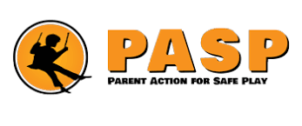**Evaluation Method**

* Observations
* Recording forms
* Children and teacher feedback

**Outcomes**

This project has:

* Increased young people’s self-confidence and communication skills. 85% of young people reported having a more positive view of themselves. 82% of young people feel they have increased their listening skills and feel more confident talking to others.
* Supported young people to facilitate play opportunities to P1 children within their school
* Supported young people’s wellbeing through play
* Increased young people’s physical activity levels during school hours

**Learning**

* On one occasion, due to a misunderstanding of the project, staff had to work with twice as many young people as expected. Staff did decide to continue to work with the larger group so that no one was turned away but felt this does not allow the programme to run to its full potential
* Another challenge was that sometimes the indoor space allocated did not provide enough space for physical activity. This was resolved on most occasions, but in the future more communication might be required to prevent this

**Reeltime Music – Music and Media Workshops**

**Aim –** To engage disenfranchised young people and develop their skills creatively, socially and personally and to help the young people make more informed decisions in future when dealing with their own mental health and wellbeing

**Service/Activity –** Creative workshops and thinking activities around different aspects of mental health

**Reach –** 75 primary school pupils, 24 secondary school pupils

**Delivery Cluster(s) –** Airdrie, St Margaret’s, St Ambrose, St Andrews, We Aspire

**Evaluation Method**

* Evaluation surveys
* Staff observations

**Outcomes**

This project has:

* Supported young people in creating music, music videos, trying instruments and group performances.
* Increased pupils’ understanding of mental health. For example, 84% of pupils who completed surveys felt they have a better understanding of how to be aware of and improve their mental health. 78% felt they have a better idea of who to contact if they have a mental health question, problem or crisis

**Learning**

* In the future the project would like to increase the time in sessions to cover more depth of detail and support further skills development
* The project saw a decrease in attendance, partly due to the background of the pupils (vulnerable, disengaging with school) and partly due to the timing of the project clashing with end of term activities

**Appendix B: Summary of All Funded Projects**

Across the funded projects, there is variation in the number of unique individuals supported when compared to the total funding award. This is due to the diverse nature of projects funded - projects varied in the intensity of support, and number of sessions delivered to each unique individual.

|  |  |  |  |  |  |  |
| --- | --- | --- | --- | --- | --- | --- |
| **Organisation** | **Project** | **Cluster** | **Total Funding Awarded**  **(£)** | **Number of Unique CYPF supported** | | |
| **Primary age children** | **Secondary age children** | **Wider family/caregivers** |
| B1. Glenboig Development Trust | Without Walls | Airdrie Academy | 8,288 | 15 | 8 | 15 families |
| B.2 HOPE for Autism | Support Anxiety Related School Absence | 3,166 | 10 | 4 | 10 families |
| Community Transition Group | 2,657 | 24 |  | 24 |
| B.3 Lanarkshire Community Food and Health Partnership | Come Dine with Me | 1,480 |  | 5 | 5 |
| B.4 Make and Create Arts | Positive Creations & Positive Families | 6,000 | 21 | 12 | 21 families |
| B.5 Reeltime Music | Reeltime Music - Airdrie | 2,400 | 0 | 16 |  |
| **Organisation** | **Project** | **Cluster** | **Total Funding Awarded**  **(£)** | **Number of Unique CYPF supported** | | |
| **Primary age children** | **Secondary age children** | **Wider family/caregivers** |
| B.6 One Parent Families Scotland | Support for Lone Parents | Bellshill Academy | 4,000 | 2 | 5 | 7 families |
| B.7 OutLET | Small Group Support | 3,131 | 8 | 0 |  |
| B.8 VIP-Pass Community Project | Creative Transitions |  | 14,611 | 1 | 2 |  |
| B.9 Action for Children | Family Support and Wellbeing | Braidhurst High | 17,749 | Delivering in 2024-25 | | |
| B.10 VIP-Pass Community Project | Creative Transitions | Brannock and Taylor High | 27,275 | 294 | 72 |  |
| B.11 Parent Action for Safe Play (PASP) | Active Play Programme | Calderhead High | 2,400 | 84 | 0 |  |
| B.12 The Miracle Foundation | Mental Health Workshops and Exam Stress Support | 10,780 | 42 | The exam stress workshops for secondary school pupils were delayed |  |
| **Organisation** | **Project** | **Cluster** | **Total Funding Awarded**  **(£)** | **Number of Unique CYPF supported** | | |
| **Primary age children** | **Secondary age children** | **Wider family/caregivers** |
|  |  |  |  |  | and will deliver in 2024-25. |  |
| B.13 Circle | Whole family, trauma recovery and early intervention support | Caldervale High | 21,654 | 8 | 3 | 9 families, including 14 parents/carers |
| B.14 Ponies Help Children | Equine Assisted Learning | 1,120 | 8 |  |  |
| B.15 Circle | Young People’s Service | Cardinal Newman High | 9295 | 0 | 11 | 9 families |
| B.16 Home-Start | 1-to-1 Support | 10,838 | 9 | 0 | 8 families |
| B.17 LANDED Peer Education Service | Harm Reduction Workshops |  | 750 | 0 | 6 |  |
| B.18 HOPE for Autism | 1-to-1 Personalised Support for Parents/Carers | Chryston High | 3,910 | 7 | 1 | 8 families |
| B.19 The Health and Wellness Hub | Stress Buster Programme | 2,196 | 0 | 10 |  |
| **Organisation** | **Project** | **Cluster** | **Total Funding Awarded**  **(£)** | **Number of Unique CYPF supported** | | |
| **Primary age children** | **Secondary age children** | **Wider family/caregivers** |
| B.20 The Miracle Foundation | 1-to-1 Art Therapeutic Support – Primary |  | 6,000 | 10 | 0 |  |
| B.21 Made4UInML2 | Employability Group Sessions | Clyde Valley High | 3,200 | 0 | 7 |  |
| B.22 OutLET | Group Support | 3,645 | 8 | 0 |  |
| Group Support | 3,112 | 5 | 0 |  |
| B.23 Ponies Help Children | Equine Assisted Learning | 1,540[2] | 1 | 2 |  |
| B.24 Social Track | Shredability, Wheeled Sports and maintenance sessions | 16,000 |  | 70 |  |
| B.25 OutLET | 8 Week Outdoor Support | Coatbridge High | 1,436 | 2 | 0 |  |
| Individual Support | 1,562 | 1[3] | 0 |  |
| **Organisation** | **Project** | **Cluster** | **Total Funding Awarded**  **(£)** | **Number of Unique CYPF supported** | | |
| **Primary age children** | **Secondary age children** | **Wider family/caregivers** |
| B.26 The Miracle Foundation | Mental Health Workshops |  | 14,400 | 42 | 30 |  |
| B.27 Action for Children | Family Support and Wellbeing | Coltness High | 13,311 | Delivering in 2024-25 | | |
| B.28 HOPE for Autism | Autism Family Training | Cumbernauld Academy | 695 | 6 | 0 | 1 family |
| B.29 OutLET | Individual and Small Group Support | 3,722 | 0 | 2 |  |
| Individual and Small Group Support (large group) | 3,722 | 3 | 8 |  |
| Individual and Small Group Support, Whitelees | 3,240 | 3 | 4 |  |
| B.30 OutLET | Small Group Support | 1,825 | 4 | 0 |  |
| Small Group Support | 1,860 | 4 | 0 |  |
| **Organisation** | **Project** | **Cluster** | **Total Funding Awarded**  **(£)** | **Number of Unique CYPF supported** | | |
| **Primary age children** | **Secondary age children** | **Wider family/caregivers** |
| B.31 Parent Action for Safe Play (PASP) | Play Champ Programme |  | 6,400 | 148 | 0 |  |
| B.32 Ponies Help Children | Equine Assisted Learning | 180 | 1 |  |  |
| B.33 Action for Children | Family Support and Wellbeing | Dalziel High | 12,471 | Delivering in 2024-25 | | |
| B.34 The Miracle Foundation | 1-to-1 Art Therapeutic Support – Primary | Greenfaulds High | 13,476 | 16 | 0 |  |
| B.35 VIP-Pass Community Project | Creative Transitions | 460 | 8 | 0 |  |
| B.36 HOPE for Autism | 1-to-1 Personalised Support (Banton) | Kilsyth High | 522 | 1 | 0 | 1 family |
| 1-to-1 Parental Support (Chapelgreen) | 270 | 1 | 0 | 1 family |
| **Organisation** | **Project** | **Cluster** | **Total Funding Awarded**  **(£)** | **Number of Unique CYPF supported** | | |
| **Primary age children** | **Secondary age children** | **Wider family/caregivers** |
| B.37 The Health & Wellness Hub | Stress Buster Programme |  | 2,341 | 0 | 18 |  |
| B.38 The Miracle Foundation | ‘Encouraging Growth & Resilience’ Mental Health Workshops | 7,867 | 25 | 0 |  |
| B.39 HOPE for Autism | 1-to-1 Parental Support (St Mary's), Neurobears + Personalised Support | Our Lady’s High Cumbernauld | 1,376 | 8 |  | 8 families |
| B.40 The Health & Wellness Hub | Stress Buster Programme | 2,261 | 0 | 16 |  |
| B.41 The Holding Space | Joining the Dots | 1,500 | 12 | 0 |  |
| B.42 The Holding Space | Joining the Dots | 1,500 | 12 | 0 |  |
| B.43 The Miracle Foundation | ‘Encouraging Growth & Resilience’ Mental Health Workshops | 6,439 | 7 | 12 |  |
| **Organisation** | **Project** | **Cluster** | **Total Funding Awarded**  **(£)** | **Number of Unique CYPF supported** | | |
| **Primary age children** | **Secondary age children** | **Wider family/caregivers** |
| B.44 HOPE for Autism | Autism Supports | Our Lady’s High Motherwell | 11,000 | 14 | 0 | 14 families |
| B.45 The Miracle Foundation | 1-to-1 Art Therapeutic Support | 6,000 | 0 | 8 |  |
| B.46 Action for Children | Family Support & Wellbeing | St Aidan’s High | 20,771 | Delivering in 2024-25 | | |
| B.47 Bazooka Arts | Therapeutic Arts Programmes | St Ambrose High | 7,950 | 11 | 9 | 7 families |
| B.48 Make and Create Arts | Positive Creations Project | 7,000 | 30 | 16 |  |
| B.49 Reeltime Music | Reeltime Music - Music Workshops | 1,025 | 8 | 8 |  |
| B.50 Bazooka Arts | 1-to-1 Therapeutic Arts Programme - Extension | St Andrew’s High | 4,000 | 20 | 18 | 7 families |
| Therapeutic Arts Programmes | 11,560 |
| **Organisation** | **Project** | **Cluster** | **Total Funding Awarded**  **(£)** | **Number of Unique CYPF supported** | | |
| **Primary age children** | **Secondary age children** | **Wider family/caregivers** |
| B.51 Make and Create Arts | Positive Creations Project |  | 9,000 | 102 | 7 |  |
| B.52 Parent Action for Safe Play | Active Play Programme | 4,080 | 96 | 0 |  |
| B.53 Reeltime Music | Reeltime Music - Music Workshops | 2,215 | 5 | 0 |  |
| B.54 Make and Create Arts | Positive Creations Project | St Margaret’s High | 4,000 | 49 | 0 |  |
| B.55 Reeltime Music | Reeltime Music - St Margaret's | 5,950 | 62 | 0 |  |
| B.56 Social Track | Shredability Sessions, Cycling, Scooting, Skateboarding Fun Sessions | 6,000 |  | 94 |  |
| B.57 The Health & Wellness Hub | Stress Buster Programme | 4,973 | 56 | 10 |  |
| **Organisation** | **Project** | **Cluster** | **Total Funding Awarded**  **(£)** | **Number of Unique CYPF supported** | | |
| **Primary age children** | **Secondary age children** | **Wider family/caregivers** |
| B.58 VIP-Pass Community Project | Creative Transitions: Horse-riding and Musical Theatre Programmes |  | 5,763 | 137 | 0 |  |
| B.59 OutLET | Community Ranger | St Maurice’s High | 8,582 | 33 | 12 |  |
| B.60 The Miracle Foundation | Art Therapeutic Support | St Maurice’s and Greenfaulds | 6,000 | 8 | 0 |  |
| B.61 OutLET | Small Group Support | We Aspire (ASN)[4] | 1,436 | 0 | 1[5] |  |
| B.62 Reeltime Music | Music and Media Workshops | 660 |  |  |  |
| **Organisation** | **Project** | **Cluster** | **Total Funding Awarded**  **(£)** | **Number of Unique CYPF supported** | | |
| **Primary age children** | **Secondary age children** | **Wider family/caregivers** |
| B.63 Social Track | Shredability |  | 3,600 | 1[6] |  |  |
| B.64 The Holding Space | Therapeutic Art, Therapy Dog, Self-Care | 4,500 | 0 | 5 |  |
| B.65 The Miracle Foundation | 1-to-1 Art Therapeutic Support | 4,800 | 3 | 4 |  |
| **TOTAL** | | | **427,381** | **1,496** | **516** | **160** |

1. *School clusters: Schools within NL are clustered into groups of one high school and surrounding primary schools, forming a network of local schools which aid issues such as pupil transition from primary to secondary school and community links. There are 23 school clusters in North Lanarkshire, which all work to the Empowering Clusters Integrated Model where schools and school leaders – supported by NLC central staff – work together to support improvements to services and outcomes for families and communities, including action to tackle poverty, improve attainment and wellbeing.
2. Costings for this cluster are higher than others, as Ponies Help Children is based in a rural location and further away from this area.
3. This funding was for a bespoke package for one individual with specialised needs.
4. Some projects supported ASN pupils in mainstream schools and therefore, the number of children and young people supported was reported with their cluster rather than the We Aspire cluster. Therefore, the number of ASN young people supported is more than the We Aspire cluster figures.
5. This funding was intended for a small group of between 1-4 young people, but only one young person attended.
6. This funding was for a bespoke package for one individual with specialised needs.