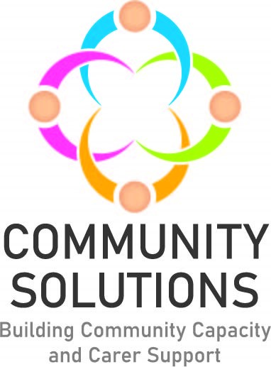

**North Lanarkshire Children and Young People Community Mental Health and Wellbeing Fund**

**Impact and Learning Report - Phase Two 2021-22**

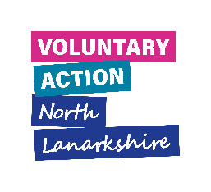

# Contents

1. Introduction to Fund – 3

2. Overview of Phase Two – 11

2.1 Summary of funded projects and number of children and young people receiving support - 11

2.2 Summary of outcomes for children receiving support - 16

3. Learning from Phase Two – 17

4. Next Steps - 23

**Appendices - 23**

Appendix A: Highlights of Six Funded Projects* - 24

Appendix B: Summary of All Funded Projects - 37

*A complementary report with more information on all funded projects is available on request.

# 1. Introduction

**1.1 Purpose**

The purpose of this report is to share the impact and learning from projects funded in Phase Two of the Children, Young People and Families (CYP) fund. The Impact and Learning report for Phase One is available here. Learning from Phase One has informed Phase Two, and learning from Phase Two will inform Phase Three. A complementary report providing summaries of all funded projects in Phase Two is also available here.

**1.2. Fund Phases**

Phase One was a rapid pilot to develop and test the approach. Given the success of the pilot, additional funding was agreed for Phase Two and, given the success of Phase Two, further funding was agreed for Phase Three, which completes in summer 2023. Phase Four has been agreed in principle.

|  |  |  |
| --- | --- | --- |
| Phase | Date | Total Funding Per Year |
| Phase One | Jan 21-Mar 21 | £100k |
| Phase Two | Sep 21-Mar 22 | £364,600 |
| Phase Three | May 22- April 23 | £516,344 (includes Phase 2 underspend of £56,588) |
|  |  | **TOTAL £463,600** |
| Phase | **Date** | **Total Custodian Funding** |
| Phase One | As above | £100K |
| Phase Two | As above | £276,600 |
| Phase Three | As above | £465,000 |
|  |  | **TOTAL £376,600** |

**1.3 Aim**

Our North Lanarkshire Children and Young People and Community Fund supports local delivery of the Scottish Government Children and Young People (CYP) Mental Health and Wellbeing framework, the North Lanarkshire Children’s Services Plan and Lanarkshire Mental Health Strategy.

**1.3.1 Outcomes**

To improve children and young people’s mental health and wellbeing, with reference to the national “SHANNARRI” framework. (See outcomes section below.)

**1.3.2 Objectives**

1.3.1.1 Increase North Lanarkshire Community and Voluntary Sector (CVS) capacity to support children and young people’s mental health and wellbeing in their local community.

1.3.1.2 Demonstrate the contribution of the North Lanarkshire CVS to improving children and young people’s mental health and wellbeing.

1.3.1.3 Improve collaboration between schools and the community and voluntary sector.

**1.4 Fund Logic Model**

The [“logic model](http://www.evaluationsupportscotland.org.uk/media/uploads/resources/supportguide1.2logicmodelsjul09.pdf)” diagram below summarises the fund’s:

* investment and other inputs
* funded projects
* beneficiaries
* types of activities delivered
* difference made (outcomes)

**Figure One: North Lanarkshire Children and Young People Mental Health and Wellbeing Fund Logic Model**  


**1.5 Funding and Fund Management**

1.5.1 Funding for this initiative is provided by the Scottish Government to the North Lanarkshire Council (NLC), which is then transferred to Voluntary Action North Lanarkshire (VANL) to manage distribution through the Community Solutions Programme - working in partnership with NLC Education and Families colleagues and CVS organisations. Decisions about local funding priorities are taken by the North Lanarkshire school clusters[1], which commission CVS organisations to provide mental health and wellbeing support for their children and young people. VANL facilitates liaison between the school clusters and the CVS; manages award payments and supports evaluation and reporting.

1.5.2 VANL supports this Fund as part of the wider Community Solutions Programme, which VANL hosts and manages on behalf of [Health and Social Care North Lanarkshire.](https://www.hscnorthlan.scot/)

**1.5.3 Funding Awards Process**

**1.5.3.1 Process for Identifying Needs and Agreeing Funding Awards**

School Cluster Improvement Integration Leads (CIILs) work alongside school staff to identify local priorities to support children and young people’s mental health, informed by a needs analysis and with a “solution-focussed” approach. CVS organisations are then invited to submit applications to deliver support which address identified priorities. Decisions on funding are taken by each school cluster team, which are made up of CIILs and head teachers.

Please see appendix D for a full list of funded CVS projects for Phase Two.

**1.6 Evaluation, Learning and Improvement**

1.6.1 Approach

The Fund’s approach to evaluation, learning and improvement is guided by the Community Solutions Performance Management, Evaluation, Learning and Improvement Framework. The Framework sets out the Community Solutions Programme’s approach to performance management, evaluation, learning and improvement to support funded projects and the programme as a whole. The Framework also sets out standardised measures and relevant supports to help funded projects make the most of their findings.

In line with the Framework, funded CVS organisations are required to assess the reach and impact/outcomes of their work, and capture and share learning to inform improvements to their service or activities, and where possible to other funded projects, the wider CVS and the Health and Social Care system. VANL staff support funded projects to undertake ongoing evaluation to facilitate learning and improvement during and at the end of project delivery, using the Framework.

1.6.2 Performance Data and Method

Evaluation forms are submitted at the mid- and-end point of a project.

Funded projects are required to capture and share with VANL key information on the following:

* type of support provided – activities
* numbers of unique individuals supported - reach
* and the difference this support made to those receiving support - outcomes.

Funded projects are also asked to measure their project outcomes using “SHANARRI” Indicators, which are widely used nationally and locally to measure outcomes as part of the Getting It Right for Every Child (GIRFEC) approach. The initials of the SHANARRI set out the following aspirations for every child and young person:

**S**afe

**H**ealthy

**A**chieving

**N**urtured

**A**ctive

**R**espected

**R**esponsible

**I**ncluded

Funded projects collect this data during at points prior to, during and post project delivery using a range of different methods, including:

* written surveys; online or via the phone
* verbal feedback
* observations
* self-assessment methods such as the [Warwick Edinburgh Mental Health and Wellbeing Scale](https://warwick.ac.uk/fac/sci/med/research/platform/wemwbs/) and progress tracker worksheets

Funded projects use this data to complete evaluation forms which are submitted to VANL at the six- and twelve-month mark of the projects.

VANL also hosts two Learning and Improvement events for representatives from funded projects and from school clusters for each phase. The purpose of these events is to collect feedback from funded projects on their experience of the Fund. This feedback informs the delivery of future fund Phases and service delivery for projects.

Data from evaluation forms and Learning and Improvement events is used to prepare Impact and Learning reports for each phase.

**1.7 Policy Context**

**1.7.1 Scottish Government’s Community Mental Health and Wellbeing Supports and Services Framework**

The Scottish Government’s[Community Mental Health and Wellbeing Supports and Services Framework](https://www.gov.scot/publications/community-mental-health-wellbeing-supports-services-framework/) guides development and delivery of local support and services for children and young people’s mental health and emotional wellbeing, with this Fund investing in the CVS to provide community-based support.



**Figure Two:**  **Scottish Government Children and Young People’s Mental Health and Wellbeing Model**

The aim of the Government’s Framework is that: “Every child and young person in Scotland will be able to access local community services which support and improve their mental health and emotional wellbeing. Every child and young person and their families or carers will get the help they need, when they need it, from people with the right knowledge, skills, and experience to support them.  This will be available in the form of easily accessible support close to their home, education, employment, or community.”

**1.7.2 North Lanarkshire Children’s Services Partnership and Plan**

The [North Lanarkshire Children’s Services Partnership](https://www.northlanarkshire.gov.uk/social-care-and-health/children-and-families/childrens-service-plan) brings together public bodies, youth representation, and CVS organisations to deliver services and supports that improve outcomes for children, young people, and families.

“The North Lanarkshire Children’s Services Plan brings together our thinking about how we best deliver services and supports for children, young people and families in North Lanarkshire and outlines what we want to collectively achieve. The focus of the CS Plan is on the shared priorities that partners identify and work together to achieve. The partnership publishes a children’s services plan every three years, and a yearly report which provides an overview of the progress made during the first year of The Children’s Services Plan 2021-23 and the context in which the ambitions of the plan have progressed.”

Cross-sector strategic planning and operational support for children and young people’s mental health and wellbeing services and support across North Lanarkshire is facilitated through a sub-group of the Children’s Services Partnership which also supports [delivery of Lanarkshire’s Mental Health Strategy.](https://www.nhslanarkshire.scot.nhs.uk/strategies/mental-health-wellbeing-2019-24/)

# 2. Overview of Phase Two: Reach and Outcomes

**2.1 Funded Projects and Children, Young People and Families Supported – Figure Three**



**2.3 Summary of Children and Young People Supported by School Cluster – Figure Four**

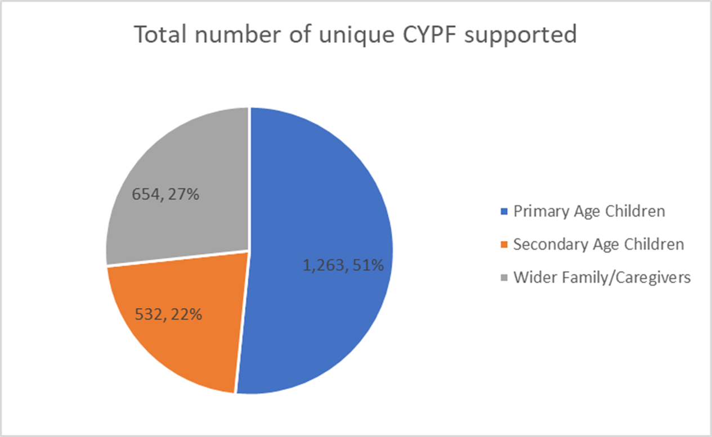

**2.4 Number of Children, Young People Supported by School Cluster: Figures 4.1 to 4.11**

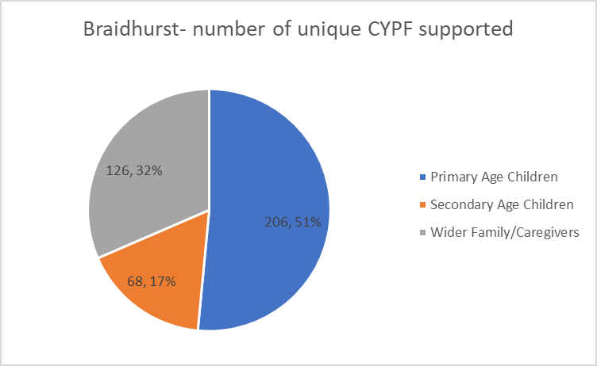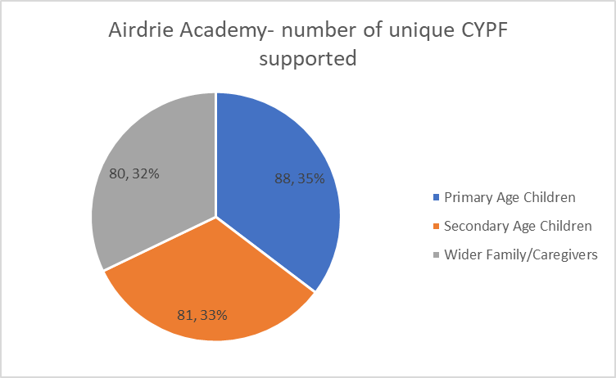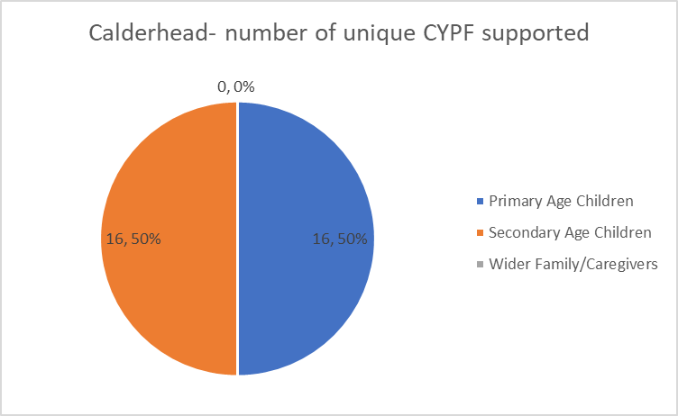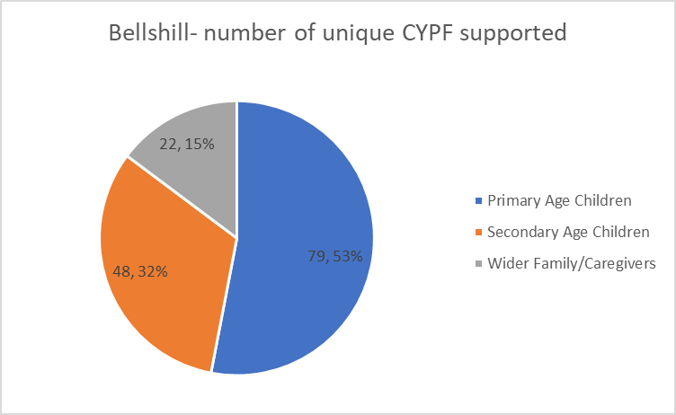

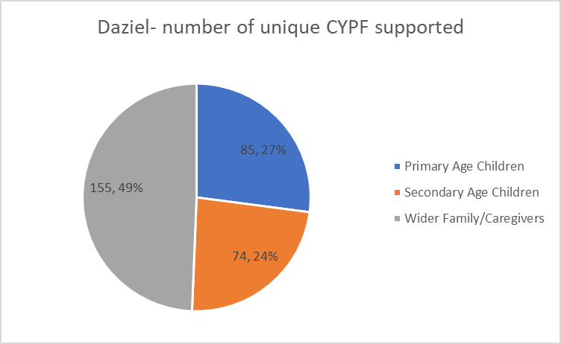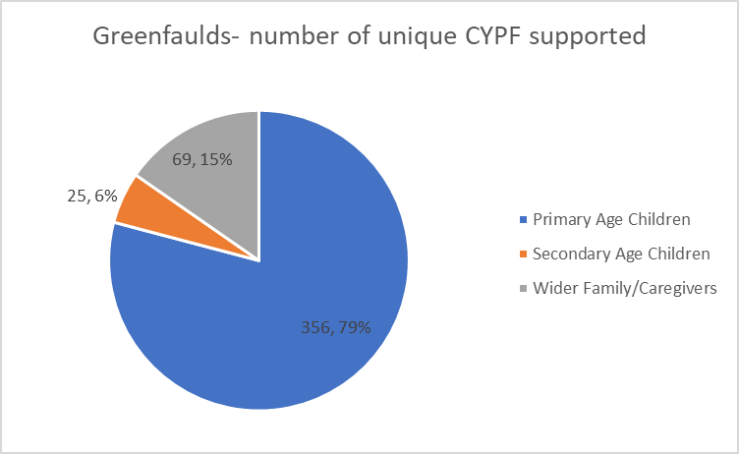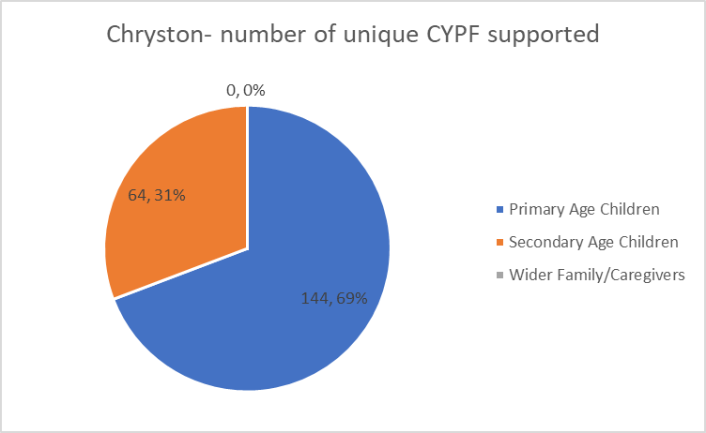

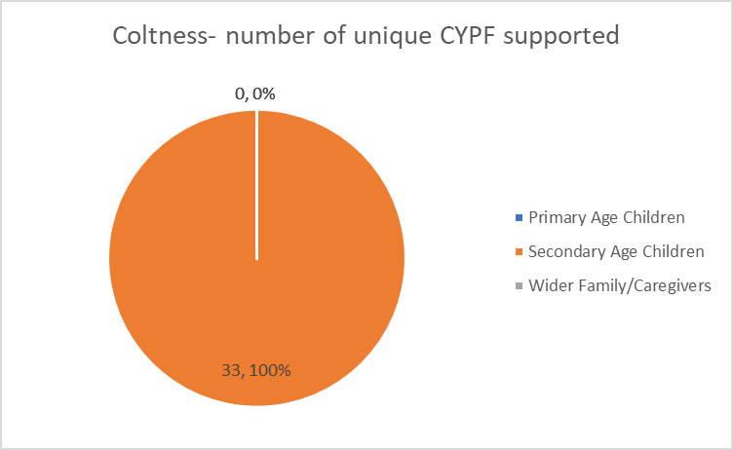

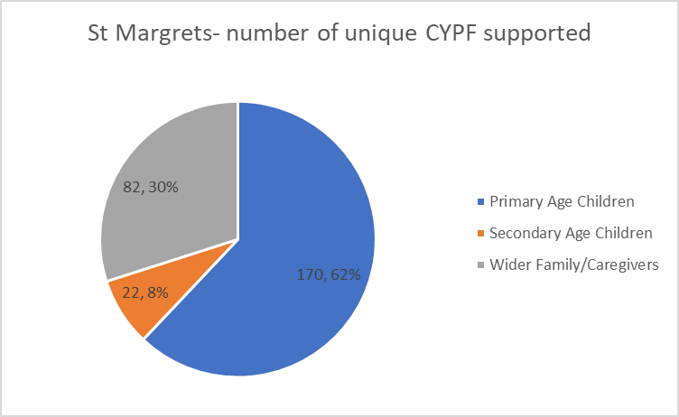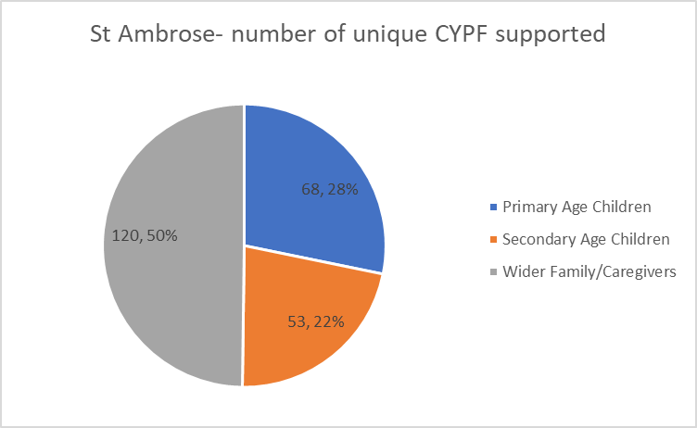

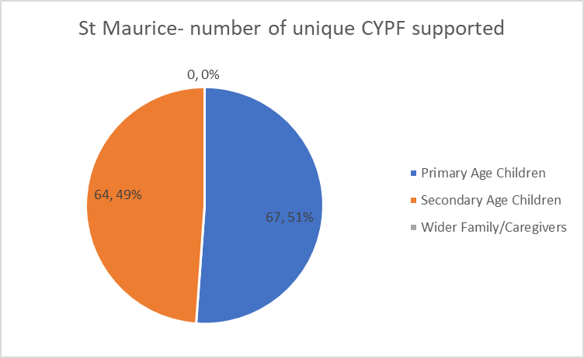

**2.5 Summary of Children and Young People’s Reported - SHANARRI Outcomes**

This information is collected by funded projects using self-assessment from the children and young people their projects support, using methods such as written pre- and post-support surveys, and verbal feedback.

. 



# 3. Learning from Phase Two

**3.1** **Feedback from School Cluster Improvement and Integration Leads**

VANL created and distributed a survey to all CIILs who participated in Phase Two to assess their experience of working collaboratively with the CVS and VANL to deliver this Fund. Feedback highlights are provided below.



**3.2 Phase Two Learning and Improvement Events**

VANL hosted two Learning and Improvement events at the end of Phase Two for CIILs and funded organisations, which were held in May 2022. A total of 10 out of 11 CILLS and 7 out of 20 funded projects participated[2]. The purpose of the events was to:

* facilitate open discussion to promote and support learning and improvements to collaboration and management of the fund and current and future services
* focus on solutions to identified challenges
* inform planning for Phase Three

The events began with a review of a first draft of this Phase Two Impact and Learning report. This was then used to prompt discussion in break-out rooms about the strengths and challenges of Phase Two.

Feedback from these discussions was analysed by VANL staff, with a summary of key themes presented below.





**3.3 Unexpected, Positive Outcomes**

Funded projects were asked to identify positive but unexpected outcomes in addition to those planned for.

**3.3.1 Reeltime Music- Creative Video Project**

While this project was not designed to increase school attendance the project improved school attendance of participating young people.

**3.3.2 SocialTrack- Wheely Good Fun**

Relationships amongst the participating young people have strengthened through participation in this project *“An unknown outcome has been group cohesion. The group gets on better than at first and as they share positive experiences, they are learning how to have positive social interactions as a group and encourage each other to try new sports and practice new techniques.”*

**3.3.3 Lanarkshire Community Food and Health Partnership- Big Chef Little Chef**

This family-based cooking project to support parent and child relationship-building amongst other outcomes, also facilitated parent peer support.

**3.3.4 One Parent Families Scotland- Creating Connections:** Through this project, One Parent Families Scotland were able to provide additional supports in addition to those previously agreed:*“The project had not planned to facilitate a peer support hub [for parents] this was a natural development that the participants found helpful to their progress in addressing daily challenges, improving family well-being and participating in local activities.”*

**3.4 Other Feedback from Funded Projects**

Additional, selected feedback from funded projects provided in monitoring and evaluation reports submitted to VANL, is highlighted below.

Overall, I feel the whole experience was good. VANL staff were very informative and gave clear instruction on the guidelines and needs for the fund. VANL helped in supporting our project by identifying Clusters who required the support. They also set up meetings with cluster leads which proved very beneficial in ensuring I knew the project was meeting the needs of the schools, children, young people, and Cluster Leads.

- The Miracle Foundation

I felt it was most useful to be involved in this fund. The young people have benefitted and we continue to work with the partners on an ongoing basis. Thank you

* Ponies Help Children

The application process to the fund went smoothly and without difficulties. Most schools were very engaged and responsive, however, with some school’s communication and engagement could be improved. Overall, the project was a great success with pupils, parents and teachers reporting positively on it and the evaluation demonstrating great project outcomes related to improved health and wellbeing.

* Lanarkshire Community Food and Health Partnership

Our experience has been an overwhelmingly positive one in which we have been given the chance to go and work with some incredible children and young people across three fantastic schools and been able to see visible improvements in all three groups

* Make & Create Arts

# 4. Future Phases

**4.1 Phase Three**

Informed by the learning of Phase Two, plans for Phase Three were developed and agreed during early 2022, with launch in May 2022. The schedule for Phase Three is as follows:

|  |  |
| --- | --- |
| Action | Date |
| Application Launch | 30th May 2022 |
| Application Closing Date | 14th June 2022 |
| Award Decision Date | January 2023 |
| Award Letters Issued | March 31st 2023 |
| Projects Delivered | August 2023-March 2024 |
| Mid-project Evaluation Report | November 2023 |
| End-of-project Evaluation Report | Summer 2024 |
| Total Funding | £516,344 (includes Phase 2 underspend of £56,588) |
| Total Custodian Funding | £465,000 |

# 4.2 Phase Four

A Phase Four has been agreed in principle and would commence in summer 2023, with a similar schedule to Phase There.

# Appendices

**Appendix A: Highlights from Six Funded Projects**

All 20 Phase Two funded projects completed and returned monitoring and evaluation forms to VANL, which were designed to demonstrate the impact their services/activities achieved with children and young people. Summaries from several funded projects’ evaluation reports are provided below, with summaries for all funded projects provided in a supplementary report.

**Hope for Autism - Support for School Transitions**

**Aim -** To support and prepare families with autistic children for their child’s transition into primary school

**Service/Activity -** A weeklysupport groupand 1:1 support sessions for parents of children with autism

**Delivery Cluster(s) -** Airdrie Academy, St Margaret’s

**Reach –** 7 children and their families

**Evaluation Method**

* Verbal feedback from parents

**Outcomes**

* Families were supported to:
  + gain more knowledge and understanding of autism
  + gain more knowledge and understanding of their child’s/young person’s autism
  + feel empowered to better support their child/young person and each other long term
* Feedback from participating families highlighted they felt less isolated because of the peer support group weekly sessions set up through the project, as the sessions gave families an opportunity to support one another, share ideas and receive advice and signposting to other supports by Hope for Autism Staff.

*“Your kind words mean so much and I feel so reassured at your experience in these situations and knowing that you have seen things get better. Thanks so much again! It was a godsend speaking to you.*” - Parent

**SHANARRI**

Indicators supported: Safe, Healthy, Achieving, Nurturing, Active, Respected, Responsible, Included

How the project supported the indicators:

* Used a peer support model to nurture a safe and supportive environment. An ethos of mutual respect was embedded within the group culture.
* Introduced the group to mental health and wellbeing strategies, training, and information.
* Physical activities.
* Group model encouraged all children and young people to participate.

**Learning**

Engagement with families was identified as a challenge due to:

* the effects of the COVID-19 pandemic, with families reporting that they had to take time to rebuild the confidence to engage with service providers which they lost during the pandemic as they had had to find their own ways to cope
* the provision of the service being delivered before and after a school holiday.

The project team believe a more consistent schedule for future delivery could help parents to regain confidence more quickly.

**One Parent Families - Creating Connections**

**Aim** - To enable single parent families to maintain and improve their family health and well-being, develop skills, awareness, and confidence, address the impact of living in poverty and gain better access to local resources and services

**Service/Activity -** Specialist one to one family support meetings, group work sessions, crisis support services, OPFS counselling services, health and wellbeing on-line support

**Delivery Cluster(s) -** St Margaret’s, Greenfaulds, Dalziel x2, Braidhurst

**Reach –** 87 single parents in North Lanarkshire

**Evaluation Method**

* Written feedback
* Individual needs assessments and feedback
* Observations of group activities

**Outcomes**

* Parents were supported to improve their wellbeing and inclusion – and in turn their children’s wellbeing – by helping parents to:
  + strengthen their confidence and skills
  + provide peer support
  + improve their access to local resources and services.
* Access to the right services at the right time helped to increase family well-being by reducing the levels of poverty families were experiencing and increasing parents’ engagement and participation in positive activities.
* The project supported parents to address challenges such as poverty and crisis situations and improve their sense of family well-being by being helped to:
* develop a better sense of control in their lives
* find strategies to manage their everyday challenges more effectively
* know where to get the right help at the right time.
* Through one-to-one support and group work activities, single parents were able to build friendships with other single parents who faced similar daily challenges to bringing up children alone, whilst living on a low income.

**SHANARRI**

Indicators supported: Safe, Healthy, Achieving, Nurturing, Active, Respected, Responsible, Included

How the project supported the indicators:

* Supported children to stay safe, set boundaries and know who to speak with if they have any worries.
* Supported children’s physical and mental wellbeing.
* Supported children’s motivation, development, and co-operation with activities.
* Improved children’s access to local services and resources, helping to improve family wellbeing.

**Learning**

Through this project and years of experience of working with single parents, OPFS are aware that they need to be:

* able to adapt services to meet the needs of single parents
* flexible in how they deliver the service

realistic about time scales as it takes time to build relationships with vulnerable families

**Parent Action for Safe Play - Play Champion and Active Play Programmes**

**Aims**

Play Champion Programme: train volunteers to develop young people’s leadership skills and ability to support children and young people’s play

Active Play Programme: to improve children and young people’s agility, balance and coordination, supported by the Play Champion volunteers

**Service/Activity**

Play Champion Programme: help young people to develop their skills and knowledge on how to facilitate free play opportunities for children and peers by shadowing qualified staff through weekly group sessions

Active Play Programme: delivery of a combination of semi-structured games and activities, creative and child-led play, designed to help children to develop their physical literacy and fundamental movement skills

**Delivery Cluster(s)-** Greenfaulds, Braidhurst, St Maurice

**Reach**

Play Champion - 36 young people

Active Play – 263 children

**Evaluation Method**

* Recording sheets for children and young people
* Staff observations
* Feedback from children, young people, and teacher

**Outcomes**

**Play Champion Programme**

* The Play Champion Programme, helped 36 young people to:
  + develop leadership skills
  + understand the risks and benefits of play
  + learn different play types
* Play Champions: the trained young 36 Play Champions developed the skills to motivate children and peers to become more active in their school playground.

**Active Play Programme**

* The Active Play Programme developed children’s physical literacy and movement skills through semi-structured games and activities.
* The Active Play Programme led to improvements in participating children’s:
* motivation and confidence to be more physically active
* agility, balance, coordination, and confidence
* teamworking
* ability to assess risks
* ability to solve problems
* emotional resilience
* concentration and behaviour

**SHANARRI**

Indicators supported: Safe, Healthy, Achieving, Nurturing, Active, Respected, Responsible, Included.

How the project supported the indicators:

* The project facilitated fun active play opportunities within a safe, familiar school setting.
* Play opportunities improved children and young people’s health and wellbeing, improved resilience, social skills, movement, and physical activity.
* Provided a wide range of high-quality play opportunities, including outdoor active play in stimulating spaces, appropriate to their age, stage, ability, and preferences.
* Facilitated opportunities for children to interact with others, give suggestions, be encouraged to get involved in decision making, take on leadership roles and be a role model within their school.

**Learning**

Young Play Champions Programme advised that they would benefit more by delivering play sessions to Primary One pupils, instead of to each other. This allowed the champions to practice what they have learned more effectively with the support of the Play Workers. This change has been incorporated into the Programme.

**Reeltime Music- Creative Video Project**

**Aim -** To increase young people’s awareness of sources of support and positive strategies related to mental health and wellbeing

**Service/Activity -** Supporting young people to create a piece of recorded music and/or video to highlight positive messages and sources of support for young people experiencing mental health and wellbeing challenges

**Delivery Cluster(s) -** St Margaret’s

**Reach –** Three young people

**Evaluation Method**

* A written survey measuring how the young people’s wellbeing progressed throughout the project

**Outcomes**

* The project encouraged young people to talk about the signs and effects of mental illness. The young people were able to talk about the barriers they face to their own positive mental wellbeing and discuss scenarios where their mental state could be negatively affected. This information went on to form part of the video content of the project.
* The project allowed young people to play instruments and create new music with a common purpose. While the participants had all been involved in music individually, this was their first opportunity to work together on this type of project.
* The musical aspect of the project led to improved communication skills, and participants showing each other how to play certain instruments, improving their overall ability to communicate and making them socially and musically more confident.
* Young people have additionally sought spaces in the Reeltime’s evening workshops. This shows that the young people have found their time in the project useful and positive and wish to continue participating in music

**SHANARRI**

Indicators supported: Safe, Healthy, Achieving, Nurturing, Active, Respected, Responsible

How the project supported the indicators:

* Young people left the project with signposting options to sources of support for mental health issues/crises.
* Young people were provided with information to help them to make positive decisions regarding their mental health and wellbeing.
* Young people decided the content of the project by themselves and worked towards both an individual and shared goal in their final presentations.
* Young people were encouraged to talk and share their feelings and opinions.

**Learning**

Inconsistent attendance by young people was a challenge. The project was adjusted to improve attendance by:

* + empowering and enthusing young people by putting them in control of the video content and music choices
  + providing varied activities to increase engagement and reduce risk of boredom
  + avoiding reliance on any single young person
  + keeping video concepts simple

**VIP- Creative Transitions Project**

**Aim -** To re-engage young people in education through creative activities.

**Service/Activity -** Supporting children and young people’s re-engagement with education through participation in varied activities such as dance, gymnastics, drama, music, exercise, horse-riding, health and beauty, and gardening.

**Delivery Cluster(s) -** Bellshill, Greenfaulds

**Reach –** 85 children and young people

**Evaluation Method**

* Pre- and post-evaluation using the Warwick Edinburgh Mental Health and Wellbeing Scale
* Regular in-person reviews with family
* Written feedback

**Outcomes**

VIP coaches worked with 85 children and young people to learn new skills and techniques in activities, including:

* Musical Theatre - creating a production
* Gardening – growing vegetables and landscaping a garden area
* Horse-riding – building bonds with the horses to understand how animals and animal therapy can create a sense of wellbeing

Children and young people participating in the activities showed:

* eagerness to learn and be involved in activities
* increased confidence and self-esteem
* a sense of purpose, from having a voice in the development of the activities
* a sense of belonging and self-worth
* ability to make new friendships

**SHANARRI**

Indicators supported: Safe, Healthy, Achieving, Nurturing, Active, Respected, Responsible, Included

How the project supported the indicators:

* Children and young people were supported within a safe space to build healthy relationships with each other and the group facilitator. The children and young people were encouraged to show respect for one another’s feelings and work together. These relationships helped the facilitator to support participants to make health choices that benefitted their overall wellbeing.
* Children and young people expressed a sense of achievement through positive participation in physical activities.
* Children and young people were encouraged to be creative and proud of their achievements.
* The project used a trauma-informed and nurturing approach to working with children and young people.
* Children and young people were included in the project with regular consultation and feeling “check-ins.”

**Learning**

* The need for flexibility and an ability to adapt plans to better meet children and young people’s needs.
* The importance of project staff receiving appropriate information about children and young people from schools so they can adjust activities appropriately. For example:
  + some require additional support staff to accompany them, which in turn affected transport and costs.
  + one child had been bereaved and this informed a change to a planned dramatic activity.

**Volunteering Matters- Youth Befriending Project**

**Aim -** To provide participants with a Volunteer Befriender who will act as a consistent and trustworthy role model.

**Service/Activity -** Befrienders engage each young person by participating in social and leisure activities in their local community, whilst providing a listening ear, time out and support when needed.

**Delivery Cluster(s) -** Chryston

**Reach –** Five young people

**Evaluation Method**

* Verbal and written feedback from volunteer befrienders, young people, families, and partners
* Regular review of befriending matches
* Impact tracker sheet for young people to complete to measure SHANARRI outcomes

**Outcomes**

* The befrienders supported the young people by providing social, emotional, and practical support assisted by individual plans in line with GIRFEC.
* Befrienders engaged with their young people according to their needs, goals, and interests, including support around healthy relationships; mental health; community participation; personal safety; physical health and exercise.

Young people receiving befriending support through this project:

* received guidance and encouragement to engage in community activities and hobbies that are meaningful, appropriate and sustainable
* provided with information about sources of other support for themselves and their families in their local area
* were supported to develop their social and communication skills, confidence and self-esteem, resilience, and inclusion.

**SHANARRI**

Indicators supported: Safe, Healthy, Achieving, Nurturing, Active, Respected, Responsible, Included

How the project supported the indicators:

The Befrienders:

* focused on developing young people’s confidence to go out in their local area and to develop their self-esteem and self-respect, their sense of identity and belonging.
* encouraged young people to spend time outside, eat healthily and exercise regularly, and get them involved in a social network.
* used regular praise and encouragement to ensure young people felt cared for and supported.
* gave the young people time-out from difficult situations at home by giving them an opportunity to do fun activities outside of the home.
* modelled good behaviour to the young people, teaching them right from wrong.

**Learning**

* Volunteering Matters initially delivered 16-week befriending placements. They have decided that going forward, they will increase to 6-month befriending placements as an ideal initial befriending period. This gives a longer period of support for the young person and also provides more time to work with young people if they don’t initially engage or if they cannot engage for other reasons, such as COVID-19, family illness or any unexpected/unavoidable life events.
* The referral form was improved to include clearer guidance for teachers who complete them.
* An information sheet was prepared for teachers, young people and families to supplement the in-person information sessions.

**Appendix B: Summary of All Phase Two Funded Projects**

|  |  |  |  |  |  |  |
| --- | --- | --- | --- | --- | --- | --- |
| **Organisation** | **Project** | **Cluster** | **Total Funding Awarded** | **Number of Unique CYPF supported** | | |
| **Primary age children** | **Secondary age children** | **Wider family/caregivers** |
| A-Jab Fitness & Emotional Support | A-jabs boxing for better mental health | Bellshill | £6,124 | 25 | 25 | 0 |
| Bazooka Arts | Therapeutic Transitions Project | Bellshill | £9,184 | 12 | 0 | 12 |
| Bazooka Arts | Creative Wellbeing - A Therapeutic Arts Transitions Support Project | Chryston | £6,859.20 | 80 | 0 | 0 |
| Getting Better Together | Community Transport | Coltness | £2,613 |  |  |  |
| Glenboig Development Trust | Primary Transition | Airdrie Academy | £4,531 | 5 | 0 | 10 |
| Glenboig Development Trust | Secondary Transitions | Airdrie Academy | £4,511 | 5 | 5 | 10 |
| Glenboig Development Trust | Seniors' year 4 – 6 | Airdrie Academy | £5,221 | 5 | 5 | 10 |
| Glenboig Development Trust | With Out Walls -Braidhurst High School | Braidhurst | £4,897 | 10 | 0 | 0 |
| **Organisation** | **Project** | **Cluster** | **Total Funding Awarded** | **Number of Unique CYPF supported** | | |
| **Primary age children** | **Secondary age children** | **Wider family/caregivers** |
| Glenboig Development Trust | With Out Walls – Muir Street 1 | Braidhurst | £2,290 | 1 | 0 | 1 |
| Glenboig Development Trust | With Out Walls – Muir Street 3 | Braidhurst | £2,290 | 3 | 0 | 3 |
| Glenboig Development Trust | With Out Walls - Unpaid Carers Respite Motherwell | Braidhurst | £4,897 | 20 | 0 | 20 |
| Glenboig Development Trust | With Out Walls – Dalziel High School | Dalziel | £2,290 | 2 | 0 | 2 |
| Glenboig Development Trust | With Out Walls - Glencairn PS Motherwell | Dalziel | £2,518 | 0 | 1 | 0 |
| Glenboig Development Trust | Horizon Project | St Ambrose | £8,515 | 20 | 20 |  |
| Glenboig Development Trust | Primary Transition | St Ambrose | £4,531 | 5 | 0 | 10 |
| Glenboig Development Trust | Secondary Transitions | St Ambrose | £4,511 | 5 | 5 | 10 |
| **Organisation** | **Project** | **Cluster** | **Total Funding Awarded** | **Number of Unique CYPF supported** | | |
| **Primary age children** | **Secondary age children** | **Wider family/caregivers** |
| Glenboig Development Trust | Seniors' year 4 – 6 | St Ambrose | £5,221 | 5 | 5 | 10 |
| HomeStart | Practical Steps Towards Change | Bellshill | £4,344 | 10 | 0 | 10 |
| Hope for Autism | Support for school Transitions | Airdrie Academy | £4,570 |  |  |  |
| Hope for Autism | Supporting Parent Carers of Autistic Children and Young People Through a Peer Group Model | St Margarets | £3,406 | 0 | 0 | 30 |
| Lanarkshire Community Food & Health Partnership | Come Dine with Us | Airdrie Academy | £8,000 | 50 | 0 | 50 |
| Lanarkshire Community Food & Health Partnership | Come Dine with Us | Braidhurst | £9,560 | 80 | 0 | 80 |
| Lanarkshire Community Food & Health Partnership | Come Dine with Us | Dalziel | £9,536 | 83 | 0 | 83 |
| **Organisation** | **Project** | **Cluster** | **Total Funding Awarded** | **Number of Unique CYPF supported** | | |
| **Primary age children** | **Secondary age children** | **Wider family/caregivers** |
| Lanarkshire Community Food & Health Partnership | Dalziel Nutrition | Dalziel | £3,100 | 0 | 10 | 10 |
| Lanarkshire Community Food & Health Partnership | Come Dine with Us | Greenfaulds | £7,185 | 40 | 0 | 40 |
| Lanarkshire Community Food & Health Partnership | Come Dine with Us | St Ambrose | £8,000 | 50 | 0 | 50 |
| Lanarkshire Community Food & Health Partnership | Big Chef Little Chef | St Margarets | £3,600 | 0 | 0 | 12 |
| Made4UinML2 | Paths to life | Coltness | £1,684.58 | 0 | 9 | 0 |
| Make and Create arts | Positive Creations, Airdrie, and St Ambrose Clusters | Airdrie Academy | £3,160 | 20 | 0 | 0 |
| Make and Create arts | Positive Creations at Portland High School | St Margarets | £3,000 | 0 | 6 | 0 |
| One Parent Families Scotland | Creating Connections: Forgewood Family Learning Centre | Braidhurst | £5,634 | 0 | 0 | 10 |
| **Organisation** | **Project** | **Cluster** | **Total Funding Awarded** | **Number of Unique CYPF supported** | | |
| **Primary age children** | **Secondary age children** | **Wider family/caregivers** |
| One Parent Families Scotland | Creating Connections: Ailsa Family Learning | Dalziel | £5,584 | 0 | 0 | 10 |
| One Parent Families Scotland | Creating Connections: Ladywell | Dalziel | £5,880 | 0 | 0 | 10 |
| One Parent Families Scotland | OPFS Creating Connections | Greenfaulds | £11,568 | 0 | 0 | 25 |
| One Parent Families Scotland | OPFS Creating Connections - Peer Led Approach | St Margarets | £15,820 | 0 | 0 | 32 |
| Parent Action for Safe Play | PASP Active Play / Play Champion Programme | Braidhurst | £2,198 | 80 | 0 | 0 |
| Parent Action for Safe Play | PASP Active Play / Play Champion Programme | Greenfaulds | £10,773 | 310 | 12 | 0 |
| Parent Action for Safe Play | PASP Active Play / Play Champion Programme | St Maurice | £5,120 | 64 | 64 | 0 |
| Ponies Help Children | Mental Health and Wellbeing Support | Coltness | £897.60 | 0 | 3 | 0 |
| Ponies Help Children | Mental health and wellbeing Support | Greenfaulds | £1,632 | 2 | 2 | 0 |
| **Organisation** | **Project** | **Cluster** | **Total Funding Awarded** | **Number of Unique CYPF supported** | | |
| **Primary age children** | **Secondary age children** | **Wider family/caregivers** |
| Reeltime Music | Portland Creative Video Project | St Margarets | £1,262.12 | 10 | 0 | 0 |
| Rivals School of Martial Arts | Reaching positive destinations through mental health and wellbeing sessions | Coltness | £1,500 | 0 | 4 | 0 |
| Social Track | Wheely Good Fun | Dalziel | £2,000 | 0 | 15 | 0 |
| The Health and Wellness Hub | Emotional Wellbeing in Schools | Airdrie Academy | £2,145 | 0 | 48 | 0 |
| The Health and Wellness Hub | Emotional Wellbeing in Schools | Braidhurst | £2,738 | 0 | 60 | 12 |
| The Health and Wellness Hub | Emotional Wellbeing in Schools- Glencairn Primary | Braidhurst | £571 | 12 | 0 | 0 |
| The Health and Wellness Hub | Emotional Wellbeing in Schools | Dalziel | £1,867 | 0 | 48 | 0 |
| The Health and Wellness Hub | Emotional Wellbeing in Schools | St Margarets | £6,830 | 160 | 16 | 8 |
| The Miracle Foundation | Secondary School Transition Support for Young People | Airdrie Academy | £3,600 | 0 | 20 | 0 |
| **Organisation** | **Project** | **Cluster** | **Total Funding Awarded** | **Number of Unique CYPF supported** | | |
| **Primary age children** | **Secondary age children** | **Wider family/caregivers** |
| The Miracle Foundation | Miracle Foundation Supporting children and young people’s mental health | Braidhurst | £1,800 | 0 | 8 | 0 |
| The Miracle Foundation | Miracle Foundation Supporting children and young people’s mental health | Calderhead | £7,200 | 16 | 16 | 0 |
| The Miracle Foundation | Miracle Foundation Supporting children and young people’s mental health | Chryston | £29,800 | 64 | 64 | 0 |
| The Miracle Foundation | Miracle Foundation Support young people’s mental health | Dalziel | £4,650 | 0 | 0 | 40 |
| The Miracle Foundation | Bereavement and Trauma Support | Greenfaulds | £4,800 | 4 | 0 | 4 |
| VIP | Creative Transitions Project | Bellshill | £8,080 | 20 | 10 | 0 |
| VIP | Coach and transport costs for guitar & musical theatre weekly sessions at Greenfaulds | Greenfaulds | £1,620 | 0 | 11 | 0 |
| **Organisation** | **Project** | **Cluster** | **Total Funding Awarded** | **Number of Unique CYPF supported** | | |
| **Primary age children** | **Secondary age children** | **Wider family/caregivers** |
| Volunteering Matters | North Lanarkshire Youth Befriending Project | St Maurice | £5,958 | 3 | 0 | 0 |
| YMCA Bellshill & Mossend | Y-Empower – 1:1 Support | Airdrie Academy & St Ambrose | £14,400 | 6 | 6 | 0 |
| YMCA Bellshill & Mossend | Digital Youth Programme | Bellshill | £5,990 | 12 | 13 | 0 |
| YMCA Bellshill & Mossend | Digital Wellness | Coltness | £5,541 | 0 | 10 | 0 |
| YMCA Bellshill & Mossend | Farmbots | Coltness | £3,468 | 0 | 7 | 0 |
|  |  | Total | £290,234 | 1263 | 532 | 654 |

[Document Ends]

1. *School clusters: Schools within NL are clustered into groups of one high school and surrounding primary schools, forming a network of local schools which aid issues such as pupil transition from primary to secondary school and community links. There are 23 school clusters in North Lanarkshire which all work to the Empowering Clusters Integrated Model where schools and school leaders, supported by NLC central staff, work together to support improvements to services and outcomes for families and communities, including action to tackle poverty, improve attainment and wellbeing.
2. Attendance at these events was not mandatory, however due to their success, from Phase 3 attendance at learning and improvement events is a condition of grant.