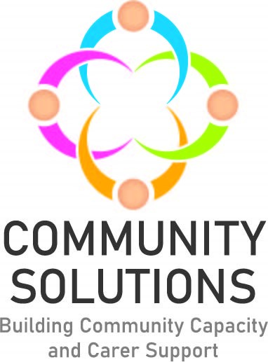

**North Lanarkshire Children and Young People Community Mental Health and Wellbeing Fund**

**Impact and Learning Report - Phase Three 2022-23**

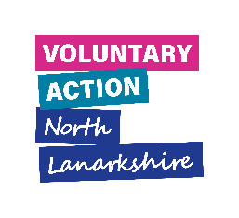



# Contents

1. Introduction to Fund – Page 3
2. Overview of Phase Three – Page 11

2.1 Summary of funded projects and number of children and young people receiving support

2.2 Summary of children and young people supported by school cluster

2.3 Summary of outcomes for children receiving support

3. Learning from Phase Three – Page 20

4. Future Phases – Page 26

**Appendices**

Appendix A: Highlights from Six Funded Projects* – Page 28

Appendix B: Summary of All Funded Projects – Page 35

*A complementary report with more information on all funded projects is available.

# 1. Introduction

**1.1 Purpose**

The purpose of this report is to share the impact and learning from projects funded in Phase Three of the **North Lanarkshire Children and Young People Community Mental Health and Wellbeing (CYP) Fund**. The Impact and Learning report for Phase One and Two are available here. Learning from Phase One and Two has informed Phase Three. A complementary report providing summaries of all funded projects in Phase Three is also available here.

**1.2. Fund Phases**

Phase One was a rapid pilot to develop and test the approach. Given the success of the pilot, additional funding was agreed for Phase Two and – given the success of Phase Two – further funding was agreed for Phase Three, which completes in summer 2023. Phase Four has been agreed in principle.

|  |  |  |
| --- | --- | --- |
| Phase | Date | Total Funding Per Year |
| Phase One | Jan 21-Mar 21 | £100,000 |
| Phase Two | Sep 21-Mar 22 | £364,600 |
| Phase Three | May 22- Apr 23 | £516,344 (includes Phase Two underspend of £56,588) |
|  | **TOTAL** | **£980,944** |
| Phase | **Date** | **Total Custodian Funding** |
| Phase One | As above | £100,000 |
| Phase Two | As above | £276,600 |
| Phase Three | As above | £465,000 |
|  |  | **TOTAL £841,600** |

**1.3 Aim**

Our **North Lanarkshire Children and Young People Community Mental Health and Wellbeing** Fund supports local delivery of the Scottish Government Children and Young People Mental Health and Wellbeing Framework, the North Lanarkshire Children’s Services Plan, and Lanarkshire Mental Health Strategy.

**1.4 Outcomes**

To improve children and young people’s mental health and wellbeing, with reference to the national [‘SHANARRI’](https://www.gov.scot/policies/girfec/wellbeing-indicators-shanarri/) framework. (See outcomes section below.)

**1.5 Objectives**

1.5.1 Increase North Lanarkshire Community and Voluntary Sector (CVS) capacity to support children and young people’s mental health and wellbeing in their local community.

1.5.2 Demonstrate the contribution of the North Lanarkshire CVS to improving children and young people’s mental health and wellbeing.

1.5.3 Improve collaboration between schools and the community and voluntary sector.

**1.6 Fund Logic Model**

The [‘logic model’](https://evaluationsupportscotland.org.uk/resources/ess-support-guide-1c-developing-a-logic-model/) diagram below summarises the fund’s:

* Investment and other inputs
* Funded projects
* Beneficiaries
* Types of activities delivered
* Difference made (i.e., outcomes)

**Figure One: North Lanarkshire Children and Young People Mental Health and Wellbeing Fund Logic Model**



**1.7 Funding and Fund Management**

1.7.1 Funding for this initiative is provided by the Scottish Government to the North Lanarkshire Council (NLC), which is then transferred to Voluntary Action North Lanarkshire (VANL) to manage distribution through the Community Solutions Programme - working in partnership with NLC Education and Families colleagues and CVS organisations. Decisions about local funding priorities are taken by the North Lanarkshire school clusters[1], which commission CVS organisations to provide mental health and wellbeing support for their children and young people. VANL facilitates liaison between the school clusters and the CVS; manages award payments and supports evaluation and reporting.

1.7.2 VANL supports this fund as part of the wider Community Solutions Programme, which VANL hosts and manages on behalf of [Health and Social Care North Lanarkshire.](https://hscnl.org.uk/)

**1.7.3** **Funding Awards Process**

**1.7.3.1 Process for Identifying Needs and Agreeing Funding Awards**

School Cluster Improvement Integration Leads (CIILs) work alongside school staff to identify local priorities to support children and young people’s mental health, informed by a needs analysis and with a ‘solution-focussed’ approach. CVS organisations are then invited to submit applications to deliver support which address identified priorities. Decisions on funding are taken by each school cluster team, which are made up of CIILs and head teachers.

Please see Appendix B for a full list of funded CVS projects for Phase Two.

**1.8 Evaluation, Learning and Improvement**

1.8.1 Approach

The Fund’s approach to evaluation, learning, and improvement is guided by the Community Solutions Performance Management, Evaluation, Learning, and Improvement Framework. The framework sets out the Community Solutions Programme’s approach to performance management, evaluation, learning, and improvement to support funded projects and the programme as a whole. The framework also sets out standardised measures and relevant supports to help funded projects make the most of their findings.

In line with the framework, funded CVS organisations are required to assess the reach and impact/outcomes of their work, and capture and share learning to inform improvements to their service or activities, and where possible to other funded projects, the wider CVS, and the Health and Social Care system. Using the framework, VANL staff support funded projects to undertake ongoing evaluation to facilitate learning and improvement during and at the end of project delivery.

1.8.2 Performance Data and Method

Funded projects are required to capture and share with VANL key information on the following:

* Type of support provided – activities
* Numbers of unique individuals supported – reach
* The difference this support made to those receiving support – outcomes.

Funded projects are also asked to measure their project outcomes using ‘SHANARRI’ indicators, which are widely used nationally and locally to measure outcomes as part of the Getting It Right For Every Child (GIRFEC) approach. The initials of the SHANARRI set out the following aspirations for every child and young person:

Safe

Healthy

Achieving

Nurtured

Active

Respected

Responsible

Included

Funded projects collect this data at points prior to, during, and post project delivery using a range of different methods including:

* Written surveys; online or via the phone
* Verbal feedback
* Observations
* Self-assessment methods such as the [Warwick Edinburgh Mental Wellbeing Scale](https://warwick.ac.uk/fac/sci/med/research/platform/wemwbs/) and progress tracker worksheets

Funded projects use this data to complete evaluation forms which are submitted to VANL at the six- and twelve-month mark of the projects.

VANL also hosts two Learning and Improvement events for representatives from funded projects and from school clusters for each phase. The purpose of these events is to collect feedback from funded projects on their experience of the fund. This feedback informs the delivery of future fund phases and service delivery for projects.

Data from evaluation forms and Learning and Improvement events is used to prepare Impact and Learning reports for each phase.

**1.9 Policy Context**

**1.9.1 Scottish Government’s Community Mental Health and Wellbeing Supports and Services Framework**

The Scottish Government’s[Community Mental Health and Wellbeing Supports and Services Framework](https://www.gov.scot/publications/community-mental-health-wellbeing-supports-services-framework/) guides development and delivery of local support and services for children and young people’s mental health and emotional wellbeing, with this fund investing in the CVS to provide community-based support.



**Figure Two:** **Scottish Government Children and Young People’s Mental Health and Wellbeing Model**

The aim of the Government’s framework is that: “Every child and young person in Scotland will be able to access local community services which support and improve their mental health and emotional wellbeing. Every child and young person and their families or carers will get the help they need, when they need it, from people with the right knowledge, skills, and experience to support them.  This will be available in the form of easily accessible support close to their home, education, employment, or community.”

**1.9.2 North Lanarkshire Children’s Services Partnership and Plan**

The [North Lanarkshire Children’s Services Partnership](https://www.northlanarkshire.gov.uk/social-care-and-health/children-and-families/childrens-service-plan) brings together public bodies, youth representation, and CVS organisations to deliver services and supports that improve outcomes for children, young people, and families.

“The North Lanarkshire Children’s Services Plan brings together our thinking about how we best deliver services and supports for children, young people and families in North Lanarkshire and outlines what we want to collectively achieve. The focus of the Children’s Services Plan is on the shared priorities that partners identify and work together to achieve. The partnership publishes a Children’s Services Plan every three years, and a yearly report which provides an overview of the progress made during the first year of the Children’s Services Plan 2021-23 and the context in which the ambitions of the plan have progressed.”

Cross-sector strategic planning and operational support for children and young people’s mental health and wellbeing services and support across North Lanarkshire is facilitated through a sub-group of the Children’s Services Partnership which also supports [delivery of Lanarkshire’s Mental Health Strategy.](https://www.nhslanarkshire.scot.nhs.uk/strategies/mental-health-wellbeing-2019-24/)

**Many thanks to the funded projects which provided information and to the VANL staff who prepared this report.**

# 2. Overview of Phase Three: Reach and Outcomes

**2.1 Figure Three: Funded Projects and Children, Young People, and Families (CYPF) Supported**



**2.2 Figure Four: Summary of CYPF Supported by Cluster**

**2.3 Figures 4.1 to 4.22: Number of CYPF Supported by School Cluster**

**2.4 Figure Five: Summary of Children and Young People’s Reported - SHANARRI Outcomes**

This information is collected by funded projects using self-assessment from the children and young people their projects support, using methods such as written pre- and post-support surveys, and verbal feedback.



# 3. Learning from Phase Three

3.1 Phase Three Learning and Improvement Events

VANL hosted two Learning and Improvement events at the end of Phase Three for CIILs and funded organisations, which were held in August 2023. The purpose of the events was to:

* Facilitate open discussion to promote and support learning and improvements to collaboration and management of the fund and current and future services
* Focus on solutions to identified challenges
* Inform planning for Phase Four

Feedback from these discussions was analysed by VANL staff, with a summary of key themes presented below.





**3.2 Unexpected Positive Outcomes**

Funded projects were asked to identify positive but unexpected outcomes in addition to those planned for.

**3.2.1 Home-Start – Practical Steps Towards Change**

The project was able to support the full family, not just the children referred to the project. In one instance, an older child in a family (not the referred child) was having trouble processing feelings and emotions related to grief and bereavement. The Family Support Worker for the project contacted the CIIL to discuss counselling opportunities at their high school.

**3.2.2 Make and Create Arts – Positive Creations**

As the children were involved in the planning of the project, the project changed and adapted organically to their ideas, suggestions, and personalities.

**3.2.3 OutLET Play – SOARing Outdoors**

An unexpected outcome for the project was that due to the session times, the older group of the young people were able to meet one of the younger groups. The older young people were able to mentor the younger group, which they really leaned into. The project reported that this boosted the confidence of the older group of young people.

**3.2.4 Bazooka Arts – Group Therapeutic Arts Programme**

A teacher noted that new friendships were formed within the group attending the project, and this allowed them to support one another. The young people were also now more comfortable speaking out in front of the class and were more open to sharing their emotions*.*

**3.3** **Other Feedback from Funded Projects**

Additional, selected feedback – provided in monitoring and evaluation reports submitted to VANL from funded projects – is highlighted below:

‘We found the application process very easy, and we were very pleased to have our application given consideration. We were very keen to make our application a diverse and responsive initiative based on what we had been told was needed in the cluster.

The communication from the team was very good and very positive.’

* Action for Children

‘As a team VIP found being part of Phase 3 highly rewarding. Reaching 380 children was a huge achievement, with many of the children being reported by their school to have increased attendance, concentration, confidence and engagement in academic subjects. For us this was as an organisation a very successful project reaching many different children over various age groups and abilities and we would hope that we are allowed to continue providing activities into the next Phase 4, which have been requested by many head teachers and report staff.’

* VIP Arts and Sports Academy

‘We had a good experience working closely with the Cluster Leads (CIILs). We found this very effective and it aided the coordination of the programme and liaison with the schools involved. We found the application process comprehensive but easy to complete. Overall, we were delighted to be part of Phase 3 and would love to be involved again in future programmes.’

* Bazooka Arts

‘We felt that some schools were more communicative and proactive than others during the initiative’

* Action for Children

‘Applying to the fund was straightforward with set timelines and clear guidance. We were happy with the process and delighted to have been a part of Phase 3 of this programme.’

* One Parent Families Scotland

‘The plus points were that in schools where staff were particularly invested, the children were also more invested which showed in the ‘before’ SHANARRI questionnaire as well as the ‘after’.  The children also enjoyed the sessions which was very visible to staff. Room for improvement could be around communication between the base, the schools, and the families.’

* The Health and Wellness Hub

‘The Miracle Foundation SCIO have enjoyed being able to play a part in Phase 3 of the Empowering Clusters model. Being able to provide services directly in school allows us to bridge a gap where we would normally not have an opportunity to do so within our premises and for families needing additional support. While we are so happy to be involved, the process for applying for the funding was extremely hard and time-consuming – only to then be changed again after all the initial effort was made for applying. We feel this can be improved and simplified to ensure effective processes and reduce issues.’

* The Miracle Foundation

# 4. Future Phases

4.1 Phase Four

The funding allocation process for Phase Four has been revised to better address school’s priority needs throughout the school year. The process for Phase Four is as follows.

The schedule for Phase Four is as follows:

|  |  |
| --- | --- |
| Action | Date |
| Application Launch | June 2023 |
| Award Decision Date | Ongoing throughout allocation process |
| Award Letters Issued | Ongoing throughout allocation process |
| Projects Delivered | August 23 – June 24 |
| Mid-project Evaluation Report | November 2023 |
| End-of-project Evaluation Report | June 2024 |
| Total Funding | £502,649.75 |
| Total Custodian Funding | £449,649.75 |

# Appendices

**Appendix A: Highlights from Six Funded Projects**

All 75 Phase Three funded projects completed and returned monitoring and evaluation forms to VANL, which were designed to demonstrate the impact their services/activities achieved with children and young people. Summaries from several funded projects are provided below, with information on all funded projects provided in the supplementary report.

**Action for Children - Young Carers Primary School Awareness Programme**

**Aim –** To raise awareness of Action for Children’s Young Carers service, and support the current and future identification of young carers within schools

**Service/Activity –** 66 classroom-based awareness and information sessions for pupils and staff to raise awareness and identify young carers

**Reach –** 200 primary school and two secondary school pupils, 60 families, and 12 young carers

**Delivery Cluster(s) –** St Margaret’s

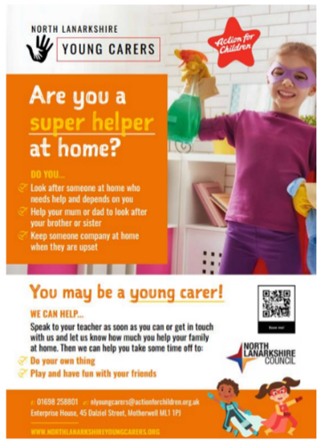**Evaluation Method**

* Written feedback from pupils
* Feedback from teaching staff
* Referrals to the service
* Attendance figures

**Outcomes**

This project has:

* Delivered 36 in-class information sessions and presentations to primary school pupils
* Delivered 30 information sessions and presentations to school teaching and support staff
* Been supported by two peer support mentors (secondary school pupils who were young carers) who supported the information sessions

**Learning**

* In the future, the project will involve more peer support mentors as the young carers felt valued and were able to support the primary school pupils
* The project typically preferred to deliver multiple sessions in small groups, however, some schools preferred a one-off presentation to a larger group
* The number of referrals after the sessions to their service has shown that there is increased awareness of the service and what it does

**Bazooka Arts – Group Therapeutic Arts Programme**

**Aim –** To support children and young people’s mental health and wellbeing through therapeutic arts

**Service/Activity –** 93 therapeutic arts workshops

**Reach –** 30 primary school pupils

**Delivery Cluster(s) –** St Margaret’s, St Ambrose, St Andrew’s, Coltness and St Aidan’s, Calderhead

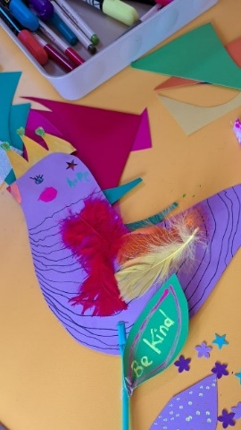

**Evaluation Method**

* Evaluation survey
* Verbal feedback

**Outcomes**

This project has:

* Delivered 93 therapeutic arts workshops using play, imagination, movement, and creative techniques
* Engaged children in activities including creating cyanotypes, dreamcatchers, and silk painting
* Focused on providing relaxation, building confidence and resilience, and increasing social interaction for children who had suffered bereavement, had low confidence and self-esteem, and who can find social interactions and the classroom environment challenging

**Learning**

* The survey highlighted:
  + 100% felt the sessions resulted in an increase in confidence
  + 100% felt the sessions improved mental health and wellbeing
* The project felt that the children would have benefitted from and wanted longer sessions. Longer sessions would give them the opportunity for the children to build more trusting, positive relationships with each other and staff
* The project would like to have more family involvement in the future

**Home Start – Practical Steps Towards Change**

**Aim –** To provide emotional support, friendship, and practical help to parents and carers of children at the P1-P3 stage who are experiencing difficulties engaging or re-engaging with their primary school

**Service/Activity –** 1-to-1 support for families

**Reach –** Six children and their families

**Delivery Cluster(s) -** Bellshill

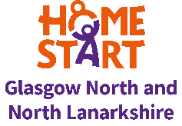**Evaluation Method**

* Weekly reviews with families
* School attendance
* Staff observations
* Verbal feedback

**Outcomes**

This project has:

* Offered six children and their families weekly 1-to-1 support through home visits and telephone calls, offering practical and emotional support and signposting to other agencies
* Held five trips including to the science centre, the PlayTalkRead bus, Summerlee Heritage Park, Strathclyde Park, and Blair Drummond Safari Park
* Provided two families with trauma-informed parenting training

**Learning**

* The project supported one pupil who was a non-attender to re-engage with school. Her attendance rate percentage is now in the high 90’s. The relationship between the family and their school has also improved and they now work together to support the child to engage fully with the curriculum. The child is also now attending the school’s summer club during the school holidays
* The project was able to support a family to access counselling for their child
* Going forward with the project, the organisation will ensure that any new schools who submit referrals understand the role of the family support worker and what support they provide, and what the expectations are on the school before starting support

**Hope for Autism – Support for School Transitions**

**Aim –** To support children with autism in early primary education with their transition into school

**Service/Activity –** 10 weekly face-to-face support sessions with the child and their family

**Reach –** Six primary children and 11 parents/carers

**Delivery Cluster(s) –** Airdrie Academy

**Evaluation Method**

* Staff observations
* Verbal feedback from parents/carers
* Thumbs-up scale with children (good, middle, bad)

**Outcomes**

This project has:

* Offered children a safe space during 10 weekly support sessions to interact with their peers
* Allowed parents/carers to seek advice about their child
* Facilitated conversations between parents, allowing them to share experiences
* Hosted a day trip to Glasgow Science Centre and Almond Valley in Livingston, hosted social gatherings in a soft play area, and a celebratory end-of-project party

**Learning**

* In future, the project would plan an initial meeting with the parents/caregivers and staff without the children, to allow them to establish a stronger relationship prior to the project. They would also hold separate sessions for children in nursey and children already in primary school, rather than a mixed age group
* Some families invited did not participate. The project extended another invitation when the group planned to visit a soft play area, and one family took up this offer

**OutLET Play – SOARing Outdoors**

**Aim –** To support young people who have experienced significant trauma and are struggling to engage with school through nature

**Service/Activity –** Weekly, individual, small group, and group outdoor learning-and-support sessions

**Reach –** 39 primary and seven secondary school pupils

**Delivery Cluster(s) –** Brannock and Taylor, Clyde Valley, Greenfaulds, Kilsyth, Dalziel, Our Lady’s High Cumbernauld

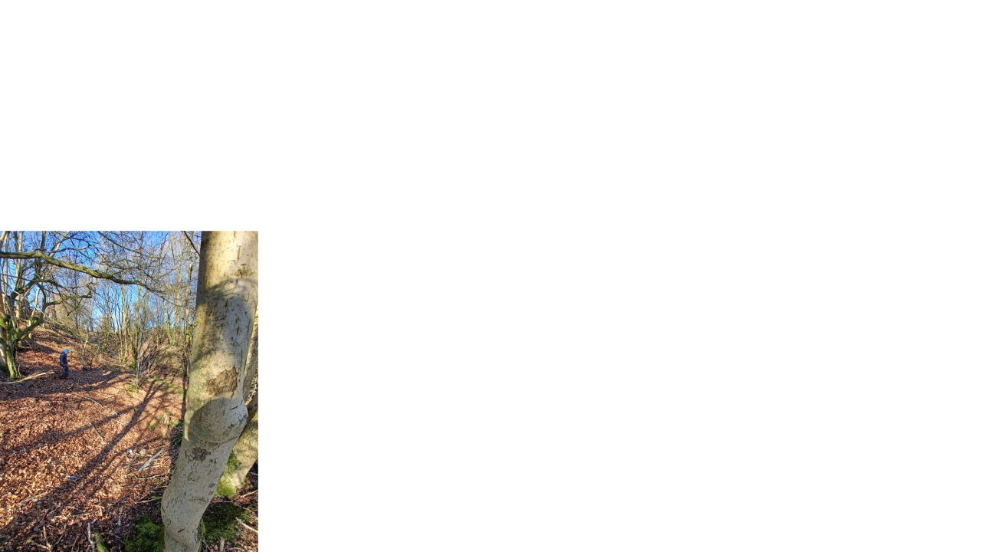

**Evaluation Method**

* Observations
* Attendance
* Verbal feedback

**Outcomes**

This project has:

* Delivered 50 two-hour small group sessions in a local woodlands area, which engaged young people in sensory-seeking activities and allowed them to play freely whilst working through their emotions
* Delivered 85 individual sessions
* Delivered 59 larger group sessions

**Learning**

* The project felt the 1-to-1 sessions were very successful, as a strong relationship was built between the young people and the facilitator. This enabled the young people to talk about their worries and difficulties with school
* A challenge the project faced was that school staff were sometimes unavailable to accompany young people at the sessions. To accommodate this, the project adjusted their procedures so other responsible adults could accompany them
* For future programmes, the project would consider asking the school to take responsibility for transporting the young people to the session

**Reeltime Music – Creative Project using Music and Media**

**Aim –** To enable young people to speak about their mental health issues whilst learning creative skills

**Service/Activity –** Weekly music and creative media workshops

**Reach –** 15 primary and 74 secondary school pupils

**Delivery Cluster(s) –** Caldervale, Airdrie Academy, Kilsyth, Our Lady’s High Cumbernauld, and Motherwell

**Evaluation Method**

* Verbal feedback from school staff
* End-of-project written questionnaire

**Outcomes**

This project has:

* Delivered 79 workshops focusing on recording music, trying instruments, group performances, creating music videos, and original music compositions
* Provided young people with information about available mental health supports and a safe space to talk about their problems

**Learning**

* The project experienced some difficulties such as inconsistent attendance, struggles with social anxiety, and lack of interest in music. However, they knew to expect these issues from experience, and found ways to work around them as the project moved forward. For example, facilitators worked with the young people to decide on the content of each activity, and put them in charge of the sessions which increased the likelihood they would attend. They also built in activities which would allow the young people to get to know one another to reduce feelings of social anxiety

**Appendix B: Summary of All Funded Projects**

|  |  |  |  |  |  |  |
| --- | --- | --- | --- | --- | --- | --- |
| **Organisation** | **Project** | **Cluster** | **Total Funding Awarded** | **Number of Unique CYPF supported** | | |
| **Primary age children** | **Secondary age children** | **Wider family/caregivers** |
| Action for Children | Young Carers Primary School Awareness Programme | Bellshill | 5,724 | 200 | 2 | 60 |
| Bazooka Arts | Group Therapeutic Arts Programme | St Ambrose and St Andrews | 1,471 | 30 |  |  |
| St Aidan’s and Coltness | 30,417 | 72 |  |  |
| Calderhead | 14,000 | 137 |  |  |
| St Margaret’s | 6,456 | 64 |  |  |
| Circle | Whole Family Support Service | Our Lady’s High Motherwell | 17,361 | *Delivering in 2023-24 | | |
| Homestart | Practical Steps Towards Change | Bellshill | 11,032 | 6 |  | 6 |
| Hope for Autism | Support for School Transitions | Airdrie Academy | 2,920 | 6 |  | 11 |
| 1,620 |
| Lunch Time Club | Kilsyth | 1,854 |  | 6 |  |
| **Organisation** | **Project** | **Cluster** | **Total Funding Awarded** | **Number of Unique CYPF supported** | | |
| **Primary age children** | **Secondary age children** | **Wider family/caregivers** |
| Lanarkshire Community Food and Health Partnership | Big Chef Little Chef | Coatbridge | 7,307 | 29 |  | 29 |
| St Ambrose | 6,576 | 23 |  | 23 |
| St Andrew’s | 11,691 | 58 |  | 58 |
| St Maurice | 6,576 | 26 |  | 26 |
| Come Dine with Me | Airdrie Academy | 2,972 | 13 | 23 | 36 |
| Caldervale | 4,757 | 36 | 6 | 42 |
| Cooking Club | Braidhurst | 5,154 |  |  |  |
| Chryston and Kilsyth | 6,280 |  | 10 |  |
| Kilsyth | 3,140 |  | 16 |  |
| St Margaret’s | 1,600 |  |  |  |
| The Nurture Project | St Ambrose | 4,000 | *Delivering in 2023-24 | | |
| St Margaret’s | 1,600 |
| **Organisation** | **Project** | **Cluster** | **Total Funding Awarded** | **Number of Unique CYPF supported** | | |
| **Primary age children** | **Secondary age children** | **Wider family/caregivers** |
| Make and Create Arts | Creative Families | Airdrie Academy | 3,000 | 24 |  | 12 |
| Positive Creations | Caldervale | 5,000 | 50 |  |  |
| St Ambrose | 7,000 | 72 | 12 |  |
| St Andrew’s | 9,000 | 108 | 12 |  |
| One Parent Families Scotland | Creating Connections | Braidhurst | 2,302 | 35 |  | 25 |
| 2,302 | 14 |  | 9 |
| 3,198 | 27 |  | 18 |
| 3,198 | 29 |  | 20 |
| Cumbernauld Academy | 5,000 |  | 15 | 10 |
| Greenfaulds | 5,000 |  | 17 | 11 |
| Our Lady’s High Cumbernauld | 5,000 |  | 17 | 12 |
| **Organisation** | **Project** | **Cluster** | **Total Funding Awarded** | **Number of Unique CYPF supported** | | |
| **Primary age children** | **Secondary age children** | **Wider family/caregivers** |
| OutLET Play | SOARing Outdoors – Individual Support | Brannock and Taylor | 3,555 | 7 | 4 |  |
| 1,648 |
| SOARing Outdoors – Small Group | Brannock and Taylor | 2,413 |
| SOARing Outdoors – Individual Support | Cumbernauld | 3,839 | 3 | 1 |  |
| SOARing Outdoors – Small Group | Cumbernauld | 5,543 |
| SOARing Outdoors | Clyde Valley | 8,645 | 12 |  |  |
| SOARing Outdoors – Individual Support | Dalziel | 1,778 | 5 | 1 |  |
| SOARing Outdoors | Dalziel | 2,353 |
| SOARing Outdoors – Small Group | Dalziel | 1,832 |
| SOARing Outdoors – Group | Dalziel | 5,399 |
| **Organisation** | **Project** | **Cluster** | **Total Funding Awarded** | **Number of Unique CYPF supported** | | |
| **Primary age children** | **Secondary age children** | **Wider family/caregivers** |
|  | SOARing Outdoors | Greenfaulds | 3,719 | 4 |  |  |
| SOARing Outdoors – Individual Support | Kilsyth | 2,656 | 5 |  |  |
| SOARing Outdoors – Small Group | Kilsyth | 1,602 |
| SOARing Outdoors – Small Group | Kilsyth | 2,298 |
| SOARing Outdoors – Small Group | Our Lady’s High Cumbernauld | 2,189 | 3 | 1 |  |
| Wild Passport | Brannock and Taylor | 4,307 | 7 | 4 |  |
| Parent Action for Safe Play (PASP) | Play Champion Programme | Cumbernauld | 5,280 | 148 |  |  |
| Greenfaulds | 7,392 | 199 |  |  |
| St Maurice | 6,228 | 135 |  |  |
| Reeltime Music | Creative Project using Music and Media | Airdrie Academy | 3,600 |  | 22 | 25 |
| **Organisation** | **Project** | **Cluster** | **Total Funding Awarded** | **Number of Unique CYPF supported** | | |
| **Primary age children** | **Secondary age children** | **Wider family/caregivers** |
|  |  | Caldervale | 1,600 |  | 7 |  |
|  |  | Kilsyth | 4,200 |  | 20 |
| Our Lady’s High  Cumbernauld | 6,400 |  | 25 |
| Our Lady’s High Motherwell | 2,400 | 15 |  |
| Social Track | Empowering Young People Through Action Sports | Calderhead | 6,000 | 14 | 9 |  |
| Clyde Valley | 10,000 | 73 | 11 |
| The Health and Wellness Hub | Emotional Wellbeing in Schools | Airdrie Academy | 1,504 | 27 | 20 | 27 |
| Braidhurst and Dalziel | 8,935 | 48 | 40 |  |
| 1,005 |
| Caldervale | 1,882 | 9 | 16 | 9 |
| Chryston | 4,515 | 93 | 12 |  |
| **Organisation** | **Project** | **Cluster** | **Total Funding Awarded** | **Number of Unique CYPF supported** | | |
| **Primary age children** | **Secondary age children** | **Wider family/caregivers** |
|  |  | St Ambrose | 280 | Unknown | | |
| St Margaret’s | 7,785 | 146 | 14 |  |
| The Miracle Foundation | Encouraging Growth and Resilience | Airdrie Academy | 1,800 | 16 |  |  |
| Caldervale | 1,800 | 9 | 3 |  |
| Coatbridge | 2,700 | 18 | 8 |  |
| Coltness | 6,600 | 8 | 4 |  |
| Chryston, Kilsyth, Our Lady’s High Cumbernauld | 9,360 | 9 | 16 |  |
| St Aidan’s | 1,800 |  | 8 |  |
| St Maurice | 7,200 | 32 |  |  |
| Supporting Children and Young People’s Mental Health | Airdrie Academy | 1,800 | 16 |  |  |
| Caldervale | 1,800 | 9 | 3 |  |
| **Organisation** | **Project** | **Cluster** | **Total Funding Awarded** | **Number of Unique CYPF supported** | | |
| **Primary age children** | **Secondary age children** | **Wider family/caregivers** |
|  |  | Coatbridge | 2,700 | 18 | 8 |  |
| Greenfaulds | 3,000 | 4 |  |  |
| St Maurice | 7,200 | 32 |  |  |
| VIP Arts and Sports Academy | Creative Me! Wellbeing Programme | Bellshill | 6,105 | 348 | 32 |  |
| Bellshill/Cardinal Newman | 16,330 |
|  | Creative Transitions | Brannock and Taylor | 28,274 | *Delivering 2023-24 | | |
| Volunteering Matters | North Lanarkshire Youth Befriending Project | St Margaret’s | 4,502 | *Delivering 2023-24 | | |
|  |  | **Total** | **434,659** | **2,531** | **425** | **469** |

[document ends]

1. *School clusters: Schools within NL are clustered into groups of one high school and surrounding primary schools, forming a network of local schools which aid issues such as pupil transition from primary to secondary school and community links. There are 23 school clusters in North Lanarkshire, which all work to the Empowering Clusters Integrated Model where schools and school leaders – supported by NLC central staff – work together to support improvements to services and outcomes for families and communities, including action to tackle poverty, improve attainment and wellbeing.