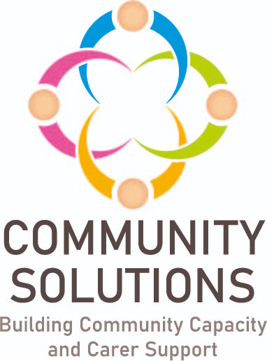

**Mental Health and Wellbeing Learning and Improvement Event – 30th May 2024**

**Event Feedback Report**

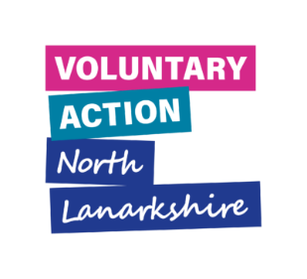



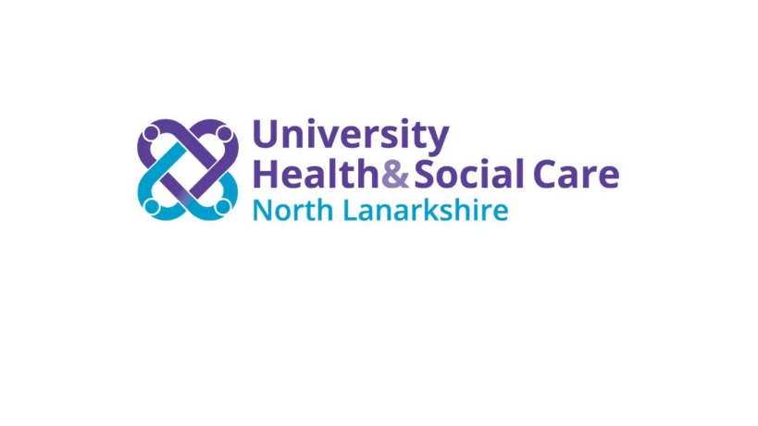

**Contents**

1. Introduction – Page 3

2. Event Feedback – Page 5

3. Next Steps – Page 7

1. Introduction

The purpose of this report is to summarise the findings from the Community Solutions Mental Health and Wellbeing Learning and Improvement Event, on May 30th 2024.

1.1 Background and Rationale

[**Community Solutions**](https://www.communitysolutionsnl.org.uk/) **is a successful, cross-sector health and social care investment and improvement programme for North Lanarkshire, established in 2012, the goal of which is to improve people’s health, wellbeing, quality of life and equality by investing in community-led initiatives which build community, family and individual strengths and resources, with a focus on prevention, early intervention and recovery.**

[Voluntary Action North Lanarkshire (VANL)](https://www.voluntaryactionnorthlanarkshire.org/) **hosts the Community Solutions Programme.**

1.1.1 Community Solutions Mental Health and Wellbeing Funding

**The Community Solutions Programme manages funding for two Mental Health and Wellbeing Funds – one for adults, and one for children, young people, and families:**

* **The** [**Community Mental Health and Wellbeing Fund (CMHWB)**](https://www.gov.scot/publications/communities-fund-list-funded-projectscommunities-mental-health-wellbeing-fund-adults-projects-awarded-funding-year-2-2022-2023/pages/1/) **is a national fund established by the Scottish Government in late 2021,** aimed at supporting ‘at risk’ groups in North Lanarkshire through community-based mental health and wellbeing support for adults provided by the community and voluntary sector (CVS)
* The [Children, Young People and Families (CYP) Mental Health and Wellbeing Fund](https://www.gov.scot/publications/children-and-young-peoples-mental-health-and-wellbeing-joint-delivery-board-information-bulletin-march-2022/) provides tailored support to children and young people in their local communities to improve mental health and wellbeing with reference to the national [‘SHANARRI’](https://www.gov.scot/policies/girfec/wellbeing-indicators-shanarri/) framework

### 1.1.2 Performance Management, Evaluation, Learning, and Improvement Framework

The Community Solutions Performance Management, Evaluation, Learning, and Improvement (PMELI) Framework sets out the Programme’s approach to PMELI, and provides support to projects funded through the Programme to set up their performance management and evaluation processes. A major review of the Framework was completed in 2022, to enhance how the impact of the Programme is measured and to better support learning and improvement for:

* each individual project
* the fund
* the Programme as a whole
* the CVS and wider Health and Social Care system

The new Framework also supports the new [Community Solutions Strategy and Investment Plan for 2022-25](https://www.communitysolutionsnl.org.uk/wp-content/uploads/Community-Solutions-Strategy-Document-Final_May23.pdf), and a number of new Funds managed through the Programme.

Using the new PMELI Framework, VANL collects standardised feedback from all funded projects and helps them to make the most of their findings for learning and improvement, which benefits the project, the programme and VANL themselves.

Following the new, more robust PMELI framework, there is now two years of evaluation for both Mental Health and Wellbeing funds.

## 1.2 Aims and Objectives

The purpose of the event was to:

* share the accumulated evidence from the two Community Solutions Mental Health and Wellbeing funds
* support wider discussion around learning and how this can support the case for continuing provision and wider improvements
* present this evidence and learning to inform the new Mental Health and Wellbeing Strategy for Lanarkshire: [‘Getting It Right For Every Person’ (GIRFEP)](https://www.nhslanarkshire.scot.nhs.uk/strategies/mental-health-wellbeing-2019-24/)

## 1.3 Participants

Participants were invited to attend from:

* CVS organisations with an interest in and/or are supporting mental health and wellbeing in North Lanarkshire
* Community Solutions funded projects, from both mental health and wellbeing Funds
* Public sector staff from NHS Lanarkshire and North Lanarkshire Council

36 people attended at the GLO Centre, Motherwell.

# 2. Event Feedback

## 2.1 How feedback was gathered

Feedback was gathered during small group discussions, facilitated by VANL staff. The discussions centred around the following questions:

* What key learning have you taken from the Funds so far?
* How can this learning support wider improvements to community-based mental health and wellbeing support? What improvements should be made?
* How can effective services be sustained?

## 2.2 Summary of key themes

Some key learning points from delivering the Community Mental Health and Wellbeing projects that were discussed at the Learning and Improvement Event include:

* **Increased awareness of funding opportunities**: Some participants are now more aware of funding available to them. For example, for some organisations this is the first time they have had external funding. This has helped them expand their programmes and make a bigger impact in their community, and made them more confident accessing funding in the future.
* **The value of talking directly to funders**: Some participants highlighted that direct communication with the funder was beneficial. For example, the support from funders to adapt their evaluation approaches to make sure they are appropriate was beneficial for the projects.
* **The value of partnership work**: These funds have allowed people within the sector to network with each other and develop supportive and collaborative connections.
* **Demonstrating impact**: Many participants spoke about the impact they have been able to make and demonstrate because of these funds. Examples that were mentioned during the event were: capacity building for BAME people, building young people’s resilience in schools, being able to provide nutritious free meals, and building young people’s sense of purpose and belonging through volunteering.

Participants identified some areas where there is an opportunity to make wider improvements to community-based mental health and wellbeing support, including:

* **Ideas for next phases of their projects such as:**
  + Addressing gaps around supports for prisoners and their families
  + Continuing to acknowledge cultural and language diversity in communities and expanding projects to create safe spaces and provide CBT in Arabic and French
  + Using feedback to try and reach harder to reach voices
  + Continuing work on SHANNARI and [the Promise](https://www.gov.scot/binaries/content/documents/govscot/publications/strategy-plan/2022/03/keeping-promise-implementation-plan/documents/keeping-promise-children-young-people-families/keeping-promise-children-young-people-families/govscot%3Adocument/keeping-promise-children-young-people-families.pdf)
  + Actioning feedback that has showed that integrating projects into the organisation’s day-to-day activities has allowed for support to be expanded to more service users outside of the project’s target beneficiaries

Participants spoke about the following topics as essential to sustain effective services:

* **Long term funding**: To allow time to establish more impactful relationships with service users, skill building for staff and volunteers, and to increase sustainability for organisations and their volunteers
* **Continuing partnership work**
* **Continuing evaluation and demonstration of impact**: Some participants discussed the possibility of demonstrating impact by highlighting the amount of money that projects are saving statutory services like the NHS through prevention and early intervention
* **Getting decision makers and statutory partners in the room**: Participants voiced their desire to be heard by decision makers and demonstrate to them the impact of the community and voluntary sector as a whole

# 3. Next Steps

Following this feedback, the next steps from this event are to:

* Continue to support and share learning and improvement through ongoing evaluation of the Community Solutions Programme and its funded projects to:
  + demonstrate the Programme’s impact to key partners and decision makers
  + make the case for longer term funding
* Support CVS organisations to identify gaps in provision in mental health and wellbeing services and access funding through Community Solutions or other sources, particularly around BAME groups, prisoners, and children and young people
* Facilitate more opportunities, like this event, for statutory partners, funders, and CVS organisations to come together
* Directing CVS organisations to the Community Solutions and VANL websites from funding information to increase awareness
* Present the feedback from this event to key partners to inform the new Mental Health Strategy for Lanarkshire