**1. Purpose**

The Locality Activity Fund(LAF) is a small grant fund to support local Community and Voluntary Sector (CVS) organisations in each of the six Community Solutions Locality Consortia (see Appendix One) to provide local services/activities which help residents from their localities improve their health and wellbeing and promote equality and inclusion. This can include services/activities which support health improvement; prevention; early intervention and recovery.

LAF-funded projects should:

* support achievement of one or more Community Solution outcomes (see Community Solutions Performance Management, Evaluation, Learning Improvement Framework here.)
* and meet one or more local priorities set out in the relevant Consortia’s Improving Lives Local Development Plan (LDP).

The LAF fund is intended to build the capacity of CVS organisations and should not be used to fund statutory or private sector organisations. Where there is no suitable CVS organisation to deliver a priority service or activity in the locality, Locality Consortia can fund a CVS organisation from outside their locality and/or consider other creative approaches. Further guidance on this issue can be provided by VANL’s Head of Community Solutions.

**2. Locality Activity Fund Allocation**

2.1 The LAF annual allocation for each Locality Consortium is agreed by the Community Solutions Governance Group by March/April each year for the financial year ahead.

2.2 The LAF allocation for each consortium will be published on the Community Solutions website and is also included in LAF reporting as below.

**3. Locality Host and Consortia Responsibilities**

3.1 Locality Hosts and Consortia members are responsible for promoting the fund locally, supporting the development of applications and making LAF decisions.

3.2 A consortium can agree to establish a LAF sub-group to consider LAF applications. Following discussion of applications can either be referred directly to the next consortium meeting or where necessary Locality Hosts can liaise with applicants to provide guidance on strengthening their application prior to submission to the consortium. However, LAF Sub-groups cannot refuse a LAF application – this can only be done at a quorate consortium meeting. Minutes of sub-group meetings must be taken; approved by the next sub-group meeting and shared with consortium members.

3.3 Locality Hosts must ensure that all consortia members receive LAF applications at least one week before the relevant consortium meeting.

3.4 Consortium members who have applied for LAF funding on behalf of their own organisation must declare a conflict of interest. Also, if a Consortium member’s organisation would benefit from a LAF application from another organisation, they must also declare this.

3.5 Consortia members make decisions on LAF applications by consensus where-ever possible or, if necessary, majority vote. The minutes of consortia meetings must include the following information:

* any declaration of conflict of interests
* notes of the presentation by applicants if provided
* a note of any questions and answers
* the decision to fund or not and whether this was by consensus or majority vote
* if the application has not been approved, the main reasons for this must also be recorded in the minutes
* that the applicant is not present for the decision.

(Approved Locality Consortia minutes will be published on the Community Solutions website in the relevant Locality section.)

3.6 Where a LAF application has been approved, Locality Hosts are responsible for liaising with VANL regarding payments and also supporting funded projects to submit agreed performance/evaluation reports to VANL.

3.7 Where a LAF application has not been agreed, the Locality Host must inform the applicant organisation in writing with the reasons why within three days of the decision. If appropriate, Locality Hosts can provide guidance on a revised or new application.

3.8 Locality Hosts will also support annual review of their LAF funding for the previous year with their consortia members before the end of March each year.

3.9 Consortia must endeavour to seek out applications and members from all areas within a locality to ensure a wide geographical spread in both membership and applications.

3.10Consortia should endeavour to only award applicants the amount they have requested. While a consortium has the right to part fund a project this should be only be used sparingly and as a last resort.

**4.GDPR Guidance**

4.1 VANL’s Community Solutions Programme deals with applications across a number of funds. Community Solutions staff, Locality Hosts and Consortia Members must acknowledge that all applications are the intellectual property of the applicant organisations.

4.2 As a result of 4.1 above, information relating to individual applications must only be accessed/shared with the applicant, Locality Host, Consortium Members and VANL Staff as appropriate.

4.3 An individual who is on a consortium mailing list for information but has not completed a consortium membership form should not gain access to any applications submitted to the consortium, failure to comply with this guidance should be reported immediately to [gordon.watson@vanl.co.uk](mailto:gordon.watson@vanl.co.uk)

4.4 The only exception to 4.3 should be if the individual gains consent to access applications from both the relevant locality host and Gordon Watson- Head of Community Solutions.

**5. VANL Responsibilities**

5.1 VANL holds LAF funding on behalf of the programme and processes LAF payments to successful LAF applicants as advised by Locality Hosts.

5.2 Locality hosts must submit approved LAF applications to [marta.Szczepanska@VANL.CO.UK](mailto:marta.Szczepanska@VANL.CO.UK) along with draft consortia minutes of the relevant meeting. The approved LAF applications must be signed by three consortia members - one CVS member (but not the applicant); one from North Lanarkshire Council and one from NHS Lanarkshire.

5.3 Once VANL receives approved LAF applications it will issue a letter to the successful applicant confirming the purpose of the award; setting out the conditions of award including the need for a Governance Review and clarifying the payment arrangements.

5.4 The funded organisation is required to return an award letter to VANL and submit an invoice for payment through bank transfer.

5.5 To ensure appropriate due diligence and support organisational improvements, VANL staff will undertake Governance Reviews of LAF funded projects as appropriate. VANL staff will also provide guidance and support on any improvement issues identified as a result of this review. Guidance on Governance Reviews will be shared with Locality Hosts and funded projects and also published on the Community Solutions website.

5.6 VANL staff also analyse LAF performance and evaluation information provided by LAF-funded projects and share this as follows:

* an NL-wide overview summary in the annual Community Solutions Reports, published in autumn each year
* an annual LAF Learning and Impact Report which provides the NL-wide overview summary plus a summary for each locality (commencing winter 2025/26 for funded projects for 2024-25.)

5.7 VANL will convene an annual LAF Learning and Improvement event in Feb. each year with Locality Hosts to support review, learning and improvement for LAF funded projects and other stakeholders.

**Appendix One: Community Solutions Locality Consortia and Hosts**

|  |  |  |
| --- | --- | --- |
| **Locality** | **Host Organisation** | **Host Contact and email** |
| Airdrie | Diamonds in the Community | Alison Weir-  [alison.weir@diamondsitc.com](mailto:alison.weir@diamondsitc.com) |
| Bellshill | Orbiston Neighbourhood Centre | George Hutchison-  [george@oncbellshill.org](mailto:george@oncbellshill.org) |
| Coatbridge | Glenboig Development Trust | Paula Robertson  [paula.r@glenboigdt.org](mailto:paula.r@glenboigdt.org%20com) |
| Motherwell | The Health and Wellness Hub | Collette Donald-  [collette.donald@thehealthandwellnesshub.org.uk](mailto:collette.donald@thehealthandwellnesshub.org.uk) |
| The North | Cornerstone House | Mary McNeil-  [locality.host@cornerstone-house.org.uk](mailto:locality.host@cornerstone-house.org.uk) |
| Wishaw & Shotts | Getting Better Together | Mark Slorance-  [mark@shottshealthyliving.com](mailto:mark@shottshealthyliving.com) |

**APPENDIX 2 – Community Solutions Local Activity Fund Process – Summary Diagram**

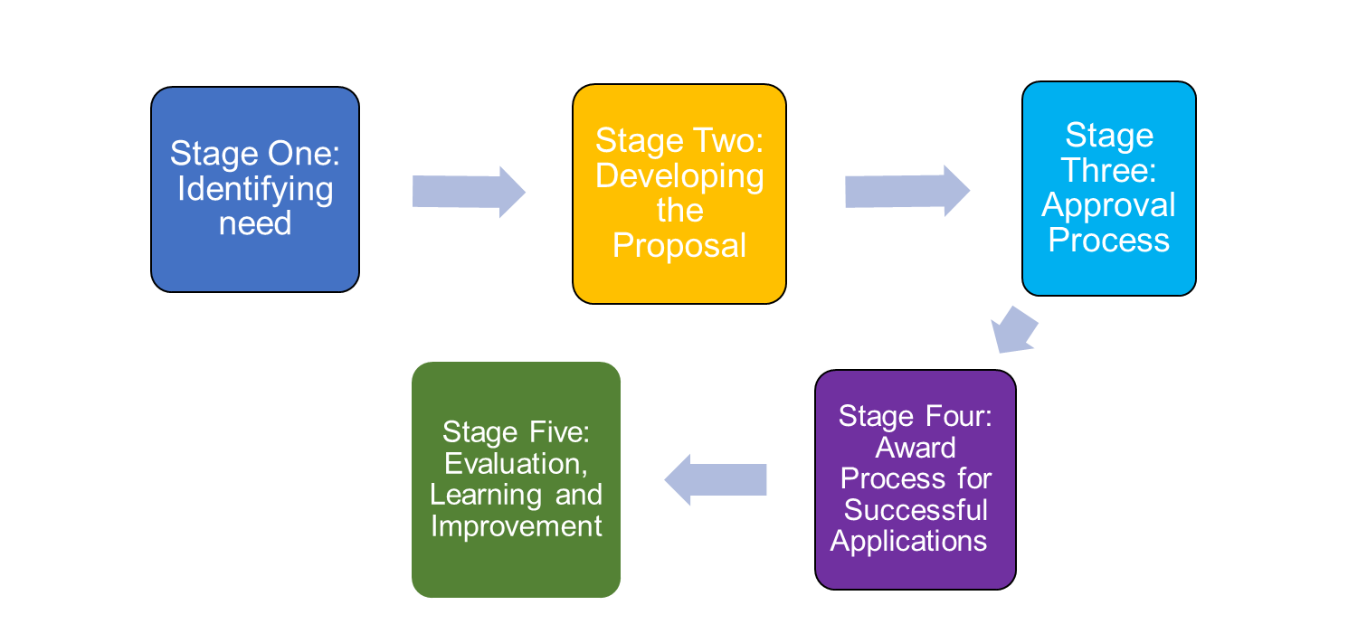

(document ends)