**1. Purpose**

The Improving Lives Initiative Locality Activity Fund(LAF) is a small grant fund to support local Community and Voluntary Sector (CVS) organisations in each of the six Community Solutions Locality Consortia (see Appendix One) to provide local services/activities which help residents improve their health and wellbeing and promote equality and inclusion. This can include services/activities which support health improvement; prevention; early intervention and recovery.

LAF-funded projects should:

* support achievement of one or more Community Solution outcomes (see Community Solutions Performance Management, Evaluation, Learning Improvement Framework here.)
* and meet one or more local priorities set out in the relevant Consortia’s Improving Lives Local Development Plan (LDP). Updated guidance on developing LDPs will be provide by February 2024 and published on the new Community Solutions website along with the agreed LDPs for each consortia)

The LAF fund is intended to build the capacity of CVS organisations and should not be used to fund statutory or private sector organisations. Where there is no suitable CVS organisation to deliver a priority service or activity in the locality, Locality Consortia can fund a CVS organisation from outside their locality and/or consider other creative approaches. Further guidance on this issue can be provided by VANL’s Senior Manager, Community Solutions.

**2. Locality Activity Fund Allocation**

2.1 The LAF annual allocation for each Locality Consortia is agreed by the Community Solutions Governance Group by Feb/March each year for the financial year ahead. VANL advises Consortia of their allocation by March.

2.2 The LAF allocation for each consortia will be published on the Community Solutions website and is also included in LAF reporting as below.

**3. Locality Host and Consortia Responsibilities**

3.1 Locality Hosts and Consortia members are responsible for promoting the fund locally, supporting the development of applications and making LAF decisions.

3.2 A consortia can agree to establish a LAF sub-group to consider LAF applications. Following discussion of applications can either be referred directly to the next Consortia meeting or where necessary Locality Hosts can liaise with applicants to provide guidance on strengthening their application prior to submission to the Consortia. However, LAF Sub-groups cannot refuse a LAF application – this can only be done by quorate consortia meeting. Minutes of sub-group meetings must be taken; approved by the next sub-group meeting and shared with consortia members.

3.3 Locality Hosts must ensure that all consortia members receive LAF applications at least one week before the relevant consortia meeting.

3.4 Consortia members which have applied to the LAF must declare a conflict of interest. Also if a consortia member may benefit from a LAF application from another organisation, they must also declare this.

3.5 Consortia members make decisions on LAF applications by consensus where-ever possible or, if necessary, majority vote. The minute of consortia meetings must include the following information:

* any declaration of conflict of interests
* notes of the presentation by applicants if provided
* a note of any questions and answers
* the decision to fund or not and whether this was by consensus or majority vote
* if the application has not been approved, the main reasons for this must also be recorded in the minutes
* that the applicant is not present for the decision.

(Approved Locality Consortia minutes will be published on the Community Solutions website in the relevant Locality section.)

3.6 Where a LAF application has been approved, Locality Hosts are responsible for liaising with VANL regarding payments and also supporting funded projects to submit agreed performance/evaluation reports to VANL.

3.7 Where a LAF application has not been agreed, the Locality Host must inform the applicant organisation in writing with the reasons why within three days of the decision. If appropriate, Locality Hosts can provide guidance on a revised or new application.

3.8 Locality Hosts will also support annual review of their LAF funding for the previous year with their consortia members before the end of March each year (commencing 2024).

**4. Applicants**

4.1 Any CVS organisation – including members of the consortia and Locality Hosts - can apply to LAF.

4.2 Applicants must use the Community Solutions LAF application form, which is available on the Community Solutions website.

4.3 Prospective applicants can seek guidance from their Locality Host.

4.4 If an applicant does not have a bank account, the grant can be held by the Locality Host on behalf of the applicant and the Locality Host can make payments for legitimate expenditure as requested by the funded project supported by appropriate documentation.

* 1. Applicants are invited to present their application to consortia members and answer questions. However, applicants cannot be part of the approval process to avoid any real or perceived conflict of interests.  For the avoidance of doubt, applicants must leave the room when the award decision is being made.

4.6 Where a LAF application is from Locality Host or CVS member organisation, they must declare a conflict of interest.

4.7 A consortium may collectively apply for a LAF to support a local development/ initiative. This application must be submitted by the Locality Host and discussed and agreed at a quorate consortia meeting.

**5. VANL Responsibilities**

5.1 VANL holds LAF funding on behalf of the programme and processes LAF payments to successful LAF applicants as advised by Locality Hosts.

5.2 Locality hosts must submit approved LAF applications to [LAF@vanl.co.uk](mailto:LAF@vanl.co.uk) along with draft consortia minutes of the relevant meeting. The approved LAF applications must be signed by three consortia members - one CVS member (but not the applicant); one from North Lanarkshire Council and one from NHS Lanarkshire.

5.3 Once VANL receives approved LAF applications it does the following.

* Issues the successful applicant an Award Letter which confirms the purpose of the award; sets out conditions of the award; and clarifies payment arrangements.

5.4 The funded organisation is required to return an acceptance form to VANL and submit an invoice for payment through bank transfer.

5.5 To ensure appropriate due diligence and support organisational improvements, VANL staff will undertake Organisational Reviews of LAF funded projects as appropriate. VANL staff will also provide guidance and support on any improvement issues identified as a result of this review. Guidance on Organisational Reviews will be shared with Locality Hosts and funded projects and also published on the forthcoming Community Solutions website.

5.6 VANL staff also analyse LAF performance and evaluation information provided by LAF-funded projects and share this as follows:

* an NL-wide overview summary in the annual Community Solutions Reports, published in autumn each year
* an annual LAF Learning and Impact Report which provides the NL-wide overview summary plus a summary for each locality (commencing winter 2023/24 for funded projects for 2022-23.)

5.7 VANL will convene an annual LAF Learning and Improvement event in Feb. each year (commencing 2024) with Locality Hosts to support review, learning and improvement for LAF funded projects and other stakeholders.

**Appendix One: Community Solutions Locality Consortia and Hosts**

|  |  |  |
| --- | --- | --- |
| **Locality** | **Host Organisation** | **Host Contact and email** |
| Airdrie | Diamonds in the Community | Alison Weir-  [alison.weir@diamondsitc.com](mailto:alison.weir@diamondsitc.com) |
| Bellshill | Orbiston Neighbourhood Centre | Haley Fitzpatrick-  [hayley@oncbellshill.org](mailto:hayley@oncbellshill.org) |
| Coatbridge | Glenboig Development Trust | Christine McNally-  [christine@glenboignh.com](mailto:christine@glenboignh.com) |
| Motherwell | The Health and Wellness Hub | Collette Donald-  [collette.donald@thehealthandwellnesshub.org.uk](mailto:collette.donald@thehealthandwellnesshub.org.uk) |
| The North | Cornerstone House | Mary McNeil-  [locality.host@cornerstone-house.org.uk](mailto:locality.host@cornerstone-house.org.uk) |
| Wishaw & Shotts | Getting Better Together | Mark Slorance-  [mark@shottshealthyliving.com](mailto:mark@shottshealthyliving.com) |

**APPENDIX 2 – Community Solutions Local Activity Fund Process – Summary Diagram**

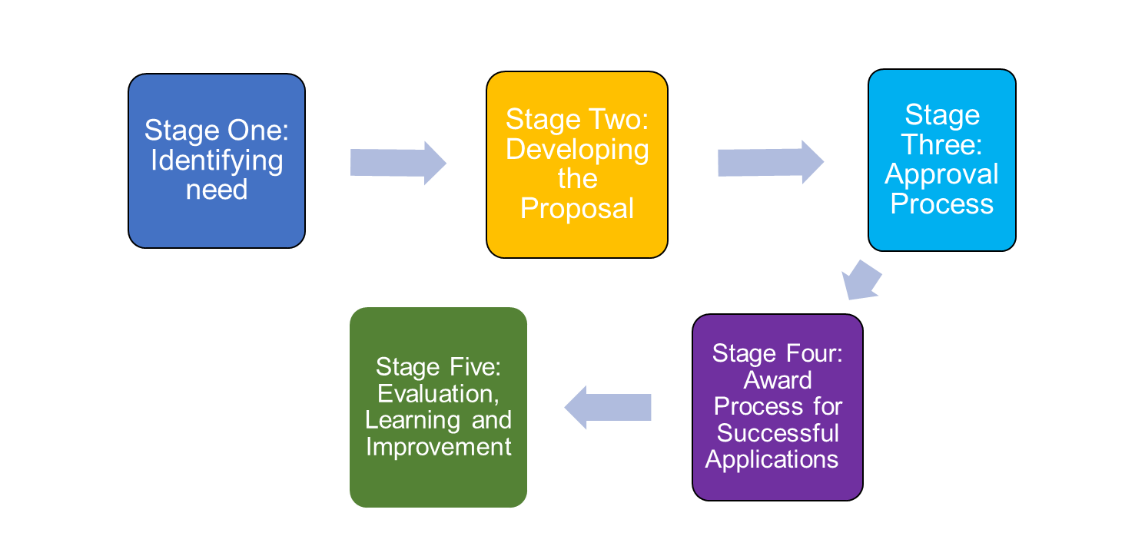

(document ends)