1. Purpose
The Locality Activity Fund (LAF) is a small grant fund established to support local Community and Voluntary Sector (CVS) organisations in each of the six Community Solutions Locality Consortia to provide local services/activities which help residents from their localities improve their health and wellbeing and promote equality and inclusion. This can include services/activities which support health improvement; prevention; early intervention and recovery.

LAF-funded projects should:
- support achievement of one or more Community Solution outcomes (Appendix 3)

- meet one or more local priorities set out in the relevant Consortia’s Local Development Plan (LDP).

The LAF fund is intended to build the capacity of CVS organisations and should not be used to fund statutory or private sector organisations. Where there is no suitable CVS organisation to deliver a priority service or activity in the locality, Locality Consortia can fund a CVS organisation from outside their locality and/or consider other creative approaches. Further guidance on this issue can be provided by VANL’s Head of Community Solutions.

2. Locality Activity Fund Allocation
2.1 The LAF annual allocation for each Locality Consortium is agreed by the Community Solutions Governance Group by March/April each year for the financial year ahead.

2.2 The LAF allocation for each consortium will be published on the Community Solutions website and is also included in LAF reporting as below.

2.3 The LAF budget for the year is made up of the initial funding from UHSCNL, the underspend from 25/26 and the additional funds made available from the introduction of the new model. This is then divided among localities based on the below formula using figures from UHSCNL Locality profiles

Total Funding x ((Population weight (50%) x population share) + (Deprivation weight (50%) x deprivation share))

3. Consortium Leads and Consortia Responsibilities

3.1 VANL Consortium Leads and Consortia members are responsible for promoting the fund locally, supporting the development of applications and making LAF decisions.

3.2 VANL Consortium Admin team support will ensure that all consortia members receive LAF applications at least 6 working days before the relevant consortium meeting.

3.3 Consortium members who have applied for LAF funding on behalf of their own organisation must declare a conflict of interest. Also, if a Consortium member’s organisation would benefit from a LAF application from another organisation, they must also declare this.

3.4 Consortia members make decisions on LAF applications by consensus where-ever possible or, if necessary, majority vote. The minutes of consortia meetings must include the following information:
- any declaration of conflict of interests
- notes of the presentation by applicants if provided
- a note of any questions and answers
- the decision to fund or not and whether this was by consensus or majority vote
- if the application has not been approved, the main reasons for this must also be recorded in the minutes
- that the applicant is not present for the decision.

Where a decision is split 50/50 between consortia members, all individual who are not in favour should provide follow up questions to the consortium lead which will be directed to applicant in the hopes of reaching a consensus. If a consensus is not reached at this point and no individuals who previously would have approved the application have changed their mind, the application should be approved.

(Approved Locality Consortia minutes will be published on the Community Solutions website in the relevant Locality section.)

3.5 Where a LAF application has been approved, the VANL Consortium Administration Support is responsible for liaising with VANL regarding payments and also supporting funded projects to submit agreed performance/evaluation reports to VANL.

3.6 Where a LAF application has not been approved, the VANL Consortium Lead must inform the applicant organisation in writing with the reasons why within five days of the decision. If appropriate, VANL Consortium Leads can provide guidance on a revised or new application.

3.7 Consortia must endeavour to seek out applications and members from all areas within a locality to ensure a wide geographical spread in both membership and applications.

3.8 Consortia should endeavour to only award applicants the amount they have requested. While a consortium has the right to part fund a project this should be only be used in exceptional circumstances and as a last resort.

4. Monitor and Conduct

VANL will be taking a consistent approach across all of its funds in line with national guidance for the community mental health and wellbeing fund towards inappropriate conduct. Should inappropriate behaviour be shown towards VANL Staff or other consortia members, the applicant/unsuccessful organisation/consortia member will be disqualified from accessing the LAF fund and be asked to leave the consortia meeting. Likewise, if this is an instance relating to a member of the consortium, membership will be revoked from the individual. In more extreme circumstances they may also be disqualified from applying for all Community Solutions funds released during the next financial year. Behaviours towards any of the previously mentioned individuals included as a part of this would include:

- Swearing
- Sarcastic comments
- Criticism of the process in direct response to being turned down for funding (VANL would still welcome feedback on our processes but this should be done in a positive and solutions-focused manner)
- Raised voices or generally angry behaviour
- Inappropriate communications aimed at VANL staff or Consortium members, whether that be in person, over the phone or by email.
- Bullying
- Harassment (both general and sexual)
- Violence or threats of violence
- Threatening behaviour such as gestures, body language or words intending to intimidate or cause harm
- Inappropriate or unwanted physical contact
- Discrimination- racist, sexist, homophobic, transphobic, ableist, ageist or otherwise discriminatory comments or behaviour
- Malicious allegations - knowingly making false or unfounded complaints against staff
- Damage to property - deliberate damage to facilities, staff belongings, or organisational property.

5. GDPR Guidance

5.1 VANL’s Community Solutions Programme deals with applications across a number of funds. Community Solutions staff and Consortia Members must acknowledge that all applications are the intellectual property of the applicant organisations.

5.2 As a result of 4.1 above, information relating to individual applications must only be accessed/shared with the applicant, Consortium Members and VANL Staff as appropriate.

5.3 An individual who is on a consortium mailing list for information but has not completed a consortium membership form should not gain access to any applications submitted to the consortium, failure to comply with this guidance should be reported immediately to gordon.watson@vanl.co.uk

5.4 The only exception to 4.3 should be if the individual gains consent to access applications from Gordon Watson- Head of Community Solutions.

6. VANL Responsibilities

5.1 VANL holds LAF funding on behalf of the programme and processes LAF payments to successful LAF applicants as advised by VANL Consortium Leads

5.2 Approved LAF applications must be signed by three consortia members - one CVS member (but not the applicant); a representative from North Lanarkshire Council and a representative from NHS Lanarkshire.

5.3 Once VANL receives approved LAF applications it will issue a letter to the successful applicant confirming the purpose of the award; setting out the conditions of award including clarifying the payment arrangements.

5.4 The funded organisation is required to return an award letter to VANL and submit an invoice for payment through bank transfer.

5.5 VANL staff also analyse LAF performance and evaluation information provided by LAF-funded projects and share this as follows:
- an NL-wide overview summary in the annual Community Solutions Reports, published in autumn each year

- an annual LAF Learning and Impact Report which provides the NL-wide overview summary plus a summary for each locality (commencing winter 2026/27 for funded projects for 2025-26.)

5.6 VANL will on an occasional basis visit LAF projects to gain an enhanced understanding of the project and the difference that LAF has made.

Appendix One: Community Solutions Locality Consortia and Hosts
Locality | Consortium Lead and Contact | Development Plan for the Locality
Airdrie | Maureen O’Neill Craig  Maureen.oneillcraig@vanl.co.uk | Airdrie
Coatbridge | Maureen O’Neill Craig  Maureen.oneillcraig@vanl.co.uk | Coatbridge
The North | Maureen O’Neill Craig  Maureen.oneillcraig@vanl.co.uk | The North
Bellshill | Nick Brown  Nick.brown@vanl.co.uk | Bellshill
Motherwell | Nick Brown  Nick.brown@vanl.co.uk | Motherwell
Wishaw & Shotts | Nick Brown  Nick.brown@vanl.co.uk | Wishaw & Shotts

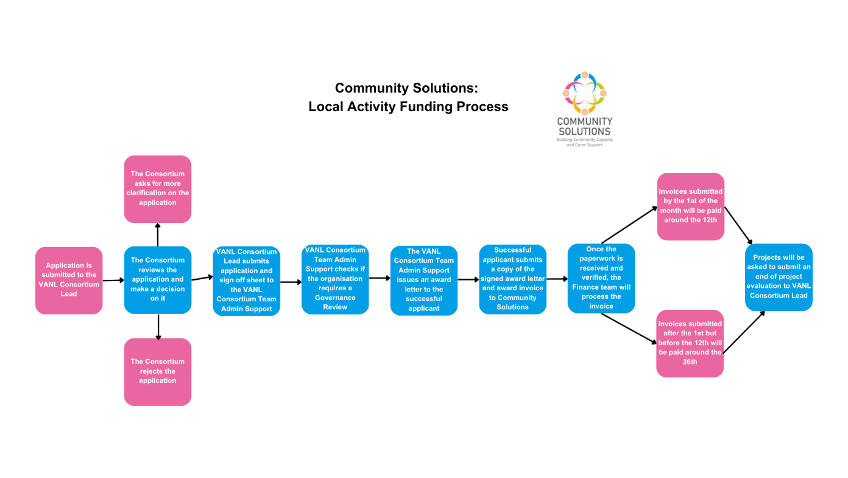
Appendix Two – Community Solutions Local Activity Fund Process Summary Diagram
Appendix Three- Community Solutions Programme Outcomes

Group | No. | Outcome
Adults | 1 | People feel more connected, included and safe
Adults | 2 | Improved health and wellbeing
Adults | 3 | People feel more informed and aware
Carers | 4 | Carers feel more informed and aware
Carers | 5 | Carers health and wellbeing are improved
Carers | 6 | Carers are more able to have a life outside of caring
Children, Young People & Families | 7 | Health and wellbeing improved
Children, Young People & Families | 8 | Family relationships are strengthened
Children, Young People & Families | 9 | Children, young people and families become more resilient

(document ends)

