1. Purpose
The Locality Activity Fund (LAF) is a small grant established to fund to support local Community and Voluntary Sector (CVS) organisations in each of the six Community Solutions Locality Consortia to provide local services/activities which help residents from their localities improve their health and wellbeing and promote equality and inclusion. This can include services/activities which support health improvement; prevention; early intervention and recovery.

LAF-funded projects should:
- support achievement of one or more Community Solution outcomes (Appendix 3)

- meet one or more local priorities set out in the relevant Consortia’s Local Development Plan (LDP).

The LAF fund is intended to build the capacity of CVS organisations and should not be used to fund statutory or private sector organisations. Where there is no suitable CVS organisation to deliver a priority service or activity in the locality, Locality Consortia can fund a CVS organisation from outside their locality and/or consider other creative approaches. Further guidance on this issue can be provided by VANL’s Head of Community Solutions.

2. Locality Activity Fund Allocation
2.1 The LAF annual allocation for each Locality Consortium is agreed by the Community Solutions Governance Group by March/April each year for the financial year ahead.

2.2 The LAF allocation for each consortium will be published on the Community Solutions website and is also included in LAF reporting as below.

2.3 The LAF budget for the year is made up of the initial funding from UHSCNL, the underspend from 25/26 and and the additional funds made available from the introduction of the new model. This is then divided among localities based on the below formula using figures from UHSCNL Locality profiles

Total Funding x ((Population weight (50%) x population share) + (Deprivation weight (50%) x deprivation share))

3. Applicants

3.1 Any CVS organisation – including members of the consortia- can apply to LAF.

3.2 Unconstituted groups can apply to LAF once and must nominate a constituted group to hold the funding on their behalf. Once constituted, another application can be made.

3.3 Applicants must use the Community Solutions LAF application form, which is available on the Community Solutions website.

3.4 Prospective applicants should seek guidance from their VANL Consortium Lead.

3.5 Applicants are encouraged to present their application to consortia members and answer questions- please note, not attending the consortium meeting your application is discussed at could delay a decision being reached by the consortium. Applicants cannot be part of the approval process to avoid any real or perceived conflict of interests. For the avoidance of doubt, applicants must leave the meeting when the award decision is being made.

3.6 Where a LAF application is from a CVS consortium member organisation, they must declare a conflict of interest.

3.7 A consortium may collectively apply for a LAF application to support a local development/ initiative.

3.8 Applicants can apply for a maximum of £5,000 per application. Unconstituted groups can apply for a maximum of £1,000 and can only apply once unless the group becomes constituted. Please note applications must show adequate need for the funding applied for and this should be equal to the amount being applied for e.g. the higher the amount requested the more detail would be expected. In order to ensure an equitable spread of funding awards, it is anticipated that only a few awards of the maximum will be made each year

3.9 Applications must link to the priorities of the localities development plan and the relevant Locality Outcome Improvement Plan (LOIP) priority. Development plans can be accessed through the Community Solutions Website (Appendix 1)

3.10 Applications should demonstrate sustainability beyond their requested LAF funding and also ensure if the project is a one-off event or trip, it must clearly demonstrate links into the wider operational or strategic goals of the organisation applying

3.11 Organisations can apply for the following:
- Volunteer costs such as training or volunteer refreshments e.g. tea and/coffee
- Equipment and resources to be used within the applications activity
- Expenses for staff or volunteers delivering the activity
- Overhead costs for the project such as rent and a proportion of the management cost to support delivery of the project and to support evaluation.
- Accessibility costs for you costs such as accessibility equipment or interpreters

3.12 Organisations can apply for staffing costs however the staff time applied for must only be used for the applied for project. Examples of this include
- Sessional staff
- Part time staff
- Identified hours of an existing member of staff
The applicant must clearly outline what form the staffing attached to their project will take.

  - Organisations cannot apply for funding to support their core running costs. Core running costs in this context meaning any work the applicant’s organisation consistently delivers as a part of its day-to-day operations. LAF funding should only be used for new or test of change projects out with the pre-existing work of the applicant organisation.

  - Under University Health and Social Care North Lanarkshire (UHSC-NL) Guidelines, organisations cannot apply for funding for clinical intervention supports such as one-to-one counselling, however complimentary and holistic psychological supports such as peer support, group facilitation, educational and early intervention and prevention programmes and community outreach programs can be applied for. Should further guidance be required on this please contact gordon.watson@vanl.co.uk

3.15 Under University Health and Social Care North Lanarkshire (UHSC-NL) Guidelines, organisations cannot apply for funding for food provision such as food parcels or meals, however, can apply for project related refreshments such as teas and coffees. Should further guidance be required on this please contact gordon.watson@vanl.co.uk

3.16 Organisations seeking funding from two localities must submit separate applications to the VANL Consortia Lead for each corresponding locality they are applying to. Applicants looking to deliver in more than two consortia should apply for the Community Solutions Thematic Fund North Lanarkshire Wide Strand.

3.17 Organisations can only apply for LAF funding if their annual income is below £1 Million unless they can clearly demonstrate that the identified need cannot be met by an organisation with a smaller income.

3.18 Applicants can submit applications to multiple localities however they must:
- Inform the relevant VANL Consortium Leads if the application can operate with funding from some of the consortia they are applying to or if one unsuccessful vote would make all applications attached unsuccessful
- Ensure that each application submitted is tailored to the locality it is being submitted to

4. Monitor and Conduct

VANL will be taking a consistent approach across all of its funds in line with national guidance for the community mental health and wellbeing fund towards inappropriate conduct. Should inappropriate behaviour be shown towards VANL Staff or other consortia members, the applicant/unsuccessful organisation/consortia member will be disqualified from accessing the LAF fund and be asked to leave the consortia meeting. Likewise, if this is an instance relating to a member of the consortium, membership will be revoked from the individual. In more extreme circumstances they may also be disqualified from applying for all Community Solutions funds released during the next financial year. Behaviours towards any of the previously mentioned individuals included as a part of this would include:

- Swearing
- Sarcastic comments
- Criticism of the process in direct response to being turned down for funding (VANL would still welcome feedback on our processes but this should be done in a positive and solutions-focused manner)
- Raised voices or generally angry behaviour
- Inappropriate communications aimed at VANL staff or Consortium members, whether that be in person, over the phone or by email.
- Bullying
- Harassment (both general and sexual)
- Violence or threats of violence
- Threatening behaviour such as gestures, body language or words intending to intimidate or cause harm
- Inappropriate or unwanted physical contact
- Discrimination- racist, sexist, homophobic, transphobic, ableist, ageist or otherwise discriminatory comments or behaviour
- Malicious allegations - knowingly making false or unfounded complaints against staff
- Damage to property - deliberate damage to facilities, staff belongings, or organisational property.

5. VANL Responsibilities

5.1 VANL holds LAF funding on behalf of the programme and processes LAF payments to successful LAF applicants as advised by consortium lead.

5.2 Approved LAF applications must be signed by three consortia members - one CVS member (but not the applicant); one from North Lanarkshire Council and one from NHS Lanarkshire.

5.3 Once VANL receives approved LAF applications it does the following.
- Issues the successful applicant an Award Letter which confirms the purpose of the award; sets out conditions of the award including payment arrangements.
5.4 The funded organisation is required to return an award letter to VANL and submit an invoice for payment through bank transfer. Where an applicant is an unconstituted group, they must partner with a constituted group who will raise an invoice with VANL to hold the funds on their behalf.

5.5 VANL staff also analyse LAF performance and evaluation information provided by LAF-funded projects and share this as follows:
- an NL-wide overview summary in the annual Community Solutions Reports, published in autumn each year

- an annual LAF Learning and Impact Report which provides the NL-wide overview summary plus a summary for each locality

6. GDPR Guidance

6.1 Community Solutions programme handles applications across multiple funds and VANL staff acknowledge these applications are the intellectual property of the applicant, this extends to consortium members

6.2 Access to applications as a result will only be accessed/shared with the applicant, members of the consortium the applicant is submitted within and relevant VANL staff.

Appendix One: Community Solutions Locality Consortium Leads
Locality | Consortium Lead and Contact | Development Plan for the Locality
Airdrie | Maureen O’Neill Craig  Maureen.oneillcraig@vanl.co.uk | Airdrie
Coatbridge | Maureen O’Neill Craig  Maureen.oneillcraig@vanl.co.uk | Coatbridge
The North | Maureen O’Neill Craig  Maureen.oneillcraig@vanl.co.uk | The North
Bellshill | Nick Brown  Nick.brown@vanl.co.uk | Bellshill
Motherwell | Nick Brown  Nick.brown@vanl.co.uk | Motherwell
Wishaw & Shotts | Nick Brown  Nick.brown@vanl.co.uk | Wishaw & Shotts

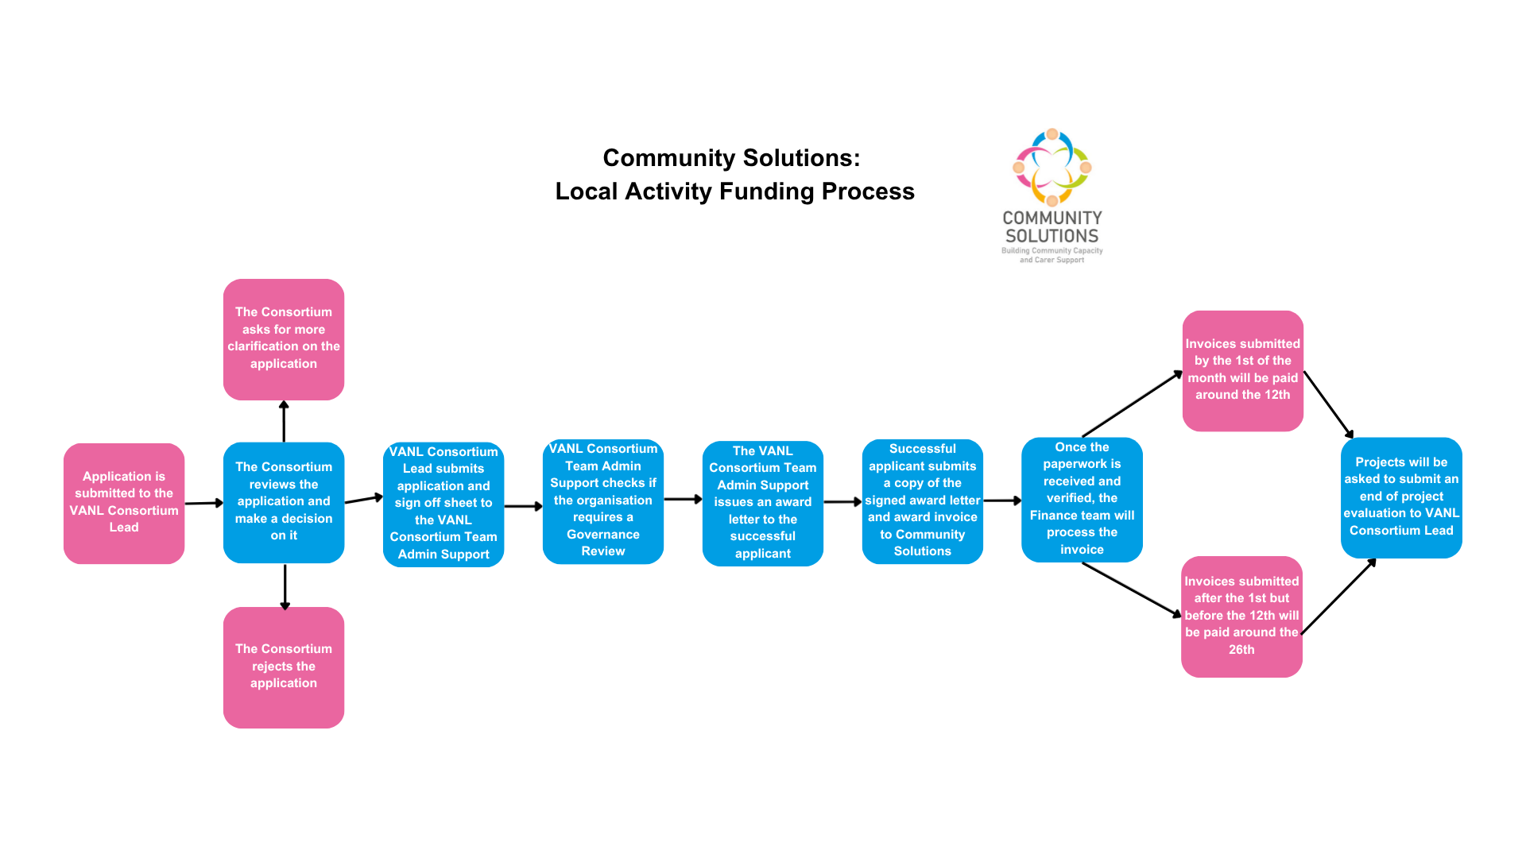
Appendix Two – Community Solutions Local Activity Fund Process Summary Diagram

Appendix Three- Community Solutions Programme Outcomes

Group | No. | Outcome
Adults | 1 | People feel more connected, included and safe
Adults | 2 | Improved health and wellbeing
Adults | 3 | People feel more informed and aware
Carers | 4 | Carers feel more informed and aware
Carers | 5 | Carers health and wellbeing are improved
Carers | 6 | Carers are more able to have a life outside of caring
Children, Young People & Families | 7 | Heal and wellbeing improved
Children, Young People & Families | 8 | Family relationships are strengthened
Children, Young People & Families | 9 | Children, young people and families become more resilient

(document ends)

