**1. Purpose**

The Locality Activity Fund(LAF) is a small grant fund to support local Community and Voluntary Sector (CVS) organisations in each of the six Community Solutions Locality Consortia (see Appendix One) to provide local services/activities which help residents from their localities improve their health and wellbeing and promote equality and inclusion. This can include services/activities which support health improvement; prevention; early intervention and recovery.

LAF-funded projects should:

* support achievement of one or more Community Solution outcomes (see Community Solutions Performance Management, Evaluation, Learning Improvement Framework [here](https://www.communitysolutionsnl.org.uk/pmeli-framework/).)
* and meet one or more local priorities set out in the relevant Consortia’s Local Development Plan (LDP).

The LAF fund is intended to build the capacity of CVS organisations and should not be used to fund statutory or private sector organisations. Where there is no suitable CVS organisation to deliver a priority service or activity in the locality, Locality Consortia can fund a CVS organisation from outside their locality and/or consider other creative approaches. Further guidance on this issue can be provided by VANL’s Head of Community Solutions.

**2. Locality Activity Fund Allocation**

2.1 The LAF annual allocation for each Locality Consortia is agreed by the Community Solutions Governance Group by March/April each year for the financial year ahead.

2.2 The LAF allocation for each consortium will be published on the Community Solutions website and is also included in LAF reporting as below.

**3. Applicants**

3.1 Any CVS organisation – including members of the consortia and Locality Hosts - can apply to LAF.

3.2 Applicants must use the Community Solutions LAF application form, which is available on the [Community Solutions website.](https://www.communitysolutionsnl.org.uk/local-activity-fund/)

3.3 Prospective applicants can seek guidance from their Locality Host.

3.4 If an applicant does not have a bank account, the grant can be held by the Locality Host on behalf of the applicant and the Locality Host can make payments for legitimate expenditure as requested by the funded project supported by appropriate documentation.

3.5 Applicants are invited to present their application to consortia members and answer questions. However, applicants cannot be part of the approval process to avoid any real or perceived conflict of interests.  For the avoidance of doubt, applicants must leave the room when the award decision is being made.

3.6 Where a LAF application is from Locality Host or CVS member organisation, they must declare a conflict of interest.

3.7 A consortium may collectively apply for a LAF to support a local development/ initiative. This application must be submitted by the Locality Host and discussed and agreed at a quorate consortia meeting.

* 1. Applicants can apply for a maximum of **£3,000** per application.

3.9 Applications must link to the priorities of the localities development plan and the relevant Locality Outcome Improvement Plan (LOIP) priority. Development plans and LOIP priorities can be accessed through each of the corresponding locality hosts

3.10 Applications should demonstrate sustainability beyond their requested LAF funding and also ensure if the project is a one off event or trip it must clearly demonstrate links into the wider strategic goals of the organisation applying

3.11 Organisations can apply for the following:

* Volunteer costs such as training or volunteer food provisions
* Equipment and resources to be used within the applications activity
* Expenses for staff or volunteers delivering the activity
* Overhead costs for the project such as rent and a proportion of the management cost to support delivery of the project and to support evaluation.

3.12 Organisations can apply for staffing costs however the staff time applied must only be used for the applied for project. Examples of this include

* Sessional staff
* Part time staff
* Identified hours of an existing member of staff

The applicant must clearly outline what form the staffing attached to their project will take.

* 1. Organisations cannot apply for funding to support the core running costs. Core running costs in this context meaning any work the applicant’s organisation consistently delivers as a part of its day to day operations. LAF funding should only be used for test of change projects out with the pre-existing work of the applicant organisation.
  2. Under University Health and Social Care North Lanarkshire (UHSC-NL) Guidelines, organisations cannot apply for funding for clinical intervention supports such as one to one counselling, however complimentary and holistic psychological supports such as peer support, group facilitation, educational and early intervention and prevention programmes and community outreach programs can be applied for. Should further guidance be required on this please contact gordon.watson@vanl.co.uk
  3. Organisations seeking funding from two localities must submit separate applications to the locality host for each corresponding locality they are applying to. Applicants looking to deliver in more than two applicants should apply for the [Community Solutions Thematic Fund](https://www.communitysolutionsnl.org.uk/community-solutions-thematic-fund/) North Lanarkshire Wide Strand.
  4. Organisations can only apply for LAF funding if their annual income is below £1 Million unless the need cannot be met by an organisation with a smaller income.

**4. VANL Responsibilities**

4.1 VANL holds LAF funding on behalf of the programme and processes LAF payments to successful LAF applicants as advised by Locality Hosts.

4.2 Locality hosts must submit approved LAF applications to [marta.Szczepanska@VANL.CO.UK](mailto:marta.Szczepanska@VANL.CO.UK) along with draft consortia minutes of the relevant meeting. The approved LAF applications must be signed by three consortia members - one CVS member (but not the applicant); one from North Lanarkshire Council and one from NHS Lanarkshire.

4.3 Once VANL receives approved LAF applications it does the following.

* Issues the successful applicant an Award Letter which confirms the purpose of the award; sets out conditions of the award including the scheduling of a Governance Review (see 4.5); and clarifies payment arrangements.

4.4 The funded organisation is required to return an award letter to VANL and submit an invoice for payment through bank transfer.

4.5 To ensure appropriate due diligence and support organisational improvements, VANL staff will undertake Governance Reviews of LAF funded projects as appropriate. VANL staff will also provide guidance and support on any improvement issues identified as a result of this review. Guidance on Governance Reviews will be shared with Locality Hosts and funded projects and also published on the Community Solutions website.

4.6 VANL staff also analyse LAF performance and evaluation information provided by LAF-funded projects and share this as follows:

* an NL-wide overview summary in the annual Community Solutions Reports, published in autumn each year
* an annual LAF Learning and Impact Report which provides the NL-wide overview summary plus a summary for each locality (commencing winter 2025/26 for funded projects for 2024-25.)

4.7 VANL will convene an annual LAF Learning and Improvement event in Feb. each year with Locality Hosts to support review, learning and improvement for LAF funded projects and other stakeholders.

**5.GDPR Guidance**

5.1 Community Solutions programme handles applications across multiple funds and VANL staff identify these applications are the intellectual property of the applicant, this extends to consortium members and Locality Host organisation staff.

5.2 Access to applications as a result will only be accessed/shared with the applicant, locality hosts, members of the consortium the applicant is submitted within and relevant VANL staff.

5.3 An individual who is on a consortium mailing list for information but has not completed a consortium membership form will not gain access to any applications submitted to the consortium, failure to comply with this guidance should be reported immediately to [gordon.watson@vanl.co.uk](mailto:gordon.watson@vanl.co.uk)

5.4 The only exception to 5.3 should be if the individual gains consent to access applications from both the relevant locality host and Gordon Watson- Head of Community Solutions.

**Appendix One: Community Solutions Locality Consortia and Hosts**

|  |  |  |
| --- | --- | --- |
| **Locality** | **Host Organisation** | **Host Contact and email** |
| Airdrie | Diamonds in the Community | Alison Weir-  [alison.weir@diamondsitc.com](mailto:alison.weir@diamondsitc.com) |
| Bellshill | Orbiston Neighbourhood Centre | George Hutchison-  [george@oncbellshill.org](mailto:george@oncbellshill.org) |
| Coatbridge | Glenboig Development Trust | Paula Robertson  [paula.r@glenboigdt.org](mailto:paula.r@glenboigdt.org%20com) |
| Motherwell | The Health and Wellness Hub | Collette Donald-  [collette.donald@thehealthandwellnesshub.org.uk](mailto:collette.donald@thehealthandwellnesshub.org.uk) |
| The North | Cornerstone House | Mary McNeil-  [locality.host@cornerstone-house.org.uk](mailto:locality.host@cornerstone-house.org.uk) |
| Wishaw & Shotts | Getting Better Together | Mark Slorance-  [mark@shottshealthyliving.com](mailto:mark@shottshealthyliving.com) |

**APPENDIX 2 – Community Solutions Local Activity Fund Process – Summary Diagram**

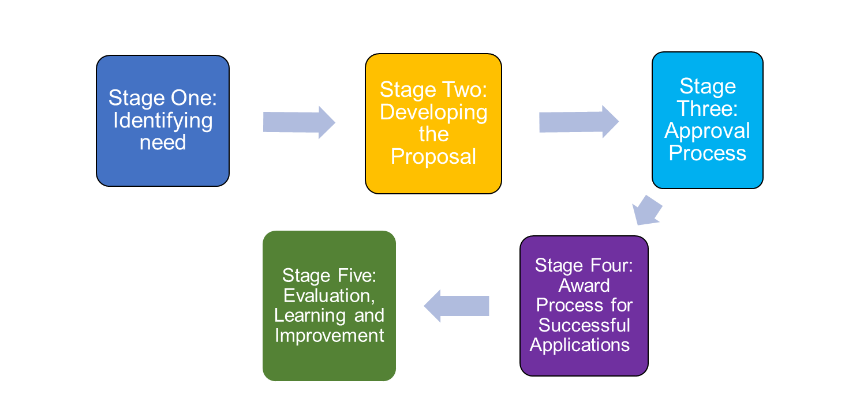

(document ends)