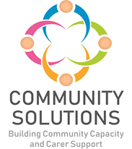

Community Solutions
Thematic Fund
Supplementary Report (2025-26)

Phase X (20XX-XX) - Impact and Learning Report

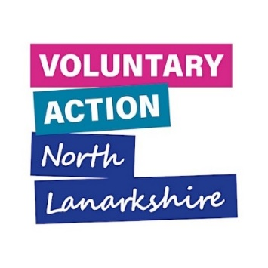


Contents

1. Introduction

1.1 Purpose
The purpose of this report is to supplement the Community Solutions Thematic Fund Impact and Learning Report (2025-26) with information on funded projects and amount of funding awarded.

Please see the main report for more information on impact, reach, and activity.

Many thanks to the funded projects, VANL staff, and key partners who have provided information and prepared this report.

2. Community Solutions Thematic Fund

2.1 Background
Community Solutions Thematic Funding is awarded to a range of community and voluntary sector organisations, to provide local services and supports to North Lanarkshire residents on selected, priority ‘thematic’ issues. This funding is provided by the University Health and Social Care Partnership North Lanarkshire.

2.2 Funding Model

In 2025-26, following a review of the Community Solutions Thematic Funding, a new funding model was implemented to make the fund more dynamic and responsive to changing themes and priorities on an annual basis, including the priorities of the Community Solutions Strategy and Investment Plan, the UHSCP-NL Strategic Commissioning Plan and Programme of Work, and public health priorities. The new model is comprised of two stages:

£196k was set aside for strategically important projects

£316k was available for CVS organisations to apply for, split into 3 strands:

Innovation

Volunteering

North Lanarkshire- wide projects

Priorities for each strand will be set annually.

In 2025-26, £512k was distributed to 25 funded organisations.

3. Funded Projects
The following table sets out all funded projects and funding amounts in 2025-26.
Community Solutions Thematic Fund

Stage One

Organisation | Project | Total Funding
Getting Better Together | Community Weight Management | 76,000
Getting Better Together | Hospital Discharge Support Programme | 80,000
North Lanarkshire Council – Active and Creative Communities | Active Health & Associated Programmes | 40,000
Innovation

Befriend Motherwell | Hospital Befriending | 23,298
Clyde Valley Community Church | Motherwell Foodbank @ Maranatha | 17,814
Deafblind Scotland | The Way Forward | 9,398
Moira Anderson Foundation | Hands on Health Self-Management Project | 12,238
Organisation | Project | Total Funding
One Parent Families Scotland | Single Parents Refresh & Release | 27,765
SAMH | Building Mental Health Literacy through Sport in Motherwell | 9,776
The Well Foundation | WF Sports for All | 5,000
VIP (The Well Foundation) | Strive and Thrive- Well foundation & VIP United | 10,000
VIP-Pass Community Project | Strive & Thrive Together | 5,000
YMCA Bellshill & Mossend | Y-Victory Esports Academy | 23,925
NL-Wide

Action for Children | North Lanarkshire Young Carers: Who we are& what we do! | 9,808
ADHD Network Scotland | Neurobrilliance - ADHD Network Scotland- Community Outreach | 12,008
HOPE for Autism | Family Fun Sessions, Family Workshops and Outdoor Activity Sessions | 10,320
HOPE for Autism | Family Fun Sessions- Outdoor Session- Trampoline Session | 9,992
Maggie’s Lanarkshire | Support for unpaid cancer carers and families at Maggie’s Lanarkshire | 10,872
Socialtrack | Shredability: Amped | 9,000
Volunteering

Organisation | Project | Total Funding
CACE | CACE Befriending Services | 25,220
Cornerstone House Centre | Cumbernauld Wheels for Wellbeing (pilot) | 23,611
COVEY | Young Ambassadors | 19,827
Glenboig Development Trust | Glenboig Befriending Service | 20,533
Lanarkshire Cancer Care Trust | Lanarkshire Cancer Care Trust Volunteer Drivers Costs | 15,000
More Than Fibro | More Than Fibro | 9,414
The Haven | Be Included, Be Involved | 12,795
TOTAL

