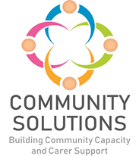

**Performance Management, Evaluation, Learning and Improvement Framework**

**Phase X (20XX-XX) - Impact and Learning Report**



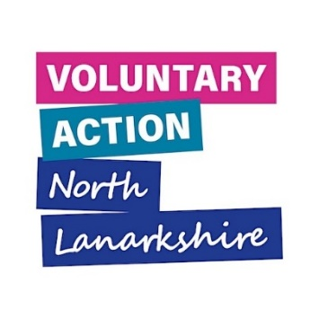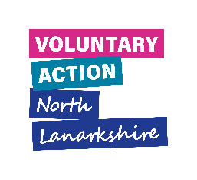



**1. Introduction**

This Framework sets out the University Health and Social North Lanarkshire [‘Community Solutions’](https://www.communitysolutionsnl.org.uk/) Programme’s approach to performance management, evaluation, learning, and improvement (PMELI).

The purpose of this Framework is to support:

* projects funded through the Community Solutions Programme
* the Community Solutions Programme as a whole.
* the wider Health and Social Care system and CVS

The Framework provides the following:

* an overview of the Community Solutions approach to PMELI
* standardised Community Solutions Programme performance and outcome measures
* standardised tools and resources to support funded projects to capture and report on their performance, outcomes and learning

This Framework is supplemented by an online [‘Demonstrating Impact’](https://www.communitysolutionsnl.org.uk/wp-content/uploads/Demonstrating-Impact-Evaluation-Toolkit.pdf) Toolkit published by Voluntary Action North Lanarkshire (VANL) for the Community and Voluntary sector (CVS) which provides a general introduction to evaluation approaches and methods with links to other, more detailed online resources.

Please note, all data collected using Community Solutions performance and outcome measures is anonymised. Where case studies and stories are shared, permission is granted from the relevant people.

* 1. **Human Learning Systems Approach**

The PMELI Framework relates to and supports a [‘Human Learning Systems’](https://www.humanlearning.systems/overview/) (HLS) approach, adopted by Health and Social North Lanarkshire’s (HSCNL) in 2023.

The Community Solutions Programme supports an HLS approach in the following ways.

* an understanding of the complex context and systems in which the people, organisations operate and achieve outcomes
* a value framework which supports person-centredness, co-production and learning
* creativity and a commitment to a cycle of learning and improvement at multiple levels – individuals, projects, organisations, programme and the wider system.

Please see the appendices for the Community Solutions Programme and Human Learning Systems Briefing Paper for more information on how the PMELI Framework relates to the HLS approach.

**2. The PMELI Approach**

This Framework sets out to support projects funded through the Community Solutions Programme to set up their performance management and evaluation processes. VANL provides this support to enable funded projects to feedback on standardised performance and outcome measures, and help them to make the most of their findings for learning and improvement. VANL staff analyse and share this feedback widely, to promote learning and improvement on four levels:

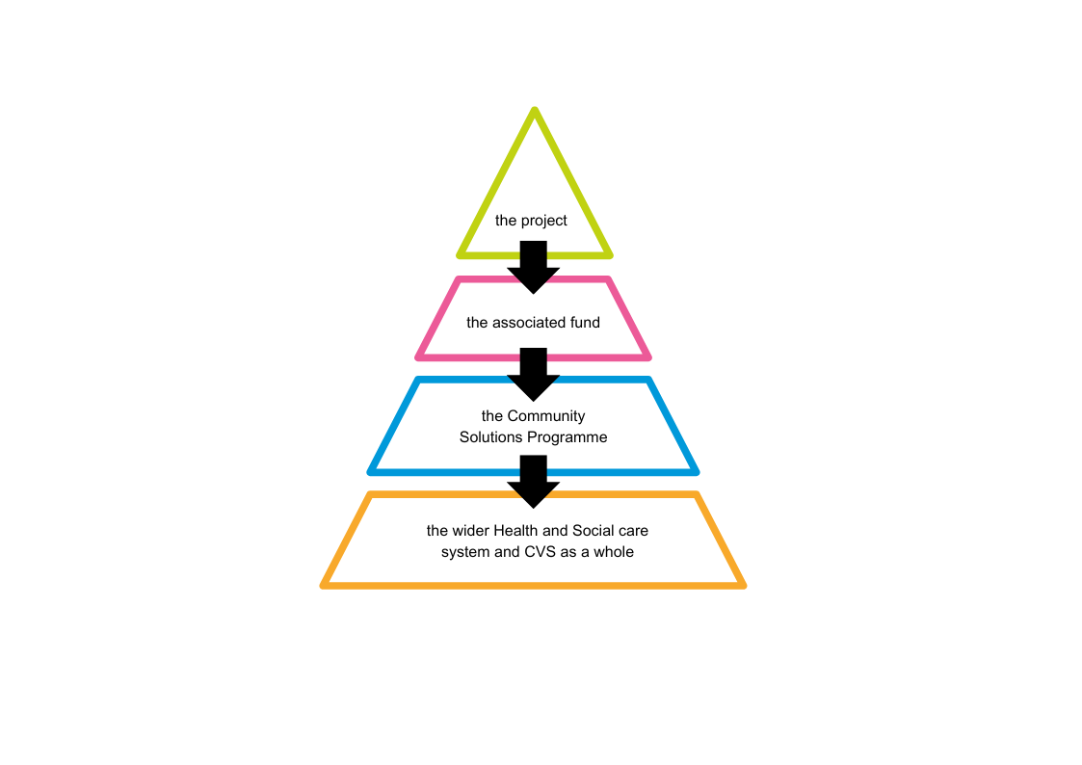

VANL staff provide support for Community Solutions PMELI as set out in the following diagram:

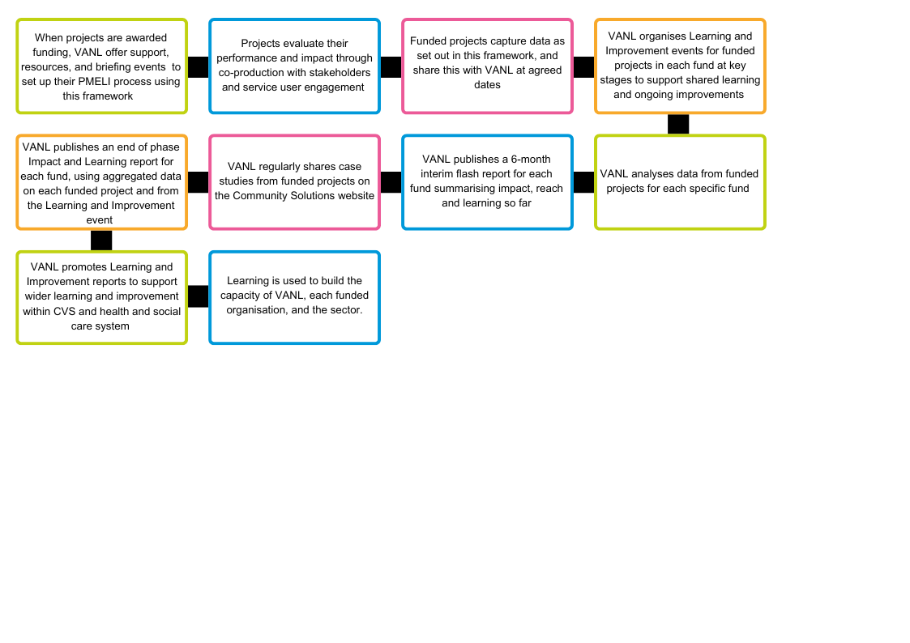

**3. Standard Performance Measures for all Community Solutions Funded Projects**

The following standardised measures are to be collected by funded projects and shared with VANL via an online evaluation and monitoring forms (via Jotform) at set points throughout the funding period as advised by VANL staff after funding award.

|  |  |
| --- | --- |
| **Measure** | **Data to collect** |
| 1. Reach and activity data | 1.1 Number and type of activities/services provided  1.2 Number of people supported in total   * Number of people participating in each activity/service   1.3 Wider beneficiaries   * Who are the indirect/direct beneficiaries e.g. carer vs cared for person |
| 2. Impact | 2.1 Number of people reporting against the project’s outcomes   * Corresponding Community Solutions outcome * What evidence has been collected to support this?   2.2 Unexpected outcomes |
| 3. Learning | 3.1 The projects’ experience of learning and improvement   * What went well, what could be improved, what learning they have taken away? |
| 4. Service user feedback | 4.1 Service users experience of the quality of the activity/service provided and thoughts on any improvements   * VANL provide a ‘Service User Feedback Survey’ to funded projects to support them to gather feedback about their project. This survey is designed to enable projects’ to complete the Community Solutions evaluation and monitoring forms   4.2 Service users’ personal stories and case studies |
| **Measure** | **Data to collect** |
| 5. General performance | 5.1 Use of Community Solutions funds  5.2 Additional funds raised/matched funding  5.3 Sustainability of funding  5.4 Engagement with stakeholders  5.4 Volunteer support   * Number of volunteers and volunteering hours spent supporting the project |
| 6. Satisfaction with VANL support | 6.1 Funded project’s satisfaction with VANL’s support for:   * Application, assessment, and award process * Monitoring, evaluation, learning & improvement |

**4. Supplementary Performance Measures for Specific Funds**

|  |  |
| --- | --- |
| **Measure** | **Data to collect** |
| 1. Locality Host performance measures | 1.1 Effective facilitation of agreement of Locality Improving Lives Development Plan with members of locality consortia and Community Boards  1.2 Effective support for wider stakeholder input into LILDP including service users, carers, wider CVS and public  1.3 Effective management of LILDP LAF and collection of performance measures as below  1.4 Support for wider public engagement in HSCNL (Health and Social Care North Lanarkshire)  1.5 Additional funding secured |
| 2. Consortia LAF performance measures | 2.1 Total sum awarded in last 12 months and percentage of total LAF available  2.2 Number of projects awarded LAF in last 12 months  2.3 Analysis of type of activity funded |
| 3. Children, Young People, and Families | NLC Education and Families request the following measures are collected by funded projects.  3.1 Where did the support take place?   * A school building, community-based setting, or family home   3.2 Collaborative working with cluster leads and associated staff within schools  3.3 Number of young people supported in total vs number who completed the project   * Why they did not complete the project   3.4 Beneficiaries   * Primary, secondary, families, young carers, and care experienced children and young people   3.5 Number of schools supported |
| 4. Community Mental Health and Wellbeing | The Scottish Government request the following measures are collected by funded projects.  4.1 What you expected to do with the funding vs what you actually did?  4.2 Main beneficiaries |
| **Measure** | **Data to collect** |
|  | 4.3 Any achievements the project is particularly proud of  4.4 Challenges/changes that slowed progress/stopped outcomes |

**5. Resources for Funded Projects**

|  |  |  |
| --- | --- | --- |
| **Resource** | **Description** | **Link** |
| Care Opinion | Care Opinion (CO) is an online platform that allows organisations that provide health care and social care services to actively collect, monitor and respond to anonymous feedback from the people who interact with their services and/or projects. Projects funded through the Community Solutions Programme are signed up to Care Opinion through the University Health and Social Care Partnership’s extended subscription as a condition of grant, to support ongoing learning and improvement.  Feedback is submitted by service users in the form of **stories**, which are reviewed, given a title, tagged to the right service, and anonymised by CO moderators before being added to the website where it is publicly available for people to read. When a story is positive, staff members’ names are left in. | <https://www.communitysolutionsnl.org.uk/pmeli-resources/> |
| Demonstrating Impact Toolkit | A toolkit for the CVS covering the introduction to the basics of evaluation with links to more detailed resources. |
| Funded Project Reporting Guidance | A guide for funded projects on how to complete the Community Solutions evaluation and monitoring forms, and the reporting requirements for each fund. |
| Jotform ‘How-to’ guide | A guide to using the online platform used by Community Solutions, Jotform. |
| Service User Feedback Survey | This survey can be given to service users by funded projects to gather feedback about their experience of the project, which will support funded projects to complete their evaluation. Funded projects can issue a word document to service users or provide them with the Jotform link. VANL will summarise responses to the Jotform link and share with each project. |
| **Resource** | **Description** | **Link** |
| Guidance on Preparing Case Studies | A guidance document on preparing project case studies with a template. |  |
| Guidance on Preparing Personal Stories | A guidance document on supporting service users to share their personal stories. |

**6. Appendices**

**Appendix A – Community Solutions Programme and Human Learning Systems Briefing Paper**

**1. Introduction**

The purpose of this briefing paper is to explore how the Health and Social Care North Lanarkshire (HSCNL) Community Solutions Programme’s (CS) overall approach, and the Programme’s integrated approach to Performance Management, Evaluation, Learning and Improvement (PMELI) relates to and supports the [‘Human Learning Systems’](https://www.humanlearning.systems/overview/) (HLS) approach, recently adopted by HSCNL.

**2. The Community Solutions Programme**

**2.1 Approach**

[Community Solutions](http://www.voluntaryactionnorthlanarkshire.org/article/about-community-solutions) is a successful, cross-sector health and social care investment and improvement programme for North Lanarkshire. The Programme - which was established in 2012 - aims to improve people’s health, wellbeing, quality of life and equality by investing in community-led initiatives which build community, family and individual strengths and resources - with a focus on prevention and early intervention.

The programme is supported by a strategy and investment plan which sets out the overall vision, mission, values and approach of the programme rather than a detailed plan of interventions. The interventions that are funded are informed by:

* the programme's values and context
* information on need and the views of users and carers
* evidence and learning of what works from sources beyond the programme and through the programme itself (see below)
* creative ideas from the Community and Voluntary Sector (CVS) and others.

The programme’s values and approach are focussed on person-centredness; community empowerment and [co-production,](https://www.coproductionscotland.org.uk/what-is-copro) where equal relationships are developed between people who use services and people who provide services – with support provided ‘**with** people’ rather than ‘to them’. The programme is organised to support involvement of people needing and receiving support and service providers in the Community and Voluntary Sector (CVS) and public sectors in a positive and participatory cycle of planning, delivery, evaluation, learning and continuous improvement. This approach is informed by the [Ladder of Participation](https://organizingengagement.org/models/ladder-of-citizen-participation/) and [National Community Engagement Standards](https://www.scdc.org.uk/what/national-standards)

The Programme invests strategically in the Community and Voluntary Sector (CVS) through several complementary strands of work.

* Local partnership-working between the CVS and public sector through six Community Solutions Locality Consortia, to identify and respond to local needs, including development of a Local Partnership Plan and management of a Local Activity Fund which makes small funding awards to CVS organisations.
* Development and delivery of direct support and services by CVS organisations on priority, thematic issues including anticipatory care; befriending; carers’ support; community transport; hospital discharge support and more.
* Capacity-building for carers and the CVS.

**2.2 The Community Solutions Performance Management, Evaluation, Learning and Improvement (PMELI) Framework**

The previous Community Solutions Programme evaluation Framework was in place for around 10 years. In late 2022, a major review of the Programme’s evaluation Framework was conducted, and the new PMELI Framework was launched in early 2023. The PMELI Framework sets out the Programme’s approach to performance management, evaluation, learning and improvement to support funded projects and the Programme.

The Framework supports projects funded through the Programme to set up their project’s performance management and evaluation processes uses a programme-wide approach with supportive tools. Voluntary Action North Lanarkshire (VANL) supports funded projects to participate in collective, learning events and uses information from these events and each project to prepare Learning and Impact Reports for each Fund and the programme overall.

This process supports ongoing learning and improvement for:

* individual funded projects and organisations
* each CS fund
* the CS Programme as a whole
* HSCNL and community planning.

**2. The ‘Human Learning Systems’ Approach**

The [Human Learning Systems (HLS)](https://www.centreforpublicimpact.org/assets/documents/hls-real-world.pdf) approach is defined as ‘purposeful activities that support human freedom and flourishing.’ HLS can support public sector services such as education, welfare provision, and healthcare and the contribution of civil society such as the work of charities and social enterprises, mutual aid groups and community development.

HLS has been developed by **Christopher Hood**, as an alternative approach to the currently dominant public management approach, ‘[New Public Management’ (NPM)](https://schoolofpoliticalscience.com/new-public-management/) which was first coined in the late 1980s and has been growing in popularity since. HLS argues that NPM takes a mechanistic, top-down managerial approach which does not reflect how outcomes are made in the real world. HLS understands that outcomes people and organisations achieve are made in a complex, messy reality. HLS defines an outcome as the pattern of results created by the combination of people and causal and contributing factors (such as the economy; level of public services; level of social support; attitudes, skills, resources) that form people’s and organisations context and create the “system” in which we all live and operate.

The HLS approach adopts a cyclical learning strategy which involves:

* learning about outcomes in context
* understanding the system outcomes are achieved or not
* experimenting with appropriate solutions to achieve the desired outcome, rather than implementing a pre-disposed strategy.

An HLS learning cycle supports change, with evaluation seen as a tool for learning and improvement, as well as a mechanism for demonstrating accountability to stakeholders. An HLS approach is about spreading learning rather than scaling up pre-disposed solutions. Learning from one context can be a useful starting point for another, but the key to HLS is the exploration within the new context, rather than implementation.

The HLS approach suggests organisations might want to use a ‘Learning Partner,’ to help organisations record and share their learning for improvement and reporting purposes. The HLS approach is about creating sharing understanding and learning together.

**3. Community Solutions Programme and HLS**

The Community Solutions Programme supports an HLS approach in the following ways.

* an understanding of the complex context and systems in which the people, organisations operate and achieve outcomes
* a value framework which supports person-centredness, co-production and learning
* creativity and a commitment to a cycle of learning and improvement at multiple levels – individuals, projects, organisations, programme and the wider system.

Prepared by Rebecca Thomson, Evaluation Officer Community Solutions Programme and Maddy Halliday, CEO, VANL, July 2023

[Document ends]