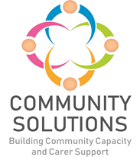

**Community Solutions**

**Impact and Learning Report 2023-24**

**Phase X (20XX-XX) - Impact and Learning Report**



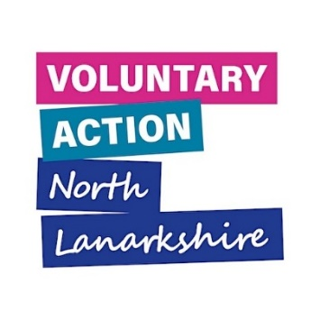



**Contents**

1. Introduction – Page 3
2. Background to Community Solutions - Page 4
3. Community Solutions Achievements 2023-24 – Page 10
4. Community Solutions Priorities for 2024-25 – Page 44
5. Appendices – Page 51

## **1. Introduction**

The [Community Solutions Programme](https://www.communitysolutionsnl.org.uk/) is a North Lanarkshire partnership initiative involving:

* [University Health and Social Care North Lanarkshire’s (UHSCNL)](https://hscnl.org.uk/) public sector partner organisations – [North Lanarkshire Council (NLC)](https://www.northlanarkshire.gov.uk/) and [NHS Lanarkshire](https://www.nhslanarkshire.scot.nhs.uk/)
* [Voluntary Action North Lanarkshire (VANL)](https://www.voluntaryactionnorthlanarkshire.org/) - the programme’s host organisation
* The Community and Voluntary Sector (CVS) funded organisations and projects

This report provides an overview of the work and achievements of University Health and Social Care North Lanarkshire’s Community Solutions Programme and its funded projects during 2023-24, with a focus on activity, reach and, where possible, outcomes and learning.

This report is formally presented to UHSCNL’s Integrated Joint Board (IJB) and is also being shared with all stakeholders to provide accountability for the programme and to support understanding, learning, and improvement within the programme and more widely across health and social care and community planning.

This report is complemented by progress reports and in-depth Impact and Learning Reports for each fund at appropriate intervals.

**Many thanks to the funded projects which provided information and to the VANL staff who prepared this report.**

**2. Background**

Community Solutions is a successful, cross-sector health and social care investment and improvement programme for North Lanarkshire. The programme – which was established in 2012 – aims to improve people’s health, wellbeing, quality of life, and equality by investing in community-led initiatives which build community, family, and individual strengths and resources, with a focus on prevention and early intervention.

The programme invests strategically in the CVS through several complementary strands of work:

* Local partnership-working between the CVS and public sector through six Community Solutions Locality Consortia, to identify and respond to local needs, including development of a Local Partnership Plan and management of a Local Activity Fund which makes small funding awards to CVS organisations
* Development and delivery of direct support and services by CVS organisations on prioritised thematic issues including anticipatory care; befriending; carers’ support; community transport; hospital discharge support, and more. In order to ensure best fit with current and emerging needs, a review of these themes by a cross-sector panel is currently underway and will report in early 2024
* Capacity building for carers and the CVS

The programme is an innovative, effective, and respected partnership and collaborative initiative between statutory and community and voluntary organisations and the public, including:

* [UHSCNL](https://hscnl.org.uk/) which is responsible for planning, commissioning, and overseeing the delivery of community health and social care services across North Lanarkshire. UHSCNL provides core and project funding for the Community Solutions Programme, as well as governance and delivery support for the programme
* The [North Lanarkshire Children’s Services Partnership](https://www.northlanarkshire.gov.uk/social-care-and-health/children-and-families/childrens-service-plan) (NLCSP) which is responsible for planning, commissioning, and overseeing children and young people’s services across North Lanarkshire. The partnership provides funding for the CVS to support children and young people’s mental health and wellbeing, which is managed through the Community Solutions Programme

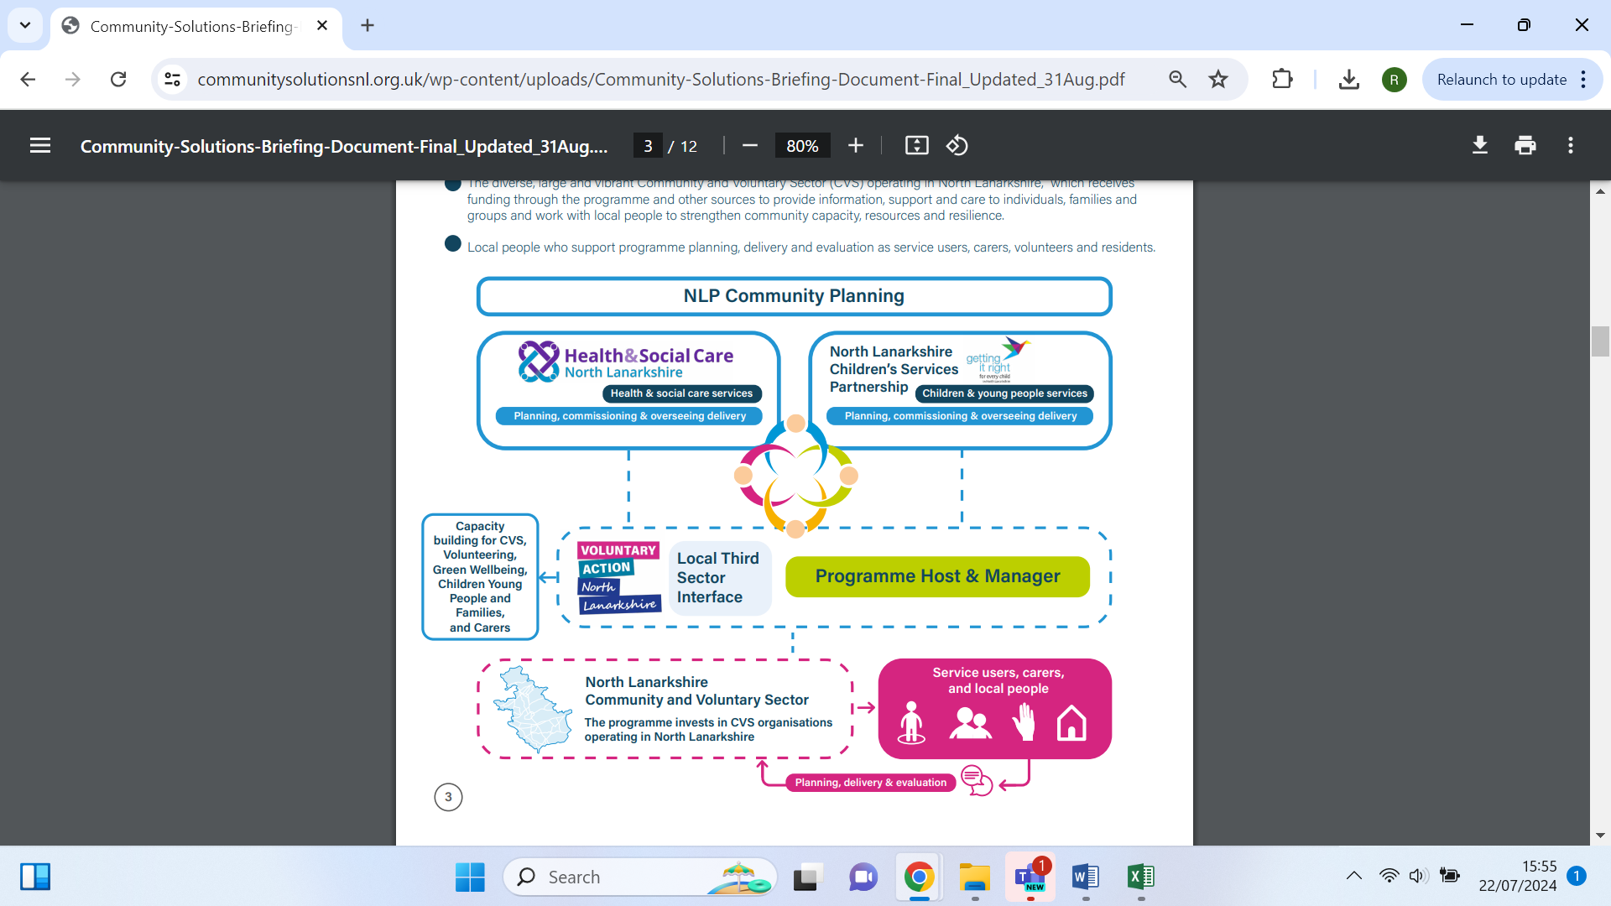

* [VANL](https://www.voluntaryactionnorthlanarkshire.org/), the local Third Sector Interface (TSI), which hosts and manages the programme on behalf of UHSCNL and the Children’s Services Partnership
* The diverse, large, and vibrant CVS operating in North Lanarkshire, which receives funding through the programme and other sources to provide information, support, and care to individuals, families, and groups, working with local people to strengthen community capacity, resources, and resilience
* Local people who support programme planning, delivery, and evaluation as service users, carers, volunteers, and residents

## **2.1 Vision and Mission**

**2.1.1 Vision**

The Community Solutions vision is for a North Lanarkshire where:

* The CVS has greater capacity to strengthen communities, improve lives, and advance equality and human rights
* Priority groups are helped to ‘live their best life’ with access to person-centered, timely, effective community-based preventative and early intervention support, provided by community and voluntary organisations, complemented by timely access to public sector services
* Communities are stronger, more resilient and inclusive, with improved health, wellbeing and quality of life, with reduced inequality and protection of human rights

**2.1.2 Mission**

The Community Solutions mission is to provide strategic investment and support to the CVS, so the sector can work with local people and public sector colleagues to achieve its vision.

## **2.2 Approach and Values**

Community Solution’s values and approach underpin our mission and provide the foundation upon which the Programme is built.

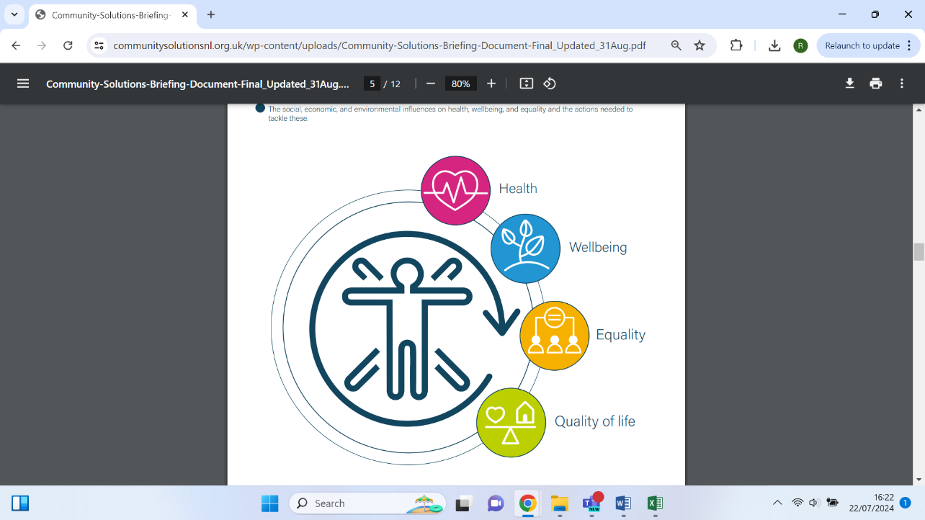

**2.2.1 Holistic and Integrated Approach**

The Community Solutions Programme takes a **holistic and integrated** **approach** to health, wellbeing, quality of life, and equality encompassing:

* Mental and physical health and wellbeing and their connections
* The social, economic, and environmental influences on health, wellbeing, and equality and the actions needed to tackle these

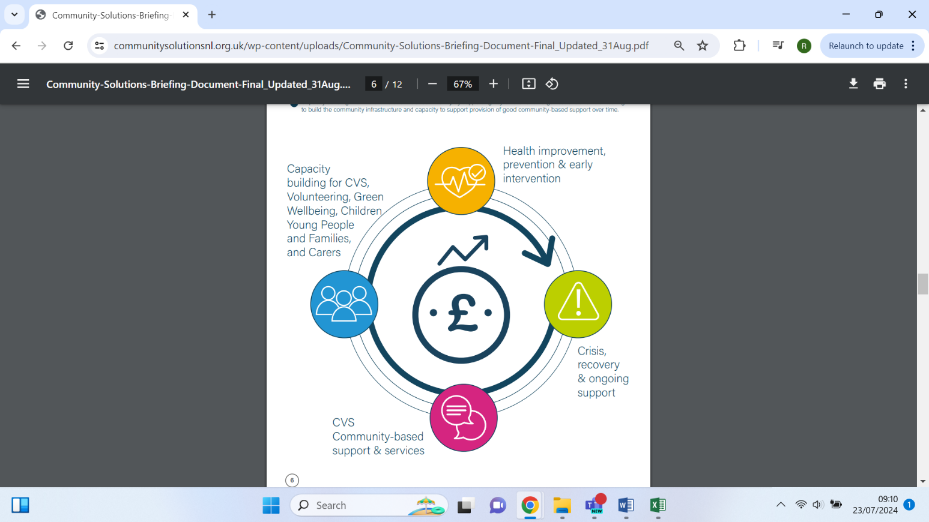**2.2.2 Strategic Investment Approach**

Community Solutions takes a **strategic investment approach** which prioritises the following in line with UHSCNL’s ambitions:

* Investment in health improvement, prevention, and early intervention activities, which reduce inequalities and protect human rights
* Investment in crisis and ongoing support, with a focus on recovery, re-enablement, self-directed support, and self-management
* Cost-effective, community-based support and services provided by CVS organisations
* Capacity building within the CVS and wider community by supporting key CVS ‘anchor’ organisations and volunteering to build the community infrastructure and capacity to support provision over time of good community-based support

**2.2.3 Values**

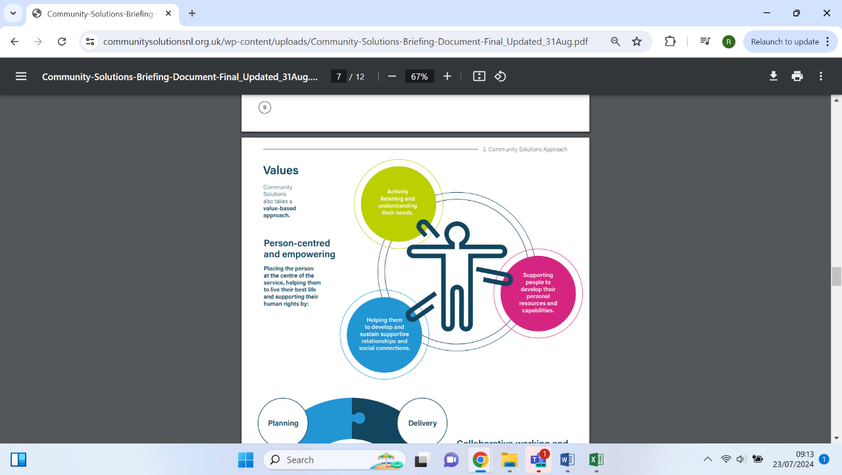Community Solutions also takes a **value-based approach**.The Community Solutions Programme values are:

* **Person-centered** **and empowering,** placing the person at the centre of the service, helping them to live their best life and supporting their human rights by:
* Actively listening and understanding their needs
* Supporting people to develop their personal resources and capabilities
* Helping them to develop and sustain supportive relationships and social connections
* 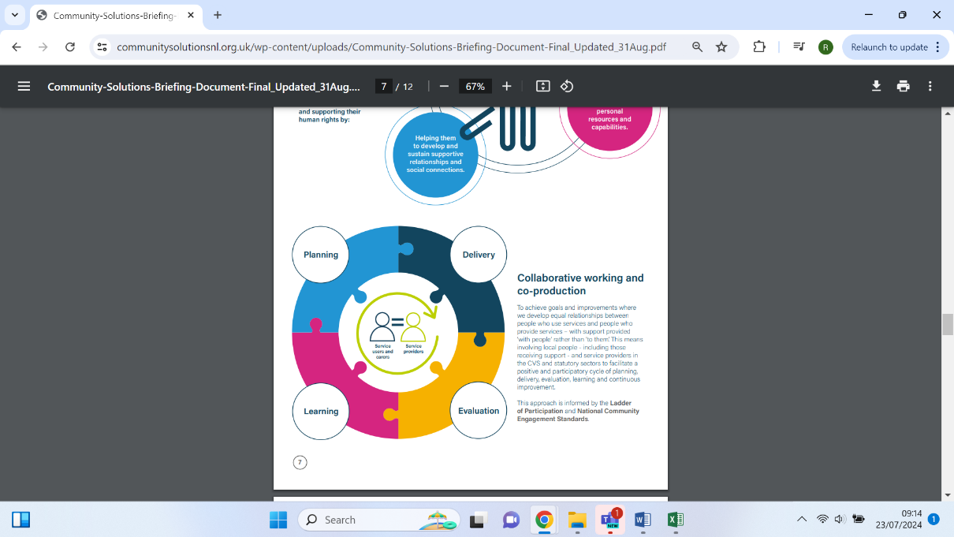**Collaborative working and** [**co-production**](https://www.coproductionscotland.org.uk/what-is-copro)to achieve goals and improvements where we develop equal relationships between people who use services and people who provide services, with support provided ‘with people’ rather than ‘to them’. This means involving local people – including those receiving support – and service providers in the CVS and statutory sectors to facilitate a positive and participatory cycle of planning, delivery, evaluation, learning, and continuous improvement. This approach is informed by the [Ladder of Participation](https://organizingengagement.org/models/ladder-of-citizen-participation/) and [National Community Engagement Standards](https://www.scdc.org.uk/what/national-standards).

## **2.3 Programme Governance**

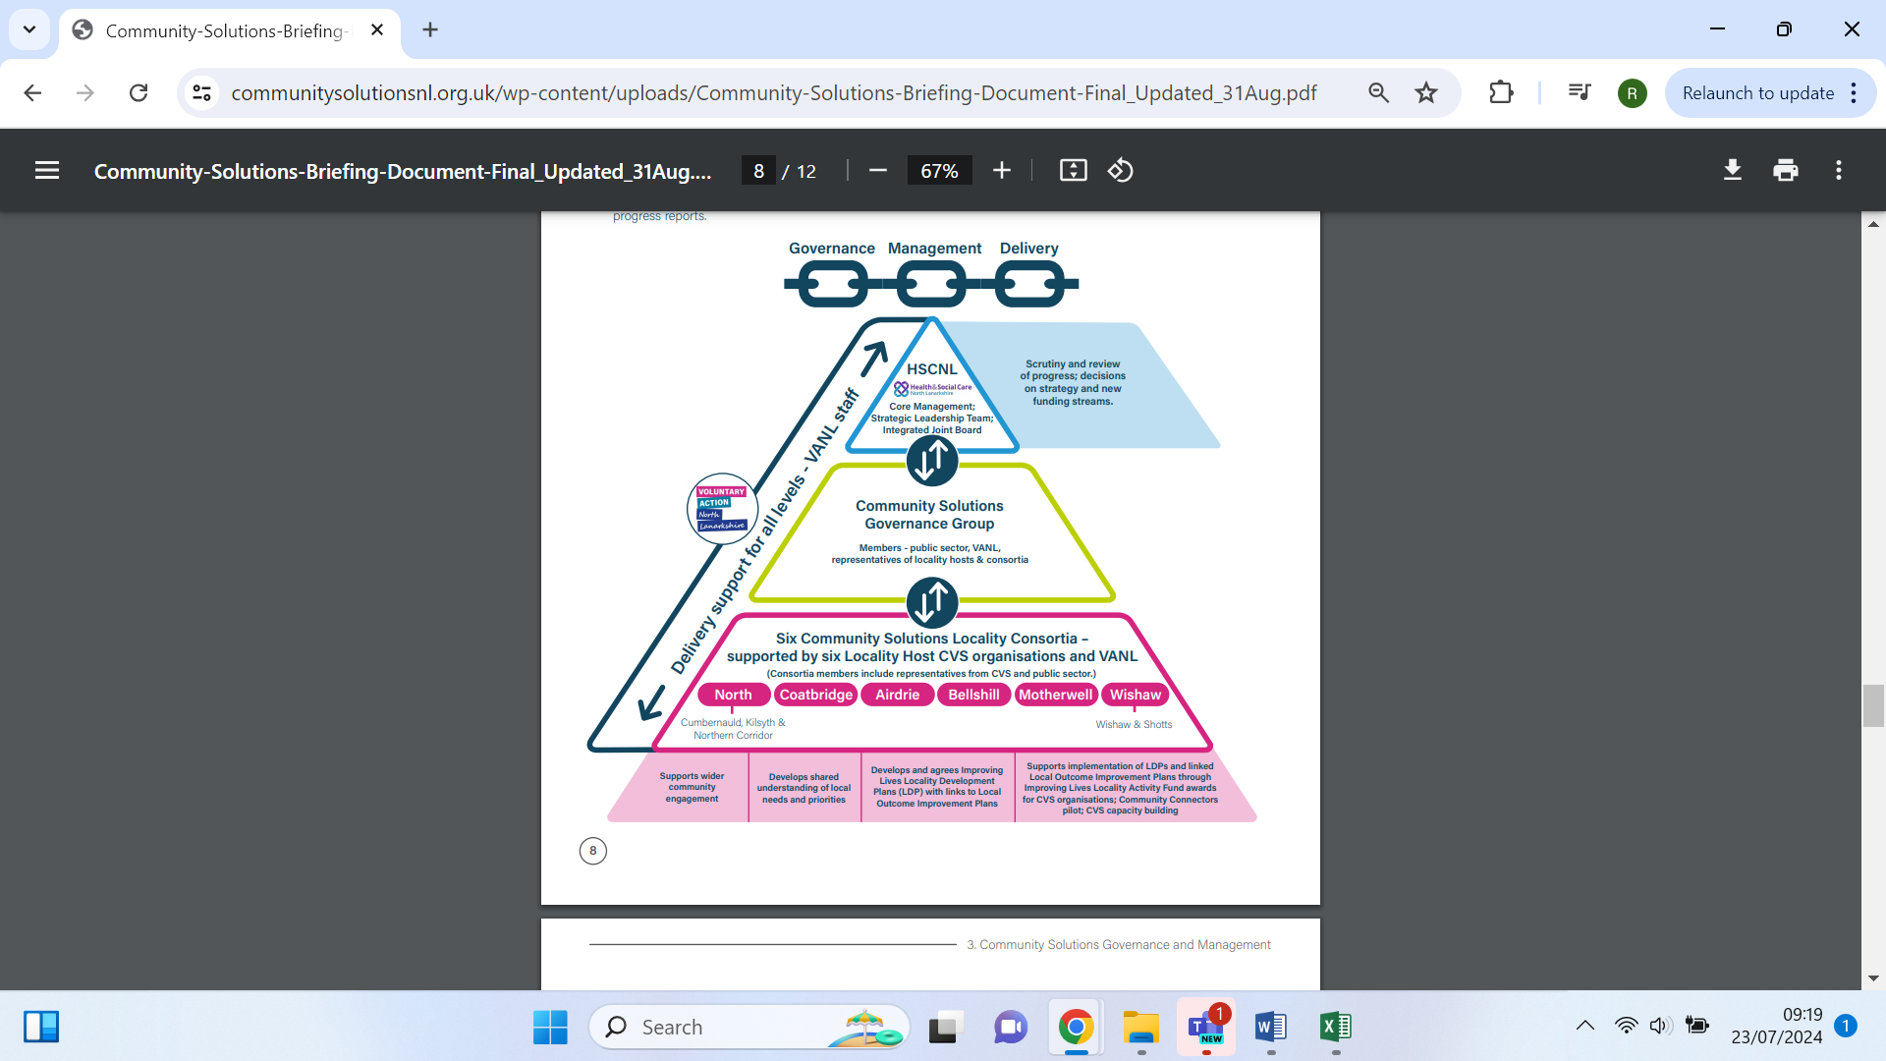Community Solutions is governed through a ‘triple-lock’ approach and supported and managed locally and across North Lanarkshire:

* Six local CVS organisations receive funding to act as ‘locality hosts’ for the Community Solutions Programme in their area, and to convene Community Solutions Locality Consortia meetings involving CVS-funded organisations; UHSCNL locality, and VANL staff. These consortia review local needs and priorities; agree a Locality Development Plan and manage a Local Activity Fund (LAF) for their area. The six locality host organisations also meet regularly with key VANL staff to share information and discuss key issues to inform locality and North Lanarkshire-wide developments
* VANL convenes and supports the Community Solutions Governance Group, which meets at least quarterly with representatives from UHSCNL, VANL, NHSL, NLC, the CVS and representatives for unpaid carers and supported people, to support strategic planning, review, improvements, and reporting
* UHSCNL’s senior management and its Integrated Joint Board agree the programme’s strategy and funding and review progress reports

**2.4 Programme Delivery and Evaluation Support**

VANL hosts and manages the Community Solutions programme on behalf of UHSCNL and the NLCSP and receives funding to cover the costs of this work, which includes the following:

* Programme governance support
* Facilitating collective planning and development of the programme overall and specific funds
* Programme communications and liaison with key stakeholders
* Management of funding awards
* Evaluation, learning and improvement support for each custodian fund and funded projects
* Overall co-ordination of programme performance management, evaluation, and reporting

In addition, VANL is commissioned by UHSCNL and others to provide capacity- building support – currently on the following three, key issues:

* CVS support for children, young people, and families
* CVS and localities
* Volunteering

VANL staff also provide wider capacity-building support for the CVS and support links between the Community Solutions Programme, health and social care, children’s services, and community planning. Much of this work is resourced by VANL’s complementary, core funding from the Scottish Government and NLC.

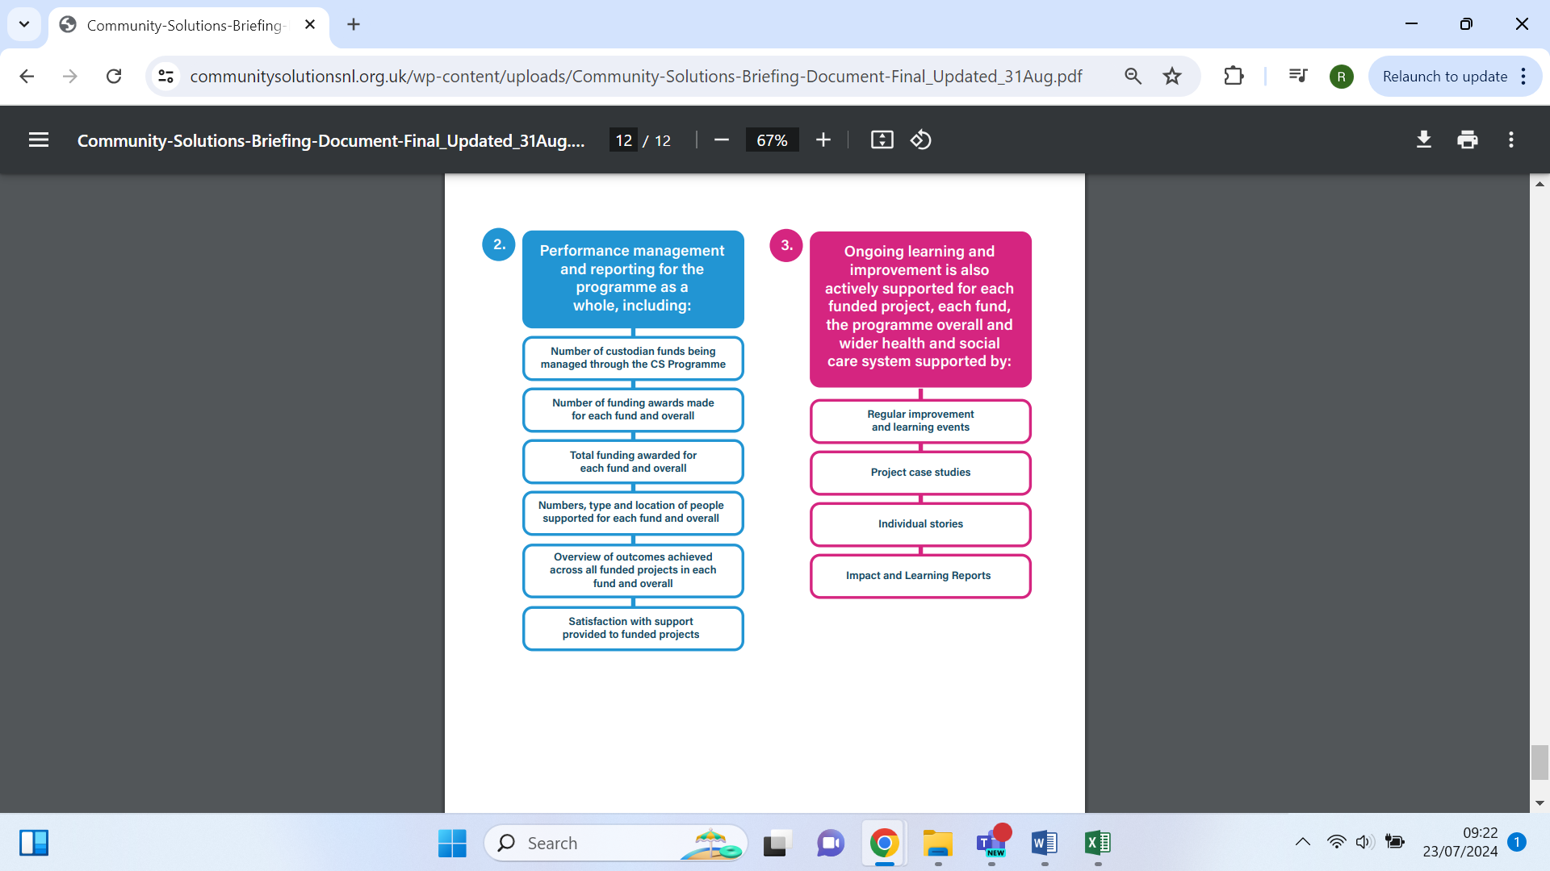VANL’s support for the Community Solutions Programme is monitored through the Programme’s ‘triple-lock’ governance arrangements.

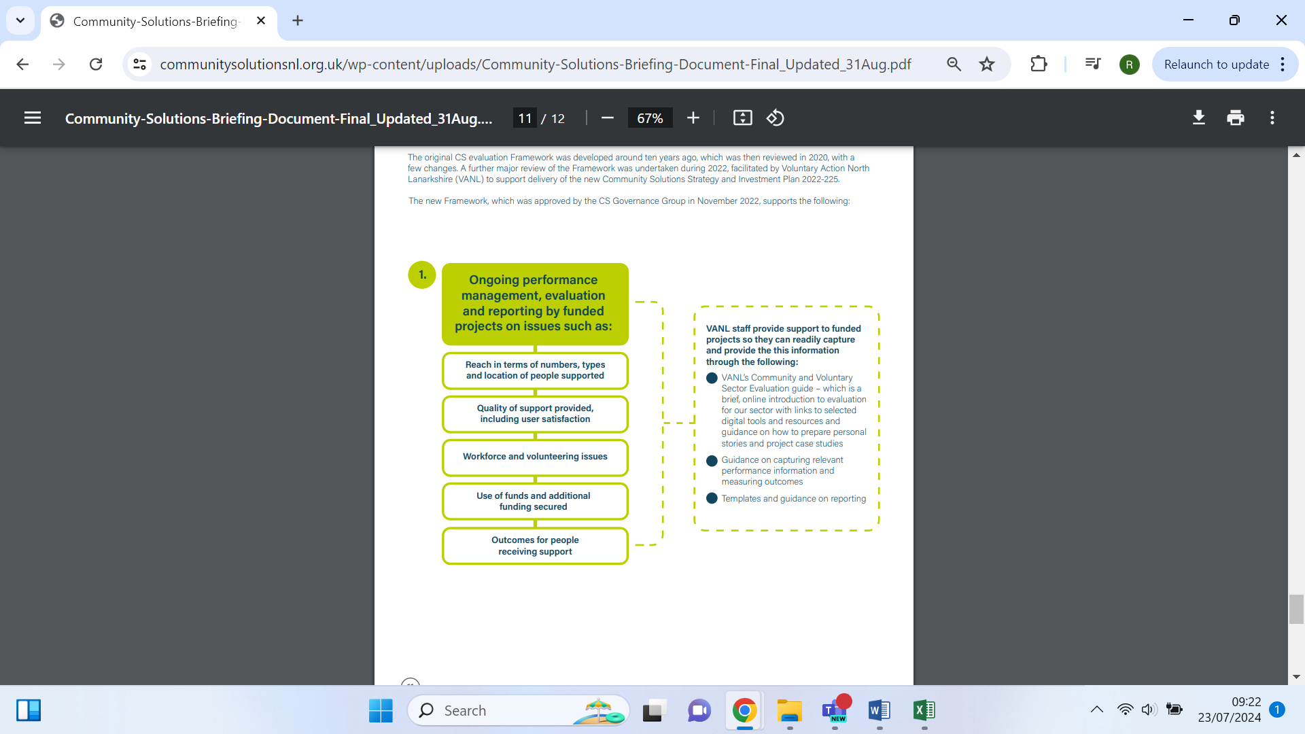

**3. Community Solutions Achievements 2023-24**

**3.1 Custodian Funds and Funding Management**

During 2023-24, over **£3.8m** of funding was managed through the Community Solutions Programme by VANL on behalf of several funders including:

* University Health and Social Care North Lanarkshire
* Scottish Government
* NLC (linked to NLCSP)

**Funding awards were made to a total of 226 projects, delivered by 93 CVS organisations.**

In addition, VANL received **£128k** in funding to support CVS capacity building as outlined above. The funding to support delivery and evaluation of the Community Solutions programme has been allocated as follows:

|  |  |  |  |  |  |
| --- | --- | --- | --- | --- | --- |
| **Community Solutions Funding 2023-24**  This table sets out all income committed and expenditure through the Community Solutions Programme in 2023-24. Money may be committed in the current financial year, for projects delivering in the next financial year. | | | | | |
| **1. Core** | | | | | |
| * 1. **Programme Management Costs** | | | | | |
| **Funding Source** | **Funding Item** | **Brought forward from 2022-23 (£)** | **Income (£)** | **Expenditure (£)** | **Carry Forward to 2024-25 (£)** |
| University Health and Social Care North Lanarkshire | Programme hosting and management | 34,707 | 138,141 | 147,900 | 24,948 |
| **Subtotal: Programme Management Costs** | | **34,707** | **138,141** | **147,900** | **24,948** |
| **1.2 VANL Capacity Building** | | | | | |
| **Funding Source** | **Funding Item** | **Brought forward from 2022-23 (£)** | **Income (£)** | **Expenditure (£)** | **Carry Forward to 2024-25 (£)** |
| University Health and Social Care North Lanarkshire | Children, young people and families | 24,614 | 30,000 | 102,150 | 50,464*  *This carry forward will be used in 2025-26 to finance existing temporary Capacity Building employment contracts. |
| CVS and locality support | 60,000 |  |
| Volunteering | 38,000 |  |
| **Subtotal: VANL Capacity Building** | | **24,614** | **128,000** | **102,150** | **50,464** |
| **1.3 Locality Funding** | | | | | |
| University Health and Social Care North Lanarkshire | Locality hosts funding |  | 240,000 | 240,000 |  |
| **Funding Source** | **Funding Item** | **Brought forward from 2022-23 (£)** | **Income (£)** | **Expenditure (£)** | **Carry Forward to 2024-25 (£)** |
| University Health and Social Care North Lanarkshire | Locality Activity Fund | 71,990 | 180,000 | 212,088*  *This figure shows the number of projects who have invoiced for funding in 2023-24. It is higher than the total figure in Appendix B, which shows the amount of funding spent by project delivery. | 39,902 |
| **Subtotal: Locality Funding** | | **71,990** | **420,000** | **452,088** | **39,902** |
| **1.3 Thematic Funding** | | | | | |
| University Health and Social Care North Lanarkshire | Anticipatory Care | 84,742[1] | 40,000 | 40,000 | 78,564 |
| Carer’s Network | 40,000 | 40,000 |
| Community Food | 40,000 | 61,500 |
| Community Transport | 72,000 | 72,000 |
| **Funding Source** | **Funding Item** | **Brought forward from 2022-23 (£)** | **Income (£)** | **Expenditure (£)** | **Carry Forward to 2024-25 (£)** |
|  | Home Visiting and Befriending |  | 195,000 | 195,000 |  |
|  | Hospital Discharge | 77,500 | 77,500 |  |
|  | Physical Activities | 40,000 | 40,000 |  |
| Contingency | 7,500 |  |
| **Subtotal: Thematic Funding** | | **84,742** | **512,000** | **518,178** | **78,564** |
| **Subtotal: Core** | | **216,053** | **1,198,141** | **1,220,316** | **193,878** |
| **2. Fixed-Term (Non-recurring)** | | | | | |
| **Funding Source** | **Funding Item** | **Brought forward from 2022-23 (£)** | **Income (£)** | **Expenditure (£)** | **Carry Forward to 2024-25 (£)** |
| **2.1 Carer Breather** | | | | | |
| University Health and Social Care North Lanarkshire | Carer Breather | 8,916 | 300,000 | 296,322 | 12,594 |
| **Subtotal: Carer Breather** | | **8,916** | **300,000** | **296,322** | **12,594** |
| **2.2 Improving Lives Initiative** | | | | | |
| **Funding Source** | **Funding Item** | **Brought forward from 2022-23 (£)** | **Income (£)** | **Expenditure (£)** | **Carry Forward to 2024-25 (£)** |
| UHSCNL/NHS Charities Together | Improving Lives Initiative, including:   * Additional Locality Host * and LAF funding * Social Prescribing Programme * Community Connectors | 67,541 | 644,328 | 453,309 | 250,806 |
| Macmillan/Scottish Government | Improving the Cancer Journey |  | 130,744 | 20,267 | *Carry forward is incorporated with Improving Lives Initiative |
| **Subtotal: Improving Lives Initiative** | | **67,541** | **775,072** | **473,576** | **250,806** |
| **Subtotal: Fixed-Term (Non-recurring)** | | **76,457** | **1,075,072** | **769,898** | **263,400** |
| **3. Fixed-Term (Other)** | | | | | |
| **Funding Source** | **Funding Item** | **Brought forward from 2022-23 (£)** | **Income (£)** | **Expenditure (£)** | **Carry Forward to 2024-25 (£)** |
| Scottish Government | Community Mental Health and Wellbeing Fund Phase Two | 191,739 |  | 162,411 | 29,321 |
| Community Mental Health and Wellbeing Fund Phase Three |  | 1,002,634 | 801,363 | 201,278 |
| Support in the Right Direction |  | 105,951 | 105,951 |  |
| North Lanarkshire Council | Children, Young People, and Families Fund Phase Three | 4,030 |  | 4,030 |  |
| Children, Young People, and Families Fund Phase Four | 40,637 | 479,000 | 346,848 | 172,789 |
| **Funding Source** | **Funding Item** | **Brought forward from 2022-23 (£)** | **Income (£)** | **Expenditure (£)** | **Carry Forward to 2024-25 (£)** |
| NHS Lanarkshire | Cervical Screening Inequalities Fund |  | 15,000 | 15,000 |  |
| **Subtotal: Fixed-Term (Other)** | | **236,406** | **1,602,585** | **1,435,603** | **403,388** |
| **TOTAL** | | **528,916** | **3,875,798** | **3,425,817** | **860,666** |

Please see the Appendices for a full break-down of the distribution of all Community Solutions funding for 2023-24.

**3.2 Localities**

The Community Solutions programme is rooted in our local communities to support effective partnership working between the CVS and public sector as well as the engagement of service users, carers, and the wider public. This partnership working and engagement is supported by Community Solutions via:

* 6 CVS locality host organisations
* 6 Local Consortia
* 6 LAFs

The Community Solutions Locality Hosting Impact and Learning Report 2023-24 is available on the Community Solutions website.

**3.2.1 Locality Hosts**

The Community Solutions programme is supported at locality level by six CVS “anchor” organisations that act as “locality hosts” for the programme. The locality hosts are responsible for:

* Convening and supporting the six Community Solutions Locality **Consortia** and facilitating links to the nine Community Boards
* Supporting Consortia members to develop a **Locality Development Plan** (LDP), which sets out priorities for local capacity building and the Locality Activities Fund. The LDP is informed by resident, service user and carers’ views and priorities, local Need Profiles, the Community Solutions Strategy and Investment Plan, and the Locality Outcome Improvement Plans (LOIPs)
* Managing, in collaboration with local consortia and Voluntary Action North Lanarkshire (VANL), the **Locality Activity Fund** (LAF) for their locality
* Supporting capacity building of local CVS organisations, including assistance in applying to LAF and providing progress reports
* Being an active member of the North Lanarkshire-wide Community Solutions Consortium and the North Lanarkshire-wide Community Solutions Locality Host Network, convened by Voluntary Action North Lanarkshire (VANL)
* Supporting and monitoring all Community Solutions activity across the locality and liaising with VANL staff to support their locality role.
* Supporting the delivery of the **Improving Lives Initiative** (ILI)

The Community Solutions’ locality hosts for 2023-24 are listed below, each of which received £40k of funding to support them in delivering these activities, plus additional funding through the ILI ranging from £18,196 to £35,674.

|  |  |
| --- | --- |
| Locality | Locality Host |
| [Airdrie](https://www.communitysolutionsnl.org.uk/airdrie/) | Diamonds in the Community |
| [Bellshill](https://www.communitysolutionsnl.org.uk/bellshill/) | Orbiston Neighbourhood Centre |
| [Coatbridge](https://www.communitysolutionsnl.org.uk/coatbridge/) | Glenboig Development Trust |
| Motherwell | The Health and Wellness Hub |
| [The North](https://www.communitysolutionsnl.org.uk/the-north/) | Cornerstone House Centre |
| [Wishaw](https://www.shottshealthyliving.com/) | Getting Better Together |

**3.2.2 Locality Consortia**

The Community Solutions Locality Consortia comprise representatives from the local CVS and health and social care staff from the council and NHS. They discuss key local issues, and support development and delivery of their Local Development Plan and LAF. In 2023-24, they met an average of 8 times. Revised and updated consortia Terms of Reference were developed in partnership with Locality Hosts in 2023, and are available on the [Community Solutions website.](https://www.communitysolutionsnl.org.uk/community-solutions-guidance-and-forms/)

Each Locality Consortium developed a Local Development Plan over the course of several meetings and Consortium Development days, which can be accessed through the following links:

|  |  |
| --- | --- |
| Locality Consortium | Local Development Plan 2023-24 |
| Airdrie | [Airdrie Development Plan](https://www.communitysolutionsnl.org.uk/wp-content/uploads/Development-Plan-Airdrie-.docx) |
| Bellshill | [Bellshill Development Plan](https://www.communitysolutionsnl.org.uk/wp-content/uploads/DEV-PLAN-Bellshill-Consortium.pptx) |
| Coatbridge | [Coatbridge Development Plan](https://www.communitysolutionsnl.org.uk/wp-content/uploads/Coatbridge-Consortium-Development-Plan-23-24.docx) |
| The North | [The North Development Plan](https://www.communitysolutionsnl.org.uk/wp-content/uploads/The-North-Development-Plan.pdf) |
| Motherwell | Currently finalising |
| Wishaw and Shotts | [Wishaw and Shotts Development Plan](https://www.communitysolutionsnl.org.uk/wp-content/uploads/Wishaw-and-Shotts-Development-Plan.docx) |

**3.2.3 Locality Activity Fund (LAF)**

There are six Community Solutions LAFs, providing small grants to CVS organisations in each locality to help them deliver a new or improved activity to support residents. Each consortium decides on how to allocate these Funds in line with their Locality Development Plan. LAF awards are then managed by locality hosts and VANL.

During 2023-24 each of the six Community Solutions Locality Consortia had £30k LAF to allocate, complemented by ILI funding ranging from £15,486 to £30,360 depending on locality, – a total of £300k, of which £190.6k was spent. (See Appendix B)

**LAF Awards 2023-24 – Reach and Activities**

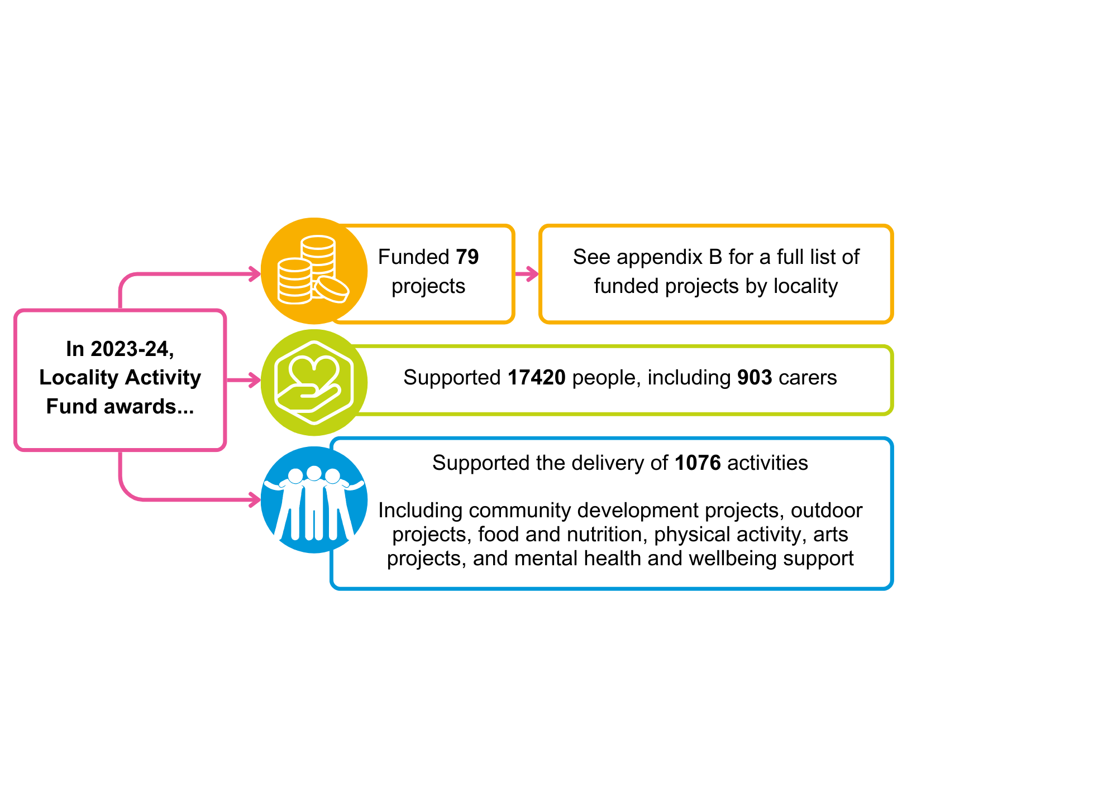

**In 2023-24, as a result of Locality Activity Fund projects... 

Outcomes organised by three categories: "Adults", "Carers", "Children, Young People and Families".  

Adults: 12,102 people felt more connected, included and safe. 7,926 people's health and wellbeing improved. 9,700 people felt more informed and aware. 

Carers: 5,982 carers felt more informed and aware. 1,030 carers' health and wellbeing improved. 1,290 carers were more able to have a life outside of caring. 

Children, Young People and Families: 9,375 children, young people and families' health and wellbeing improved. 2,317 families' relationships were strengthened. 3,410 children, young people and families became more resilientLAF Awards 2023-24 – Impact**

**3.3 Thematic Funding**

Community Solutions funding is awarded to a range of CVS organisations to provide services and support to residents on selected, priority ‘thematic’ issues, which are outlined below, with details of funding, reach, and outcomes for 2023-24.

**3.3.1 Anticipatory Care**

**Background**

Community Solutions funds local CVS organisation Equals Advocacy to employ advocacy workers to support anticipatory care for older, frail adults in liaison with health and social care staff. This funding has been in place since 2012.

Anticipatory Care in North Lanarkshire helps connect older, frail adults to services and support at an early stage, supported by a Primary Care Frailty Multidisciplinary Team (MDT) and an independent advocacy worker, employed by Equals Advocacy.

GPs support this service and approach by identifying an older person with increasing frailty. The person is then referred to Equals Advocacy who help the person complete one or more assessments at home, supported by an advocacy worker. This information is shared with the MDT which then develops and agrees an Anticipatory Care Plan in liaison with the service user.

During 2023-24, Equals Advocacy received a funding award of £40k through the Community Solutions Programme to support their role in this service.

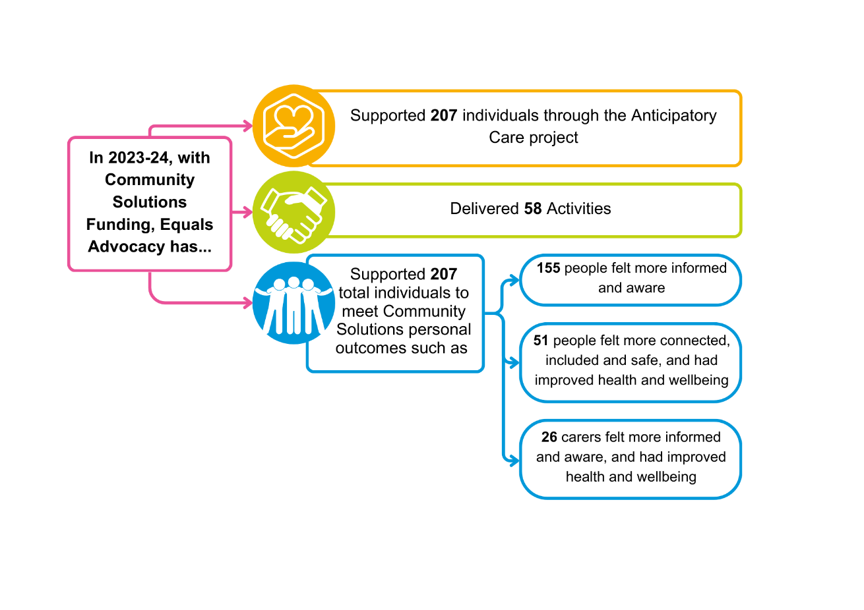**Achievements 2023-24**

**3.3.2 Befriending**

**Background**

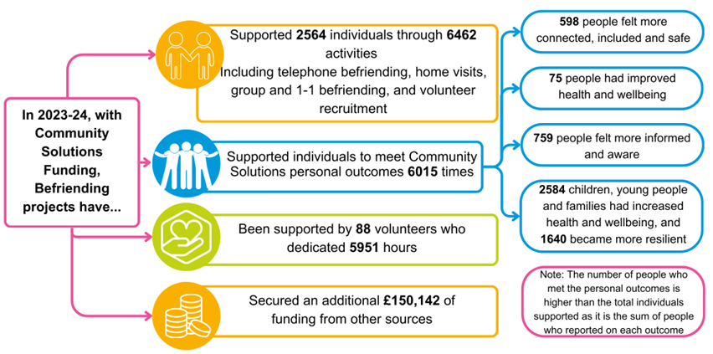Befriending provides support to people who are lonely and isolated to increase their social support and connections, thus improving their quality of life and wellbeing. Since 2012, Community Solutions has provided funding to the following nine CVS organisations to recruit, and support trained, volunteer befrienders:

* Befriend Motherwell
* CACE (Cumbernauld Action for Care of the Elderly)
* Elim Befriending
* Getting Better Together
* Glenboig Development Trust
* Home-Start
* Orbiston Neighbourhood Centre
* Volunteering Matters
* YMCA Bellshill and Mossend

Total amount awarded: £195k

**Achievements 2023-24**

**3.3.3 Cancer Screening Inequalities Fund**

**Background**

The Cancer Screening Inequalities Fund was approved by UHSCNL in early 2023 for the delivery period from summer 2023 to March 2024, to support increased take-up of cervical and breast screening in Airdrie and Bellshill localities due to their particularly low uptake rates:

* Cervical screening uptake is falling in Lanarkshire and across Scotland. Evidence demonstrates that uptake is around 20% lower in those from the lowest socio-economic areas in comparison to those in living in the highest
* There is also growing concern over the youngest 25-34-year-old group and their participation in screening
* There is less available data on uptake in Black and Minority Ethnic (BAME) communities, those that experience physical or learning disability, and LGBT communities, but indications are that screening uptake is generally lower compared to the white UK population

A total of £15k was made available (£7.5k for each locality) to CVS organisations for delivery in either or both locality areas. A cross-sector funding panel met in May 2023 and awarded funding to two projects:

* Bear Necessities (Airdrie) - £7.5k
* Culture Junction (Bellshill) - £7.4k

Due to staffing issues, reporting on this Fund has been delayed until late 2024. Full reporting will follow in the 2024-25 report.

**3.3.4 Carer Breather Phase Two (Year One)**

**Background**

The Community Solutions Carer Breather Fund was established in 2020, informed by a cross-sector review of previous Community Solutions funding for unpaid carers. The purpose of the fund is as follows:

* To enable CVS organisations to enhance and extend regular and locally based support for unpaid carers, including carers who do not necessarily wish to identify as a carer and/or are unknown to formal services
* For carers to be supported to:
  + 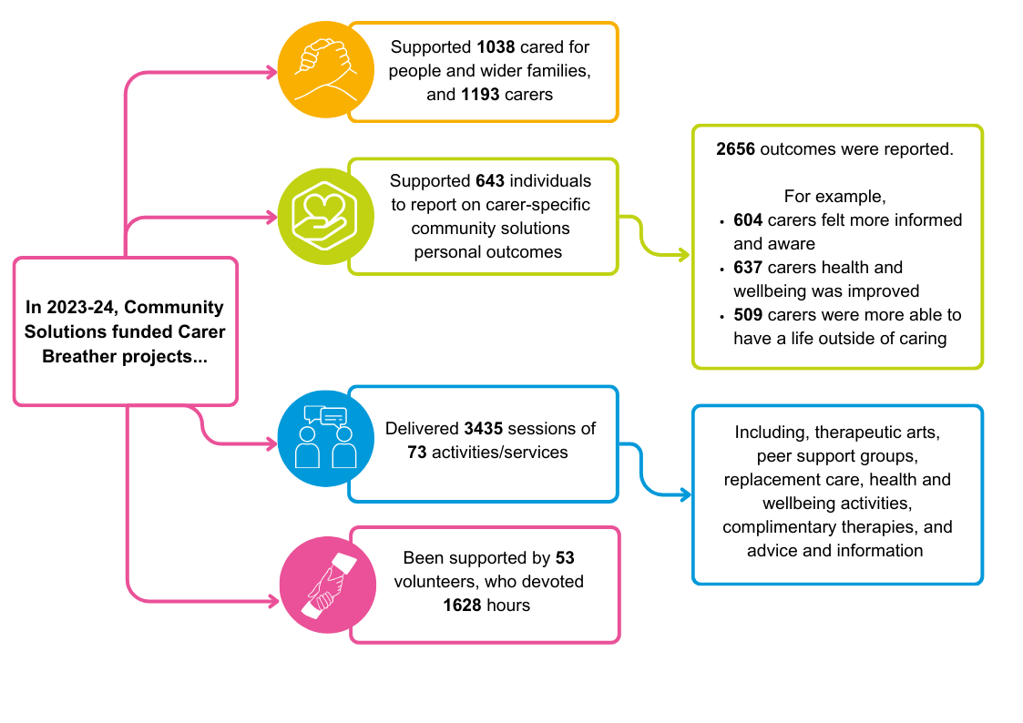Enjoy the benefits of regular and ongoing breaks in their neighbourhood
  + Access support without having to formally link up with a carers’ support organisation

Community Solutions provided Carer Breather funding to the following 11 CVS organisations in Phase Two:

* Bazooka Arts
* Getting Better Together
* Glenboig Development Trust
* North Lanarkshire Disability Forum
* One Parent Families Scotland
* PAMIS (Promoting A More Inclusive Society)
* Parkinson’s Self-Help Group
* PlayPeace
* The Haven
* The Health and Wellness Hub
* Watch US Grow

Total amount awarded: £271.5k

**Achievements 2023-24**

The Impact and Learning report for Year One of Phase Two of the Carer Breather Fund is available on the [Community Solutions website.](https://www.communitysolutionsnl.org.uk/carer-breather-fund-2/)

**3.3.5 Carer’s Capacity Building**

**Background**

Community Solutions supports capacity building for carers by funding [North Lanarkshire Carers Together](http://www.carerstogether.org/) to support the [North Lanarkshire Carer Forum](http://www.carerstogether.org/carer-forum/) and a range of other carers’ support activities.

**Achievements 2023-24**

During 2023-24, North Lanarkshire Carers Together received a grant of £40k, allowing them to:

* Support the North Lanarkshire Carer Forum, which brings carers together to share information, provide peer support, and develop collective views to inform improved policy and practice
* Support development and delivery of the Carer Breather Fund (see Section 3.3.3), including supporting network organisations with general guidance around Carer Breather Fund applications for Phase Two
* Influence carers’ policy and services through participation in the North Lanarkshire Carers’ Strategy Group and other forums
* Support carers to contribute to North Lanarkshire council budget consultations during the week beginning 15th January 2024. During two equality group sessions facilitated by council officers, carers were able to emphasise the importance of ASN Education, alternative education, and health and social care provision, which helped inform decisions in the budget.

**3.3.6 Children, Young People and Families’ Mental Health and Wellbeing Fund Phase Four**

**Background**

The purpose of this fund is to improve the mental health and wellbeing of children and young people in North Lanarkshire by increasing support provided by local CVS organisations in liaison with schools.

The fund was developed in 2020 with an initial pilot (Phase One) involving schools, staff in the council’s Education and Families team, VANL staff, and CVS organisations.

Decisions regarding funding awards are led by schools, and informed by local needs and learning from the previous phase.

The fund is managed and supported by School Cluster Improvement and Integration Leads (CILLs) and VANL staff, who work closely together.

The fund supports delivery of the [Scottish Government Children and Young People’s Mental Health and Wellbeing framework](https://www.gov.scot/publications/community-mental-health-wellbeing-supports-services-framework/) and the [North Lanarkshire Children’s Services Plan](https://www.northlanarkshire.gov.uk/social-care-and-health/children-and-families/childrens-service-plan), and is part of a suite of mental health and wellbeing initiatives for children and young people in North Lanarkshire, managed through our Children’s Services Partnership.

Funding is provided by the Scottish Government via NLC to VANL for distribution to the North Lanarkshire CVS.

The Impact and Learning reports for Phases One-Four of the Children and Young People’s Mental Health and Wellbeing Fund are available on [the Community Solutions website.](https://www.communitysolutionsnl.org.uk/children-young-people-and-families-mental-health-and-wellbeing-fund/)

**Funding Awards 2023-2024**

Total number of CVS projects funded: 85

Total amount awarded: £449.7k

**Achievements 2023-24**

**Reach and Activities**

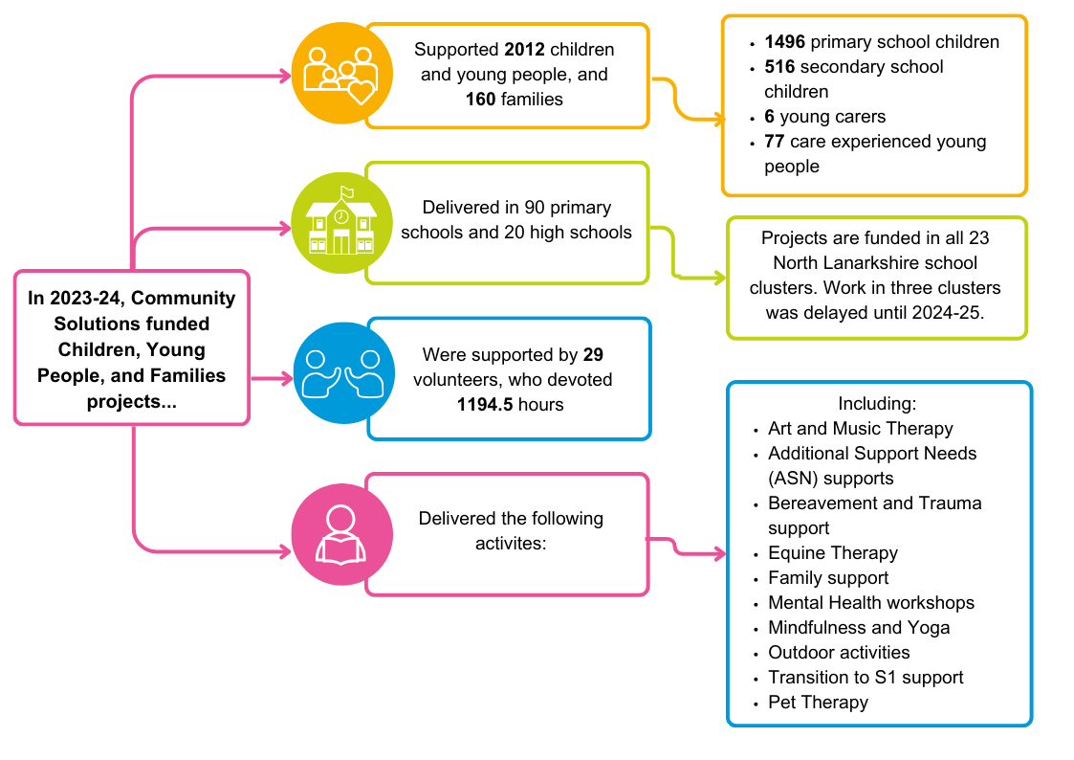

**Children and Young People’s - Impact**

The outcomes for children and young people supported by the above funded projects are assessed using [‘The SHANARRI Wellbeing indicators for children and young people’](https://www.gov.scot/policies/girfec/wellbeing-indicators-shanarri/). Outcomes for 2023-24 for children and young people (CYP) are summarised below:

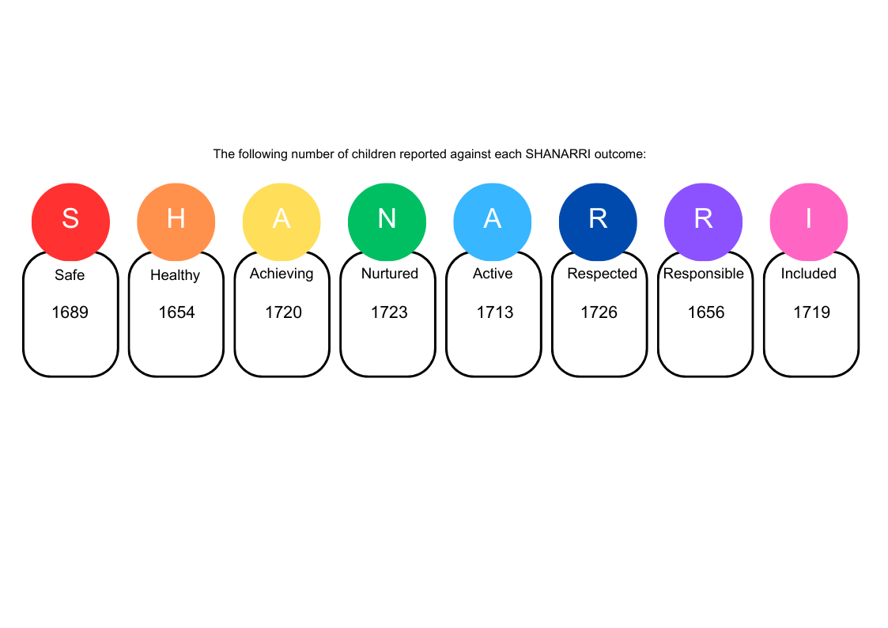

**3.3.7 Community Mental Health and Wellbeing Fund Phase Two**

**Background**

The Community Mental Health and Wellbeing Fund is a national fund established by the Scottish government in late 2021 to help local CVS groups provide increased mental health and wellbeing support. The Scottish Government asked the 32 Third Sector Interfaces (TSIs) in Scotland, including VANL as North Lanarkshire’s TSI, to manage this funding on their behalf.

VANL was required to manage the fund in partnership with UHSCNL and, given the existence of the successful Community

Solutions programme, it made sense to incorporate this new fund into the programme, thus supporting synergy with other programme funding.

Following the success of Phase One, VANL was allocated £955k from the Scottish government for Phase Two.

The Impact and Learning reports for Phase One and Two of the Community Mental Health and Wellbeing Fund are available on the [Community Solutions website.](https://www.communitysolutionsnl.org.uk/community-mental-health-and-wellbeing-fund/)

**Funding Awards 2023-24**

Number of Projects: 33

Total amount: £955k

**Achievements 2023-24**

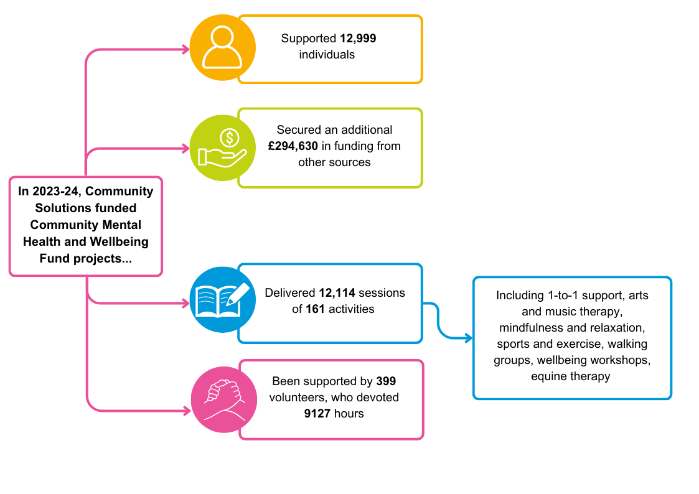**Mental Health and Wellbeing - Reach and Activities**

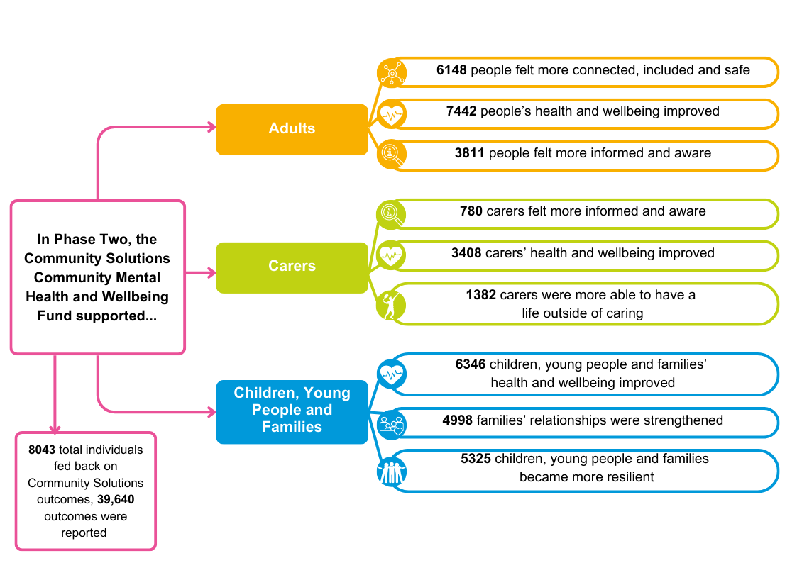**Mental Health and Wellbeing - Impact**

**3.3.8 Community Transport**

**Background**

The Community Solutions funding to support Community Transport has been provided to the North Lanarkshire CVS organisation Getting Better Together (GBT) since 2016.

Community Transport supports vulnerable residents to travel to essential appointments and key activities, supporting their health, wellbeing, and inclusion. Community Transport services are demand-responsive and therefore determined by service users’ requirements.

GBT receiveda Community Solutions funding award of £72k during 2023-24, which, combined with funding from other sources, helped GBT deliver the following community transport services:

* Transport for community groups, schools, CVS, and non-profit organisations using bookable, fully wheelchair accessible minibus and multi-purpose vehicles
* A volunteer driver service, where volunteers use their own car to transport people to essential NHS appointments and are reimbursed for their expenses
* A Community Transport HUB pilot partnership with NHS Lanarkshire and Community Transport Glasgow providing transport support for patients, staff, samples, and supplies

**Achievements 2023-24**

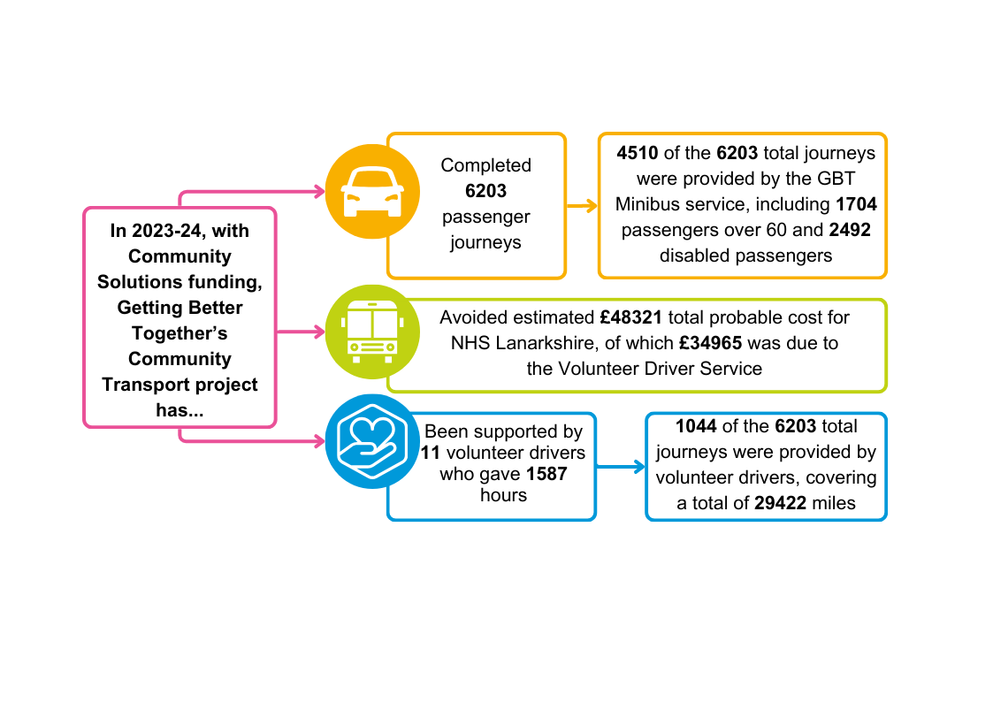

**3.3.9 Hospital Discharge**

**Background**

The Community Solutions funding for the Hospital Discharge Support Service (HDSS) has been provided to the CVS organisation Getting Better Together (GBT) since 2013.

The aim of the HDSS is to help patients and carers to access additional community-based support following hospital discharge to:

* Support rehabilitation and recovery, including physical activity
* Support self-management
* Reduce loneliness and isolation

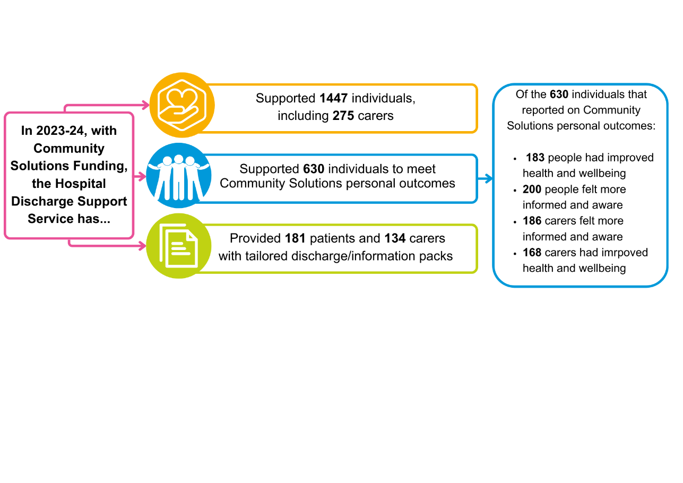

The service is available to all North Lanarkshire residents aged over 16. The HDSS has a base in the University Hospitals in Monklands and Wishaw. HDSS staff also liaise with University Hospital Hairmyres and other rehabilitation settings throughout Lanarkshire to support the discharge of North Lanarkshire-based

patients.

HDSS staff provide guidance and support to patients, carers and families through the discharge process. The service uses a person-centred approach – with staff discussing personal outcomes with patients, carers, and families. Engagement can take the form of ward visits, home visits pre- and post-discharge, as well as remotely via telephone and email. Staff also signpost service users to sources of personal and community support – including support -provided by CVS organisations – that they can access following discharge from hospital.

The funding award to GBT to provide the HDSS during 2023-24 was £77.5k.

An extension of the HDSS was agreed in 2021 for October 2021-September 2024, to improve the availability of support for carers in the hospital discharge process. The extension aimed to address demand from increased referrals for carers, and increase support available to carers with hospital discharge planning and once the patient returns home

In 2023-24, £139.9k was awarded to GBT for the extension.

**Achievements 2023-24**

**3.3.10 Improving Lives Initiative**

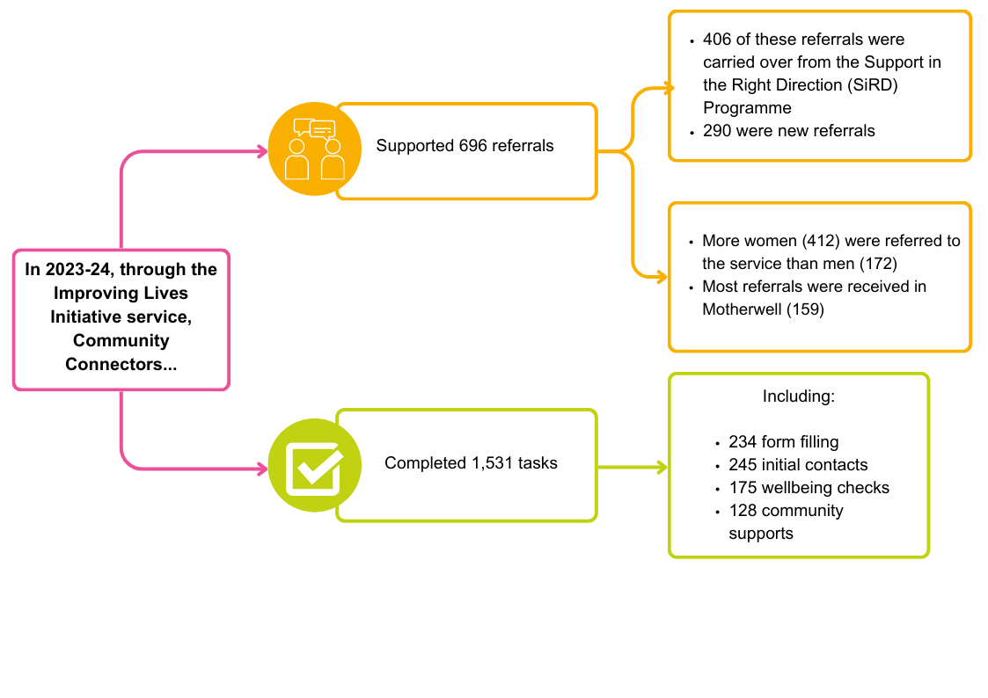**Background**

The Improving Lives Initiative (ILI) was developed collaboratively during 2022-23 with the Community Solutions Governance Group, UHSCNL Core Management team, NHS Lanarkshire Health Improvement senior staff, and Macmillan Cancer Support.

The aim is to help improve people’s physical, mental, and social wellbeing through a locally co-ordinated approach to providing community-based support for vulnerable and equality groups

The ILI provides additional funding for 24 months for the six Community Solutions locality hosts, and the LAF, to complement the existing recurrent funding.

**Community Connectors**

Through the ILI, a team of 10 Community Connectors were appointed in 2023-24 to support vulnerable people with long-term conditions in North Lanarkshire. This includes people referred through the Improving Cancer Journey project, connecting them to non-clinical support provided by CVS organisations locally. The Community Connectors were deployed to North Lanarkshire Disability Forum, beginning in November 2023, with official launch in March 2024.

**Achievements 2023-24**

**3.3.11 Improving the Cancer Journey**

The Improving the Cancer Journey service was funded by Macmillan Cancer Support and the Scottish Government, to improve outcomes for people living with or affected by cancer through the introduction of Community Connectors posts across North Lanarkshire, offering Holistic Needs Assessments at the point of diagnosis.

**Achievements 2023-24**

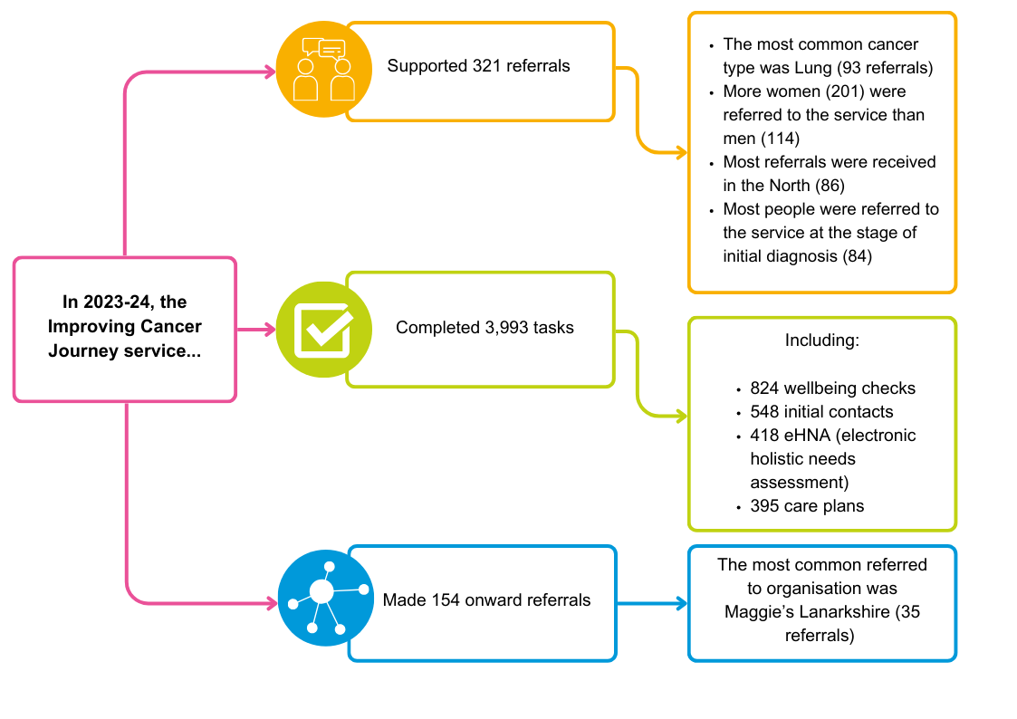

**3.3.12 Physical Activities**

**Background**

During 2023-24, Community Solutions provided the North Lanarkshire Council with £40k to support provision of physical activities for people across North Lanarkshire with a range of health conditions to enhance their physical and mental wellbeing. Referrals to the service were received from a health and social care staff.

From 2024-25, funding for the Active Health project will not be allocated through Community Solutions, but rather through the North Lanarkshire Council directly.

**Achievements 2023-24**

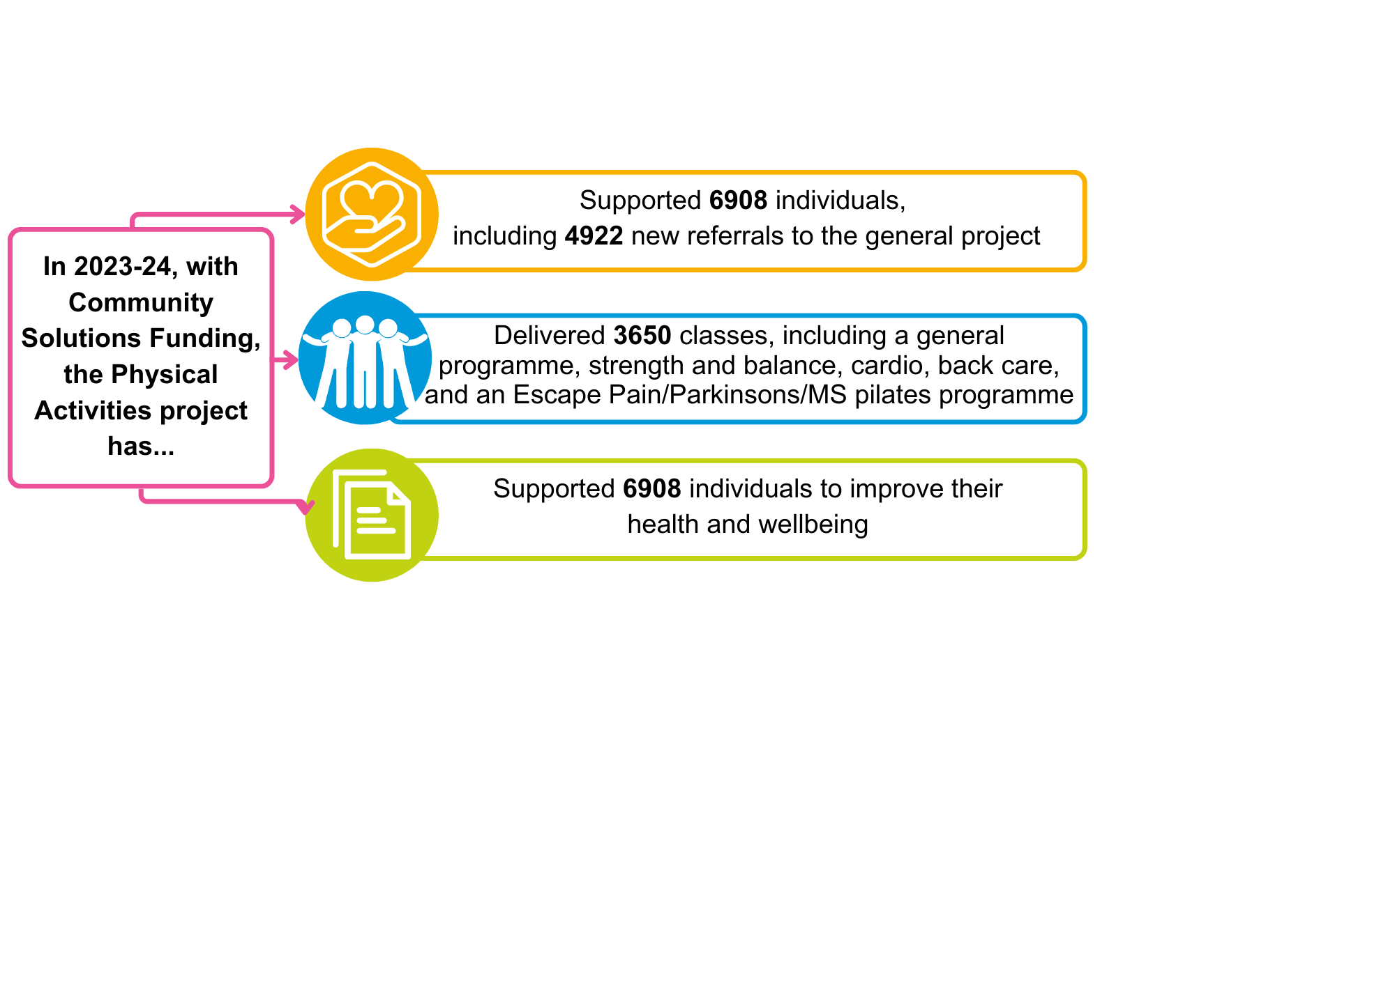

**3.3.13 Positive Smoke-Free Role Models**

**Background**

In partnership with NHS Lanarkshire’s ‘Quit Your Way’ Tobacco Control Team and Community Links, VANL managed funding for the Positive Smoke-Free Role Models Project. The project provided funding for CVS organisations across the six North Lanarkshire localities to develop and deliver:

* Work across the North Lanarkshire University Health and Social Care Partnership area which developed and promoted the concept of positive smoke-free role models
* Engagement with individuals, communities, and organisations to understand, sign up, and pledge action to become Positive Smoke-Free Role Models

NHS Lanarkshire’s Positive Smoke-Free Role Models project has a particular focus on children, and works towards:

* Preventing children and young people becoming the next generation of people who smoke
* Protecting children, adults, and pets from the harmful effects of second-hand smoke

The Project was originally launched in 2020, but some actions were postponed due to the Covid-19 pandemic and changing priorities. The Project was re-prioritised in April 2023.

NHSL allocated £36k of custodian funding for VANL to manage. (Split between the six localities, providing £6K to each.)

Funding decisions are made by locality consortia, allocation of funding will follow the LAF model (see section 3.2.3).

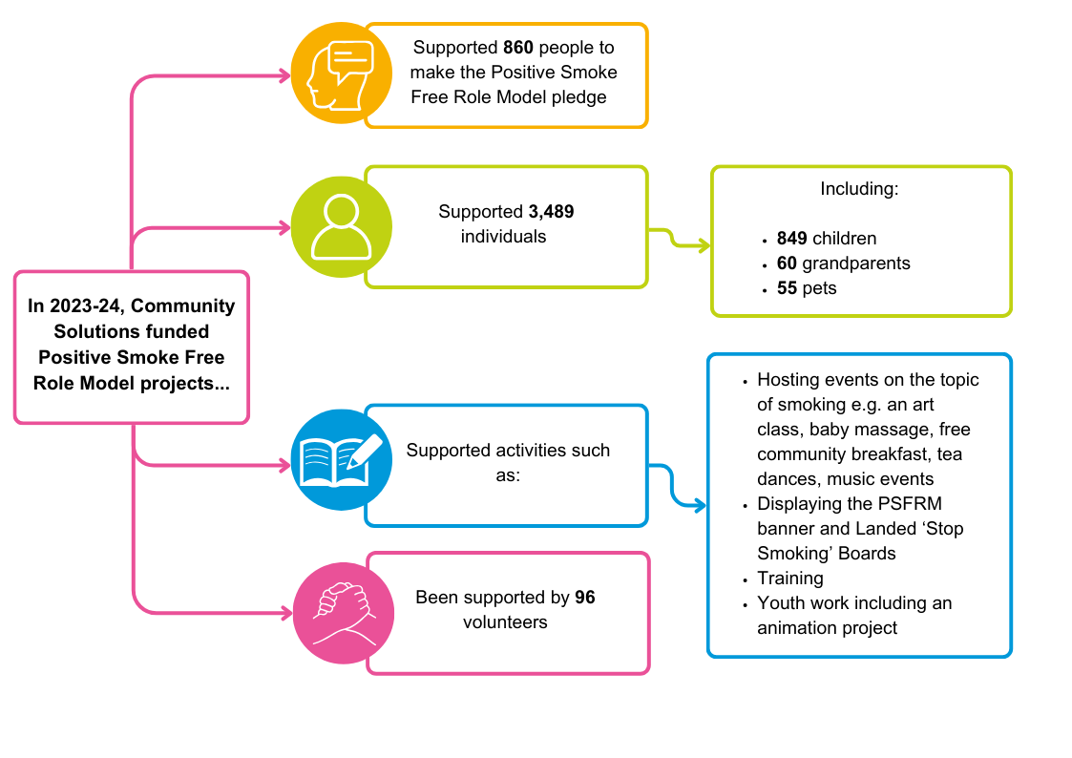**Achievements 2023-24**

**3.3.14 Support in the Right Direction**

**Background**

The Scottish Government funds a national ‘Support in the Right Direction’ ([SiRD](https://www.inspiringscotland.org.uk/funds/support-in-the-right-direction/)) programme which aims to empower people and carers receiving social care support and services to be equal partners in their care where they have real choice and control over their lives, including:

* Decisions about where they live and the services they receive
* Participation in fulfilling activities and their community
* Employment, if appropriate

This is usually referred to as ‘self-directed support’.

The national SIRD Fund has been managed by [Inspiring Scotland](https://www.inspiringscotland.org.uk/) on behalf of the Scottish Government and VANL since 2017. VANL has distributed this funding through the Community Solutions Programme to two CVS organisations:

* Equals Advocacy
* North Lanarkshire Disability Forum

Their Community Solutions funding helps these two organisations provide the following services:

* General and focussed in-depth self-directed support including 1-to-1 case work, online and Zoom conversations, and information sessions
* Community connectors, who work directly with people to find suitable supports such as groups and activities

**Funding Awards 2023-24**

Number of Projects: 2

Total amount: £106k

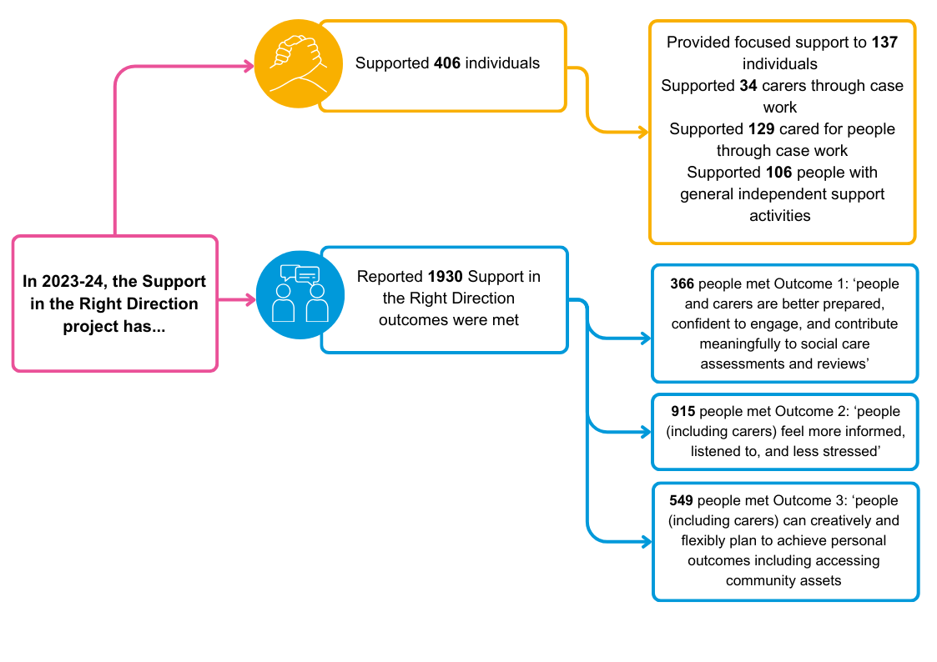**Achievements 2023-24**

**3.3.15 Community Food**

**Background**

Since 2012, Community Solutions has provided **£40k** per year to Lanarkshire Community Food and Health Partnership (LCFHP) to provide cookery classes and nutritional advice for groups within North Lanarkshire, to contribute to a positive change in eating behaviour and a healthier diet. The training is carried out by fully qualified nutritionists and primarily helps people to eat more healthily on a budget and provides support to those with identified health issues, such as those at risk of developing Type 2 Diabetes.

In 2021-22, due to organisational issues, Community Solutions thematic funding to LCFHP was suspended. Following suspension of funding, VANL continued to offer support to LCFHP.

At the same time, due to the Covid-19 pandemic lockdown, NLC allocated money to LCFHP until September 2023 to provide emergency food parcels to vulnerable local residents. Due to demand, this became the sole focus of the organisation, delivering up to 800 food parcels per month. The demand for emergency food parcels continued beyond the end of funding, and it was requested that LCFHP continued to provide the emergency food, averaging 220 per month. This impacted capacity and ability of the organisation to communicate with VANL effectively.

LCFHP contacted VANL to seek financial support for the emergency food parcels and 4 payments of £20.5k were made as follows between August 2023 and May 2024, using underspend from the suspended thematic funding.

LCFHP worked with VANL staff to agree an action plan to resolve their organisational issues, and agreed that the Community Food Thematic funding will be reinstated in 2024-25. A payment of **£23,334** will be made in 2024-25, using underspend from their suspension. An additional payment of **£29,260** will be made to fund emergency parcels until the end of March 2025, also using suspended funds. This equates to an average of 220 parcels per month, at £19 per food parcel over 7 months (Sept 24 – Mar 25). LCFHP will be fully responsible for securing funding to provide emergency food parcel from April 2025 onwards.

**3.4 Review of Community Solutions Thematic Funding**

**Background**

In line with the Community Solutions Strategy and Investment Plan 2022-25, the Community Solutions Governance Sub-Group on Wednesday 16th November 2022 approved the decision to undertake a review of the NL-Wide Thematic Funded Programme in 2023-24.

The intention of the remodelling of the thematic approach is to better reflect the purpose of the Community Solutions Programme to provide funding to support new ideas for community-based supports and to inform service redesign within UHSCP-NL. A new funding model would intend to be more dynamic and responsive to changing themes and priorities on an annual basis, including the priorities of the Community Solutions Strategy and Investment Plan and the UHSCP-NL Strategic Commissioning Plan and Programme of Work.

Community Solutions first set out to review the Thematic Funding approach at the end of 2022. A Thematic Review Group was established in 2023, drawn from stakeholders involved in the Community Solutions triple-lock Governance Structures, the University Health and Social Care Partnership North Lanarkshire (UHSCP-NL) Senior Leadership Team, the Community Solutions Governance sub-group and the NL-Wide Consortium Organisations.

Based on learning from the initial stages from the thematic review, the Lens process, and experience managing the CMHWB Fund, a new approach to remodelling the thematic funding was proposed and presented to the Governance Group on 23rd July 2024, who agreed to continue a consultation with the previously established Thematic Review Group, the Locality Hosts, and the NL-Wide Consortium.

Subject to the consultation, a final report will be presented for consideration and agreement to the Community Solutions Governance Sub-Group on Wednesday the 4th September. If agreed, any changes to the themes will be implemented over the coming financial year (2025/26) to allow for a phased transition and recommissioning in-line with the agreed changes.

**3.5 Capacity Building**

VANL receives recurrent funding through UHSCNL to support capacity building in the following areas:

* Carers
* CVS capacity building for the sector generally and for CVS organisations to support Children, Young People and Families (CYPF)
* Volunteering

**3.5.1 Community and Voluntary Sector Capacity-Building**

**Background**

VANL receives funding through the Community Solutions programme to support our provision of capacity-building support to the CVS [so the sector is able to effectively contribute to improved health and wellbeing of residents and local communities](https://www.voluntaryactionnorthlanarkshire.org/index.php/cvs-services-and-support/) through:

* Provision of support and services to improve physical and mental health
* Community wealth-building to support social and economic inclusion
* Protection and improvements to our natural environment, including climate action

The capacity-building [support and services](https://www.voluntaryactionnorthlanarkshire.org/index.php/services-and-support/) provided by VANL includes the following:

* Information provision through the [Voluntary Action North Lanarkshire website](https://www.voluntaryactionnorthlanarkshire.org/), [digital bulletins](https://voluntaryactionnorthlanarkshire.us3.list-manage.com/subscribe?u=94c77b3d6f7ed18735f59fe03&id=f1088388a0) and social media
* Organisational development guidance on issues such as:
  + Set up and governance
  + Strategic planning
  + Income generation
  + Finance
  + HR
  + Performance management and evaluation
* Peer support and learning opportunities by:
* Providing or facilitating access to structured training and informal learning
* Convening and supporting the [CVS Strategic Partnership Group](https://www.voluntaryactionnorthlanarkshire.org/index.php/north-lanarkshire-community-and-voluntary-sector-partnership-group/) and linked [thematic networks](https://www.voluntaryactionnorthlanarkshire.org/index.php/cvs-collaboration-and-partnership-working/) on key issues such as befriending; mental health and wellbeing; employability; and Social Enterprise
* Organising regular [events](https://www.voluntaryactionnorthlanarkshire.org/index.php/newsandevents/) for the CVS, including locality meetings and an annual conference
* Supporting CVS to participate in our local partnerships and contribute to delivery of associated plans including:
* Our North Lanarkshire Community Planning Partnership, [North Lanarkshire Partnership](https://www.voluntaryactionnorthlanarkshire.org/index.php/north-lanarkshire-partnership-2/) and its [Plan for North Lanarkshire](https://www.northlanarkshire.gov.uk/your-council/council-strategies-and-plans/council-strategies/plan-north-lanarkshire), associated North Lanarkshire- wide strategies such as the Tackling Poverty Strategy and nine linked Local Outcome Improvement Plans. (See partnership section in the diagram below)
* [University Health and Social Care North Lanarkshire partnership](https://www.voluntaryactionnorthlanarkshire.org/index.php/health-and-social-care-north-lanarkshire/) and its Commissioning Plan and linked strategies on mental health and wellbeing, alcohol and drugs, and the [Community Solutions Strategy and Investment Plan](https://www.voluntaryactionnorthlanarkshire.org/index.php/community-solutions-programme/).
* [The Children’s Services Partnership and Plan](https://www.voluntaryactionnorthlanarkshire.org/index.php/childrens-services-partnership/) – see the Children, Young People, and Families section below

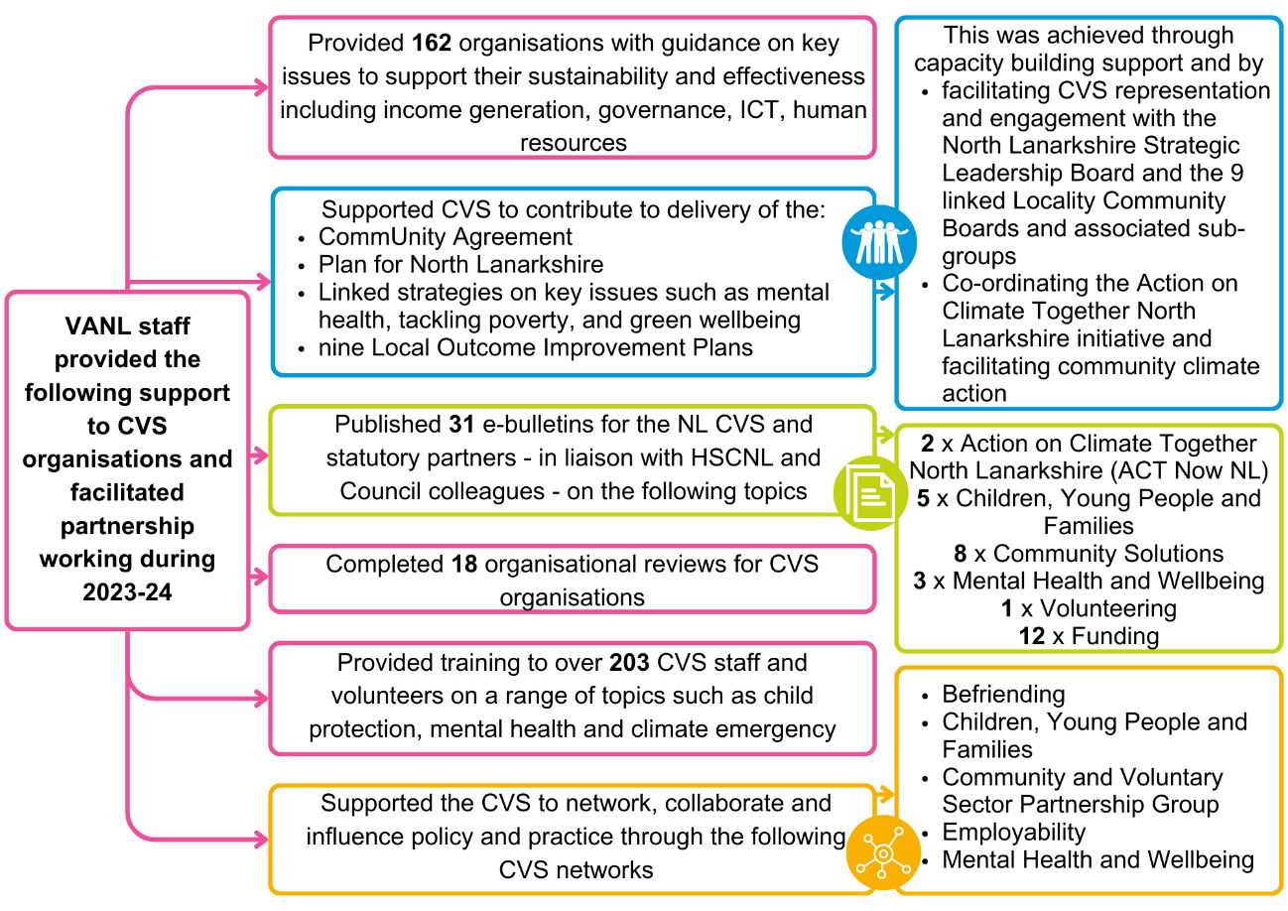VANL staff also undertake organisational reviews of CVS organisations receiving funding through Community Solutions to provide appropriate due diligence checks and identify areas where they may require support on above issues.

VANL’s CVS capacity-building work was supported during 2023-24 with a £60k grant provided through Community Solutions, and supplemented by core funding from the Scottish Government and North Lanarkshire Council. (Also see the Children, Young People, and Families section below.)

**Achievements 2023-24**

**3.5.2 Children, Young People, and Families**

**Background**

VANL staff undertake capacity-building with the CVS to strengthen the support they provide to local children, young people, and families to improve their health, wellbeing, and inclusion. VANL does this by:

* Convening and supporting the [North Lanarkshire CVS Children, Young People and Families Network](https://www.voluntaryactionnorthlanarkshire.org/index.php/cvs-collaboration-and-partnership-working/) to provide information-sharing; peer support; and to support CVS partnership working with the public sector through the [North Lanarkshire Children’s Services Partnership;](https://www.voluntaryactionnorthlanarkshire.org/index.php/childrens-services-partnership/) [UHSCNL](https://www.voluntaryactionnorthlanarkshire.org/index.php/health-and-social-care-north-lanarkshire/); [North Lanarkshire Partnership (NLP](https://www.voluntaryactionnorthlanarkshire.org/index.php/north-lanarkshire-partnership-2/))
* Supporting the CVS to strengthen their contributions to:
  + Helping mothers breastfeed successfully with bespoke training from the Infant Mental Health Team and links with community midwives
  + Child protection, through provision of training by VANL staff
  + Tackling poverty, including supporting CVS organisations that support:
    - Employment
    - Money and welfare advice
    - Community food support
  + Children and young people’s mental health, including:
    - A key role in developing arrangements for the Children and Young People’s Community Mental Health and Wellbeing Fund (see 3.4.4)
    - CVS support for improving infant mental health with access to Infant Mental Health Training and the Infant Mental Health toolkit
* Encouraging [young people to volunteer](https://www.voluntaryactionnorthlanarkshire.org/index.php/youth-volunteering/) to support development of their skills and confidence, and community engagement and contribution
* Supporting CVS participation in the Children’s Services Partnership (CSP) and facilitating links between the CSP, Community Solutions, UHSCNL and community planning

During 2023-2024, UHSCNL provided VANL with a grant of£30k to support the CVS to strengthen their support for children, young people, and families as outlined above. This funding was complemented by VANL’s core funding from the Scottish Government and North Lanarkshire Council which also supports VANL ability to provide capacity-building support to the CVS for children, young people, and families.

**Achievements 2023-24**

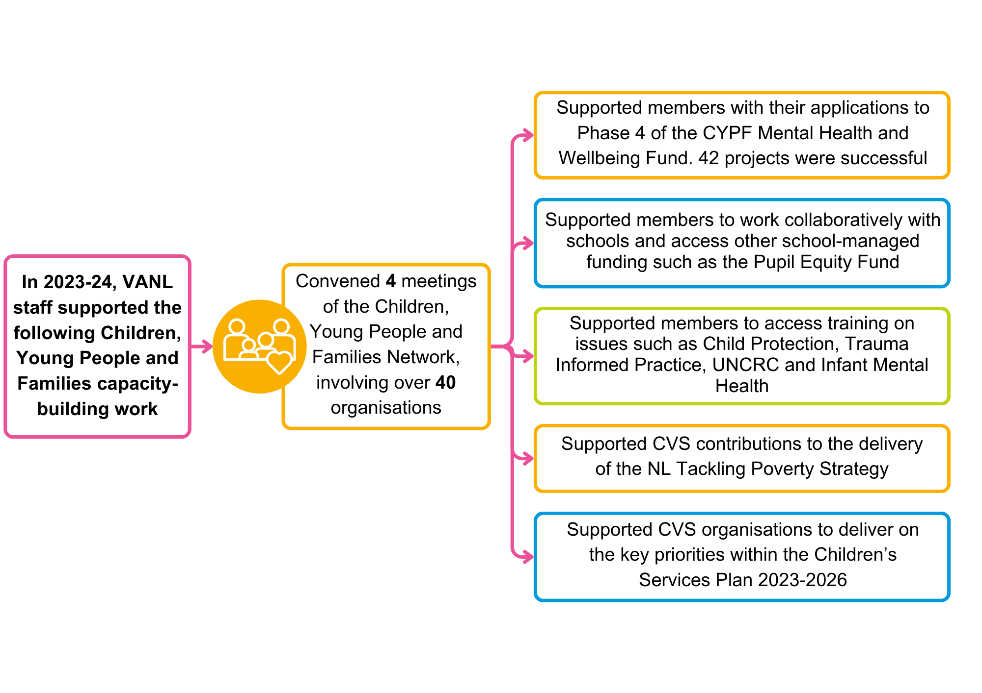

**3.5.3 Volunteering**

VANL staff support [volunteering developments](https://www.voluntaryactionnorthlanarkshire.org/index.php/volunteering/) across North Lanarkshire, working with:

* The CVS – which involves and relies on many thousands of volunteers to deliver their support and services
* Public sector partners – including North Lanarkshire Council, NHS Lanarkshire, Police and Fire and Rescue – which also involve volunteers and support volunteering more widely
* Employers in all sectors, including the business sector, which contributes through [employer-supported volunteering](https://www.voluntaryactionnorthlanarkshire.org/index.php/employer-supported-volunteering/)

VANL staff support volunteering strategically and operationally including:

* Setting up and convening the [North Lanarkshire Volunteering Partnership](https://www.voluntaryactionnorthlanarkshire.org/index.php/volunteering-partnership/) to facilitate improved cross-sector support for volunteering. The Partnership developed a new [North Lanarkshire Volunteering Strategy 2023-2026](https://www.voluntaryactionnorthlanarkshire.org/wp-content/uploads/North-Lanarkshire-Volunteering-Strategy-2023-2026.docx) which was approved in spring 2023.
* [Promoting volunteering opportunities](https://www.voluntaryactionnorthlanarkshire.org/index.php/volunteering-opportunities/) to the public and supporting matching to roles
* [Supporting volunteer-involving organisations](https://www.voluntaryactionnorthlanarkshire.org/index.php/support-for-volunteering-involving-organisations/) to improve their recruitment and support for volunteers, including accreditation through the Volunteer-Friendly award
* Supporting CVS organisations to join and use the volunteer management software [Team Kinetic](https://vanl.teamkinetic.co.uk/)

During 2023-2024, UHSCNL provided VANL with a grant of£38k to support the development of Volunteering in North Lanarkshire.

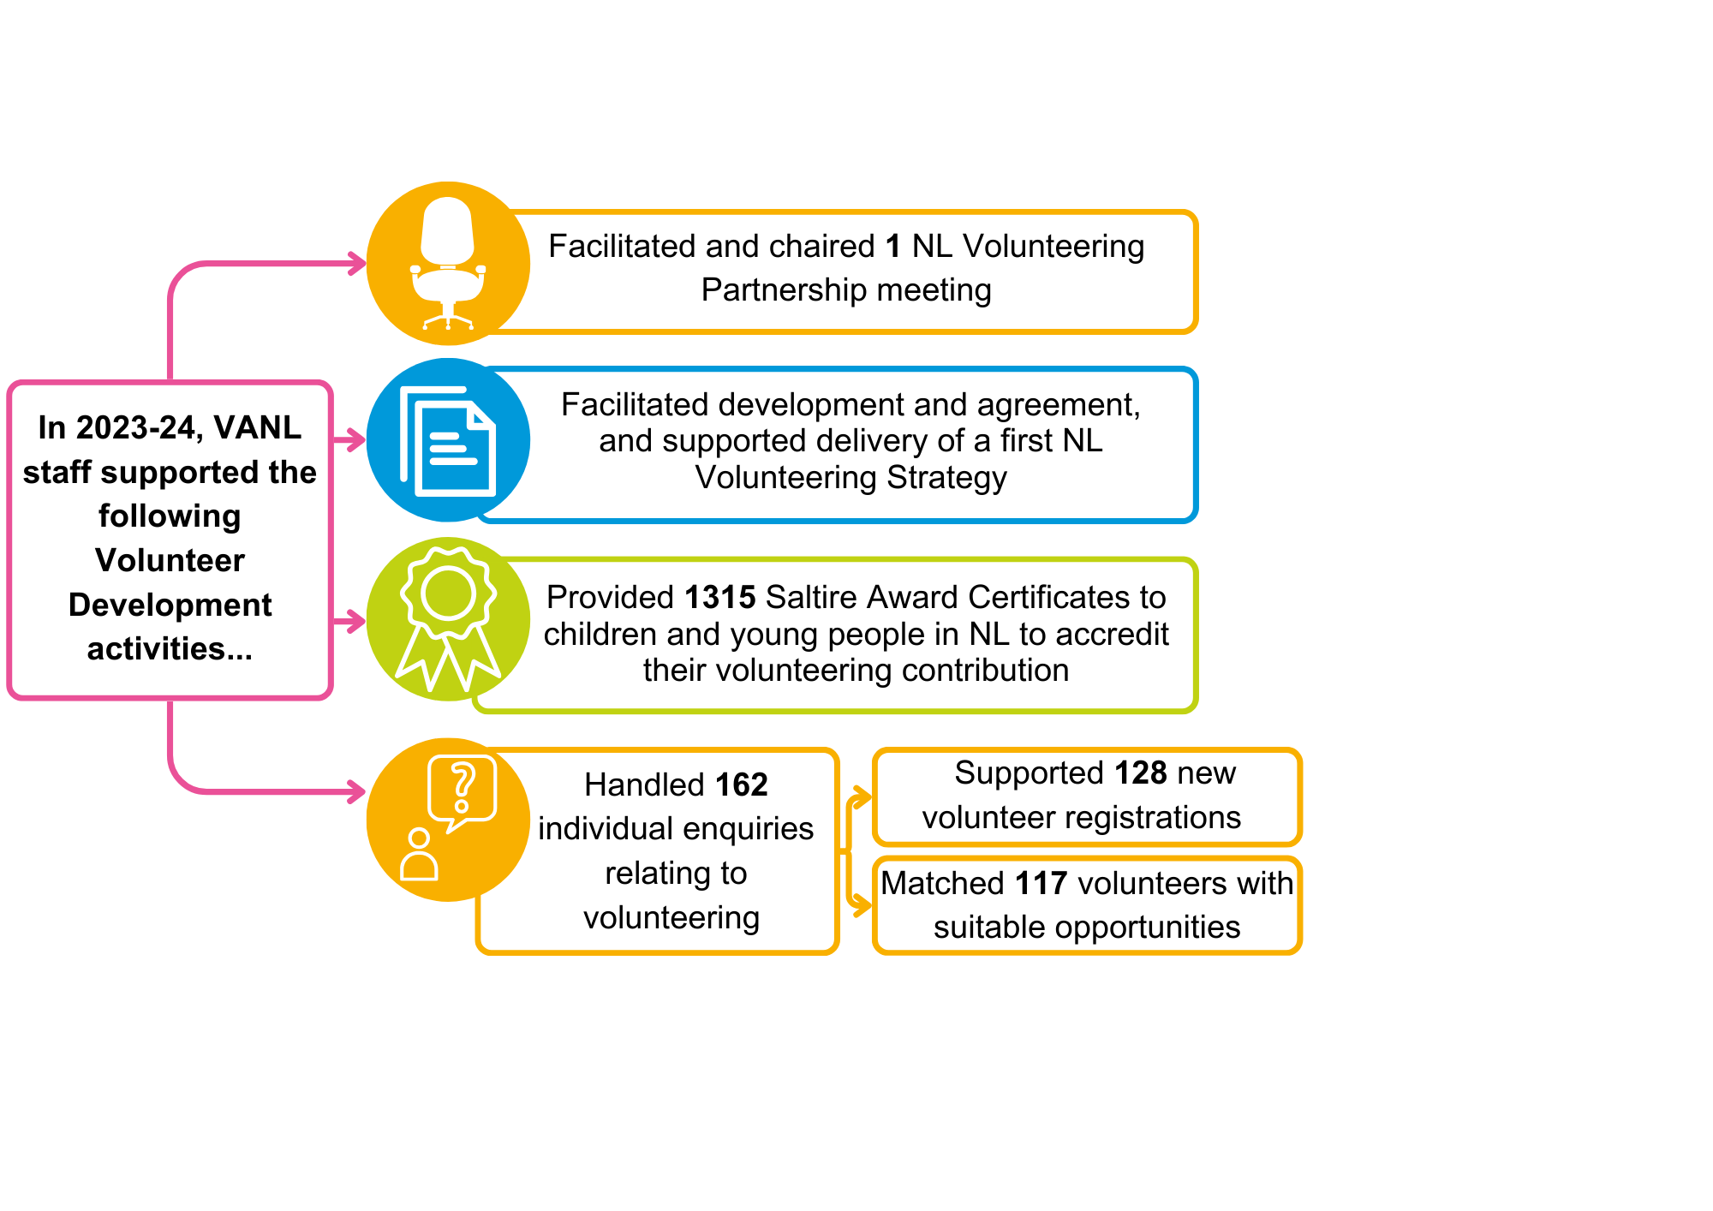**Achievements 2023-24**

**4. Community Solutions Priorities 2024-25**

This section provides an overview of development priorities for the Community Solutions Programme during 2024-25.

**4.1 Custodian Fund Developments**

**4.1.1 Improving Lives Initiative**

As we enter year two of the Improving Lives Initiative (ILI) the focus remains on working with the Locality Hosts to strengthen the overall approach to co-designing services to improve prevention, early intervention and recovery supports within the health and social care system. The priorities for the coming year are:

* Ensure the core recurring and the additional Locality Activity Fund (LAF) is fully committed by the end of year 2 of the ILI.
* That all consortia’s have a robust Locality Development Plan in place going forward that can be updated on an annual basis.
* The Social Prescribing Network is established.
* That investment priorities for LAF applications are clear and that they align with:
  + local needs
  + the priorities of the Local Outcome Improvement Plans (LOIPs) and
  + gaps in services identified by Community Connectors and the Social Prescribing Network.
* Identify additional funding to align the existing ILI funding with the Improving Cancer Journey funding for the 10 Community Connectors (to September 2027)
* Imbed the use of Care Opinion and ALISS (A Local Information System for Scotland) in all funded programmes.
* Establish a strong referral pathway with the Locality Enabling Hubs.

The final main priority is to work with partners to agree a new Strategy and Investment Plan for the Community Solutions as the current plan that can be found [here](https://www.communitysolutionsnl.org.uk/wp-content/uploads/Community-Solutions-Strategy-Document-Final_May23.pdf) covers the period April 2022 to March 2025. The new strategy will aim to strengthen the funding management element of the Community Solutions Programme to increase the level of funding invested in build the capacity of CVS organisations to provide support in the community.

The new strategy will also aim to further imbed the Performance Management, Evaluation, Learning and Improvement (PMELI) Framework within the University Health and Social Care Partnership so that it can inform service re-design by focusing on the learning and improvement that comes from the test projects invested in with the custodian funds.

**4.1.2 Community Mental Health and Wellbeing Being Fund Phase Three**

Funding for Phase Three of the Community Mental Health and Wellbeing Fund was announced by the Scottish Government in Autumn 2023, with a total of £955k available to fund CVS organisations in North Lanarkshire.

Applications were sought from CVS organisations during November/December 2023. A cross-sector panel involving staff from VANL, NHS Lanarkshire, and North Lanarkshire Council assessed all applications and made funding decisions in early March 2024. Awards were issued by the end of March 2024 for activity to be delivered from April. Funding was awarded to 32 funded projects.

Learning from Phase One and Two informed phase three, strengthening the ringfenced funding to support BAME and LGBTIA+ groups. It will also inform phase four with a commitment to strengthening the scoring panel to make it more diverse, and giving applicants longer to prepare their applications for the fund. The application form and guidance will also be updated and if time permits, funding surgeries will be offered to applicants to review their applications and to consider other sources of funding to sustain their projects.

**4.1.3 Children and Young People’s Community Mental Health and Wellbeing Fund Phase Five**

Funding for Phase Five of this fund was agreed by NLC and the Children’s Services Partnership in spring 2024, with a launch event in June 2024.

As with previous phases, funding awards for Phase Four were made to local CVS organisations to provide support to children and young people to improve their mental health and wellbeing.

The approach to awarding funding decisions has been revised for Phase Five, with funding decisions now being focused on two rounds, with the first scheduled for June 2024 and the second scheduled for January 2025. If required, a final mop up round will be scheduled for March 2025 to fully allocate all of the available funding.

With learning from the Community Mental Health and Wellbeing funding, school clusters will be supported to establish a scoring panel to review applications, using ongoing needs assessment by Cluster Improvement Integration Leads (CIILs) and local head teachers.

**4.1.4 Carer Breather Fund Phase Two**

Year two of Phase Two of the Carer Breather Fund, which was approved by UHSCNL in December 2022 to cover the period from April 2023 to March 2025. Staff in VANL continue to work with North Lanarkshire Carers Together (NLCT) to support the 11 organisations funded for the two years of the programme

Learning from Phase One and Phase Two is informing the plans for a possible Phase three, which it is hoped will be included in the next commissioning round for carers support services, which is scheduled for February 2025.

**4.1.5 Review of Community Solutions Thematic Funding**

The focus for the coming year is to complete the Thematic Funding Review, which will now focus more on a changing the funding model to make it more dynamic and responsive to the priorities contained in the Community Solutions Strategy and Investment Plan (2022-25) and the new UHSCNL Strategic Commissioning Plan (2023-26).

The aim is also to ensure that the thematic funding, which is currently £510,000 per year from the recurring funding provided by UHSCNL, is invested to build the capacity of the CVS and to inform service change to provide a more sustainable model of service as appropriate.

The New Funding Model will take learning from the Community Mental Health and Wellbeing Fund, setting funding priorities on an annual basis and ringfencing some funds into specific strands to open it up to the wider Community & Voluntary Sector (CVS) to make funding applications for new innovative services to support the people of North Lanarkshire.

**4.1.6 Cancer Screening Inequalities Fund**

The Cancer Screening Inequalities Fund was approved by UHSCNL in early 2023 for the delivery period from summer 2023 to March 2024, to support increased take-up of cervical and breast screening in Airdrie and Bellshill localities due to their particularly low uptake rates.

A total of £15k was made available (£7.5k for each locality) to CVS organisations for delivery in either or both locality areas. A cross-sector funding panel met in May 2023 and awarded funding to two projects.

Due to some delay’s in start-up and delivery, the projects have been extended in to 2024, with the evaluation report scheduled for Winter 2024. It is hoped that this will inform future funding for phase two.

**4.2 Capacity Building Priorities**

**4.2.1 Children, Young People and Families**

During 2023-24, VANL staff will continue to develop and deliver capacity-building support to the CVS as set out above in section 3.5.3, so these organisations are more able to contribute to improve the wellbeing of our children, young people, and families.

This function will be strengthened with funding from the Local Authority to further develop the management and distribution of the Children, Young People and Families Mental Health and Wellbeing Fund, that will be entering phase 3 of the programme. The funding will now be focused on two funding rounds in June and December 2024, with a final mop-up round in the spring of 2025 if required. A new scoring process will also be introduced for this round.

**4.2.2 CVS Capacity Building**

During 2023-24, VANL staff will continue to develop and deliver capacity-building support to the CVS, as set out above in section 3.5.2, so both Community Solutions funded organisations and the wider sector are better able to contribute to improved wellbeing of residents and communities.

By part funding a Community Development officer for each of the four Community Planning Partnership areas of:

* The North Locality
* Airdrie and Coatbridge Localities
* Bellshill and Motherwell Localities
* Wishaw and Shotts Locality

The programme also contributes to the work of the Income Generation Officer, to support CS Funding applicants to seek other funding to complement funding from the programme and to become a more sustainable organisation.

**4.2.3 Volunteering Support**

During 2023-2024, VANL staff continued to support volunteering across North Lanarkshire, working closely with public sector partners and the CVS in the ways set out in section 3.5.4.

With the publication of the North Lanarkshire (NL) Volunteering Strategy (2023 – 2026) by the NL Volunteering Partnership in 2023 and the introduction of the new “Team Kinetic” volunteer management and recruitment system, the function will be strengthened from ring-fenced reserves for volunteering to promote the new system and to support more organisations from across North Lanarkshire to develop volunteering within their organisations.

**4.2.4 Carers**

With Funding from the Community Solutions North Lanarkshire (NL) wide thematic programme, NL Carers Together continue to support the Carers Network and work colligatively with the CS team to manage the Carer Breather Fund, which enters it second year.

The CS Programme continues to support carers through all of its funding programmes and continues to work in partnership with NL Carers Together to support other developments for carers, as it approaches a recommissioning exercise in the spring of 2025.

**4.2.5 Community Mental Health and Wellbeing**

Mental health and wellbeing capacity building has been previously supported with recurring funding from the Community Solutions Capacity Building programme. This work will now be supported from the Scottish Government funding for the Community Mental Health and Wellbeing Programme as it enters the third year of funding.

The Community Mental Health and Wellbeing Network will be re-established in 2024-25, with a focus on forging stronger links with statutory services to ease pressure on clinical therapeutic supports. A major symposium is planned for autumn 2024 to agree how community and voluntary sector organisations can provide complementary mental health support to people in the community.

**4.3 Programme Performance Management, Evaluation, Learning and Improvement**

**4.3.1 Development of Improved Approach**

During 2023-24, VANL staff continued to implement the Community Solutions approach to performance management, evaluation, learning and improvement for funded projects, funds, and the programme as a whole, following the Programme’s [Performance Management, Evaluation, Learning and Improvement (PMELI) framework.](https://www.communitysolutionsnl.org.uk/pmeli-framework/) Ongoing feedback was sought throughout the year from the CVS and statutory partners to make continuous improvements to the Programme.

The following developments began in 2023-24, and will inform the approach to evaluation in 2024-25:

* A wider stakeholder learning and improvement to showcase learning from the two mental health and wellbeing funds
* Shorter flash reports for each fund
* A focus on sharing case studies and personal stories via the Community Solutions website, to showcase and celebrate the impact of the CVS locally

**4.3.2 Reporting Approach**

In 2022-23, the Community Solutions Programme seen a significant increase in the number of managed funds, and a subsequent increase in the evaluation returns received from funded projects. To manage this increased workload, a review of available software was conducted in June/July 2023 and [the JotForm platform](https://eu.jotform.com/myforms/?path=%2Fmyforms) has been implemented throughout 2023-24. Ongoing feedback from funded projects on the new Platform has been positive. VANL will continue to use feedback to inform ongoing improvements to the evaluation and monitoring forms in 2024-25.

**4.4 Programme Communications and Liaison**

During 2023-24 VANL staff will continue to:

* Communicate and liaise with all programme stakeholders including funded projects, locality hosts and consortia, and UHSCNL colleagues
* Represent the Community Solutions Programme and CVS on UHSCNL’s Strategic Leadership Team, IJB Board, and Performance, Finance and Audit Committee
* Share key information about the programme online through Community Solutions e-bulletins

Development of a new Community Solutions website was planned for 2022 but due to staffing capacity issues has been deferred to early 2024.

**4.5 Programme Governance**

VANL staff will continue to convene and support the Community Solutions Governance Group during 2023-24 as outlined above in section 2.3.

During 2022-23 membership of the group was reviewed to strengthen representation and engagement of key stakeholders including:

* UHSCNL staff
* Council staff from the Enterprise and Communities, and Education and Families departments
* Locality hosts and consortia (for implementation from spring 2023)

**5. Appendices**

**Appendix A**

|  |  |  |  |
| --- | --- | --- | --- |
| **Community Solutions Locality Host Funding 2023-24:**  **Total Funding £381K** | | | |
| **CVS Organisation** | **Locality** | **Locality Award Fund (£)** | **Improving Lives Initiative – supplementary funding (£)** |
| A.1 Diamonds in the Community | Airdrie | 40,000 | 23,390 |
| A.2 Orbiston Neighbourhood Centre | Bellshill | 40,000 | 18,196 |
| A.3 Glenboig Development Trust | Coatbridge | 40,000 | 19,757 |
| A.4 Cornerstone House Centre | The North | 40,000 | 35,674 |
| A.5 The Health and Wellness Hub | Motherwell | 40,000 | 22,415 |
| A.6 Getting Better Together | Wishaw and Shotts | 40,000 | 21,568 |
| **Total across the 6 Locality Hosts** | | **240,000** | **141,000** |

|  |  |  |  |
| --- | --- | --- | --- |
| **Community Solutions Locality Activity Funding 2023-24:**  **Total Distributable Funding £300K** | | | |
| **CVS Organisation** | **Locality** | **Locality Activity Fund (£)** | **Improving Lives Initiative – additional LAF funding (£)** |
| A.7 Diamonds in the Community | Airdrie | 30,000 | 19,907 |
| A.8 Orbiston Neighbourhood Centre | Bellshill | 30,000 | 15,486 |
| A.9 Glenboig Development Trust | Coatbridge | 30,000 | 16,815 |
| A.10 Cornerstone House Centre | The North | 30,000 | 30,360 |
| A.11 The Health and Wellness Hub | Motherwell | 30,000 | 19,077 |
| A.12 Getting Better Together | Wishaw and Shotts | 30,000 | 18,355 |
| **Total across the 6 Locality Hosts** | | **180,000** | **120,000** |

**Appendix B Locality Activity Fund Distribution**

|  |  |  |
| --- | --- | --- |
| **Locality Activity Fund Distribution 2023-24** | | |
| **Total number of projects funded in the six Community Solutions localities: 79** | **Total funds for 2023-24: £300,000** | **Total spend:**  **£190,648**  **of which**  **£61,479 from ILI** |

|  |  |  |
| --- | --- | --- |
| **Airdrie Locality** | | |
| **Organisation** | **Project**  projects outlined in green were funded through the Improving Lives Initiative | **Total Funding Amount (£)** |
| B.1 Airdrie CAB | Befriending project | 3,120 |
| B.2 Airdrie Kinship | Airdrie kinship carers support | 2,110 |
| B.3 Longriggend Village Association | Villagers Coming Together | 4.500 |
| B.4 Make and Create Arts | Making Healthy Choices, Creating Happy Smiles | 2,050 |
| B.5 Monklands Women's Aid | Women’s Peer Support Group – Women Empowering Women | 1,000 |
| **Organisation** | **Project**  projects outlined in green were funded through the Improving Lives Initiative | **Total Funding Amount (£)** |
| B.6 Parkinson's Self-Help Group | Benefits of Greenspace | 400 |
| Time for Me | 1,198 |
| B.7 Whinhall Allotments | Muddy Boots 'Rain or Shine' | 2,050 |
| B.8 Bear Necessities | Easter school holiday fun days programme | 1,000 |
| B.9 HOPE for Autism | Easter Bingo & Coffee Morning and Flip Out Trip | 420 |
| B.10 Airdrie Adult Learning Forum | AALF Holiday Provision Project **\*** | 3,050 |
| **No. of projects**  **11**  **\* project funded in 23-24, (continuing) delivery in 24-25** | **Total** | **20,897.98**  **of which**  **7,610 from ILI** |

|  |  |  |
| --- | --- | --- |
| **Bellshill Locality** | | |
| **Organisation** | **Project**  projects outlined in green were funded through the Improving Lives Initiative | **Total Funding Amount (£)** |
| B.11 Lanarkshire Community Food & Health Partnership (LCFHP) | Let’s Fix Fussy Eaters | 7,230 |
| B.12 Voice of Experience Forum (VOEF) | Voice of Experience Forum Calendar 2024 | 3,308 |
| Rabbie Does Strictly – Tea Dance | 952 |
| B.13 Viewpark Conservation Group | Restoring Minds, Restoring Nature | 8,694 |
| B.14 Deep Fried Media | Family Friendly Art & Photography | 2,246 |
| B.15 Orbiston Neighbourhood Centre | Community Fridge | 4,300 |
| B.16 YMCA Bellshill & Mossend | YMCA Digital Hub * | 2,839 +  1,414.70 (extension) |
| **No. of projects**  **7** | **Total** | **30,983.70**  **of which**  **8,694 from ILI** |

|  |  |  |
| --- | --- | --- |
| **Coatbridge Locality** | | |
| **Organisation** | **Project**  projects outlined in green were funded through the Improving Lives Initiative | **Total Funding Amount (£)** |
| B.17 Kirkshaws Neighbourhood Centre | Art in the Community | 1,500 |
| Kirkshaws Health & Wellbeing Community Programme | 5,700 |
| B.18 Glenboig Development Trust | Together We Thrive | 6,100 |
| Keep Moving, Keep Improving | 2,390 |
| B.19 Coatbridge Consortium | Men Talk | 8,840 |
| **No. of projects**  **5** | **Total** | **24,530**  **of which**  **10,340 from ILI** |

|  |  |  |
| --- | --- | --- |
| **The North Locality** | | |
| **Organisation** | **Project**  projects outlined in green were funded through the Improving Lives Initiative | **Total Funding Amount (£)** |
| B.20 Friends of Kilsyth | Community Pantry | 4,500 |
| B.21 Kilsyth Civic Week | Intergenerational Tea Dance | 1,200 |
| B.22 Auchinloch Community Council | Auchinloch Community Hub | 1,760 |
| B.23 CACE (Cumbernauld Action for Care of the Elderly) | CACE Local Community Family Fun Day and Open Day | 350 |
| CACE Community Transport Support | 3,000 |
| B.24 Strathcarron Hospice | Absent Friends Week and National Grief Awareness Week Bereavement Support | 2,400 |
| B.25 Storehouse Church | Christmas Winter Wonderland | 2,600 |
| B.26 Cornerstone Christian Fellowship | Livestreaming of Interactive Events | 3,500 |
| B.27 Abronhill Guild of Friendship | Abronhill Guild of Friendship Christmas Party Lunch | 1,000 |
| B.28 St Patrick's Church Kilsyth | Kilsyth and Villages Health and Wellbeing Project | 5,232 |
| **Organisation** | **Project**  projects outlined in green were funded through the Improving Lives Initiative | **Total Funding Amount (£)** |
| B.29 Manipulate Arts | AnimATE Croy | 4,959 |
| B.30 Cardowan Community Meadow | Cardowan Outdoor Learning Project * | 4,290 |
| B.31 Cloudberry Communities CiC | Community Health Building * | 4,000 |
| **No. of projects**  **13**  **\* project funded in 23-24, (continuing) delivery in 24-25** | **Total** | **38,791**  **of which**  **13,482 from ILI** |

|  |  |  |
| --- | --- | --- |
| **Motherwell Locality** | | |
| **Organisation** | **Project**  projects outlined in green were funded through the Improving Lives Initiative | **Total Funding Amount (£)** |
| B.32 Voice of Experience Forum | Tea Dance | 952 |
| B.33 The Economic Forum for Women Empowerment Scotland | Free Family Summer Day Trip to the Beach | 2,000 |
| B.34 The Salvation Army Motherwell | Let’s Introduce Anxiety Management (LIAM) | 1,390 |
| B.35 Motherwell CAB | Help First | 5,000 |
| B.36 Families and Friends affected by Murder and Suicide (FAMS) | FAMS Goals – Give Youth a Chance | 4,950 |
| B.37 Lanarkshire Community Food & Health Partnership | Cooking on a budget – Slow Cooker * | 2,875 |
| Big Chef Little Chef * | 2,863 |
| B.38 Elim Befriending Services | Oasis Summer Trip * | 1,329 |
| B.39 Bestway Community Development | Community event * | 3,984 |
| B.40 Clydesdale Community Initiative | Airbles Road Extension Garden | 3,621 |
| **Organisation** | **Project**  projects outlined in green were funded through the Improving Lives Initiative | **Total Funding Amount (£)** |
| B.41 North Lanarkshire Carers Together | Carers’ Health and Wellbeing * | 1,000 |
| Family Support Outcome Star * | 500 |
| B.42 PlayPeace | Parents as the Experts * | 1,418 |
| B.43 The Good Deed | The Good Deed | 1,669 |
| B.44 Motherwell Foodbank | Motherwell Foodbank @Maranatha * | 4,415 |
| **No. of projects**  **15**  **\* project funded in 23-24, (continuing) delivery in 24-25** | **Total** | **37,966**  **of which**  **11,458 from ILI** |

|  |  |  |
| --- | --- | --- |
| **Wishaw and Shotts Locality** | | |
| **Organisation** | **Project**  projects outlined in green were funded through the Improving Lives Initiative | **Total Funding Amount (£)** |
| B.45 Elements Netball | Elements NC | 2,109 |
| B.46 Getting Better Together | Health and Wellbeing Day | 1,000 |
| B.47 Newmains Community Trust | Newmains on Wheels | 1,760 |
| B.48 North Lanarkshire Carers Together | Family Support Outcome Star * | 500 |
| B.49 Clydesdale Community Initiatives | Therapeutic Garden | 1,866 |
| B.50 Getting Better Together | Making a Difference to Communities Hardest to Reach - Participatory Budgeting |  |
| B.51 Getting Better Together | African Drumming Ensemble Set * | 2,000 |
| B.52 Bonkle Church | Bonkle Church Warm Hub | 1,000 |
| B.53 Coltness Community Council | Coltness Community Christmas Fun Day | 625 |
| B.54 Spotlight Shotts | Family Christmas Pantomime Shows | 5,200 |
| B.55 Voice of Experience Forum | Rabbie Does Strictly | 952 |
| B.56 Wishaw YMCA | Keep fit Challenge * | 2,000 |
| Coding Club * | 2,240 |
| She Time * | 1,440 |
| B.57 Overtown Parish Church | Game Changers * | 6,160 |
| B.58 PlayPeace | Parents as the Experts * | 1,418 |
| B.59 Ponies Help Children | Digital Transformation * | 6,300 |
| **No. of projects**  **17**  **\* project funded in 23-24, (continuing) delivery in 24-25** | **Total** | **37,480**  **of which**  **9,894 from ILI** |

**Appendix C**

|  |  |
| --- | --- |
| **Community Solutions Thematic Funding 2023-24:**  **Total Awards: £893.5k** | |
| **C.1 Anticipatory Care: Total Awards £40k** | |
| **CVS Organisation/Project** | **Total Funding Amount (£)** |
| Equals Advocacy | 40,000 |
| **C.2 Carer Breather: Total Awards £272k** | |
| Bazooka Arts | 21,848 |
| Getting Better Together | 27,212 |
| Glenboig Development Trust | 20,760 |
| North Lanarkshire Disability Forum | 28,052 |
| One Parent Families Scotland | 27,322 |
| PAMIS | 24,168 |
| Parkinson’s Self-Help Group | 25,845 |
| PlayPeace | 21,918 |
| **CVS Organisation/Project** | **Total Funding Amount (£)** |
| The Haven | 27,487 |
| The Health and Wellness Hub | 26,476 |
| Watch Us Grow | 20,565 |
| **C.3 Carers’ Support Network: Total Awards £40k** | |
| North Lanarkshire Carers Together | 40,000 |
| **C.4 Cancer Screening Fund: Total Awards £15k** | |
| Bear Necessities | 7,500 |
| Culture Junction | 7,400 |
| **C.5 Community Transport: Total Awards £72k** | |
| Getting Better Together | 72,000 |
| **C.6 Befriending: Total Awards £195k** | |
| Befriend Motherwell | 8,000 |
| CACE | 20,600 |
| Elim Christian Centre | 14,228 |
| **CVS Organisation/Project** | **Total Funding Amount (£)** |
| Getting Better Together | 29,000 |
| Glenboig Development Trust | 20,000 |
| HomeStart | 33,000 |
| Orbiston Neighbourhood Centre | 20,000 |
| Volunteering Matters | 29,800 |
| YMCA Bellshill | 20,000 |
| **C.7 Hospital Discharge Support Programme: Total Award £77.5k** | |
| Getting Better Together | 77,500 |
| **C.8 Positive Smoke-Free Role Models: Total Award £36k** | |
| Airdrie | 6,000 |
| Bellshill | 6,000 |
| Coatbridge | 6,000 |
| Cumbernauld | 6,000 |
| Motherwell | 6,000 |
| **CVS Organisation/Project** | **Total Funding Amount (£)** |
| Wishaw and Shotts | 6,000 |
| **C.9 Physical Activities: Total Award £40K** | |
| North Lanarkshire Leisure Trust | 40,000 |
| **C.10 Support in the Right Direction Fund: Total Awards £106k** | |
| Equals Advocacy | 16,838 |
| North Lanarkshire Disability Forum | 89,113 |

**Appendix D**

|  |  |  |  |
| --- | --- | --- | --- |
| **Community Solutions Children and Young People Fund 2023-24:**  **Total Awards: £449.7k for 73 projects across 20 CVS organisations**  (See main body of this report – and also the separate Learning and Impact Report – for this Fund) | | | |
| **CVS Organisation** | **Project** | **Total Funding**  **Amount (£)** | **Schools’**  **Cluster** |
| D.1 Glenboig Development Trust | Without Walls | 8,288 | Airdrie Academy |
| D.2 HOPE for Autism | Support Anxiety Related School Absence | 3,166 |
| Community Transition Group | 2,657 |
| D.3 Lanarkshire Community Food and Health Partnership | Come Dine with Me | 1,480 |
| D.4 Make and Create Arts | Positive Creations & Positive Families | 6,000 |
| D.5 Reeltime Music | Reeltime Music - Airdrie | 2,400 |
| D.6 One Parent Families Scotland | Support for Lone Parents | 4,000 | Bellshill Academy |
| D.7 OutLET | Small Group Support | 3,131 |
| **CVS Organisation** | **Project** | **Total Funding**  **Amount (£)** | **Schools’**  **Cluster** |
| D.8 VIP-Pass Community Project | VIP Alternative Curricular Activities | 14,611 |  |
| D.9 Action for Children | Family Support and Wellbeing | 17,749 | Braidhurst High |
| D.10 VIP-Pass Community Project | Creative Transitions | 27,275 | Brannock and Taylor High |
| D.11 Parent Action for Safe Play (PASP) | Active Play Programme | 2,400 | Calderhead High |
| D.12 The Miracle Foundation | Mental Health Workshops and Exam Stress Support | 10,780 |
| D.13 Circle | Whole family, trauma recovery and early intervention support | 21,654 | Caldervale High |
| D.14 Ponies Help Children | Equine Assisted Learning | 1,120 |
| D.15 Circle | Young People’s Service | 9,295 | Cardinal Newman High |
| D.16 Home-Start | 1-to-1 Support | 10,838 |
| D.17 LANDED Peer Education Service | Harm Reduction Workshops | 750 |
| **CVS Organisation** | **Project** | **Total Funding**  **Amount (£)** | **Schools’**  **Cluster** |
| D.18 HOPE for Autism | 1-to-1 Personalised Support for Parents/Carers (Chryston HS) | 3,910 | Chryston High |
| D.19 The Health and Wellness Hub | Stress Buster Programme | 2,196 |
| D.20 The Miracle Foundation | 1-to-1 Art Therapeutic Support | 6,000 |
| D.21 Made4UInML2 | Employability Group Sessions | 3,200 | Clyde Valley High |
| D.22 OutLET | Group Support | 6,757 |
| D.23 Ponies Help Children | Equine Assisted Learning | 1,540 |
| D.24 Social Track | Shredability and maintenance sessions | 16,000 |
| D.25 OutLET | 8 Week Outdoor Support | 1,436 | Coatbridge High |
| Individual Support | 1,562 |
| D.26 The Miracle Foundation | 4x Mental Health Workshops | 14,400 |  |
| D.27 Action for Children | Family Support and Wellbeing | 13,311 | Coltness High |
| **CVS Organisation** | **Project** | **Total Funding**  **Amount (£)** | **Schools’**  **Cluster** |
| D.28 HOPE for Autism | Autism Family Training | 695 | Cumbernauld Academy |
| D.29 OutLET | Individual and Small Group Support | 14,369 |
| D.30 Parent Action for Safe Play (PASP) | Play Champ Programme | 6,400 |
| D.31 Ponies Help Children | Equine Assisted Learning | 180 |
| D.32 Action for Children | Family Support and Wellbeing | 12,471 | Dalziel High |
| D.33 The Miracle Foundation | Art Therapeutic Support | 1,476 | Greenfaulds High |
| Art Therapeutic Support - 10 Weeks | 3,000 |
| 1-to-1 Counselling/Art Therapy | 9,000 |
| D.34 VIP-Pass Community Project | Creative Transitions | 460 |
| D.35 HOPE for Autism | 1-to-1 Personalised Support | 792 | Kilsyth High |
| D.36 The Health & Wellness Hub | Stress Buster Programme | 2,341 |
| **CVS Organisation** | **Project** | **Total Funding**  **Amount (£)** | **Schools’**  **Cluster** |
| D.37 The Miracle Foundation | 1-to-1 Art Therapeutic Support | 3,000 |  |
| 1-to-1 Art Therapeutic Support | 1,267 |  |
| Mental Health Workshops | 3,600 |  |
| D.38 HOPE for Autism | 1-to-1 Parental Support (St Mary's) | 271 | Our Lady’s High Cumbernauld |
| Neurobears + Personalised Support | 1,105 |
| D.39 The Health & Wellness Hub | Stress Buster Programme | 2,261 |
| D.40 The Holding Space | Joining the Dots | 3,000 |
| D.41 The Miracle Foundation | 1-to-1 Art Therapeutic Support | 1,106 |
| 1-to-1 Art Therapeutic Support | 1,733 |
| Mental Health Workshops | 3,600 |
| **CVS Organisation** | **Project** | **Total Funding**  **Amount (£)** | **Schools’**  **Cluster** |
| D.42 HOPE for Autism | Autism Supports | 11,000 | Our Lady’s High Motherwell |
| D.43 The Miracle Foundation | 1-to-1 Art Therapeutic Support | 6,000 |
| D.44 Action for Children | Family Support & Wellbeing | 20,771 | St Aidan’s High |
| D.45 Bazooka Arts | Therapeutic Arts Programmes | 7,950 | St Ambrose High |
| D.46 Make and Create Arts | Positive Creations Project | 7,000 |
| D.47 Reeltime Music | Reeltime Music - Music Workshops | 1,025 |
| D.48 Bazooka Arts | Therapeutic Arts Programmes | 15,560 | St Andrew’s High |
| D.49 Make and Create Arts | Positive Creations Project | 9,000 |
| D.50 Parent Action for Safe Play | Active Play Programme | 4,080 |
| D.51 Reeltime Music | Reeltime Music - Music Workshops | 2,215 |
| D.52 Make and Create Arts | Positive Creations Project | 4,000 | St Margaret’s High |
| D.53 Reeltime Music | Reeltime Music - St Margaret's | 5,950 |
| **CVS Organisation** | **Project** | **Total Funding**  **Amount (£)** | **Schools’**  **Cluster** |
| D.54 Social Track | Shredability Sessions, Cycling, Scooting, Skateboarding Fun Sessions | 6,000 |  |
| D.55 The Health & Wellness Hub | Stress Buster Programme | 4,973 |
| D.56 VIP-Pass Community Project | Horse-riding | 988 |
| VIP Horse-riding & Musical Theatre programmes | 4,775 |
| D.57 OutLET | Community Ranger | 8,582 | St Maurice’s High |
| D.58 The Miracle Foundation | Art Therapeutic Support | 6,000 | St Maurice’s and Greenfaulds |
| D.59 OutLET | Small Group Support | 1,436 | We Aspire (ASN) |
| D.60 Reeltime Music | Music and Media Workshops | 660 |
| D.61 Social Track | Shredability | 3,600 |
| D.62 The Holding Space | Therapeutic Art, Therapy Dog, Self-Care | 4,500 |
| **CVS Organisation** | **Project** | **Total Funding**  **Amount (£)** | **Schools’**  **Cluster** |
| D.63 The Miracle Foundation | 1-to-1 Art Therapeutic Support + Workshops | 4,800 |  |

**Appendix E**

|  |  |  |
| --- | --- | --- |
| **Community Solutions Community Mental Health and Wellbeing Fund 2023-24:**  **Total Awards: £955k for 33 projects across 32 organisations**  (See main body of this report – and also the separate Learning and Impact Report –  for this Fund) | | |
| **CVS Organisation** | **Project** | **Total Funding Amount (£)** |
| E.1 Airdrie Citizens Advice Bureau | Action Beyond Courage (ABC) | 40,311 |
| E.2 Bazooka Arts | Create & Connect Year Two: Community | 34,900 |
| E.3 Circle | Family Wellbeing Team | 50,987 |
| E.4 Cloudberry Communities | Natural Connections | 43,600 |
| E.5 Cornerstone Community Care | Cornerstone Connects North Lanarkshire | 10,714 |
| E.6 FAMS | Spring Ahead – Connection & Information | 38,640 |
| E.7 Forgewood Housing Cooperative | Forgewood & Gowkthrapple: Taking steps towards a happier and healthier life | 44,739 |
| E.8 Fresh Start NL | Let's Talk | 12,440 |
| E.9 Getting Better Together | Bump to Birth and Beyond | 27,482 |
| **CVS Organisation** | **Project** | **Total Funding Amount (£)** |
| E.10 Getting Better Together | Healthy & Active Lifestyles Project | 30,660 |
| E.11 Glenboig Development Trust | Glenboig Community Garden | 45,131 |
| E.12 Home-Start | Healthy- Happy Families | 35,671 |
| E.13 Lanarkshire Rape Crisis Centre | Community Support Project | 16,774 |
| E.14 Lanarkshire Community Food and Health Partnership (LCFHP) | Food for Mood for Families | 27,862 |
| E.15 MADE4U IN ML2 | Wellbeing in ML2: Adults and Older People | 49,846 |
| E.16 Maggie’s Lanarkshire | Lanarkshire psychological wellbeing sessions and courses | 21,771 |
| E.17 Make and Create Arts | Positive Youth Connections | 13,293 |
| E.18 Motherwell and Wishaw Citizens Advice Bureau | Community Engagement Project | 41,450 |
| E.19 Motherwell Football Club Community Trust | The Well Hub | 30,300 |
| E.20 New Opportunities Project | New Opportunities Project | 23,122 |
| E.21 North Lanarkshire Recovery Community | NLRC Recovery Therapies | 18,400 |
| **CVS Organisation** | **Project** | **Total Funding Amount (£)** |
| E.22 OutLET | Outdoors for Wellbeing | 18,393 |
| E.23 PAMIS (Promoting a more inclusive society) Lanarkshire | PAMIS Well-being Project | 21,139 |
| E.24 Parkinson’s Self-Help Group | Nurture, Develop and Grow | 26,972 |
| E.25 Playlist for Life | Playlist for Life North Lanarkshire | 21,625 |
| E.26 Ponies Help Children | Volunteer Development Officer | 18,500 |
| E.27 The Economic Forum for Women’s Empowerment | BAME women food festival and wellbeing project | 10,000 |
| E.28 The Health and Wellness Hub | BAME Engagement Focus and Support Project | 30,212 |
| E.29 The Miracle Foundation | Diverse Community Development & Engagement | 43,765 |
| E.30 The Venture Trust | Outdoor Therapy | 35,020 |
| E.31 The Well Foundation | The Well Foundation Community Sports Hub | 33,760 |
| E.32 Venture Scotland | Challenge Yourself, Discover Yourself Phase 2 | 19,965 |
| E.33 YMCA Bellshill & Mossend | Y-Virtual Wellbeing | 16,427 |

1. Funding for Community Food was suspended in 2022-23, and then received new investment in 2023-24.