

**c**

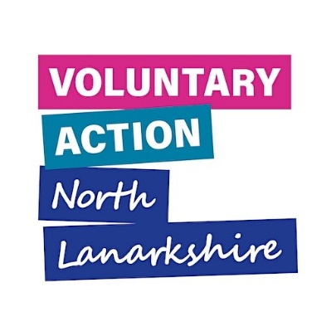



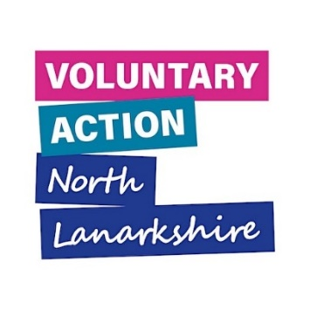

**Community Solutions**

**Reporting Guidance 2025-26**

**Table of Contents**

1. Introduction 3

1.1 Purpose 3

1.2 Overview of the Community Solutions Evaluation Process 2025-26 3

1.3 Community Solutions outcomes 3

2. Reporting Requirements by Fund 5

2.1 Funded Projects 5

2.2 Locality Hosts and LAF 5

3. Resources 8

3.1 Demonstrating Impact Evaluation Toolkit 8

3.2 Service Users’ Feedback Survey for Funded Projects 8

3.3 Guidance for Funded Projects on Preparing Case Studies 8

3.4 Guidance for Funded Projects on Preparing Personal Stories 8

3.5 Guidance for Funded Projects on Care Opinion 8

3.6 Guidance for Funded Projects on Jotform 8

4. Good Practice 9

4.1 Storing Information Safely and Securely 9

# 1. Introduction

## 1.1 Purpose

The purpose of this Guidance is to outline the reporting process for projects funded through the Community Solutions Programme. This document explains:

* which evaluation and monitoring forms are required for each fund
* how to complete them

The range of supporting resources mentioned in this Guidance is also available on the Community Solutions website.

**If you require further support with evaluation, please contact Senior Evaluation Officer, Rebecca Thomson (**[**rebecca.thomson@vanl.co.uk**](mailto:rebecca.thomson@vanl.co.uk)**) or Learning and Improvement Officer, Iris Henzel (**[**iris.henzel@vanl.co.uk**](mailto:iris.henzel@vanl.co.uk)**).**

## 1.2 Overview of the Community Solutions Evaluation Process 2025-26

Projects funded through Community Solutions will be required to report on evaluation at approximately 6 months (mid-project reporting) and 12 months (end of project reporting) into their delivery period.

Evaluation forms will differ between funds but generally include the following information:

* General project information
* Performance reporting – activities and people supported, including whether outcomes were met
* Service User feedback
* Learning and Improvement
* Project income and expenditure
* Volunteer support
* Funded project’s views on VANL support

## 1.3 Community Solutions outcomes

Projects funded through Community Solutions often will have their own intended outcomes. In the evaluation forms we will additionally ask how these outcomes correspond to the Community Solutions outcomes. This allows us a framework to evaluate and demonstrate the accumulative impact of a wide variety of funded projects.

The Community Solutions outcomes are listed below:

|  |  |  |
| --- | --- | --- |
|  | **Group** | **Outcome** |
| **1** | Adults | People feel more connected, included and safe |
| **2** | Adults | People’s health and wellbeing improved |
| **3** | Adults | People feel more informed and aware |
| **4** | Carers | Carers feel more informed and aware |
| **5** | Carers | Carers’ health and wellbeing are improved |
| **6** | Carers | Carers are more able to have a life outside of caring |
| **7** | Children, young people and families | Children and young people’s health and wellbeing improved |
| **8** | Children, young people and families | Family relationships are strengthened |
| **9** | Children, young people and families | Children, young people and families have become more resilient |

# 2. Reporting Requirements by Fund

## 2.1 Funded Projects

All projects should also complete a fund-specific version of the Funded Project Performance Report survey at six and twelve months. These will also be sent to projects 4 weeks ahead of the 6-month and 12-month reporting deadlines over email.

Please complete the correct Fund form below:

* [Children, Young People and Families Mental Health and Wellbeing Fund](https://form.jotform.com/242471756809365)
* [Community Mental Health and Wellbeing Fund 6-month reporting](https://form.jotform.com/250402342706345)
* [Community Mental Health and Wellbeing Fund 12-month reporting](https://form.jotform.com/241572622799366)
* [Community Solutions Thematic Funded Project 6-month reporting](https://form.jotform.com/250402080626345)
* [Community Solutions Thematic Funded Project 12-month reporting (NL-wide)](https://form.jotform.com/250402637958361)

Further guidance on how to complete forms on Jotform can be found on the Community Solutions website.

## 2.2 Locality Hosts and LAF

Reporting for Locality Hosts and LAF is different to the above because of the nature of the fund.

Locality hosts should complete the [Funded Project Performance Report: Locality Hosts](https://form.jotform.com/232533997406060) at six and twelve months.

Locality hosts will also complete the below LAF monitoring spreadsheet.

[Locality Activity Fund Monitoring Spreadsheet - 2024-25 (4).xlsx](Locality%20Activity%20Fund%20Monitoring%20Spreadsheet%20-%202024-25%20(4).xlsx)

Hosts should issue LAF funded projects the below evaluation form, to support them to complete the spreadsheet.



# 

# 3. Resources

The following resources can be found on the Community Solutions website, and used by funded projects to support their reporting.

## 3.1 [Demonstrating Impact Evaluation Toolkit](https://www.communitysolutionsnl.org.uk/wp-content/uploads/Draft-Demonstrating-Impact-Report-Style-1-updated-Feb2025.pdf)

The toolkit is an introduction to the basics of evaluation with links to more detailed resources.

## 3.2 [Service Users’ Feedback Survey for Funded Projects](https://www.communitysolutionsnl.org.uk/wp-content/uploads/Service-User-Feedback-Survey-2024-Version.docx)

This survey can be given to service users by organisations funded through Community Solutions to gather feedback about their experience of the activity/service delivered, to support them to complete their evaluation and monitoring forms.

Funded projects can issue the survey as a word document to service users or provide them with the [JotForm link](https://form.jotform.com/242873282618363). VANL will summarise responses to the JotForm link and share with each organisation.

## 3.3 [Guidance for Funded Projects on Preparing Case Studies](https://www.communitysolutionsnl.org.uk/wp-content/uploads/VANL-Guidance-for-Funded-Projects-on-Preparing-Case-Studies.docx)

A guidance document on preparing project case studies with template.

## 3.4 [Guidance for Funded Projects on Preparing Personal Stories](https://www.communitysolutionsnl.org.uk/wp-content/uploads/VANL-Guidance-for-Funded-Projects-on-Preparing-Personal-Stories.docx)

A guidance document on supporting service users to share their personal stories.

## 3.5 [Guidance for Funded Projects on Care Opinion](https://www.communitysolutionsnl.org.uk/wp-content/uploads/Care-Opinion-Guidance-for-CS-Funded-projects.docx)

A guidance document on how funded projects might interact with Care Opinion as a way of interacting with feedback from service users.

## 3.6 [Guidance for Funded Projects on Jotform](https://www.communitysolutionsnl.org.uk/wp-content/uploads/Community-Solutions-Funded-Project-Jotform-Guidance.docx)

A guidance document on how to complete forms on Jotform.

# 4. Good Practice

## 4.1 Storing Information Safely and Securely

The following guidance outlines how to store your evaluation and monitoring information safely and securely:

* Choose a secure storage method such as a secure cloud storage, database or password protected file
* Keep back-up copies of information in different locations and perform regular updates on laptops/computers
* Protect your devices by using strong passwords or two-factor authentication
* Keep physical files in secure locations
* Keep liquids away from electrical devices
* Limit access to personal information
* Do not keep confidential and personal information for longer than necessary

If you lose your information, or expect you will need an extension, please contact Learning and Improvement Officer Iris Henzel ([iris.henzel@vanl.co.uk](mailto:iris.henzel@vanl.co.uk)) or Senior Evaluation Officer, Rebecca Thomson ([Rebecca.thomson@vanl.co.uk](mailto:Rebecca.thomson@vanl.co.uk)).

(document ends)