

c

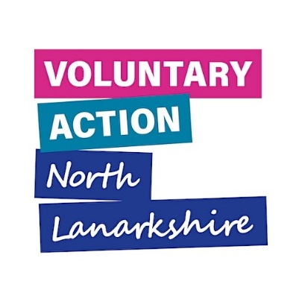


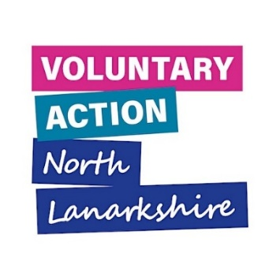
Guidance on JotForm
for Community Solutions funded projects
Contents
1. What is JotForm and why do we use it 3
2. How do I access the right form for my project? 3
3. Saving and Returning to your JotForm 4
4. Submitting your JotForm 5
5. How to change text box size on JotForm 6

1. What is JotForm and why do we use it
JotForm is a website for online surveys and forms. We use it to gather evaluation from Community Solutions funded projects, as well as for other purposes such as the VANL feedback survey. We refer to individual surveys on JotForm as JotForms too.

In this document you will find guidance on using JotForm. If your questions are not answered after reading this, don’t hesitate to get in contact with either:

Rebecca Thomson (Senior Evaluation Officer): rebecca.thomson@vanl.co.uk , or
Iris Henzel (Learning and Improvement Officer): iris.henzel@vanl.co.uk

2. How do I access the right JotForm for my project?
At the 6-month timepoint and at the end of your funded period, Community Solutions funded projects are required to report on their projects.

Ahead of the evaluation deadline, usually 1 month and 2 weeks before the deadline, you will receive an email from the evaluation team with a link to the specific JotForm you are required to complete. Clicking this link will open the form for you and you will be able to start completing it.

3. Saving and Returning to your JotForm
If you would like to return to work on your form later, scroll to the bottom and select ‘Save’.

If you have accessed the JotForm link via your email, this will automatically send a draft copy of the form to your email. If you have not accessed JotForm via your email, the below box will pop up asking you to sign up for JotForm. If you don’t want to sign up, select ‘Skip Create an Account’ and it will allow you to send a draft copy to your email.

Please note, if you are completing the same form for more than one project, you cannot create multiple drafts of a form without submitting. You must either:
- Work on one draft at a time and submit when you are done before moving on to the next form
- Submit the uncompleted form early. This will send you an email with the option ‘Edit this submission’, and you can click this to continue working on the form and resubmit.

4. Submitting your JotForm
When you are ready to submit your form, scroll to the bottom and select ‘Review Answers’. This will allow you to review your answers before you submit the form.
Once you have reviewed your answers, scroll to the bottom and click ‘Submit’ to submit your form to VANL.
If you have accidentally submitted a JotForm you would like to continue working on, check your email inbox for the email confirming that you have submitted the form. At the bottom of this email you will find the “Edit your submission” link. This allows you to edit and resubmit your form.

5. How to change text box size on JotForm
To increase the size of the textboxes on JotForm to make them easier to read, follow the following steps.
Locate the stripes in the bottom right-hand corner of the text box.
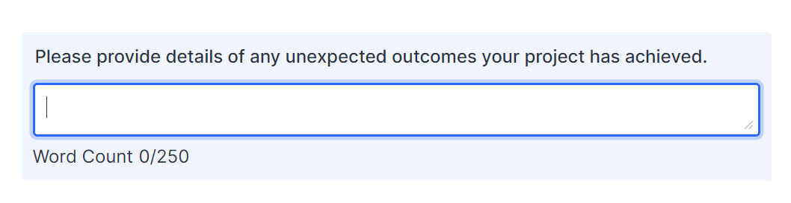
Click and drag down to increase size of the text box. This should increase the readability of your text.
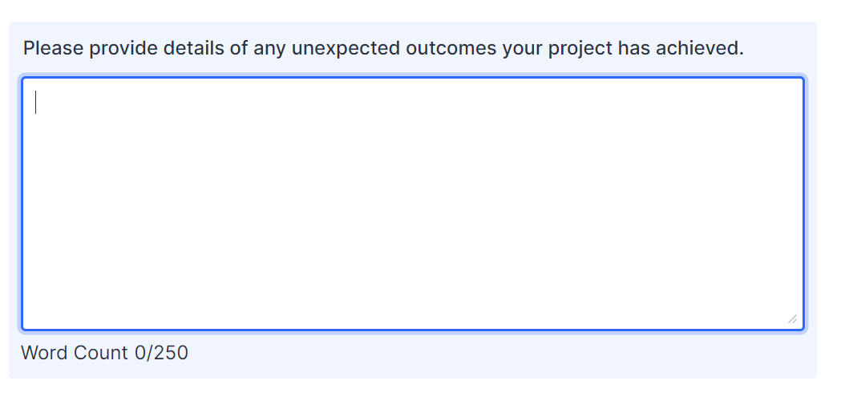

(document ends)

