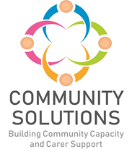

**Carer Breather Fund**

**Impact and Learning Report - Phase Two Year One (2023-24)**

**Phase X (20XX-XX) - Impact and Learning Report**



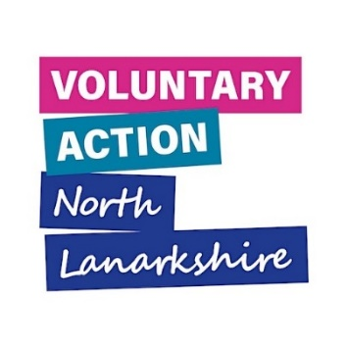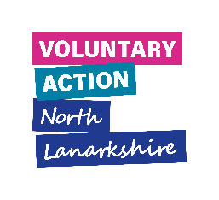

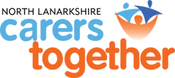

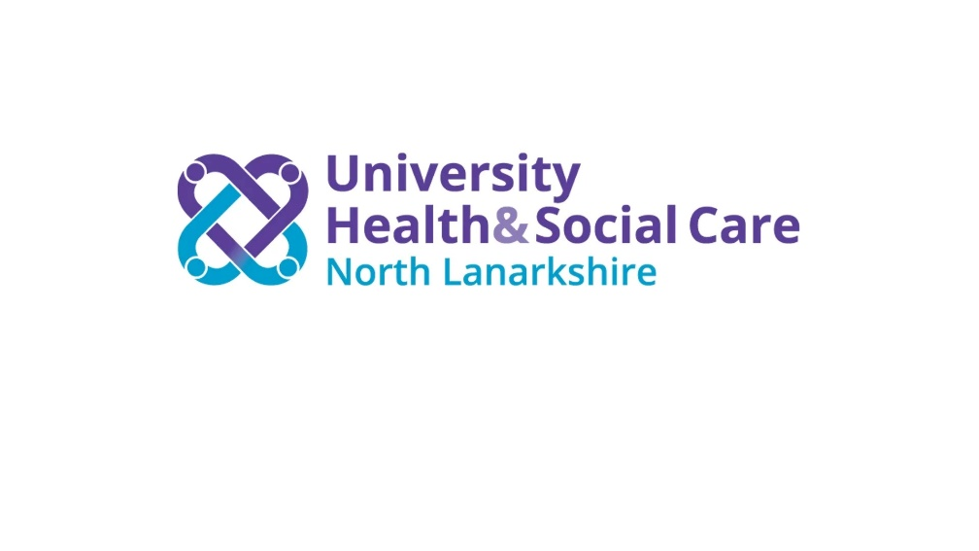

# Contents

1. Introduction – Page 3

2. Overview of Phase Two: Reach and Impact – Page 8

3. Learning – Page 10

**Appendices – Page 17**

Appendix A: Funded Project Summaries – Page 17

Appendix B: Summary of All Funded Projects – Page 29

Appendix C: Case Studies – Page 31

**1. Introduction**

**1.1 Purpose**

The purpose of this report is to share the impact of, and learning from, projects funded in Phase Two of the Carer Breather Fund.

**1.2 Fund Phases**

Phase One of the Carer Breather Fund was established in 2021. Given the success of Phase One, additional funding was agreed for Phase Two, which completes in 2025.

|  |  |  |  |  |  |
| --- | --- | --- | --- | --- | --- |
| Phase | Date | Total Custodian Funding | VANL Delivery Costs | NLCT Delivery Costs | Total Funding (Over Two Years) |
| Phase One | Dec 2021 – Mar 2023 | £248,000 | £82,000 | £20,000 | £350,000 |
| Phase Two | Apr 2023 – Mar 2025 | £543,000 | £30,000 | £27,000 | £600,000 |

**1.3 Aims**

The aim the Carer Breather fund is to enhance and extend regular and locally based support for carers, including:

* Those providing care but who do not necessarily wish to identify with a carers’ organisation
* Carers currently unknown to formal services

**1.3.1 Outcomes**

The Fund was set up to achieve the following outcomes for carers in North Lanarkshire:

* Carers feel more informed and aware
* Carers’ health and wellbeing is improved
* Carers are more able to have a life outside of caring

These outcomes are aligned with outcome 6 of the [Scottish Government Health and Wellbeing National Outcome](https://www.gov.scot/publications/national-health-wellbeing-outcomes-framework/pages/5/) for carers which states that:

“People who provide unpaid care are supported to look after their own health and wellbeing, including to reduce any negative impact of their caring role on their own health and wellbeing”

**1.3.2 Objectives**

Carers in North Lanarkshire will be supported to:

* Enjoy the benefits of regular and ongoing breaks to support caring roles in their neighbourhood
* Access support without having to align themselves with an organisation designed to support carers

**1.4 Funding and Fund Management**

The Carer Breather Fund is funded by [University Health and Social Care North Lanarkshire](https://hscnl.org.uk/) (UHSCNL) to support community and voluntary sector (CVS) organisations in North Lanarkshire to provide ongoing breaks and activities for carers. Delivery of the fund, including the facilitation of the Carer Support Network (CSN), is co-ordinated by North Lanarkshire Carers Together (NLCT).

Voluntary Action North Lanarkshire (VANL) supports this fund as part of the wider Community Solutions Programme, which VANL hosts and manages on behalf of UHSCNL and other funders.

The fund was informed by consultation with carers and support services in North Lanarkshire to better understand carers’ support needs – particularly in relation to the impact of the pandemic on their ability to fulfil their caring role. The consultation was undertaken with the support of the NLCT and the CSN between April to May 2021 and identified that a high priority for carers locally was to have regular, ongoing breaks that they can depend upon on a weekly or fortnightly basis – especially during the period of recovery from COVID-19. The consultation also identified the need to ensure that those who identify as carers but are currently unknown to services are able to find and benefit from such breaks and other relevant services.

**1.4.1 Funding Awards Process**

An open call for applications from CVS organisations was made in late 2022. A cross-sector, independent panel was formed, including carers’ representatives from the North Lanarkshire Carers Together Forum to decide award of funding.

Funding was awarded to 11 organisations. Please see Appendix B for a full list of CVS funded projects in Phase Two.

**1.5 Evaluation, Learning and Improvement**

**1.5.1 Approach**

The Fund’s approach to evaluation, learning and improvement is guided by the Community Solutions Performance Management, Evaluation, Learning and Improvement (PMELI) Framework. The framework sets out the Community Solutions Programme’s approach to performance management, evaluation, learning, and improvement to support funded projects and the programme as a whole. The Framework also sets out standardised measures and relevant supports to help funded projects make the most of their findings.

In line with the framework, funded CVS organisations are required to assess the reach, impact, and outcomes of their work, capturing and sharing learning to inform improvements to their service or activities, and where possible also sharing with other funded projects, the wider CVS, and the health and social care system. Using the framework, VANL staff support funded projects to undertake ongoing evaluation to help facilitate learning and improvement both during and at the end of project delivery.

**1.5.2 Performance Data and Method**

Funded projects are required to capture and share key information with VANL on the following:

* Activities - the type of support provided
* Reach - the numbers of unique individuals supported
* Outcomes - the difference this support made to those receiving support

Funded projects are also asked to measure their project using the Community Solutions outcomes outlined in Section 1.3.1.

Funded projects collect this data at points prior to, during, and post project delivery using a range of different methods, including:

* Written surveys; online or via the phone
* Verbal feedback
* Observations
* Self-assessment methods such as the [Warwick Edinburgh Mental Health and Wellbeing Scale](https://warwick.ac.uk/fac/sci/med/research/platform/wemwbs/)
* ‘What’s Important Now’ (WIN) holistic needs-analysis

Funded projects use this data to complete evaluation forms which are submitted to VANL at the six- and twelve-month mark of the projects. As this funding was over two years, funded projects submitted a mid and end form for each year.

VANL also hosted a Learning and Improvement event for representatives from funded projects. The purpose of these events is to collect feedback from funded projects on their experience of the fund. This feedback informs the delivery of future fund phases and service delivery for projects, as well as helping build and make the case for future investment.

**1.6 Background**

**1.6.1 Community Solutions Support for Carers**

Support for carers has consistently been a key focus of the Community Solutions programme since its inception in 2012, with the programme’s roots in the national ‘Reshaping Care for Older People’ initiative.

In addition to funding this initiative, Community Solutions also provides funding for the North Lanarkshire Carer Support Network (CSN) which has the following aims:

* Support the implementation of the Carers (Scotland) Act 2016
* Develop support, including short breaks for adult and young carers
* Support carer representation within the CSN and Health & Social Care North Lanarkshire locality planning groups
* Support implementation of the Carer Pathway Toolkit.

NLCT are funded through Community Solutions to support the CSN, with the following responsibilities:

* Support carers’ engagement and influence across North Lanarkshire through:
  + Facilitation of the CSN
  + Liaison on carer issues with the NL Community and Voluntary Sector Partnership Group, Home Visiting and Befriending Network, and the Children, Young People, and Families Network
  + Consultation on, and development and implementation of, the Carers’ Engagement Tool (with Equals Advocacy)
  + Supporting implementation of the Carers (Scotland) Act 2016 through active participation in UHSCNL’s Carers’ Strategy Implementation Group

* Provide guidance and support to funded carer projects to strengthen the support that they provide to carers, and to facilitate carer engagement in the CSN and other engagement opportunities

* Work collaboratively and in consultation with carers, CSN, and UHSCNL to determine the support needs of carers – in particular carers unknown to services – and develop proposals for funding

**Many thanks to North Lanarkshire Carers Together and the funded projects which provided information and to the VANL staff who prepared this report.**

**2. Overview of Phase Two: Reach and Impact**

**2.1 Funded Projects and Carers/Cared-for People Supported – Figure One**

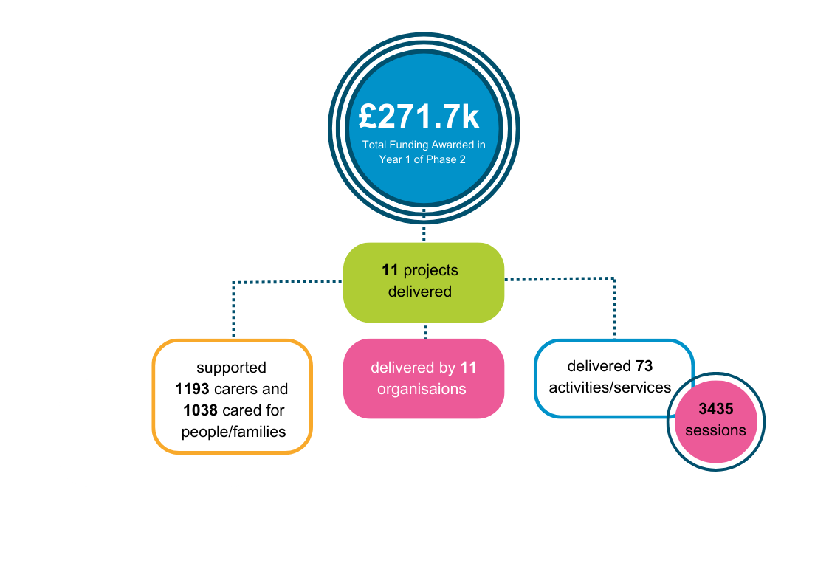[1]

**2.2 Summary of Carers’ Reported Community Solutions Outcomes**

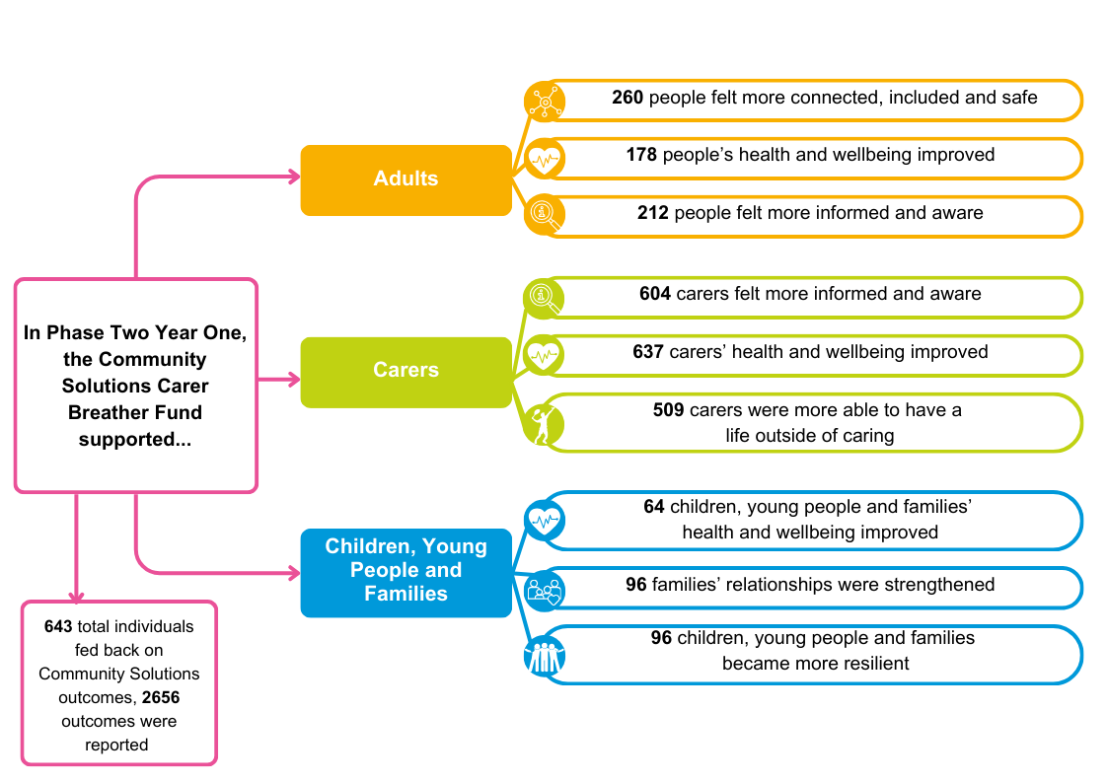

**3. Learning**

**3.1 Phase Two Learning and Improvement Event**

VANL hosted one Learning and Improvements event during Year One of Phase Two for funded organisations – in May 2024. A total of seven out of 11 organisations participated. The purpose of the events was to:

* Facilitate open discussion to promote and support learning and improvements, both to collaboration and the management of the fund, and current and future services
* Focus on solutions to identified challenges
* Inform future plans

The event structure involved a group discussion using the following prompts:

* What, if any, benefits/successes have you noticed from longer term funding?
* How have you found the new online evaluation process?
* Any achievements to date that you are particularly proud of?
* Some projects identified early issues with uptake of the projects, was this something you experienced and is this issue resolved?
* Any challenges you encountered that slowed the progress/stopped the outcomes from happening, and is there anything VANL could change to help with this?

Feedback from these discussions was analysed by VANL staff, with a summary of key themes presented below:

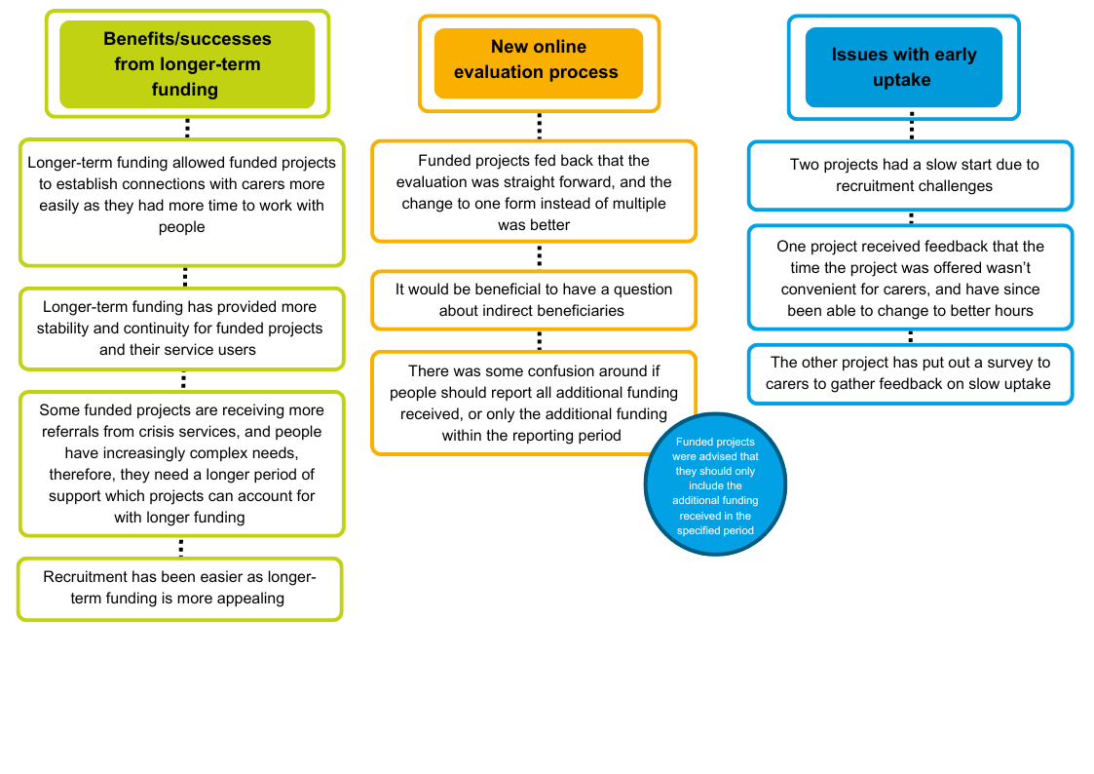

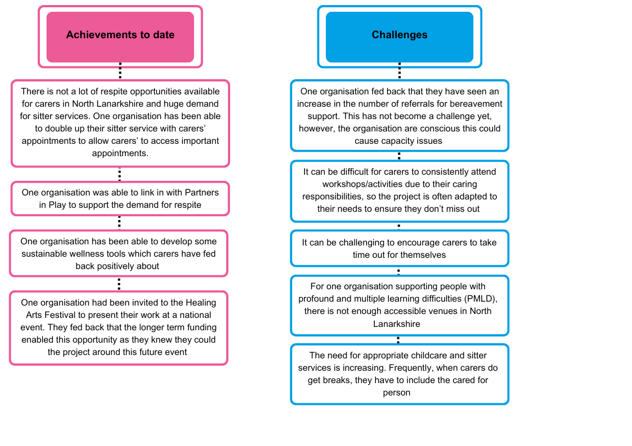

**3.2 Unexpected Positive Outcomes**

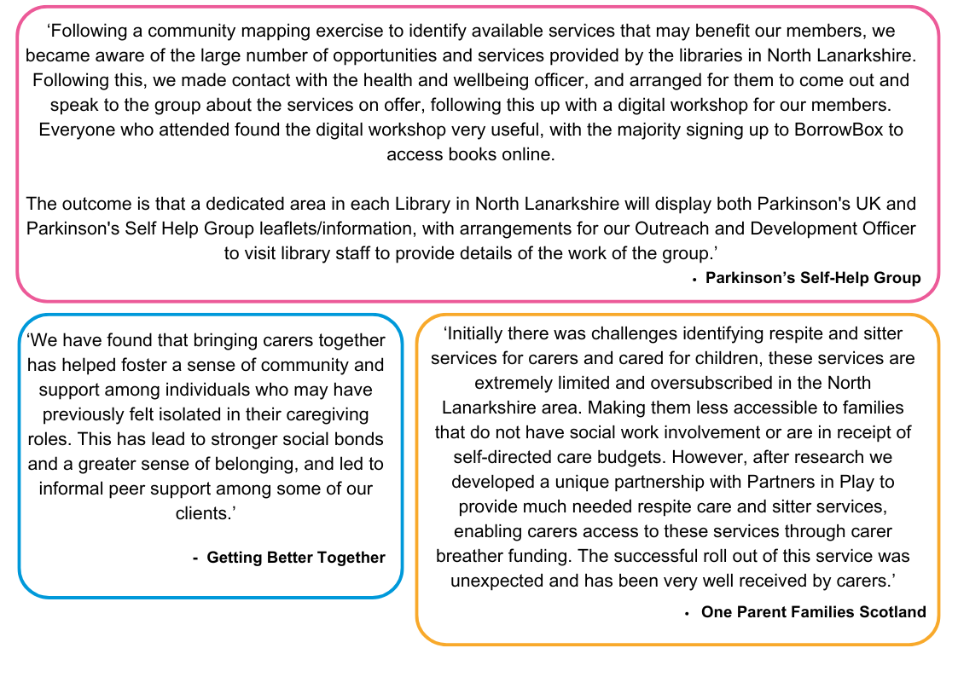In addition to their planned outcomes, funded projects were asked to identify positive but unexpected outcomes. Some examples were:

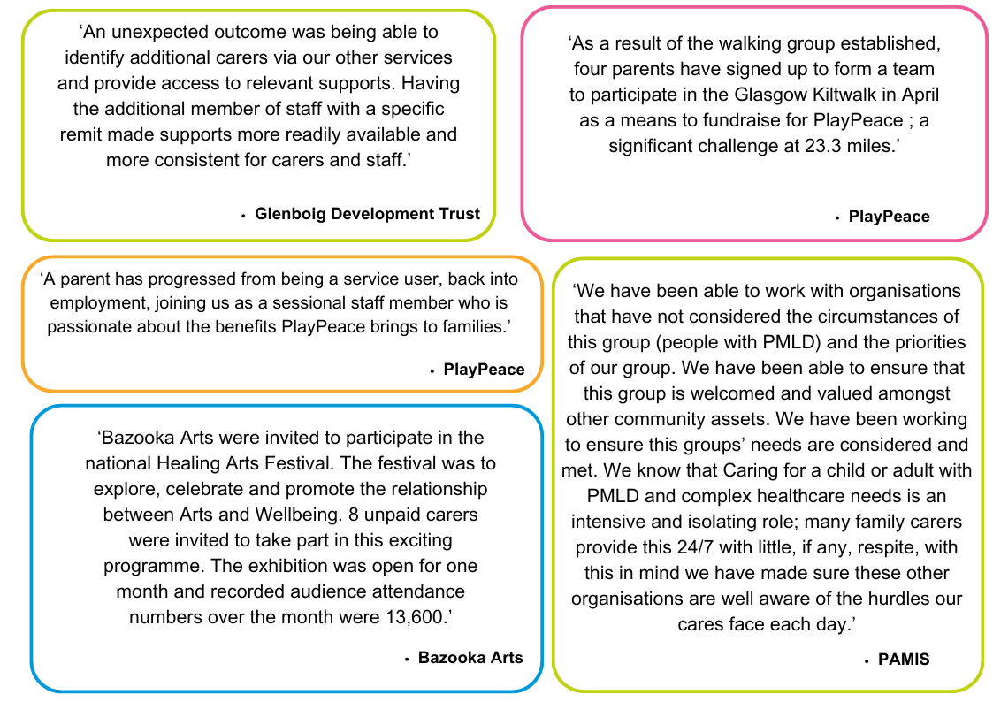

**3.3 Other Feedback from Funded Projects**

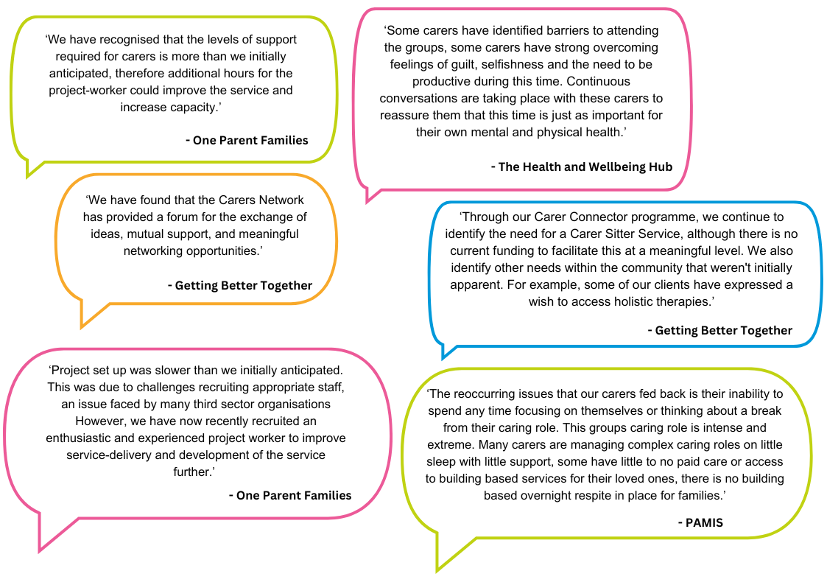Additional, selected feedback from funded projects – provided in monitoring and evaluation reports submitted to VANL – is highlighted below.

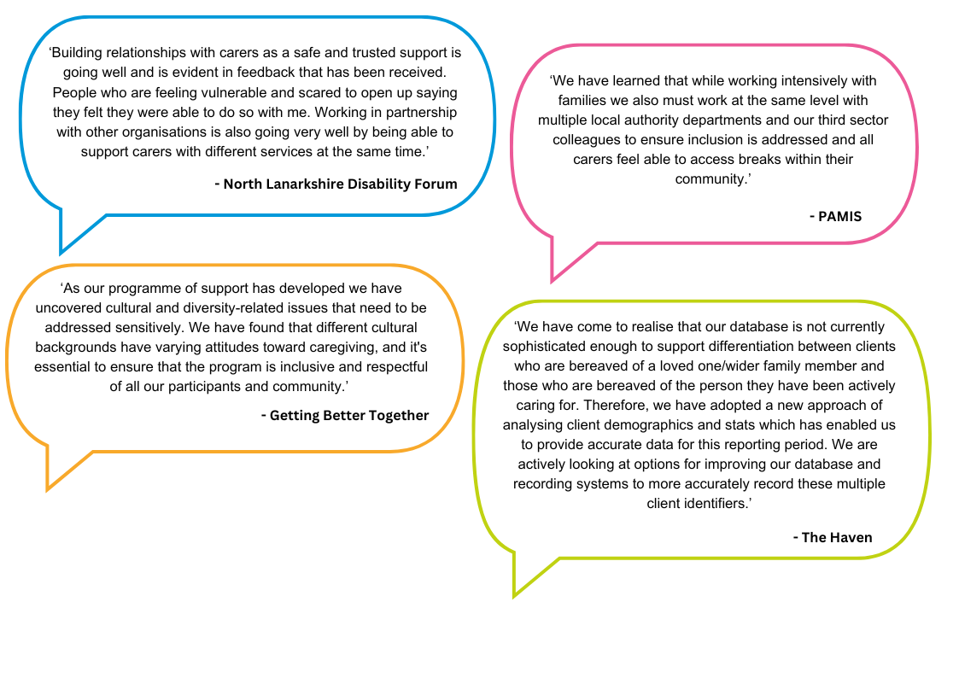

**4. Appendices**

**Appendix A: Funded Project Summaries**

All Phase Two funded projects completed and returned monitoring and evaluation forms to VANL, which were analysed to demonstrate the impact that their services and activities achieved for carers and cared-for people. Summaries from all funded projects’ evaluation reports are provided below.

Each summary includes the:

* Project aim
* Service/activity delivered and reach
* Evaluation method used
* Project outcomes
* Learning and improvement

**Bazooka Arts – Creative and Connected Carers**

**Aim –** To provide carers with creative opportunities to improve mental health and wellbeing, develop friendships beyond their caring responsibilities and access a wider network of supports

**Service/Activity –** 184 in-person and remote therapeutic arts workshops

**Reach –** 61 carers, 28 cared-for people and wider families

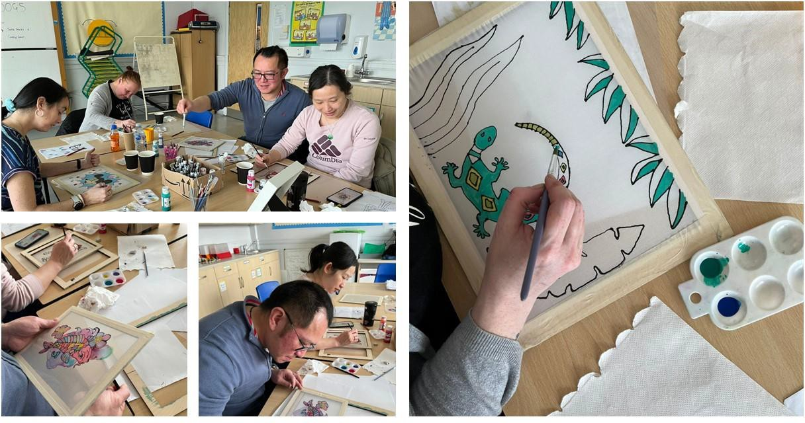**Evaluation Method**

* Group discussion
* 1-to-1 verbal feedback
* Observations

**Outcomes**

This project has:

* Delivered 16 therapeutic visual art sessions, 8 therapeutic drama sessions, 7 therapeutic movement sessions
* Delivered 35 1-to-1 support sessions and wellbeing calls
* Connected with local and national organisations, arts festivals and events including a partnership with Glasgow Print Studio, and participating in the Scottish Mental Health Arts Festival

**Learning**

This project has prompted the organisation to undergo an organisation review, and the review has highlighted areas to work on, including producing a new handbook and registration form, redefining programme boundaries, and strengthening partnership working to support referrals and signposting. The organisation also delivered a higher number of taster sessions or shorter programmes to increase reach and access for new referrals.

**Getting Better Together – Caring Matters**

**Aim –** To allow carers to access a break from their caring responsibilities and provide engaging activities for cared-for individuals, whilst increasing awareness about carers rights and the supports available

**Service/Activity –** Weekly carer support group and socialisation, and Carer Champion working directly with carers to identify and access activities and supports in their own community

**Reach –** 74 carers, 167 cared-for people and wider families

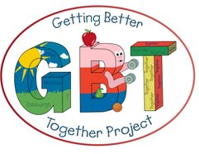**Evaluation Method**

* 1-to-1 and group verbal feedback
* Surveys
* Case studies

**Outcomes**

This project has:

* Delivered 50 sessions of the weekly carer support group
* Delivered 25 afternoon teas, one tea dance, and two-day trips
* Delivered 75 sessions of in person group activities
* Provided 75 sessions of online support

**Learning**

* The project found that bringing cares together has helped foster a sense of community and support amongst individuals who previously felt isolated in their caregiving roles. This has led to informal peer support among some service users.
* The Carer Champion has identified systemic issues or gaps in policies that affect service users’ lives, and has supported them to become directly involved in consultations and forums that may improve support for carers.
* There is still a need for a Carer Sitter service, although there is no funding to facilitate this.

**Glenboig Development Trust – Carer Breather Sitter Service**

**Aim –** To empower carers to take control of their own health and social needs by accessing a break from caring

**Service/Activity -** Providing a volunteer staff member to ‘sit’ cared-for people (engaging them in activities or spending time with the person), to allow carers to access a break from their caring role

**Reach –** 74 carers,152 cared-for people and wider families

**Evaluation Method**

* Verbal feedback
* Self-assessment

**Outcomes**

This project has:

* Delivered 528 sessions of the sitter service
* Delivered 423 sessions of their carer befriender to access group and 480 sessions of group befriending for carers
* Made 575 telephone befriending calls
* Provided 32 people with advice, support, and signposting

**Learning**

* The project felt that having the additional member of staff with a specific remit made the supports more readily available and more consistent for carers and staff
* The project was able to identify carers through other services and projects and provide access to relevant supports

**North Lanarkshire Disability Forum – The Little Care Hub**

**Aim –** To arrange and facilitate in person information and support sessions for unpaid carers and the people they care for to improve mental health and wellbeing

**Service/Activity –** 1-to-1 and group support sessions including health and wellbeing activities and sustainable wellness tools

**Reach –** 70 carers, 36 cared-for people and wider families

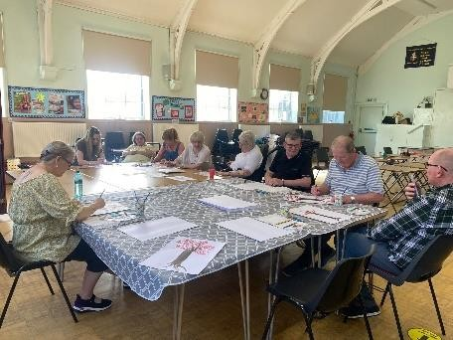

**Evaluation Method**

* Verbal feedback
* Personal stories
* Pictures of participation

**Outcomes**

This project has:

* Delivered 3 sessions of an Art Therapy course as requested by carers
* Delivered a block of 6 sessions with a multiple sclerosis group
* Delivered 6 sessions of 1-to-1 support
* Delivered a block of 3 sessions with young carers

**Learning**

* The project lead fed back that they would like to develop a more refined variety of workshops. The project is carer-led so it is flexible, but the project lead found that sometimes people respond well to more guided activities
* The project is looking at starting new groups where there is need and additionally offering 1-to-1 session for a more tailored experience for carers
* One group of carers who enjoyed the Art Therapy course fed back that they were going to order art supplies so they could continue to benefit from this support

**One Parent Families Scotland – Connecting Carers**

**Aim –** To support single parent family carers to access support services and breaks from their caring role

**Service/Activity** – Sitter service and provision of flexible breaks, and signposting to other services

**Reach –** 42 carers, 11 cared-for people and wider families



**Evaluation Method**

* Written evaluation forms
* Verbal feedback
* Case studies

**Outcomes**

This project has:

* Delivered 102 sessions of 1-to-1 support
* Provided childcare for 1 carer, supporting 3 cared-for people/wider family members
* Provided 17 carers with financial advice and support
* Supported 7 carers and their families to access family outings and short breaks

**Learning**

* There were initially some challenges identifying respite and sitter services for carers and cared-for children as these services were limited and oversubscribed in North Lanarkshire. The project developed a partnership with Partners in Play to provide respite and sitter services. This has been very well received by carers.
* Moving forward, the project aims to work with Partners in Play and organisations such as Take Control North Lanarkshire (a centre for inclusive living to support families to access specialist information and advice on care budgets, additional grants, and funds to help promote inclusive living
* The level of support required for carers has been more than initially anticipated. Additional hours for the project-worker could improve the service and increase capacity.

**PAMIS – Family Carer Support Service**

**Aim –** To offer support to family members caring for a person with Profound and Multiple Learning Disabilities (PMLD)

**Service/Activity ­**– 3-day Family Support Service providing support, advice, and information

**Reach –** 141 carers, 40 cared-for people/wider families

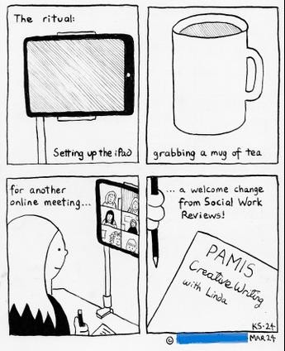

**Evaluation Method**

* Verbal feedback
* Written feedback in ‘Suggestions and Comments’ book

**Outcomes**

This project has:

* Provided intensive 1-to-1 support to eight carers, over 56 sessions
* Delivered two information sessions
* Delivered a range of activities including six sessions of a family friendship club, 16 sessions of yoga, one cold water therapy session, four creative writing sessions and nine pottery/arts sessions

**Learning**

* This funding has enabled the project to work with organisations that have not considered the circumstances of carers supporting people with PMLD, to ensure their needs are considered
* The project has highlighted that carers feel unable to spend any time focussing on themselves or thinking about a break from their caring role. The caring role of this group of carers is intense and complex. The project has learned that when working with families, they must also work with multiple local authority departments and Community and Voluntary Sector (CVS) colleagues to ensure they are included and carers feel able to access breaks within their community.

**Parkinson’s Self-Help Group - Time for Me**

**Aim –** To encourage and nurture peer support networks for carers to improve quality of life and wellbeing

**Service/Activity –** Provision of education sessions, complimentary therapies, weekly support groups for carers, and outreach work with a focus on condition specific needs

**Reach –** 135 carers, 370 cared-for people/wider families



**Evaluation Method**

* Community Solutions Service User Feedback Survey
* Verbal feedback from members and staff
* Volunteer observations

**Outcomes**

This project has:

* Provided 29 carers with 65 sessions of complimentary therapies
* Hosted 15 carer peer support group sessions
* Hosted 65 community lunches
* Delivered 6 sessions of positive mental health activities and 7 physical health activities
* Hosted 8 drop-in community information events

**Learning**

* The project completed a community mapping exercise to identify available services that may benefit their members, and as a result became aware of opportunities and services provided by libraries in North Lanarkshire. The project arranged for a talk about these services and a digital workshop, and most attendees signed up to use the BorrowBox service to access books online
* Going forward, the project would like to increase interagency and intergenerational working, raising awareness of Parkinson’s and local support available
* The project fed back that the introduction of the Memory Days has been popular. Two sessions were hosted where members shared memories of school and weddings.

**PlayPeace – PlayPeace Cares**

**Aim –** To reduce social isolation by providing access to short breaks to parent carers and other carers of children and young people with additional support needs

**Service/Activity –** Peer support groups and wellbeing activities recognising parent carers role

**Reach –** 361 carers, 94 cared-for people/wider families

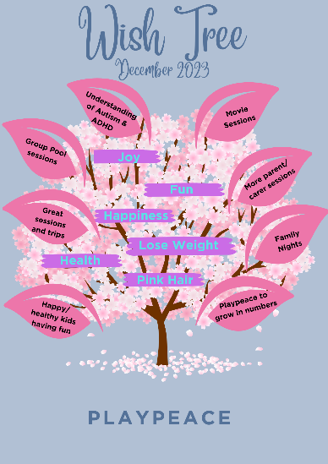

**Evaluation Method**

* Online written feedback from online platform
* Verbal feedback

**Outcomes**

This project has:

* Hosted two online support and information platforms: a closed Facebook group and a WhatsApp support group
* Delivered seven parent carer support sessions at the Healing Cave
* Hosted festive events included three festive family short breaks, a Christmas and New Years’ Day family celebration
* Delivered 5 sessions of a walking group

**Learning**

* The project fed back that the parent carer peer support group has been beneficial in prompting parents to gain knowledge on how to navigate available services from advice and lived experience of others.
* From the walking group, four parents have signed up to participate in the Glasgow Kilt walk to fundraise for PlayPeace
* The project found that the range of activities delivered were well received and there has been demand for more of the same, which has shaped the development of the project going forward

**The Haven – Carer Support**

**Aim –** To provide emotional and wellbeing support to unpaid carers providing care to loved ones who are affected by life-limiting illnesses

**Service/Activity –** 1-to-1 emotional, wellbeing and pre/post bereavement supportive services, and provision of a wellbeing toolkit

**Reach –** 73 carers

**Evaluation Method**

* Holistic ‘What’s Important Now’ (WIN) needs self-assessment framework
* [Warwick Edinburgh Mental Health and Wellbeing Scale](https://warwick.ac.uk/fac/sci/med/research/platform/wemwbs/) (WEMWBS)
* Staff observations
* Database recording client engagement with activities and use of toolkit resources

**Outcomes**

This project has:

* Delivered 111 sessions of 1-to-1 emotional support to 44 carers
* Delivered 22 sessions of 1-to-1 wellbeing support sessions to nine carers, including relaxation and mindfulness
* Provided therapeutic resources through the wellbeing toolkit 23 times

**Learning**

* The project held a trial session of a potential new wellbeing service (massage and therapeutic touch for people with dementia). This session involved carers and cared-for people affected by dementia, which demonstrated gentle touch and massage technique the carer could use with their loved one. Carers found this beneficial, and were observed to be relaxed. This feedback will be used to inform the development of this activity
* The project found that as they have returned to in-person centres post-Covid, it has been easier to collect survey responses from clients

**The Health and Wellness Hub – Wraparound Wellbeing Support Programme**

**Aim –** To support isolated carers to access opportunities to improve their health and wellbeing, their connections with their communities and their life chances

**Service/Activity** – Emotional, social, and physical wellbeing supports including massage, group exercise, specialised treatments, and peer support

**Reach –** 116 carers. 13 cared-for people/wider families

**Evaluation Method**

* Pre and post self-assessment survey

**Outcomes**

This project has:

* Delivered 10 activity classes including chair-based exercise, body balance, Zumba, and chair yoga
* Delivered 11 sessions of group wellbeing activities including arts and crafts, sound bath, meditation, self-massage, and a quiz
* Delivered 36 weekly peer support groups
* Hosted 18 group lunches
* Provided 137 holistic therapies to carers

**Learning**

* The project fed back that some carers identified barriers to attending the groups. Some carers have strong feelings of guilt, selfishness, and feeling the need to be productive during the session time. The project has had continuous conversations with these carers to reassure them that this time is just as important for their own mental and physical health

**Watch Us Grow – Carer Breather**

**Aim –** To support carers to experience regular, dependable respite opportunities

**Service/Activity** – 2.5 hour evening activities and respite, and 6 hour activities delivered 5 days a week

**Reach –** 46 carers, 87 cared-for people/wider families

**Evaluation Method**

* Verbal feedback
* Attendance numbers

**Outcomes**

This project has:

* Helped carers to access regular breaks through
* 120 sessions of weekday replacement care activities
* 24 sessions of Tuesday night replacement care activities
* 24 sessions of Thursday night replacement care activities

**Appendix B: Summary of All Funded Projects**

**Learning**

* The project uses ongoing learning to be responsive to service user’s needs, as service users are given the opportunity to identify what activities they would like
* The project uses a ‘two-pronged’ approach by delivering a purposeful, education activity regularly for the cared-for person, whilst also providing respite for the carer

|  |  |  |  |  |
| --- | --- | --- | --- | --- |
| **Organisation** | **Project** | **Total Funding Award (£)** | **Number of unique individuals supported** | |
| **Cared-for people & wider families supported** | **Carers supported** |
| B.1 Bazooka Arts | Creative and Connected Carers | 21,848 | 28 | 61 |
| B.2 Getting Better Together | Caring Matters | 27,212 | 167 | 74 |
| B.3 Glenboig Development Trust | Carer Breather Sitter Service | 20,760 | 152 | 74 |
| B.4 North Lanarkshire Disability Forum | The Little Care Hub | 28,052 | 36 | 70 |
| B.5 One Parent Families Scotland | Connecting Carers | 27,322 | 11 | 42 |
| B.6 PAMIS | Family Carer Support Service | 24,168 | 80 | 141 |
| B.7 Parkinson’s Self-Help Group | Time for Me – a life alongside caring | 25,845 | 370 | 135 |
| B.8 PlayPeace | PlayPeace Cares | 21,918 | 94 | 361 |
| **Organisation** | **Project** | **Total Funding Award (£)** | **Number of unique individuals supported** | |
| **Cared-for people & wider families supported** | **Carers supported** |
| B.9 The Haven | Carer Support | 27,487 | 0 | 73 |
| B.10 The Health and Wellness Hub | Wraparound Wellbeing Support Programme | 26,476 | 13 | 116 |
| B.11 Watch Us Grow | Carer Breather | 20,565 | 87 | 46 |
|  | **TOTAL** | **271,653** | **1038** | **1193** |

**Appendix C: Case Studies**

This section provides four case studies from projects funded in Phase Two. These case studies are illustrative of the range of great work that has been done by all organisations and have been selected to highlight the variety of services provided.

**C.1 The Haven – Massage for People Living with Dementia**

**Background**

The Haven’s Wellbeing Practitioner received 1-day training in massage for people living with dementia from a specialist trainer, and was able to transfer this learning in practical way to the Haven’s clients. The training involved:

* How to communicate with a person living with dementia
* How to gain consent when verbal communication/capacity may be limited in dementia clients
* Implementing therapeutic touch techniques with dementia clients
* How to work with carers including validating their experience, encouraging them and using knowledge of communication styles/dementia/self-awareness and regulation to help the carer make sense of dementia
* How to navigate compassionately with their loved one
* How to teach carers simple therapeutic touch techniques to aid communication, relaxation and compassionate communication, to support co-regulation (relaxation/lowered stress levels), and support disconnections in relationships as a result of illness

**Intervention**

Three families (a carer and person living with dementia) were invited by the Haven Nurse to:

* Receive and experience therapeutic touch/massage from the Haven Wellbeing Practitioner
* Learn how to provide simple therapeutic touch techniques to their loved one
* Provide feedback about the session and be an equal partner in the shaping, designing, development and delivery of the Haven services

Prior to the session, clients were consulted by the Wellbeing Practitioner on medical and wellbeing information to inform the interventions given.

**Outcome**

One couple – a man living with dementia and his wife who is his carer, were invited to the session. The man (M) could be agitated and did not like to be separated from his wife. The woman (W) could be very stressed due to the demands of her caring role. W was provided with a therapeutic touch teaching session to support her with her stress levels.

During the session, the Wellbeing Practitioner worked with W to help her recognise her own levels of stress. It was gently highlighted to W that her levels of stress may impact M’s level of distress. It was also highlighted to W how M might be feeling living with dementia e.g. fearful, highly anxious, and lost. W was assured that by addressing her stress and how M might be feeling, she could learn to co-regulate with her husband.

W was initially quite nervous at how her husband would react at first. She was reassured that this was a safe, non-judgemental space.

M did not want to receive therapeutic touch; however, it was observed that he became more relaxed from being in the room whilst his wife was relaxing. The couple’s conversation opened up. Whilst initially averse to touch, M gradually allowed W to hold his hand, and then allowed W to utilise a pressure point at the back of his knee to relieve knee pain.

There was an observable difference in the couple’s demeaner by the end of the session – they both seemed calmer and more relaxed. W fed back that she found the session beneficial, and both clients were keen to participate in more sessions.

The learning from these sessions will be used to shape future services.

**C.2 PAMIS – Family Carer for PMLD**

**Background**

S is a 7-year old girl with PMLD. She lives at home with her mum and dad. S’s condition means she is unable to walk, is non-verbal, has limited understanding, and becomes distressed easily. S requires 24-hour care as she has complex health needs and cannot be left alone without significant risk. Her parents have received little support from external services, and her parents have no close family around them to offer them a break.

S’s parents were introduced to the PAMIS Family Support Director at a school parent’s night. It was decided that a PAMIS staff member would visit the family home to discuss the services PAMIS provides, and to find out what type of support and services the family felt they needed.

**Intervention**

The home visit identified a number of issues causing stress and concern for the family. Their home environment was not meeting the family’s needs, there was no input from social work and no help with care, no support from extended family, and finances were extremely restricted as both parents were unable to work due to their caring role. A clear plan was made with the family by PAMIS staff to address each concern and offer emotional support throughout.

The PAMIS staff member did the following:

* Completed a Family Fund application with the family, to access funded equipment that would benefit S.
* Made an appointment with Citizen’s Advice to complete a benefit check to maximise income
* Contacted social work and the housing department to establish a link to further support
* Provided the family ongoing emotional support

**Outcome**

After a few weeks of support, the family were able to start attending other PAMIS activities where they met other carers with similar circumstances. The family have now become regular attendees together or individually as carers. Work with this family is ongoing, however, great progress has been made already, with the mother feeding back:

‘No one told us we could get help. PAMIS have introduced us to lots of other families and helped us with so many things. I feel so much better knowing I can call and get help when I feel stressed with all that S needs.’

**C.3 North Lanarkshire Disability Forum – Wellness Sessions**

**Background**

The Little Care Hub project at North Lanarkshire Disability Forum (NLDF) gives carers a regular break from their caring role in the form of a break or activities. The Little Care Hub is flexible to meet the needs of carers, offering 1-to-1, group, or family sessions and can include cared-for people. There are three elements to the sessions; wellness, information and sharing.

**Intervention**

Through the Little Care Hub, NLDF delivered a block of wellness sessions for 8 carers to access three sessions of various wellness topics including:

* Reiki
* Sound bath/healing
* Cold water therapy
* Indian head massage
* Positive thinking and more

Taxis were arranged for those who don’t drive so that the project was easily accessible for anyone who wanted to attend. Each carer also got a gift card for a free treatment of their choice at the end of the block of sessions.

One of the aims of the project was to produce sustainable wellness tools so the sessions provided information on how to continue each wellness topic at home.

**Outcome**

Carers have fed back asking for more sessions, and NLDF are already planning their next block, and looking at extending the sessions in different ways in line with feedback. Some of the feedback they have received is asking for sessions with children, and day retreats.

Carers have also fed back that they are implementing the sustainable wellness tools at home, which is having a positive impact on their wellbeing. Some key words have been identified summarising how the carers felt after the sessions:

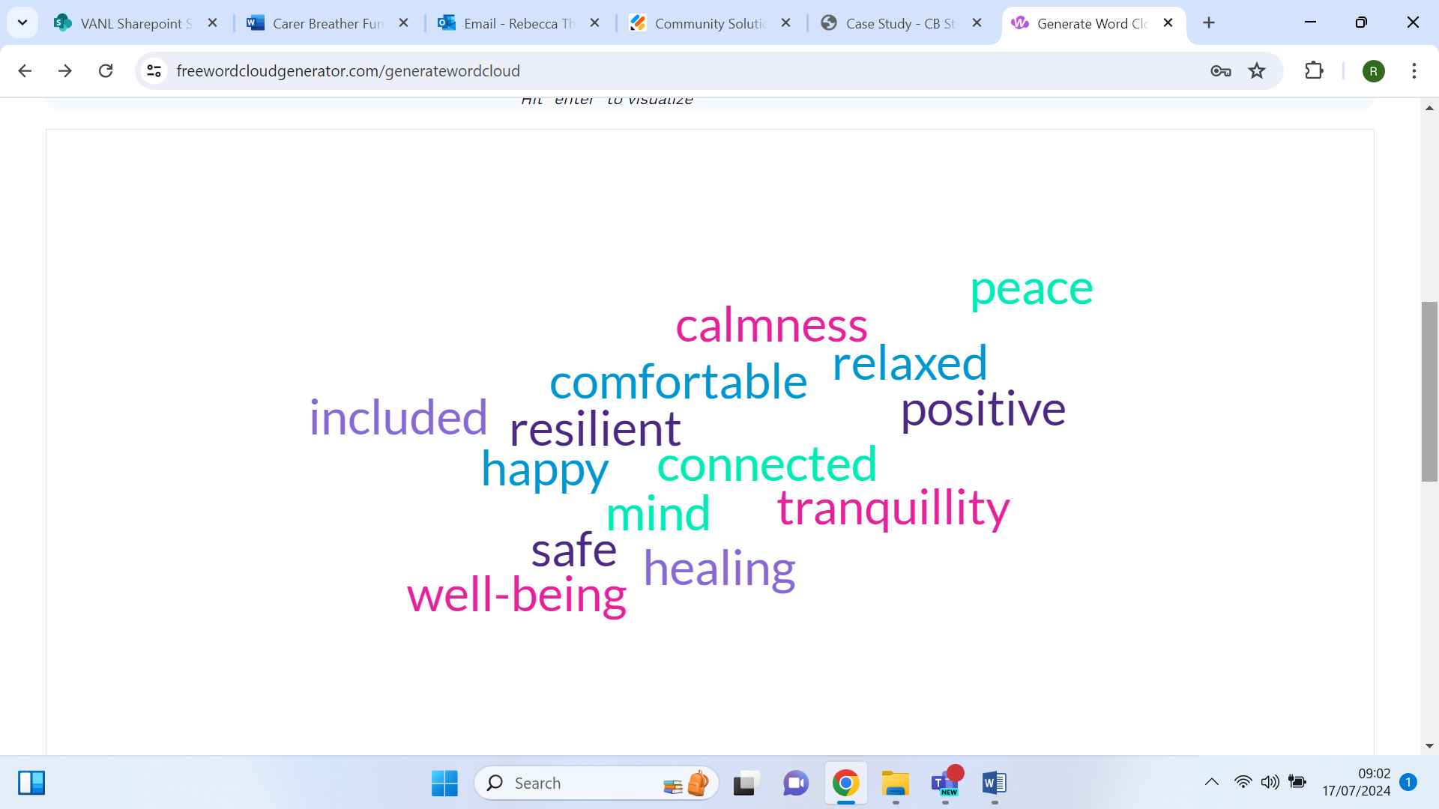

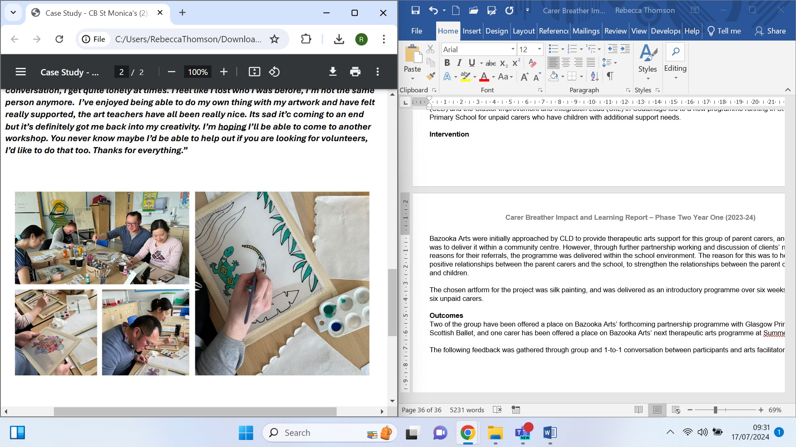**C.4 Bazooka Arts – Therapeutic Arts Group for Unpaid Carers**

**Background**

Between October 2023 and March 2024, Bazooka Arts have been working to strengthen their referral and signposting pathways to increase access to their programmes, and to support participant progression to new community-based opportunities or other support services. A recent, successful partnership with North Lanarkshire Council (NLC) Community Learning and Development (CLD) and the Cluster Improvement and Integration Lead (CIIL) in Coatbridge led to a new programme running in St Monica’s Primary School for unpaid carers who have children with additional support needs.

**Intervention**

Bazooka Arts were initially approached by CLD to provide therapeutic arts support for this group of parent carers, and the intention was to deliver it within a community centre. However, through further partnership working and discussion of clients’ needs and reasons for their referrals, the programme was delivered within the school environment. The reason for this was to help foster positive relationships between the parent carers and the school, to strengthen the relationships between the parent carers, school, and children.

The chosen artform for the project was silk painting, and was delivered as an introductory programme over six weeks to a group of six unpaid carers.

**Outcomes**

Two of the group have been offered a place on Bazooka Arts’ forthcoming partnership programme with Glasgow Print Studio and Scottish Ballet, and one carer has been offered a place on Bazooka Arts’ next therapeutic arts programme at Summerlee Museum.

The following feedback was gathered through group and 1-to-1 conversation between participants and

arts facilitators:

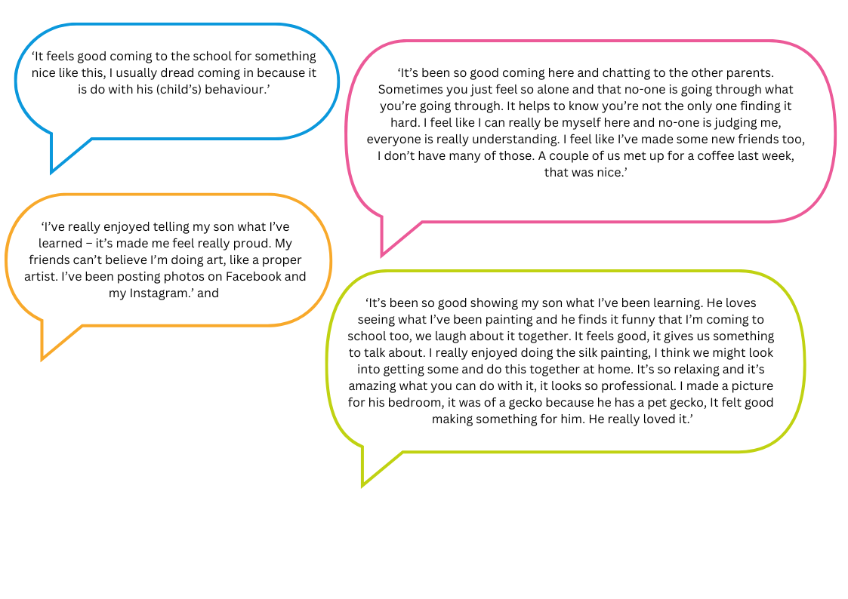

[Document ends]

1. The number of carers and cared for people/families reported is the number of unique individuals supported, and therefore, may differ from the number of carers/cared for people reported in the Carer Census.