Care Opinion - February 2025



# What is Care Opinion and how does it work ?

[Care Opinion](https://www.careopinion.org.uk/info/about) is a website where people of all ages can share their experiences, positive or critical, of the services they have used from University Health and Social Care North Lanarkshire. They welcome views from service users, carers, friends and family members and encourage people to feedback on their experience. Care Opinion staff moderate all posts, they do not publish anything irrelevant, offensive language and any criticism of services needs to be constructive.

Once their story has been received, a notification is sent to the appropriate team and a response should be provided by the representative of the team involved.

Care Opinion is an impartial organisation and is all about connection, collaboration and change. They make it safe and simple for people to share their story online and see other people's stories too. You can see how stories are leading to change.

By sharing honest experiences of Health and Social Care, we learn to see the world differently. Working together, we can all help make care better.

# Care Opinion - University Health and Social Care North Lanarkshire

Within University Health and Social Care Partnership North Lanarkshire, we value the voices of everyone who uses Health and Social Care services. We receive a high level of comment from people who use our Health services, but we‘d like to hear more from people who use Social Work services too. We believe that every experience matters and are committed to increasing the visibility and feedback for all users.

By encouraging feedback from those who use our services, we plan to use this information to improve and shape the future of Health and Social Care, ensuring that it meets the needs of all individuals and communities.

To this end, we would ask that you ask the people you are in contact with to provide their opinions on our services.

If you'd like more information or promotional materials, please contact QAResourceWorkers@northlan.gov.uk

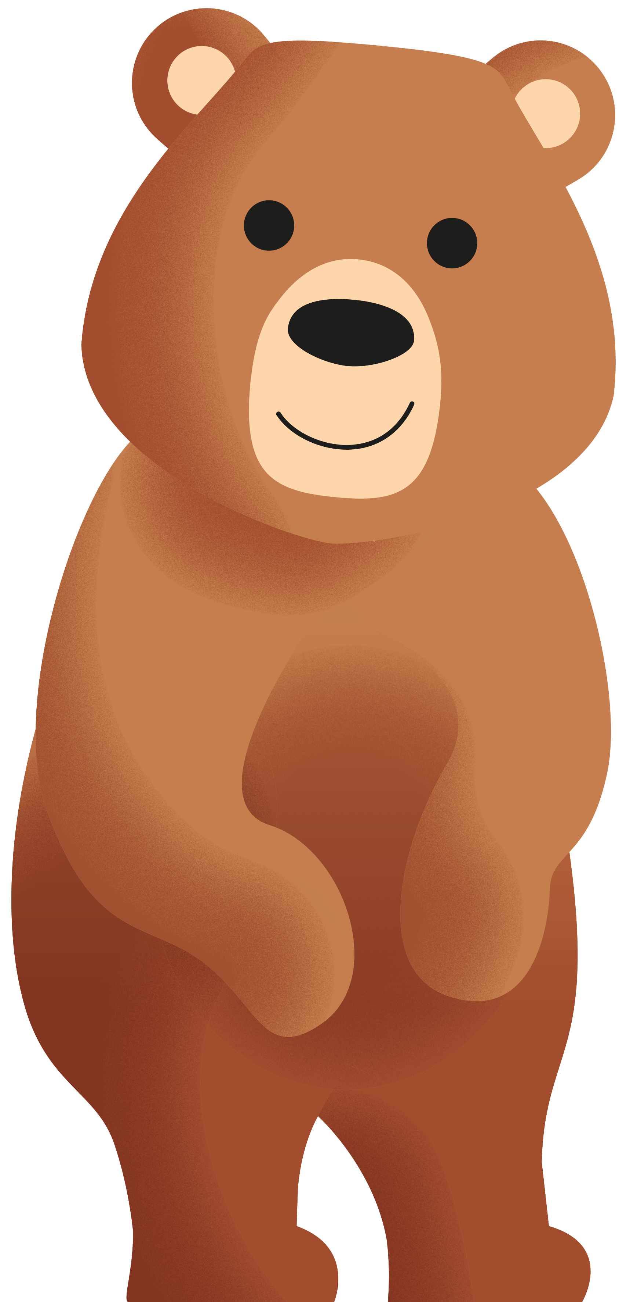

Care Opinion is not just for adults, children can share their experiences too with the help of Bear.

Bear has been introduced to make it easier for children and young people to submit their stories as their voice is important too. Guidance is available [here](https://www.careopinion.org.uk/info/cyp-story-telling) to support them to do this.

Children under the age of 12 are asked to seek permission from a Parent or Guardian before submitting their story and advice is given to ensure that they keep safe online.

# Our stories

In the third quarter of 2024/25, **University Health and Social Care Partnership North Lanarkshire** received a fantastic **99** stories on Care Opinion from members of the public as shown in the slides below:

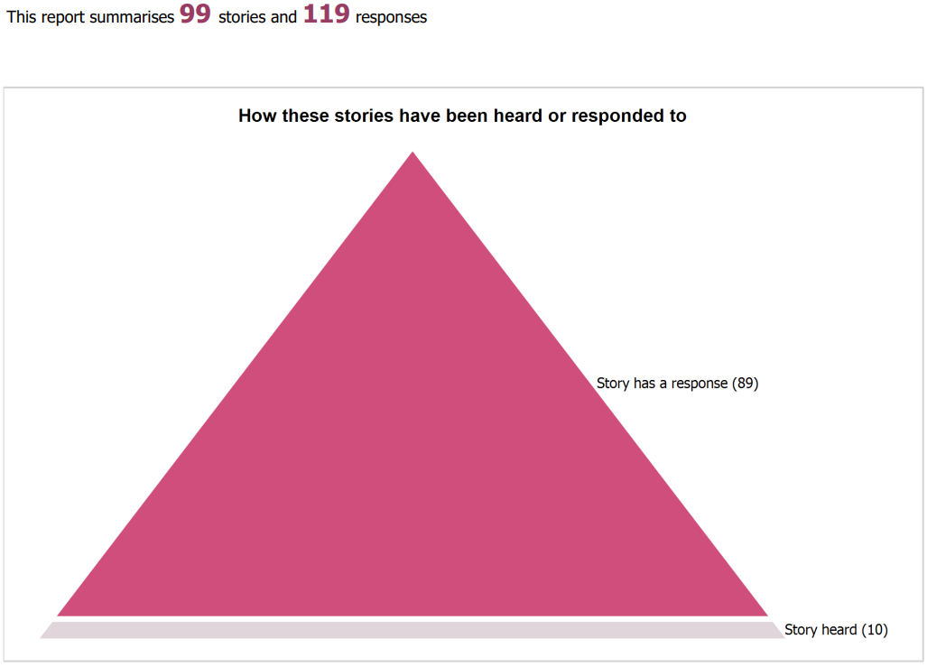

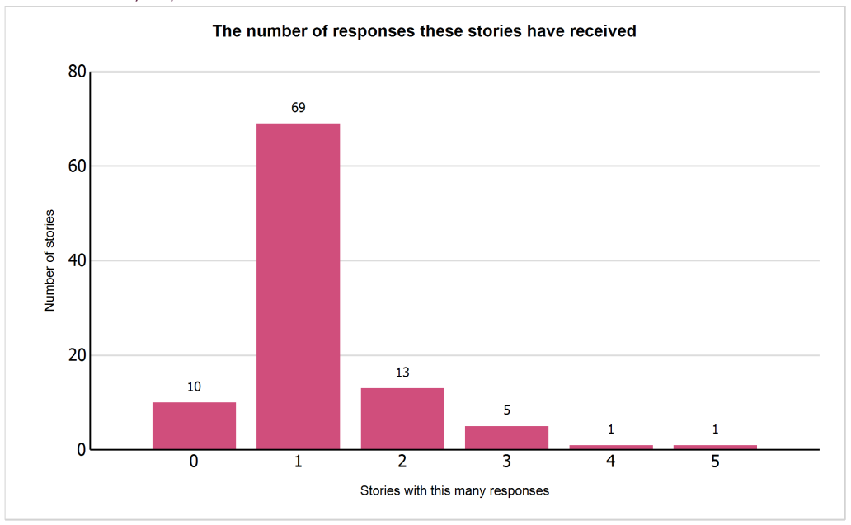

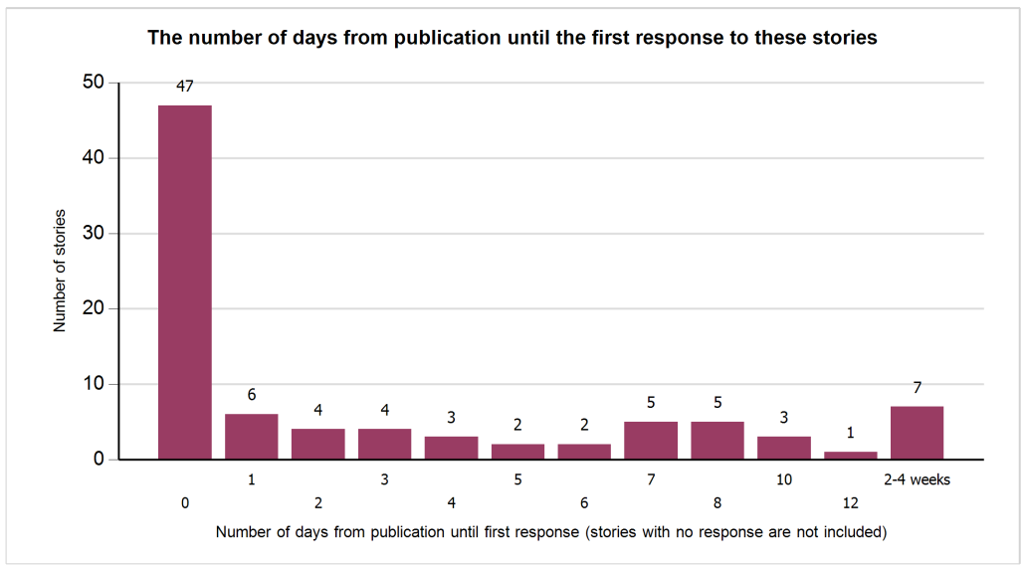

While there is always potential for improvement, it is noteworthy that 75% of the feedback received was positive.

We've noted that communication is our most common area for improvement. We're committed to getting better at this and will keep striving to make our interactions clearer and more effective.

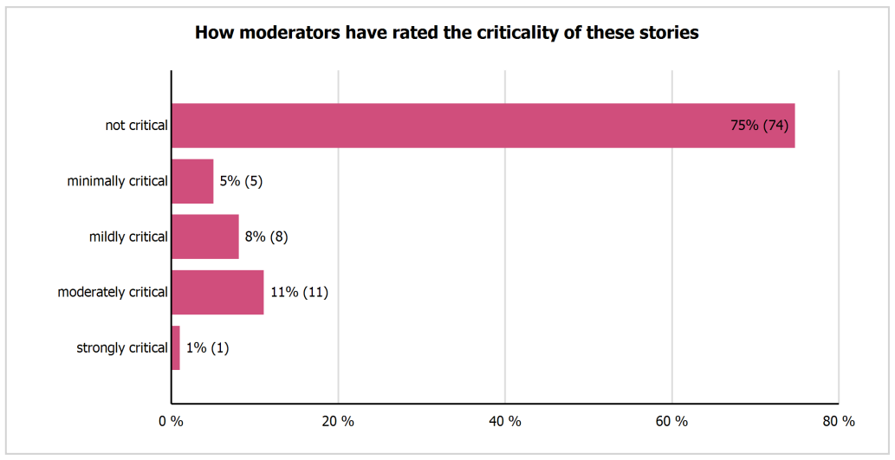

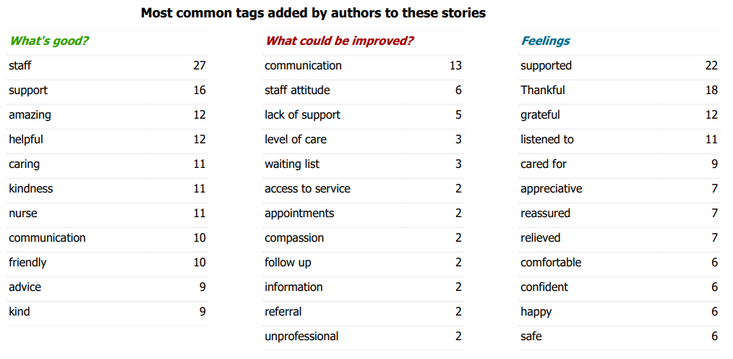

# Positive feedback

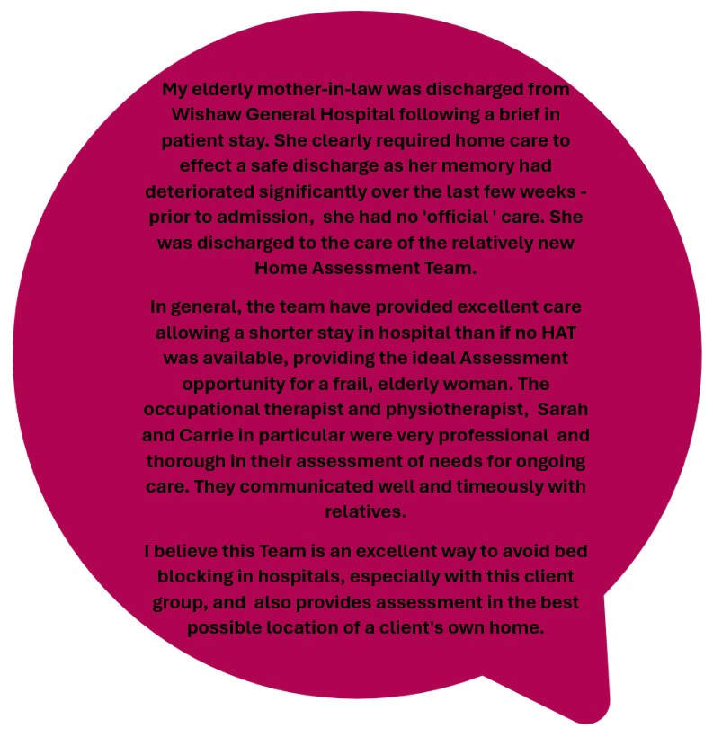

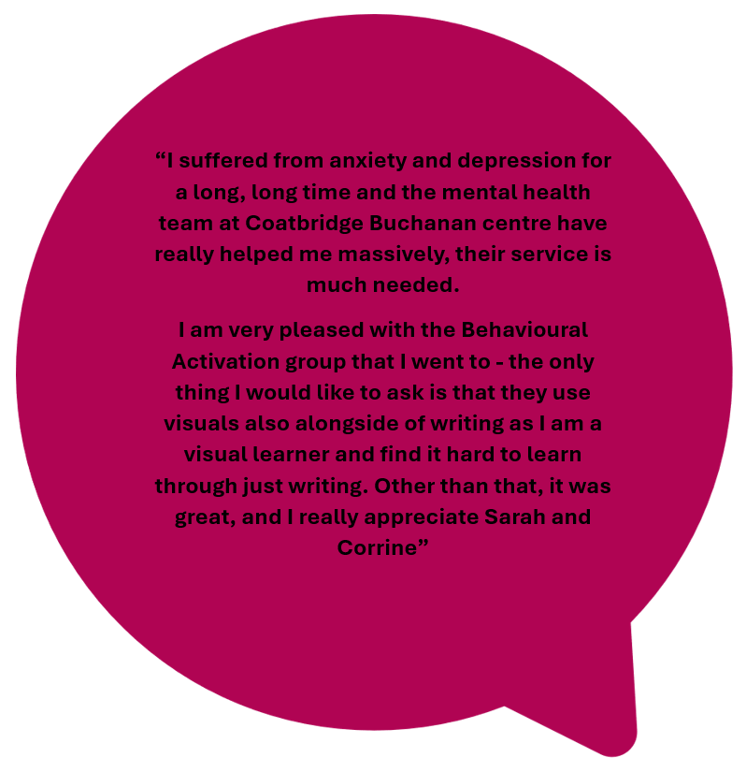

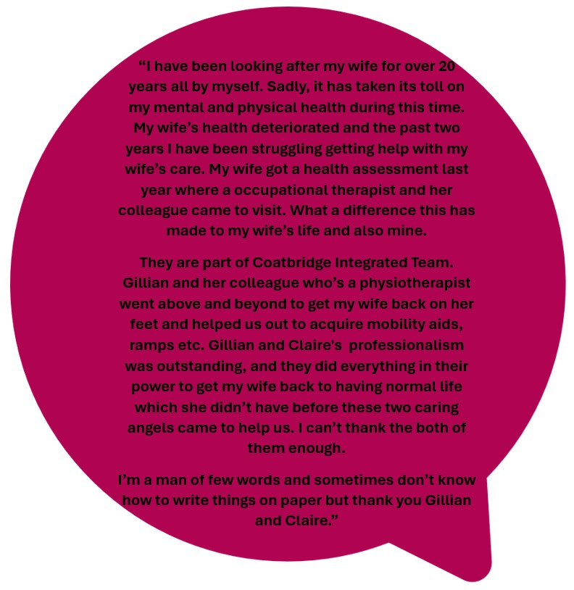

# Encouraging feedback

To facilitate and improve your understanding of how to ask for feedback, we have included slides below:

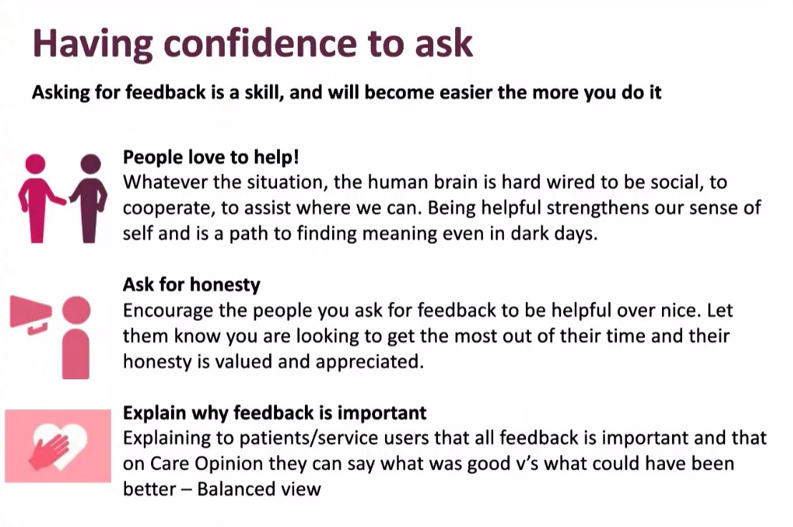

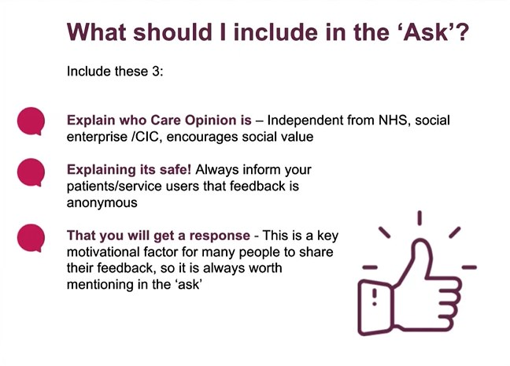

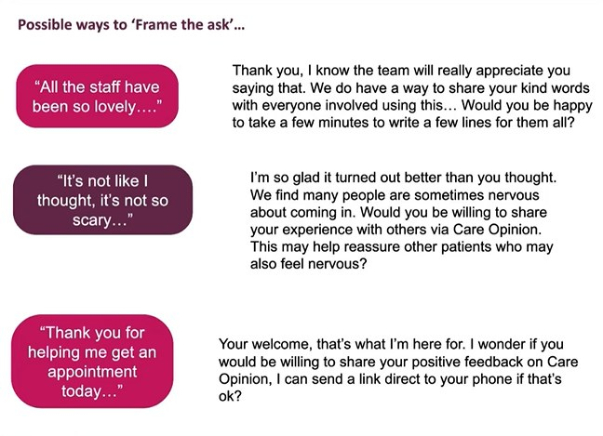

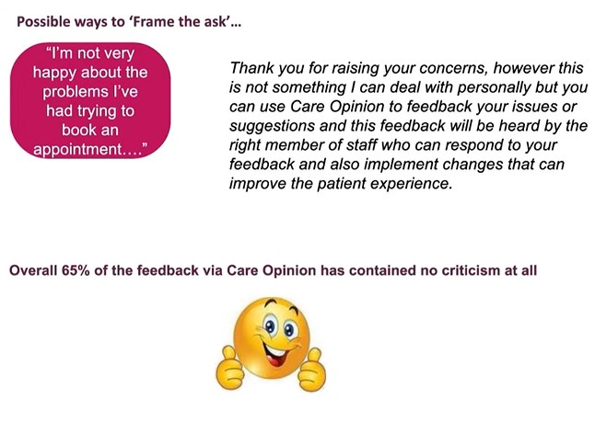

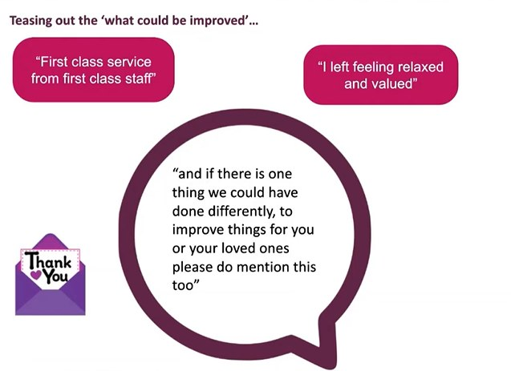

# We want to hear from you, please complete the short survey below:

Embed://<iframe width="640px" height="480px" src="https://forms.office.com/e/ZULmD8JUPJ?embed=true" frameborder="0" marginwidth="0" marginheight="0" style="border: none; max-width:100%; max-height:100vh" allowfullscreen webkitallowfullscreen mozallowfullscreen msallowfullscreen> </iframe>