

**c**







**Guidance on Care Opinion**

**for Community Solutions funded projects**

**Contents**

1. What is Care Opinion and why do we use it? 3

2. How does your service get added to Care Opinion? 5

3. Where can you find your service on Care Opinion? 7

4. How to collect stories from the people you support 11

5. Assisted storytelling 12

6. Accessibility and Care Opinion 13

7. Overview of Care Opinion training and resources 14

# 1. What is Care Opinion and why do we use it?

Care Opinion (CO) is an online platform that allows organisations that provide health care and social care services to actively collect, monitor and respond to anonymous feedback from the people who interact with their services and/or projects.

Feedback is submitted by service users in the form of **stories**, which are reviewed, given a title, tagged to the right service, and anonymised by CO moderators before being added to the website where it is publicly available for people to read. When a story is positive, staff members’ names are left in.

The majority of stories are positive and therefore a great way to get recognition for your work. Below are some examples that have been recently submitted about Community Solutions funded projects:

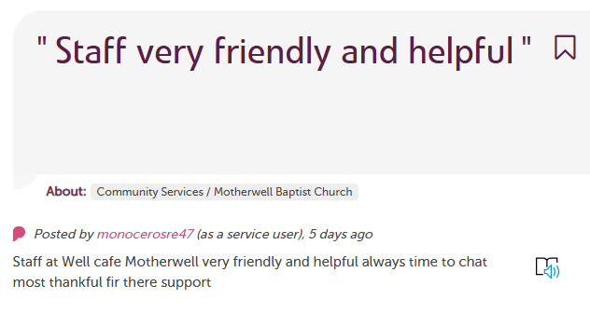

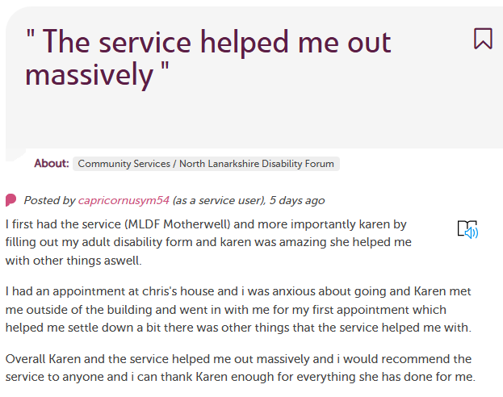

While Care Opinion has historically been used for traditional health and care bodies such as the NHS, they recognise that Community and Voluntary Sector (CVS) organisations also play a great role in people’s health and wellbeing.

Community Solutions and the University Health and Social Care Partnership North Lanarkshire are keen to trial CO as a tool to help you gather and respond to feedback, and to **demonstrate the impact that the CVS is making** to people across North Lanarkshire.

This guide is meant to help you, as an organisation funded through Community Solutions, better understand how to use Care Opinion and what resources are available to you.

# 2. How does your service get added to Care Opinion?

1. After you are awarded funding, if your organisation has not been added to CO yet, VANL staff will submit the following details to CO staff for review:
   1. the name of the organisation,
   2. the name, role, and email address of a staff member who will be responsible for responding to stories,
   3. a short description of the organisation based on the funding application
2. Care Opinion staff will feed back to VANL whether they think the service is appropriate for the website. Note: the decision from CO about whether your service is appropriate for the website has no impact on your Community Solutions funding.
   1. Examples of services that have previously been deemed not appropriate to CO: Projects that are one-off events, uniform banks, wellness cafes, sports hubs, unless they have a direct wellbeing and health focus through programmes eg. focussing on specific groups of vulnerable people, having a dedicated weight management programme.
3. If deemed appropriate, your service will be added as part of “[community services](https://www.careopinion.org.uk/services/s37000021-vanl)” under the University Health and Social Care Partnership North Lanarkshire (UHSCP) CO subscription. As your organisation is added under the UHSCP subscription, this is free of charge. If you are a larger organisation and wish to take out your own CO subscription, please contact them directly.
4. You will receive an email from [team@careopinion.co.uk](mailto:team@careopinion.co.uk) to say that you’ve been added, with a link to create your password. The email will look something like this:

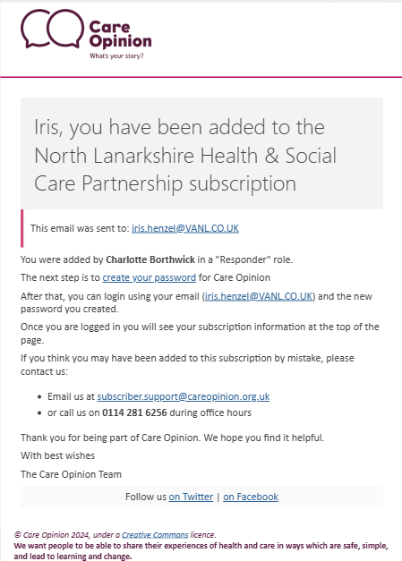

1. Click the “create your password” link in the email to create your password. This completes the set-up of your CO responder account. After this, you can make changes to your account such as adding a description to your service, adding a photograph to your responder account, and adding other colleagues to your organisation. From then, you will receive an email to notify you if a story has been submitted about your service with a personalized link that will allow you to read submitted stories and post responses.
2. Your account will remain up for the duration of your funding.

Useful Care Opinion resources

* A 2-minute cartoon which can be shared with your service users to explain what Care Opinion is and how it works:

<https://vimeo.com/215724873>

* A link to a 20-minute introduction webinar for staff on what Care Opinion is and how it works:

<https://vimeo.com/manage/videos/427688549>

* Here are some useful links on how to respond well to feedback: <https://www.careopinion.org.uk/info/responding>

<https://www.careopinion.org.uk/blogposts/1122/how-to-respond-well-webinar---21st-nov-2023>

# 3. Where can you find your service on Care Opinion?

If searching directly for your service in the search box does not produce your service, please follow the below instructions. Your service will be added as part of “Community Services” under the North Lanarkshire Health and Social Partnership. Here is the direct link to the page listing the community services: <https://www.careopinion.org.uk/services/s37000021-vanl>

Apart from the above link, the easiest way to find your service is outlined below.

1. Go to the [Care Opinion website](https://www.careopinion.org.uk/)
2. Search for North Lanarkshire Health & Social Care Partnership in the search box at the top right of your screen.

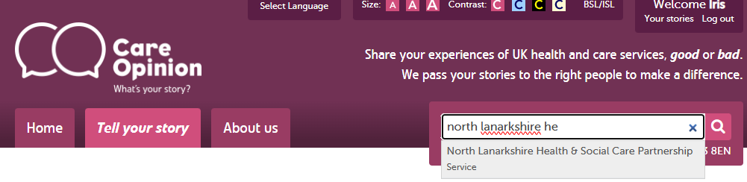

1. This brings up an overview of recently submitted stories to services in the Health and Social Care partnership. Click the link to North Lanarkshire Health & Social Care Partnership.

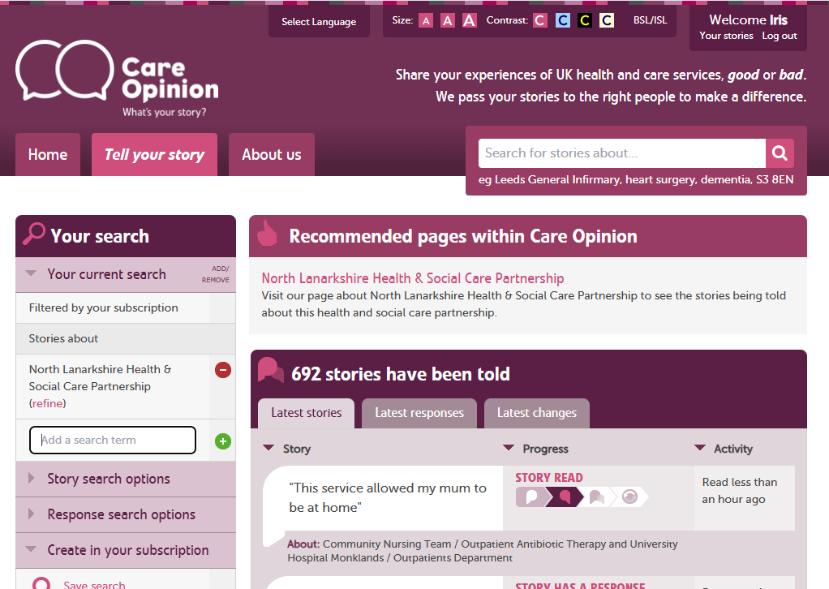

1. This brings up the North Lanarkshire Health & Social Care Partnership page. Click “More services within North Lanarkshire Health & Social Care Partnership”

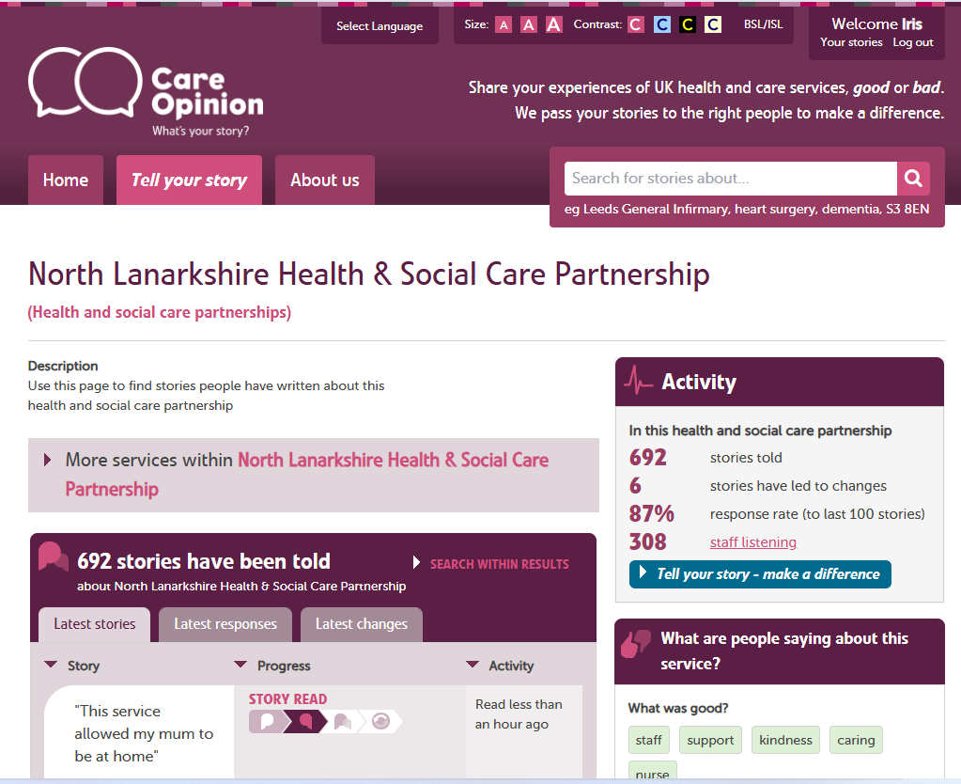

1. Click “Community Services”

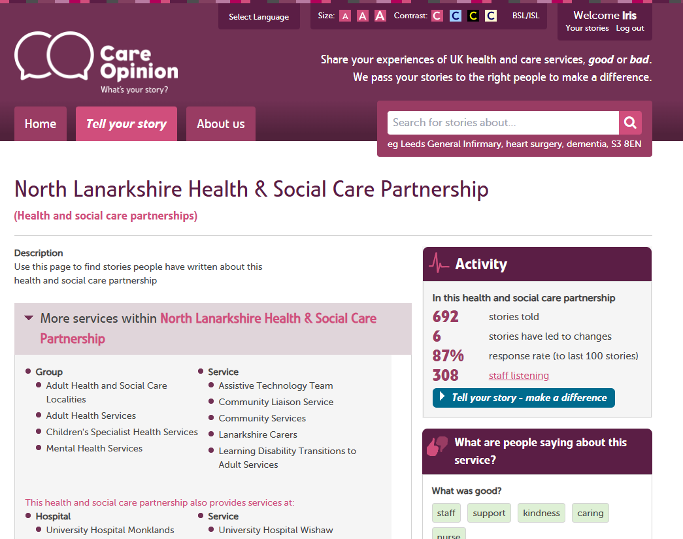

1. This opens up the page listing all Community Services. Your service, when added, will be listed in “More services within Community Services”

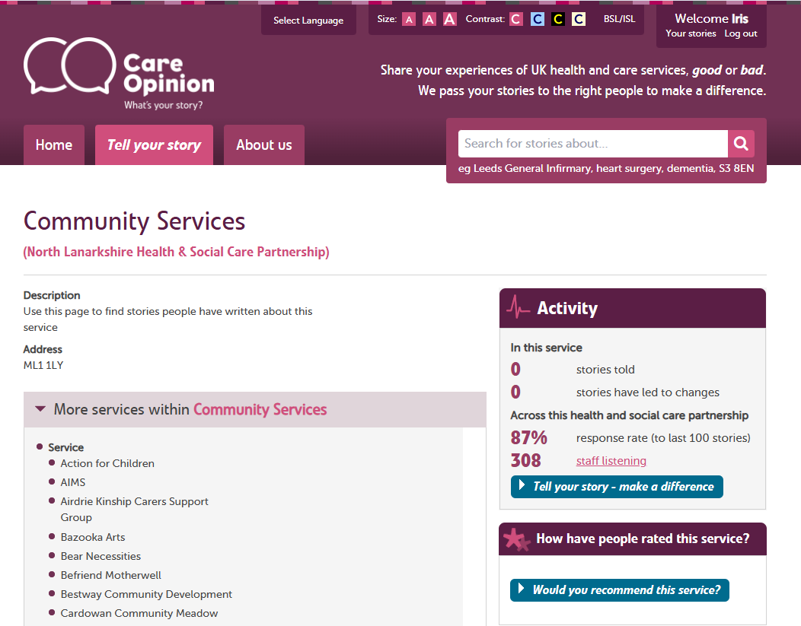

If your service is not listed here, please get in contact with **iris.henzel@vanl.co.uk**

# 4. How to collect stories from the people you support

Service users submit stories through the [Tell your story](https://www.careopinion.org.uk/tellyourstory) page on the care opinion website.

The best way to ensure that stories submitted by your service users are linked to your service is to create your own invitation link. This is a bespoke link that takes the service user directly to a ‘Tell your story’ page that is linked to your service.

For example, you could have a poster up at events containing the QR code from the invitation link. A service user would then scan this code, leave feedback, and it would come to the CO moderation team already linked to your service.

The link must be set up by a person from the organisation themselves. Guidance on how to do this can be found in the resources below. In the appendices you can also find templates for flyers you can use to promote CO and your personalized links.

Useful Care Opinion resources

* Information on invitation links

<https://www.careopinion.org.uk/info/invitation-links>

* Creating, updating or deleting links

<https://www.careopinion.org.uk/info/create-invitation-link>

* Customising links

<https://www.careopinion.org.uk/info/customise-invitation-link>

* Sharing the link

<https://www.careopinion.org.uk/info/share-invitation-link>

* Video on how to create/use invitation links:

<https://vimeo.com/manage/videos/681943773>

# 5. Assisted storytelling

Although it is preferred that service users submit their stories themselves, as this is expected to generate the most honest stories and allows service users to actively engage with responses to their feedback, CO recognise that not everyone might be able to submit stories without support. If this is the case, it can be useful for volunteers or staff members to support service users to submit their stories by sitting down with them and completing the Tell Your Story form together.

When submitting a story on behalf of a service user, it is important to declare that you are a staff member of volunteer supporting a service user, rather than pretend you are the service user themselves. You can do this on the second page of the Tell Your Story workflow:

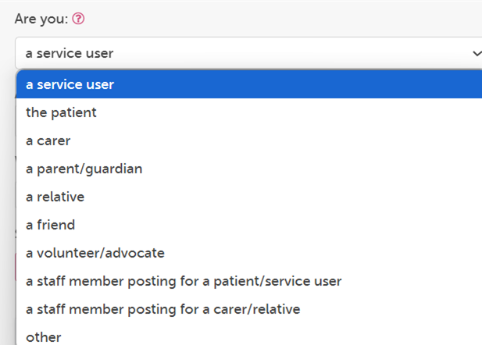Please note that stories submitted by staff members on behalf of service users should account for a maximum of 5% of your organisation’s total stories.

Useful Care Opinion resources

* An overview of resources on for staff and volunteers

<https://www.careopinion.org.uk/info/staff-and-volunteer-overview>

* The volunteer toolkit

<https://www.careopinion.org.uk/resources/content-page-files/volunteer-tool-kit-may22.docx>

* More information on assisting with sharing stories

<https://www.careopinion.org.uk/info/assisting-with-sharing-stories>

* An offline version of the Tell Your Story form. Only to be used when there is no internet access or the service user struggles significantly with the digital format

<https://www.careopinion.org.uk/resources/content-page-files/taking-a-story-form.pdf>

# 6. Accessibility and Care Opinion

Care Opinion are constantly improving the accessibility and inclusivity. Some examples are the tools available on the top of the website, including the possibility to translate the website into different languages, change font size, change colours and contrast, and a link to more information on British and Irish sign language:

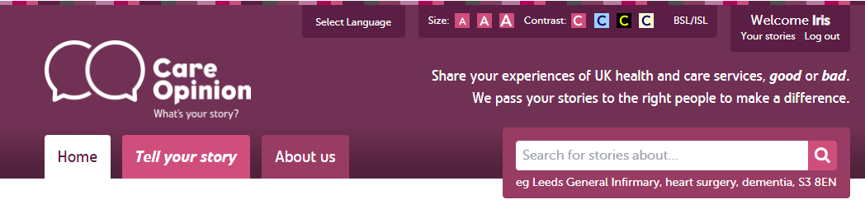

They also recently launched their bitesized videos, which are all subtitled, and their training sessions are all recorded and can be watched with closed captions.

Additionally, to make the story submission process more accessible for children and people of all ages, there’s the opportunity to submit a story with the help of the Care Opinion Bear.

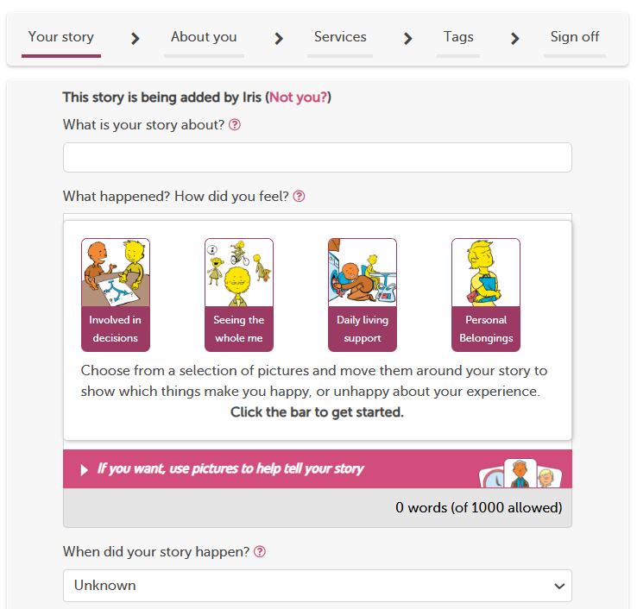Another accessibility feature for submitting stories is the possibility to use picture cards to help people tell their story.

Useful Care Opinion resources

* Links to the videos currently available in ISL and BSL

<https://www.careopinion.org.uk/info/signed-videos>

<https://www.careopinion.org.uk/info/meet-our-storytellers>

* Bitesize videos

<https://www.careopinion.org.uk/info/subscriber-help-videos>

* Tell your story with Bear

<https://www.careopinion.org.uk/info/tell-your-story-with-bear>

* More information on accessibility

<https://www.careopinion.org.uk/info/accessibility>

# 7. Overview of Care Opinion training and resources

There is range of available training and materials that will help you with how to promote feedback within your service, how you can respond to this feedback and how you can use this feedback within your service for learning and change.

Resources on what Care Opinion is

* A 2-minute cartoon which can be shared with your service users to explain what Care Opinion is and how it works:

<https://vimeo.com/215724873>

* A 20-minute introduction webinar for staff on Care Opinion:

<https://vimeo.com/manage/videos/427688549>

* Here are some useful links on how to respond well to feedback: <https://www.careopinion.org.uk/info/responding>

<https://www.careopinion.org.uk/blogposts/1122/how-to-respond-well-webinar---21st-nov-2023>

Resources on how to promote feedback within your service

* A webinar focusing on how to promote feedback within your service:

<https://vimeo.com/884348046/92fd495cc2>

* Information on invitation links

<https://www.careopinion.org.uk/info/invitation-links>

* Creating, updating or deleting links

<https://www.careopinion.org.uk/info/create-invitation-link>

* Customising links

<https://www.careopinion.org.uk/info/customise-invitation-link>

* Sharing the link

<https://www.careopinion.org.uk/info/share-invitation-link>

* Video on how to create/use invitation links:

<https://vimeo.com/manage/videos/681943773>

General training and guidance

* A blog and training webinar on how to produce reports and visualisations:

<https://www.careopinion.org.uk/blogposts/1026/alert-reporting-visualisations-webinar---7th-march-2023>

* This link takes you to Care Opinion’s “know how” pages, that has articles on all things Care Opinion:

<https://www.careopinion.org.uk/info/subscriber-know-how>

* Printable materials available on the Care Opinion website:

<https://www.careopinion.org.uk/info/new-materials>

* Training and support webinars:

<https://www.careopinion.org.uk/info/support-webinars>