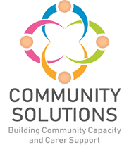

Community Solutions Locality Hosting and Impact Report 2023-24

Phase X (20XX-XX) - Impact and Learning Report



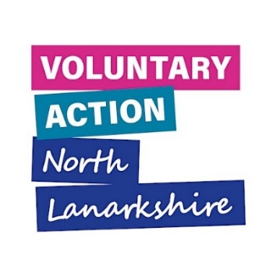
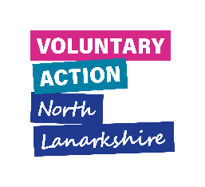


Contents

1. Introduction 3
2. Locality Activity Fund (LAF) Overview 2023-24 – Reach and Impact 11
3. Locality Consortia Overview 2023-24 15
4. Learning 18
5. Next steps 25
6. Appendices 26
Appendix A Community Solutions Locality Host Funding 26
Appendix B Locality Activity Fund Distribution 28

1. Introduction
1.1 Purpose
The purpose of this report is to share the impact and learning from Locality Hosts, locality consortia, and projects funded through the Locality Activity Fund (LAF) and the Improving Lives Initiative (ILI) in 2023-24.

Many thanks to the funded projects, consortia members and Locality Hosts which provided information and to the VANL staff who prepared this report.

1.2 Background
The Community Solutions programme is rooted in our local communities to support effective partnership working between the CVS and public sector as well as the engagement of service users, carers, and the wider public. This partnership working and engagement is supported at locality level by six Community and Voluntary Sector (CVS) “anchor organisations” that act as “locality hosts” for the programme. Each hosts a consortium and distributes LAF in their locality. See figure 1 for an overview of the Community Solutions structure, with the Locality Hosts and Consortia in pink.
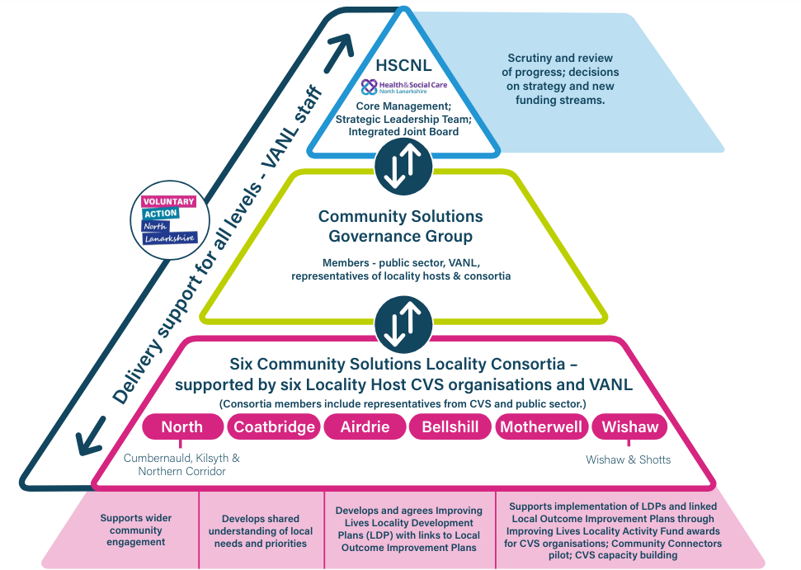
Figure 1 Overview of triple lock structure of the Community Solutions Programme

1.2.1 Locality Hosts

The locality hosts are responsible for:
- Convening and supporting the six Community Solutions Locality Consortia and facilitating links to the nine Community Boards
- Supporting Consortia members to develop a Locality Development Plan (LDP), which sets out priorities for local capacity building and the Locality Activity Fund. The LDP is informed by resident, service user and carers’ views and priorities, local Need Profiles, the Community Solutions Strategy and Investment Plan, and the Locality Outcome Improvement Plans (LOIPs)
- Managing, in collaboration with local consortia and Voluntary Action North Lanarkshire (VANL), the Locality Activity Fund (LAF) for their locality
- Supporting capacity building of local CVS organisations, including assistance in applying to LAF and providing progress reports
- Being an active member of the North Lanarkshire-wide Community Solutions Consortium and the North Lanarkshire-wide Community Solutions Locality Host Network, convened by Voluntary Action North Lanarkshire (VANL)
- Supporting and monitoring all Community Solutions activity across the locality and liaising with VANL staff to support their locality role
- Supporting the delivery of the Improving Lives Initiative

The Locality Host organisations for 2023-24 are listed below.
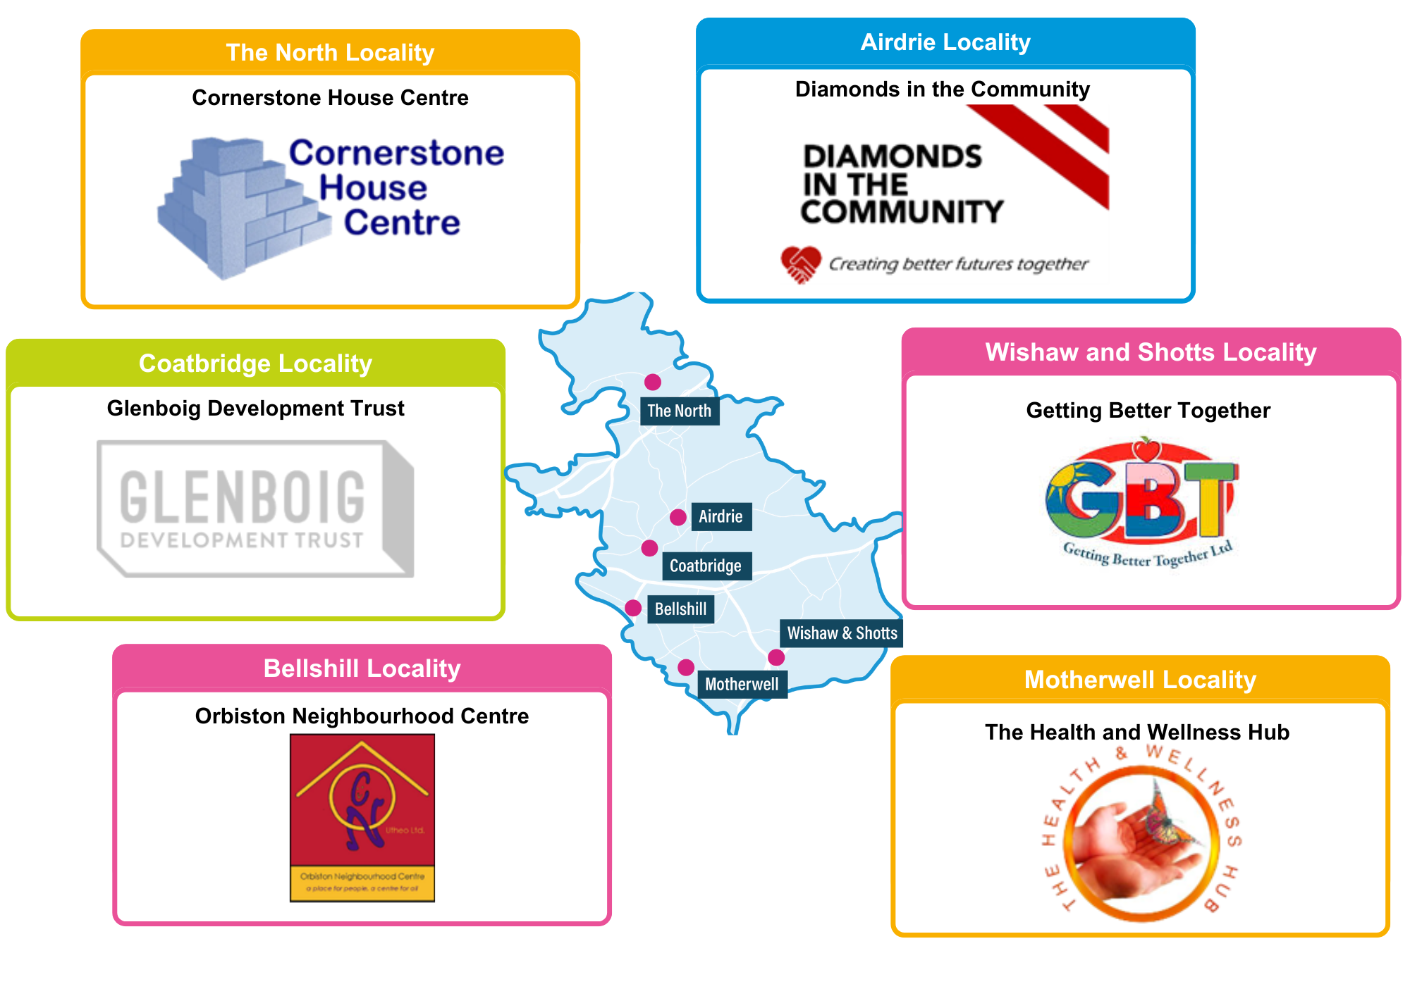
The Health & Wellness Hub
Getting Better Together
Orbiston Neighbourhood Centre
Glenboig Development Trust
Diamonds in the Community
Cornerstone House Centre
The Community Solutions Programme Locality Hosts are reviewed annually by the Community Solutions Senior Programme Officer and the Community Solutions Senior manager. The review assesses the Locality Host performance, their support of the local Consortium and LAF, and their support of the wider Community Solutions and capacity building work in their locality. The next review is due in December 2024.

1.2.2 Locality Consortia
The Community Solutions Locality Consortia comprise representatives from local CVS organisations, and health and social care staff from North Lanarkshire Council, NHS Lanarkshire, and University Health and Social Care North Lanarkshire, providing opportunity for collaboration between them in supporting development within each of the six localities.

Annually, the Consortia develop and deliver their Local Development Plan (LDP). LDPs set out priorities for local capacity building and priorities for the Locality Activity Fund, and is informed by resident, service user and carers’ views and priorities, Health and Social Care Locality Profiles, the Community Solutions Strategy and Investment Plan, and the Locality Outcome Improvement Plans (LOIPs).

The Consortia meet at least quarterly to discuss key local issues, allocate LAF, and discuss how to support local CVS organisations in accordance with their LDP.

1.2.3 Locality Activity Fund (LAF)
There are six Community Solutions Locality Activity Funds (LAF), providing small grants to CVS organisations in each locality to help them deliver a new or improved activity to support residents.
CVS organisations apply to Locality Consortia, who assess applications and make awards on an ongoing basis throughout the year. Assessment of LAF applications by consortia are informed by priorities set out in their Locality Development Plan and Community Solutions general outcomes as listed below. Locality Hosts and VANL support management of the funding awards once consortia make award decisions.
The Community Solutions outcomes are separated into three key groups: adults, carers, and children, young people, and families.
Theme | Outcome
Adults: Outcome 1 | People feel more connected, included and safe
Adults: Outcome 2 | Improved health and wellbeing
Adults: Outcome 3 | People feel more informed and aware
Carers: Outcome 4 | Carers feel more informed and aware
Carers: Outcome 5 | Carers health and wellbeing are improved
Carers: Outcome 6 | Carers are more able to have a life outside of caring
Children, Young People, and Families: Outcome 7 | Health and wellbeing improved
Children, Young People, and Families: Outcome 8 | Family relationships are strengthened
Children, Young People, and Families: Outcome 9 | Children, young people, and families become more resilient

Each LAF funded project is required to capture and share with Locality Hosts key information on the following:

- type of support provided – activities
- numbers of unique individuals supported – reach
- the difference this support made to those receiving support – outcomes (with reference to the Community Solutions outcomes outlined above).

Funded projects collect this data at points prior to, during, and post project delivery from service users, using different methods, including:
- written surveys; online or via the phone
- verbal feedback
- observations
Locality Hosts use the performance data provided by funded projects to complete and submit to VANL a brief evaluation form for each funded project and a LAF monitoring spreadsheet for their locality at six- and twelve-months. VANL’s Senior Evaluation Officer and/or the Learning and Improvement Officer then analyses this information to prepare this and other reports for each year. This approach to LAF evaluation is informed by the Community Solutions Performance Management, Evaluation, Learning and Improvement Framework but adapted to allow for the modest size of LAF awards.

1.2.3 Improving Lives Initiative
The proposal for the Community Solutions Improving Lives Initiative (ILI) was developed collaboratively during 2022-23 with the Community Solutions Governance Group, HSCNL Core Management team, NHS Lanarkshire Health Improvement senior staff, and Macmillan Cancer Support.

The ILI provides increased funding for 2023-24 and 2024-25 for our six Community Solutions locality hosts – complementing their existing recurrent funding – to enable them to do the following work in addition to their existing locality support work:

- Improve engagement with the CVS within their localities
- Supporting the adoption of the ALISS (A Local Information System for Scotland) service directory
- Supporting the work of the Community Connectors, who support vulnerable people in the community based on the principles of the Three Conversations Model. This includes people referred through the Improving Cancer Journey to connect them to non-clinical support provided by CVS organisations (social prescribing).
- Strengthening links between Community Solutions and Community Planning at locality level

ILI also provides increased funding for the Community Solutions LAF for 2023-24 and 2024-25 (complementing existing recurrent funding) to increase small grant funding for local CVS organisations to improve support for local people. This means the LAF budget has increased from £180,000 a year across the six localities to £300,000 a year for 2023-24 and 2024-25.

The distribution of £120,000 ILI funding across the six localities is informed by the Scottish Index of Multiple Deprivation (SIMD) and population of the localities (see Appendix A for a breakdown of ILI funding across the localities). In 2023-24, the additional money from the Improving Lives Initiative funded 19 projects, and was targeted at organisations who had not previously been funded through LAF (see Appendix B for a full breakdown of funded projects by locality, with projects funded through ILI in green).

2. Locality Activity Fund (LAF) Overview 2023-24 – Reach and Impact
During 2023-24:
- each of the six Community Solutions Locality Consortia had a £30k LAF, complemented by ILI funding ranging from £15,486 to £30,360 depending on locality, to allocate – a total of £300k, of which £208.4k was spent

- LAF was distributed to a total of 76* projects in 52 CVS organisations (see Appendix B for a full breakdown of funded projects by locality).

* This report and appendices report the number of projects who received funding within the 23-24 financial year. The number of projects whose applications were approved in 23-24 is 88, as some projects were approved at the end of 23-24, and did not receive their funding until 24-25.
2.1 Summary of funded projects and number of people receiving support
2.2 Summary of outcomes
This information is collected by LAF funded projects using self-assessment from the people their projects support. Methods for gathering information vary between projects. Common methods in 2023-24 included:
- Conversation with participants. – For example, through consultations, small group discussions, post-project gatherings, member catch ups, and informal chats with service users/community groups/members.
- Participant evaluation. – For example, through evaluation forms, exit questionnaires, feedback forms, and case studies.
- Observation and feedback from practitioners. – For example, observations of engagement with activities, and differences in social interaction.
- Quantitative methods. – For example, Attendance, membership numbers, number of resources given out, number of people referred to other services.

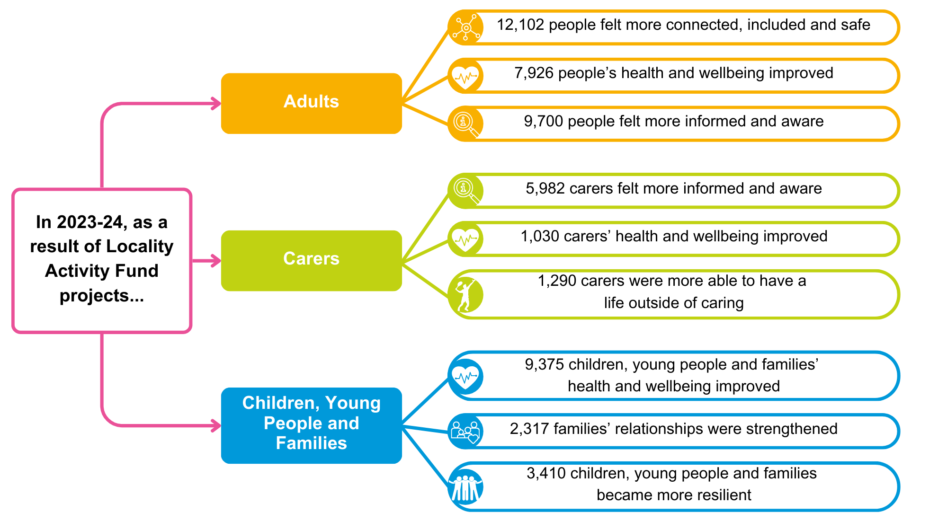

3. Locality Consortia Overview 2023-24
3.1 Summary of Locality Consortia – Meetings and Local Development plans
In 2023-24 an average of 8 consortia meetings were held across the six localities.
Each Locality Consortium developed a Local Development Plan over the course of several meetings and Consortium Development days, which can be accessed through the following links:
Locality Consortium | Local Development Plan 2023-24
Airdrie | Airdrie Development Plan
Bellshill | Bellshill Development Plan
Coatbridge | Coatbridge Development Plan
The North | The North Development Plan
Motherwell | Currently finalising
Wishaw and Shotts | Wishaw and Shotts Development Plan

During Locality Consortia meetings, different topics and key issues were covered that aligned to the priorities set out in their LDP. These included for example:
- Review and support of LAF applications and projects.
- Opportunities for collaboration and information sharing between CVS organisations through discussing training opportunities and sharing advice, such as:
  - Advice on energy and money by the local Citizen’s Advice Bureau
  - Advice on reducing alcohol abuse and harm through engaging with young people by Community Alcohol Partnership
- The implementation and utilisation of ALISS, promoting awareness of ALISS among community members, and identifying strategies to enhance accessibility of the platform.
- Discussions on funding opportunities other than the Locality Activity Fund.
- Discussions on community engagement and how to reach groups that are not aware of Community Solutions and the Consortiums.

  - Changes made to Locality Consortia
Operations of the Locality Consortia are continually reviewed and improved as opportunities for improvement and enhanced support by VANL are identified. In 2023-24 the following changes were made to the way the Consortia work:
- Updated guidance for Locality Hosts, to include areas of guidance not previously covered
- Updated Terms of Reference as per September 2023
- Updated Code of Conduct as per December 2023
- VANL provided more additional support and guidance around the role of Locality Hosts and Consortium members, including the introduction of an annual LAF Learning and Improvement event.
- Updated and refined LAF guidance and LAF application form to provide more clarity to Consortiums when discussion LAF allocation
- Created a membership form for Consortium members, to create transparency and support to Consortiums in increasing diversity within the Consortium in terms of geographic areas, representation, and split between statutory and voluntary sector organisations. This was first developed by the Wishaw and Shotts Consortium, and subsequently adapted for North Lanarkshire-wide use.

4. Learning
4.1 Case studies from LAF
Several locality hosts provided case studies from the LAF funded projects in various formats, including text, quotes, and pictures. Below is a selection of these case studies to demonstrate the diversity and various impacts of the LAF funded projects.

4.1.1 Time for Me, North Lanarkshire Parkinson’s Self Help Group – LAF funded project for Airdrie
Background
Time for Me delivered massage treatments to Parkinson’s Self Help Group (PSHG) members with a neurological condition. Massage has known physical and mental health benefits including for example decreased muscle stiffness, decreased joint inflammation, reduced pain, improved relaxation and decreased anxiety. These benefits are particularly helpful for people with Parkinson’s disease and Parkinsonisms which typically causes muscle stiffness and rigidity.
Intervention
The Time for Me project provided 4 sessions on PSHG’s Support Group days. They also provided lunches to encourage positive eating habits in a social setting.
Outcome
Those who had accessed the service stated how they have benefited from the treatments, and that it had a positive effect on both their physical and mental health. They were all keen to access the treatments going forward.
The individuals also built a trusting relationship with the therapist. They were comfortable discussing any concerns or difficulties they were experiencing. The therapist was able to encourage individuals to speak to a member of staff who can provide additional guidance, and further practical and emotional support.

4.1.2 Bookbug, HOPE for Autism – LAF funded project for the North
Background
HOPE for Autism, a North Lanarkshire charity which works to make a positive difference to the lives of children and young people with autism and their families through personalised needs-led support, was awarded LAF funding in April 2024 to deliver Stay and Play with Bookbug Sessions for local families with children with complex needs.

HOPE for Autism collaborated with Freedom City Church in Cumbernauld to provide a pilot block of eight weekly two-hour Stay and Play sessions for 10 autistic and neurodivergent pre-school children and their parents and carers. Each week's delivery incorporated a 20-30 minute Bookbug session involving sharing of stories, rhymes and songs tailored to accommodate the specific additional support needs of participants. One of the families supported was a married couple with two children (aged three and four) with complex additional support needs, including visual impairments and Autism Spectrum Disorder (ASD), with both attending a nursery for children with complex needs. The mother worked part-time and father remained at home to support the children, with one day per week of volunteering offering him some respite and social interaction with others away from his caring role. The family reached out to HOPE for Autism to seek support in developing the skills and school readiness of the children.
Intervention
HOPE for Autism’s Autism Support Practitioner produced a Family Development Plan on the complexity of the needs of the children, and offered the family a block of eight Bookbug sessions. The parents were eager to take part in Bookbug sessions in a supported environment because they had both had unsatisfactory experiences of attending Bookbug in libraries that were too busy and noisy for their children. The eight sessions took place from May to July 2024, with adaptations made to storytelling, rhyme and other delivery elements to accommodate the communication and sight difficulties of the children.
Outcome
The parents’ confidence in reading with their children improved exponentially, with the father highlighting that although they had always read quite a lot as a family, Bookbug gave them ideas for ways in which they could read with the children in a more engaging manner by using activities that involve actions and feel. The facilitator observed that the family spent a significant amount of time undertaking chores and physical activities relating to the children’s care, such as attending hospital appointments, feeding and physiotherapy. In contrast, Bookbug offered the family a therapeutic activity to do together away from the busyness of everyday tasks and caring responsibilities. The family also noticed collective social benefits from doing the sessions together.
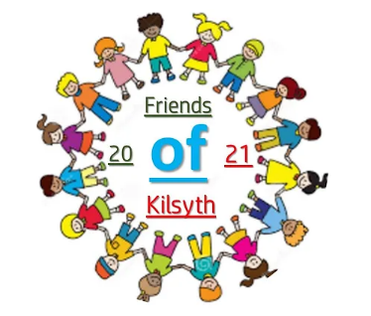
4.1.3 Community Pantry, Friends of Kilsyth – LAF funded project for the North
Background
Friends of Kilsyth, a community group committed to promoting the interests and welfare of Kilsyth and its residents, successfully launched and delivered a local food pantry initiative at Storehouse Church during 2023-24.
Intervention
Friends of Kilsyth created a membership-based pantry, allowing residents to access a variety of groceries without the need for professional referrals. This approach ensured that the pantry was inclusive and accessible to all community members, fostering a sense of dignity and self-sufficiency among its users.
Outcome
This model was proven sustainable and impactful for approximately 300 beneficiaries, with project funds wisely invested in purchasing food and other essential items from FareShare, a charity known for redistributing surplus food to community groups.
The following quotes from Helen Anderson, Community Pantry Facilitator at Friends of Kilsyth, show how the Community Pantry has had a positive effect on the health and wellbeing of members, interconnectedness of the community, and the environment:

“Many members have expressed relief at being able to feed their families without sacrificing other essential needs. The saving made by accessing affordable food have allowed individuals to allocate their limited resources to other crucial areas, such as housing, utilities, and healthcare. This financial reprieve has been instrumental in reducing stress and improving quality of life for many residents”

“The scheme has also fostered a stronger sense of community. Members have shared stories of newfound friendships and support networks formed through their weekly visits. The Community Pantry has become more than just a place to get groceries; it is a hub of social interaction and mutual aid. Volunteers, too, have found a sense of purpose and fulfilment in contributing to the wellbeing of their neighbours.”

“The initiative has made a positive environmental impact. By partnering with FareShare, the pantry helps reduce food waste, ensuring that surplus food is put to good use rather than ending up in landfills. This sustainable approach aligns with broader efforts to address climate change and promote environmental stewardship within the community”

This approach has inspired similar initiatives in the neighbouring communities. Looking ahead, Friends of Kilsyth plans to build on this success. There are discussions about expanding the pantry’s offerings to include household items and personal care products. There is also interest in developing educational programmes on nutrition and budgeting, further empowering members to make informed choices about their health and finances.
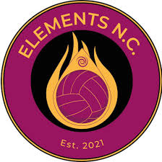
4.1.4 Elements NC, Elements Netball – LAF funded project for Wishaw and Shotts
Background
Elements NC received LAF funding to help continuing running their junior netball club, providing playing and coaching opportunities to girls between the ages of 10 to 15. They want to make the sport and club accessible to all during the economic crisis, to support the young people’s mental and physical health and give them the opportunity to be part of a team sport, developing life skills, tackling isolation and loneliness, and build relationships.
Intervention
With LAF funding, the club was able to start up an under 13 age group, host a celebration event, and purchase club kit.
Outcome
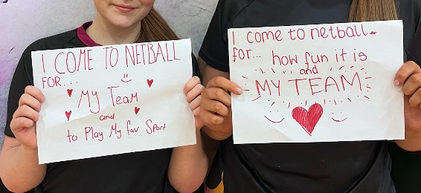
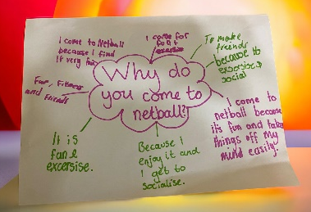
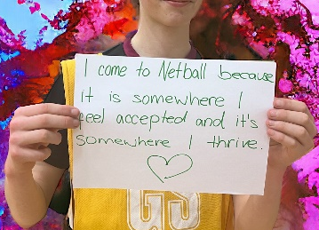
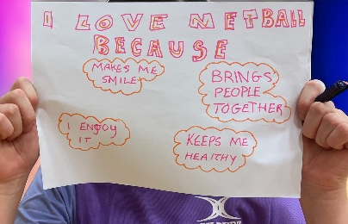
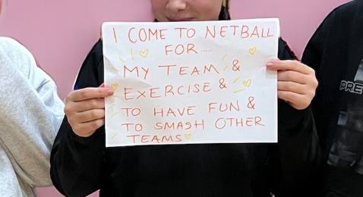
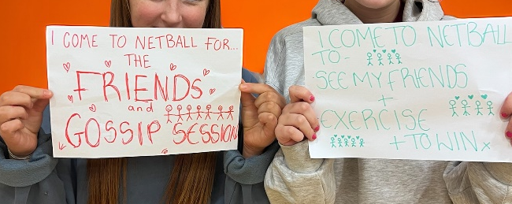
Below are pictures of the young netball players holding up signs showing why they come to netball:
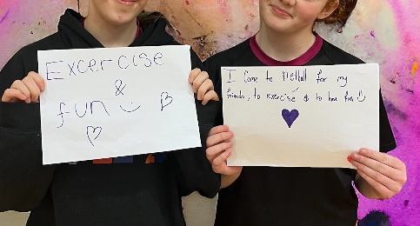
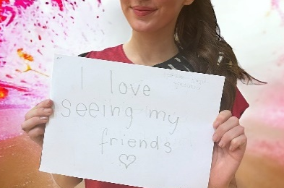
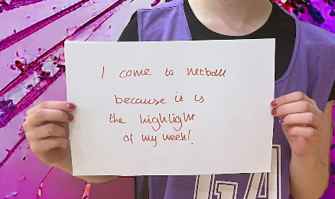
4.2 Unexpected outcomes
This section outlines unexpected outcomes from the locality hosts and consortia, recognising unanticipated outcomes are no less valuable, and often change can happen when challenges are approached creatively. Not all locality hosts identified unexpected outcomes.
4.2.1 Participatory budgeting trial by Wishaw and Shotts Consortium
An unexpected outcome from the Wishaw and Shotts Consortium was a trial of a Participatory Budget Model in the Pather/Newmains area.
The Consortium had Community Engagement discussions around reaching smaller groups who are not aware of Community Solutions and the Consortia. This led to a test of change where the Consortium and the Locality Host Getting Better Together worked with their North Lanarkshire Council Community Partnership Team and match funded a Participatory Budget Model in the Pather/Newmains area, called “Making a Difference to Communities Hardest to Reach”. A participatory budgeting event was also organised. This led to three applications being successfully approved and funded by LAF for the following smaller groups, to the value of £5k:
- Seniors With Energetic Life Styles (SWELS) – Chair Aerobics and Tai Chi classes
- St Brigid’s Primary School Parent Teacher Association (PTA) – Community Project
- Newmains Primary School Parent Council – PTA Trip
These projects will be delivering in the 2024-25 period. Additionally, another £5k will be allocated in 2024-25 to continue the trial of participatory budgeting for reaching harder to reach communities.
While the projects funded through this trial have not yet been delivered, and the trial itself is not yet finished, the process so far can be seen as successful. It is very positive that an initiative like this was developed by the Consortium in response to a local challenge they identified, and 2023-24’s funding was successfully distributed. VANL’s Senior Programme Officer has also commended the Wishaw and Shotts Locality host for their clear communication throughout.

4.2.2 Engagement with local challenges by the North Locality Host
Locality Host Cornerstone House Centre reported on how they have engaged with local challenges and community engagement in The North. They were actively involved in facilitating and participating in local discussions related to transport, mental health, social isolation, youth services, employment opportunities, climate change, housing affordability and community cohesion to foster dialogue between residents, service users, carers and key stakeholders. They also collaborated with local media outlets to raise awareness of key health and social care issues and promote community engagement and discussion.
A specific example which demonstrated their dedication to ensuring local voices are heard, was their joint-facilitation and promotion of three successful Challenge Poverty Week Community Engagement Events (in partnership with North Lanarkshire Council’s Community Partnership Team and Cumbernauld Community Board’s Food and Financial Insecurity Priority Sub-Group) during October 2023.
Events were specifically targeted in areas of high deprivation (Abronhill, Carbrain and Kildrum), with each session incorporating a special market place at which a number of stall holders were present and provided confidential and impartial support and advice in challenging the stigma of poverty. Participating agencies included (amongst others) North Lanarkshire Council’s Tackling Poverty Team, NHS Lanarkshire’s Health Improvement Team, Cumbernauld Poverty Action, Cumbernauld and Kilsyth Citizens Advice Bureau, Home Energy Scotland, Lanarkshire Association for Mental Health (LAMH) and Routes to Work.
This work by the North Locality Host is a great demonstration of the value of a locality approach to supporting CVS organisations and residents in engaging with issues that matter to them, as well as the value of the Locality Host in creating connection and collaboration between residents, businesses, CVS organisations and local decision makers.

5. Next steps
In 2023-24, the Community Solutions Locality Hosts, Locality Consortia and projects funded through the Locality Activity Fund and the Improving Lives Initiative contributed towards the Community Solutions vision of a North Lanarkshire where communities are stronger, more resilient and inclusive, with improved health, wellbeing and quality of life, with reduced inequality and protection of human rights.
In 2023-24, LAF supported over 10k more people, of which 363 more carers, compared to the 2022-23 period. The additional funding made available through the Improving Lives Initiative has made a significant impact in increasing the support for local CVS organisations in supporting to community groups and voluntary organisations to deliver a new or improved activity to improve local wellbeing. It will be exciting seeing this continue in 2024-25.
Following this report, the next steps for 2024-25 are to:
- Continue support for CVS organisations in the six localities through LAF funding. Some projects funded in 2023-24 are continuing their delivery in 2024-25.
- Continue to assess and develop support and guidance for Locality Hosts and Locality Consortia by VANL.

6. Appendices

Appendix A Community Solutions Locality Host Funding

Community Solutions Locality Host Funding 2023-24:
Total Funding £381K

CVS Organisation | Locality | Locality Award Fund (£) | Improving Lives Initiative – supplementary funding (£)
A.1 Diamonds in the Community | Airdrie | 40,000 | 23,390
A.2 Orbiston Neighbourhood Centre | Bellshill | 40,000 | 18,196
A.3 Glenboig Development Trust | Coatbridge | 40,000 | 19,757
A.4 Cornerstone House Centre | The North | 40,000 | 35,674
A.5 The Health and Wellness Hub | Motherwell | 40,000 | 22,415
A.6 Getting Better Together | Wishaw and Shotts | 40,000 | 21,568
Total across the 6 Locality Hosts |  | 240,000 | 141,000

Community Solutions Locality Activity Funding 2023-24:
Total Distributable Funding £300K

CVS Organisation | Locality | Locality Activity Fund (£) | Improving Lives Initiative – additional LAF funding (£)
A.7 Diamonds in the Community | Airdrie | 30,000 | 19,907
A.8 Orbiston Neighbourhood Centre | Bellshill | 30,000 | 15,486
A.9 Glenboig Development Trust | Coatbridge | 30,000 | 16,815
A.10 Cornerstone House Centre | The North | 30,000 | 30,360
A.11 The Health and Wellness Hub | Motherwell | 30,000 | 19,077
A.12 Getting Better Together | Wishaw and Shotts | 30,000 | 18,355
Total across the 6 Locality Hosts |  | 180,000 | 120,000

Appendix B Locality Activity Fund Distribution

Locality Activity Fund Distribution 2023-24

Total number of projects funded in the six Community Solutions localities: 76 | Total funds for 2023-24: £300,000  Plus, c/f underspend from 2022/23:  £29,899 | Total spend:  £208,418  of which  £61,979 from ILI

Airdrie Locality

Organisation | Project  projects outlined in green were funded through the Improving Lives Initiative | Total Funding Amount (£)
B.1 Upperton Residents Committee | Community Shed | 420
B.2 Airdrie CAB | Befriending project | 3,120
B.3 Airdrie Kinship | Airdrie kinship carers support | 2,110
Organisation | Project | Total Funding Amount (£)
B.4 Longriggend Village Association | Villagers Coming Together | 4.500
B.5 Make and Create Arts | Making Healthy Choices, Creating Happy Smiles | 2,050
B.6 Monklands Women's Aid | Women’s Peer Support Group – Women Empowering Women | 1,000
B.7 Parkinson's Self-Help Group | Benefits of Greenspace | 400
B.7 Parkinson's Self-Help Group | Time for Me | 1,198
B.8 Whinhall Allotments | Muddy Boots 'Rain or Shine' | 2,050
B.9 Bear Necessities | Easter school holiday fun days programme | 1,000
B.10 HOPE for Autism | Easter Bingo & Coffee Morning and Flip Out Trip | 420
B.11 Airdrie Adult Learning Forum | AALF Holiday Provision Project * | 3,050
No. of projects  12  * project funded in 23-24, (continuing) delivery in 24-25 | Total | 21,318  of which  7,610 from ILI
Bellshill Locality

Organisation | Project  projects outlined in green were funded through the Improving Lives Initiative | Total Funding Amount (£)
B.12 VIP-Pass Community Project | Muddy Boots | 5150
B.13 I Am Studios | I AM ASN Community Dance, Sensory & Wellbeing Project | 8,050
B.14 Lanarkshire Community Food & Health Partnership (LCFHP) | Let’s Fix Fussy Eaters | 7,230
B.15 Voice of Experience Forum (VOEF) | Voice of Experience Forum Calendar 2024 | 3,308
B.15 Voice of Experience Forum (VOEF) | Rabbie Does Strictly – Tea Dance | 952
B.16 Viewpark Conservation Group | Restoring Minds, Restoring Nature | 8,694
B.17 Deep Fried Media | Family Friendly Art & Photography | 2,246
B.18 Orbiston Neighbourhood Centre | Community Fridge | 4,300
B.19 YMCA Bellshill & Mossend | YMCA Digital Hub * | 2,839 +  1,415 (extension)
No. of projects  10  * project funded in 23-24, (continuing) delivery in 24-25 | Total | 44.184  of which  8,694 from ILI

Coatbridge Locality

Organisation | Project  projects outlined in green were funded through the Improving Lives Initiative | Total Funding Amount (£)
B.20 Kirkshaws Neighbourhood Centre | Art in the Community | 1,500
B.20 Kirkshaws Neighbourhood Centre | Kirkshaws Health & Wellbeing Community Programme | 5,700
B.21 Glenboig Development Trust | Together We Thrive | 6,100
B.21 Glenboig Development Trust | Keep Moving, Keep Improving | 2,390
B.22 Coatbridge Consortium | Men Talk | 8,840
No. of projects  5 | Total | 24,530  of which  10,340 from ILI

The North Locality

Organisation | Project  projects outlined in green were funded through the Improving Lives Initiative | Total Funding Amount (£)
B.23 Moodiesburn Community Action Group | Moodiesburn Community Listening Event | 2,000
B.24 Friends of Kilsyth | Community Pantry | 4,500
B.25 Kilsyth Civic Week | Intergenerational Tea Dance | 1,200
B.26 Auchinloch Community Council | Auchinloch Community Hub | 1,760
B.27 CACE (Cumbernauld Action for Care of the Elderly) | CACE Local Community Family Fun Day and Open Day | 350
B.27 CACE (Cumbernauld Action for Care of the Elderly) | CACE Community Transport Support | 3,000
B.28 Strathcarron Hospice | Absent Friends Week and National Grief Awareness Week Bereavement Support | 2,400
B.29 Storehouse Church | Christmas Winter Wonderland | 2,600
B.30 Cornerstone Christian Fellowship | Livestreaming of Interactive Events | 3,500
Organisation | Project  projects outlined in green were funded through the Improving Lives Initiative | Total Funding Amount (£)
B.31 Abronhill Guild of Friendship | Abronhill Guild of Friendship Christmas Party Lunch | 1,000
B.32 St Patrick's Church Kilsyth | Kilsyth and Villages Health and Wellbeing Project | 5,232
B.33 Manipulate Arts | AnimATE Croy | 4,959
B.34 Cardowan Community Meadow | Cardowan Outdoor Learning Project * | 4,290 +  500 (extension)
B.35 Cloudberry Communities CiC | Community Health Building * | 4,000
No. of projects  15  * project funded in 23-24, (continuing) delivery in 24-25 | Total | 41,291  of which  13,982 from ILI

Motherwell Locality

Organisation | Project  projects outlined in green were funded through the Improving Lives Initiative | Total Funding Amount (£)
B.32 Voice of Experience Forum | Tea Dance | 952
B.33 The Economic Forum for Women Empowerment Scotland | Free Family Summer Day Trip to the Beach | 2,000
B.34 The Salvation Army Motherwell | Let’s Introduce Anxiety Management (LIAM) | 1,390
B.35 Motherwell CAB | Help First | 5,000
B.36 Families and Friends affected by Murder and Suicide (FAMS) | FAMS Goals – Give Youth a Chance | 4,950
B.37 Lanarkshire Community Food & Health Partnership | Cooking on a budget – Slow Cooker * | 2,875
B.37 Lanarkshire Community Food & Health Partnership | Big Chef Little Chef * | 2,863
B.38 Elim Befriending Services | Oasis Summer Trip * | 1,329
B.39 Bestway Community Development | Community event * | 3,984
Organisation | Project  projects outlined in green were funded through the Improving Lives Initiative | Total Funding Amount (£)
B.40 Clydesdale Community Initiative | Airbles Road Extension Garden | 3,621
B.41 North Lanarkshire Carers Together | Carers’ Health and Wellbeing * | 1,000
B.41 North Lanarkshire Carers Together | Family Support Outcome Star * | 500
B.42 PlayPeace | Parents as the Experts * | 1,418
B.43 The Good Deed | The Good Deed | 1,669
B.44 Motherwell Foodbank | Motherwell Foodbank @Maranatha * | 4,415
No. of projects  15  * project funded in 23-24, (continuing) delivery in 24-25 | Total | 37,966  of which  11,458 from ILI

Wishaw and Shotts Locality

Organisation | Project  projects outlined in green were funded through the Improving Lives Initiative | Total Funding Amount (£)
B.45 Elements Netball | Elements NC | 2,109
B.46 Shotts Bon Accord Football Academy | Shotts Bonny! Play & Spray | 1650
B.47 Newmains Community Trust | Newmains on Wheels | 1,760
B.48 North Lanarkshire Carers Together | Family Support Outcome Star * | 500
B.49 Clydesdale Community Initiatives | Therapeutic Garden | 1,866
B.50 Getting Better Together | Health and Wellbeing Day | 1,000
B.50 Getting Better Together | Making a Difference to Communities Hardest to Reach - Participatory Budgeting | While the participatory budgeting process took place in 23-24, selected projects’ funds were not funded until 24-25
B.50 Getting Better Together | African Drumming Ensemble Set * | 2,000
Organisation | Project  projects outlined in green were funded through the Improving Lives Initiative | Total Funding Amount (£)
B.51 Bonkle Church | Bonkle Church Warm Hub | 1,000
B.52 Coltness Community Council | Coltness Community Christmas Fun Day | 625
B.53 Spotlight Shotts | Family Christmas Pantomime Shows | 5,200
B.54 Voice of Experience Forum | Rabbie Does Strictly | 952
B.55 Wishaw YMCA | Keep fit Challenge * | 2,000
B.55 Wishaw YMCA | Coding Club * | 2,240
B.55 Wishaw YMCA | She Time * | 1,440
B.56 Overtown Parish Church | Game Changers * | 6,160
B.57 PlayPeace | Parents as the Experts * | 1,418
B.58 Ponies Help Children | Digital Transformation * | 6,300
Organisation | Project  projects outlined in green were funded through the Improving Lives Initiative | Total Funding Amount (£)
B.59 Salsburgh Health and Wellbeing Group* | Spring Outing | 910
No. of projects  19  * project funded in 23-24, (continuing) delivery in 24-25 | Total | 39,130  of which  9,894 from ILI

[document ends]

