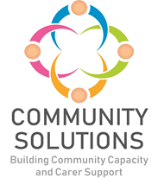

**Community Mental Health and Wellbeing Fund**

**Phase 1 (2022-23) - Impact and Learning Supplementary Report**

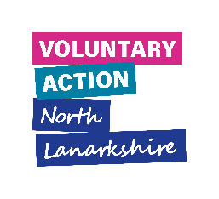



**Contents**

1. Introduction – Page 3

2. Summary of All Funded Projects – Page 4

3. Case Studies – Page 51

**1. Introduction**

**1.1 Background**

The purpose of this report is to supplement the Community Mental Health and Wellbeing Fund (CMHWB) Impact and Learning report for Phase One. The full report includes an overview and background of the fund, and a summary of achievements, reach and impact data, whereas this supplementary report provides additional information about all projects funded through Phase One of the Fund. This report provides a summary of the following for each funded project:

* The project aims
* The service/activity provided
* The project reach
* The evaluation method used to measure outcomes
* The achieved project outcomes
* The learning from each project

This report also includes case studies from six funded projects.

**1.2** The following projects were funded during Phase One, however, could not deliver their projects during 2022-23. The projects have agreed with Voluntary Action North Lanarkshire (VANL) staff to deliver their projects and report to VANL during 2023-24:

* Bipolar Scotland – Enabling Groups
* The Conservation Volunteers – Natural Connections Legacy
* Fair Play Foundation – Active8

**2. Summary of All Funded Projects**

This section presents a project-by-project summary of the projects funded through Phase One.

**Airdrie Citizens Advice Bureau – Action Beyond Courage**

**Aim –** To provide advice, support and assistance to the most vulnerable in the North Lanarkshire community

**Service/Activity –** 1-to-1 advice sessions

**Reach –** 253 people



**Evaluation Method**

* Listening events for feedback
* Feedback questionnaires

**Outcomes**

This project has:

* Provided advice and support to 253 people across North Lanarkshire in 1-to-1 advice sessions
* Developed a partnership with Women’s Aid to offer a bespoke weekly gender specific advice service
* Provided an advice service to Diamonds in the Community with initiatives to improve physical and mental wellbeing
* Worked collaboratively with partners to deliver a joined-up working approach, to ensure clients receive the correct information and assistance when they need it

**Learning**

* The Women’s Aid service received feedback that the service provided is safe, comfortable, and familiar for clients to come to for advice. All of the Women’s Aid service clients have reported in their feedback that the service has improved their financial or mental wellbeing.
* Clients identified that they would like more outreach surgeries in the areas they live, as travel costs are currently too high. Therefore, the organisation hosted Community Breakfasts outreach events to provide information on benefits, fuel poverty, and other general advice. This gave clients the opportunity to attend a warm space and have a breakfast roll. The organisation noted there were significant numbers of clients in attendance at these events

**Bazooka Arts – Connect Access**

**Aim –** To provide therapeutic arts support to people with newly identified or worsening mental health

**Service/Activity –** Three sessions of a therapeutic arts support programme

**Reach –** 75 people



**Evaluation Method**

* Online questionnaires
* Reflections from service users
* Interviews
* Informal verbal feedback

**Outcomes**

This project has:

* Delivered three weekly beginners therapeutic arts support groups for 75 people
* Opened three new rooms at their location at Kirkshaws Neighbourhood Centre
* Supported 61 service users to access an online creative community via the platform Cluster, where they can share creative achievements with others
* Signposted 75 individuals to other supportive services in the community, 20 of which were signposted to Bazooka Arts’ Connect Community project

**Learning**

* The organisation allowed service users to move between their two CMHWB funded projects, meaning individuals were able to choose the most appropriate support for them at the time, which was beneficial to service users. They were able to make progress on their own terms, develop new skills, and improve their confidence and sense of agency
* Their end of project survey showed:
  + 100% of participants felt that taking part had improved their overall mental health and wellbeing
  + 100% felt that they had made new friends and/or connections in the community
  + 100 % felt they had learned new skills that they could share with others
  + 100% felt taking part reduced feelings of social isolation
  + 75% have accessed other support, such as subsidised food support

**Bazooka Arts – Connect Community**

**Aim –** To support people in need of long term or intensive therapeutic support through therapeutic arts

**Service/Activity –** 168 therapeutic arts programme group sessions and 98 1-to-1 support sessions

**Reach –** 106 people

**Evaluation Method**

* Feedback survey
* Verbal feedback

**Outcomes**

This project has:

* Delivered 168 sessions of their group therapeutic arts programme for 64 people, including activities such as visual art, film production, drama, drama therapy, yoga, and movement
* Supported 76 service users to engage with an online creative community
* Offered individual support to 42 people through 98 sessions
* Been supported by volunteers including past service users
* Established a two-way signposting and referral pathway with other Community and Voluntary sector (CVS) organisations and statutory agencies

**Learning**

* The content of the therapeutic arts programme was determined by what service users’ goals, needs, and interests were

The questionnaire showed:

* 100% of respondents felt participating in the service improved their mental health and wellbeing
* 100% felt participating reduced their feelings of social isolation and loneliness
* 100% felt they were able to share their skills with others

**CACE – CACE Groups**

**Aim –** To promote and support the social, economic, and environmental conditions for good mental health and wellbeing, by providing older people with activities and groups to reduce social isolation, improve wellbeing, and reduce risk of mental health problems

**Service/Activity –** Delivery of weekly activity groups and a community transport service for older people

**Reach –** More than 300 older people on a monthly basis

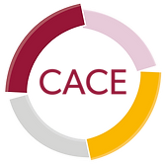

**Evaluation Method**

* Attendance of activities
* Journeys completed
* Written evaluation survey
* Staff feedback

**Outcomes**

This project has:

* Ran on average five activity groups a week, delivered four quarterly newsletters, and delivered daily online communication
* Secured a new minibus to support their community transport service which has driven over 7000 miles, including daily transport to activity groups, and group outings (pantomimes, lunches, sightseeing, parties, and concerts)
* Developed a range of new promotional publications for the services including a continuing quarterly newsletter
* Trained staff in passenger assistance and minibus driver assessment and training (MiDAS)

**Learning**

* The group’s engagement increased by over 100 people in the past 12 months
* The group have a suggestion box for ideas from service users in their activity suite

**Cloudberry Communities – Natural Connections**

**Aim –** To support individual wellbeing through connection to nature

**Service/Activity –** Weekly nature-based activities including health and nature walks, green prescription, 1-to-1 support, outdoor learning and drop-in cafés

**Reach –** 191 people

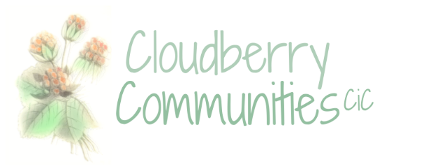

**Evaluation Method**

* Verbal feedback

**Outcomes**

This project has:

* Held 278 nature walks
* Hosted 90 sessions of a drop-in café
* Held 135 1-to-1 support sessions
* Participated in a pilot referral project with GP link workers, the Lanarkshire Green Health Partnership, the Community Board and LOIP development

**Learning**

* Unfortunately, the group’s drop-in café had to stop due to a lack of accommodation
* Between the six and 12-month review, the project saw 57 new participants
* As the project is outdoors, the weather could be a challenge. In future, the project will endeavour to hold wellbeing sessions at least partially indoors

**Community Action Newarthill – Summer Programme**

**Aim –** To offer activities to improve mental health and wellbeing over the summer

**Service/Activity –** A 10-week summer programme including a weekly community lunch and drop-in sessions

**Reach –** 50 people

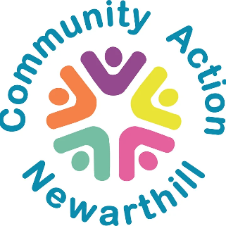

**Evaluation Method**

* Verbal feedback

**Outcomes**

This project has:

* Delivered 19 drop-in sessions
* Held nine lunches, and 10 afternoon teas with an activity or walk
* Held a 4-week cookery class for one
* Contributed volunteers to a local youth group working towards their Duke of Edinburgh's Award

**Learning**

* The project identified a widowed father of four young children who attended the group. After talking to him, they found out he had no cooking experience, and were able to offer him a weekly course teaching him easy-to-cook healthy meals
* The project was able to provide transport for some elderly people
* The project felt that having seasonal workers was a good decision, as some of their regular volunteers were able to enjoy the activities instead of leading them

**Cruse Bereavement – Bereavement Support**

**Aim –** To support bereaved people to find strategies to cope with their grief and feel less isolated

**Service/Activity –** 1-to-1 listening and support sessions and immediate listening, advice, and information

**Reach –** 442 people

**Evaluation Method**

* ‘Client Voices’ focus group – a group made up of 20 members (who used Cruse’s services) to collect feedback to inform improvements
* [Warwick Edinburgh Mental Wellbeing Scale](https://warwick.ac.uk/fac/sci/med/research/platform/wemwbs/using/register/resources/user_guide-june_2020_v4.pdf) (WEMWBS)
* Written survey

**Outcomes**

This project has:

* Delivered 294 listening and support sessions (more than six months on from their bereavement) which helped 49 bereaved people to cope with their grief and feel less isolated
* Delivered 62 early support sessions for 37 adults (within the first six months of their bereavement) to help them build resilience
* Offered immediate advice and information to 356 adults to help them better understand their grief, and signpost to specialist support if needed
* Attended the North Lanarkshire Mental Health Network and other local relevant bereavement and mental health forums

**Learning**

* From their WEBWMS evaluation:
  + 87% of Cruse’s clients said they felt less lonely and isolated
  + 90% of clients agreed their wellbeing had significantly improved
* From their written survey:
  + 80% said Cruse’s advice and information helped them understand their grief
  + 95% agreed Cruse provided reassurance that their feelings were a normal reaction to grief
  + 90% understood how to access further support if needed
* Over the past year, Cruse have seen an increase in people coming to them with more complicated grief and additional support needs. With more people also requiring sessions with their highest skilled volunteers, Cruse will invest in more volunteer training.

**Cumbernauld FM – Living History**

**Aim –** To share stories from people living with mental health problems and/or experiencing isolation to increase understanding of mental health

**Service/Activity –** Creation of a video and audio exhibition for the public, and a radio broadcast presenting stories on mental health

**Reach –** 37 people

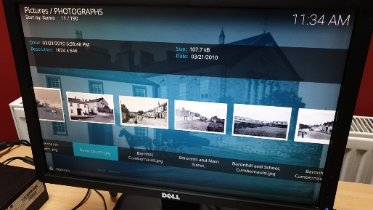

**Evaluation Method**

* Verbal feedback
* Personal stories
* Written feedback via social media from radio listeners

**Outcomes**

This project has:

* Filmed stories with 19 older people
* Engaged with 10 BAME young people and their families to hear their stories
* Delivered a mental health awareness programme to eight people

**Learning**

* The project found it was harder to reach out to older people who lived in care homes initially. Senior members of the team were able to overcome this by making initial contact and setting up interviews. Some older people were reluctant to be filmed
* The team were able to show some of their previously recorded materials to people at Cornerstone House, which made people more comfortable to participate. The team were then able to film a number of Cornerstone’s members

**Deaf Services Lanarkshire – Wellbeing Activities**

**Aim –** To support deaf/hard of hearing people through activities designed to improve mental health and wellbeing

**Service/Activity –** Set up of a hard of hearing networking group to deliver activities such as exercise and massage

**Reach –** 66 people

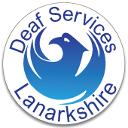

**Evaluation Method**

* Attendance of activities
* Verbal feedback

**Outcomes**

This project has:

* Established a hard of hearing networking group and appointed two hard of hearing group facilitators
* Provided weekly gentle exercise group sessions to 12 people
* Provided massage therapy to eight people
* Held a drama group with six people
* Delivered activities such as cookery classes and flower therapy

**Learning**

* The group identified an underspend which was used to deliver a drama group project at Hamilton School for the Deaf
* The networking group hope to appoint a committee to oversee their activities, supported by Deaf Services Lanarkshire
* The networking group has become a drop-in support group for service users

**Deafblind Scotland – Don’t Worry Be Happy**

**Aim –** To support isolated and vulnerable deafblind people living in North Lanarkshireto improve their mental health and wellbeing

**Service/Activity –** Making wellbeing contact with deafblind people in North Lanarkshire

**Reach –** 12 people who are deafblind



**Evaluation Method**

* Wellbeing survey at the beginning and end of the project
* Informal verbal feedback

**Outcomes**

This project has:

* Made 43 wellbeing phone calls, lasting between 1.5-2 hours
* Held 5 video calls with service users
* Made 2 extended home visits
* Provided wellbeing support packs to all members, which include breathing space tips, hot chocolate sachets, fleece blankets, lavender pillow spray and mental health promotion resources
* Trained 21 staff in Adult Support and Protection training

**Learning**

The findings from their wellbeing survey show:

* Before project delivery, when asked ‘on a scale of 1-10, 1 being lowest and 10 being highest, how were you coping before we started contacting you?’ the average answer was 1.3/10.
* After the project ended, when asked ‘on a scale of 1-10, again 1 being lowest and 10 being highest, how are you coping now we are making contact?’, the average answer increased to 6.3/10
* Average scores for loneliness increased from 2.5/10 before contact, to 6.3/10 after contact was established.
* Average scores for general mood before contact was 1.5/10, which increased to 6.6/10 after contact was established.

**Drumpellier Christian Fellowship – Townhead Community Hub**

**Aim –** To provide a safe space for people to come together, meet others, and access support

**Service/Activity –** Community Hub

**Reach –** 45 people

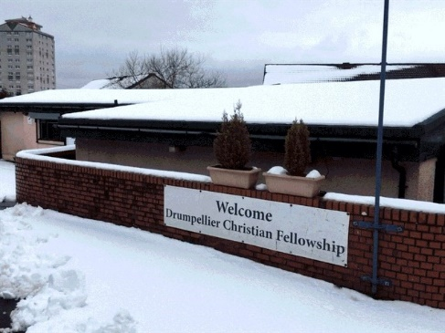

**Evaluation Method**

* Verbal feedback
* Attendance of activities

**Outcomes**

This project has:

* Provided people with a safe space to form relationships with other service users and facilitators, and discuss any concerns and access support
* Provided support to people for addiction, benefits advice, and work opportunities
* Worked with other organisations in the area e.g. the local Pharmacy to engage with more people
* Formed a local residents’ and tenants’ group to inform the service

**Learning**

* The project received feedback that people were surprised by the hub’s relaxing and friendly atmosphere. They found that people were happy to have someone to talk to and a place where they could go to discuss any concerns they had

**FAMS – Moving Forward**

**Aim –** To help people living with mental illness to develop proactive coping strategies and offer supportive services to improve their quality of life

**Service/Activity –** A range of mental health supportive services including mindfulness sessions, breathing techniques, stress and anxiety management sessions, massage and reiki, stress cafés, and a grief, loss and bereavement support group

**Reach –** 1146 people

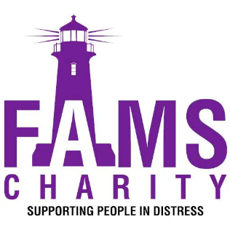**Evaluation Method**

* Feedback questionnaires
* Staff and partner organisation feedback
* Verbal feedback
* In person 1-to-1 feedback sessions
* Focus groups

**Outcomes**

This project has:

* Held 13 music group sessions with Reeltime Music
* Held 154 youth group sessions
* Held two ‘stress less’ cafés per week (224 sessions) where people could access support for issues causing them stress and anxiety
* Provided 140 people with holistic therapies including massage, reiki, and kinetic chain release
* Held 100 family social nights
* Held 24 sessions of a ‘Just for Men’ support group

**Learning**

* The project found that people preferred in-person support. Therefore, FAMS changed their ‘stress less’ café from via the phone to in person
* Due to the popularity of their ‘stress less’ café, FAMS put on a second café a week
* From their client feedback questionnaires, FAMS stated that 95% of service users reported that their services were ‘excellent’ and the remaining 5% said they were ‘very good’

**Forgewood Housing Cooperative – Taking Steps**

**Aim –** To engage the communities of Forgewood and Gowkthrapple in community development and offer support to people with mental health issues

**Service/Activity –** A range of activities via two Community Hubs (Forgewood Community Centre and CentrePoint Community Hub)

**Reach –** 674 people

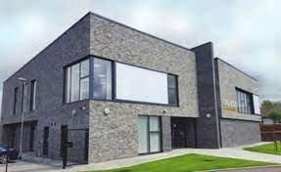

**Evaluation Method**

* Verbal feedback

**Outcomes**

This project has:

* Led eight community clean-ups which allowed the project to engage with local community and partner organisations
* Held 20 men’s group sessions
* Held 12 drop-in and mental health awareness sessions
* Completed four community art projects
* Held eight community garden parties
* Established a constituted community volunteer group

**Learning**

* The project uses a co-design approach, allowing them to tailor supports to what is impacting people in the community
* Feedback indicated that signposting of people to other projects and services was beneficial to local residents. This also highlighted a gap in nearby support for the community

**Getting Better Together – The Parent Journey**

**Aim –** To improve health and wellbeing and reduce mental health stigma by delivering inclusive and informative activities within a supportive environment for families

**Service/Activity –** Educational and fun antenatal and early years group services for families

**Reach –** 228 people

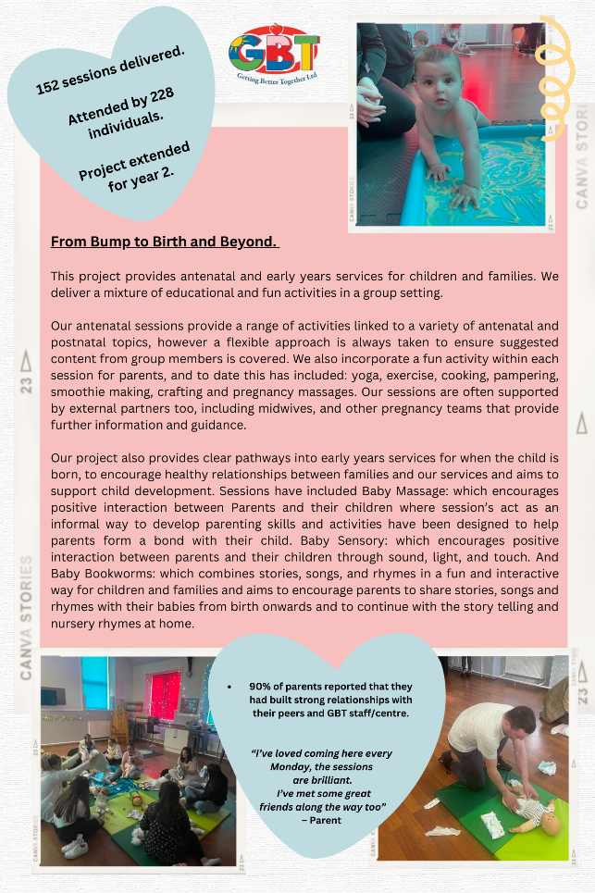**Evaluation Method**

* Consultation with service users to assess need
* Feedback and suggestion forms
* Anecdotal evidence and case studies
* Engagement levels

**Outcomes**

This project has:

* Held 18 antenatal group sessions with 30 people, incorporating fun activities including yoga, exercise, cooking, papering, smoothie making, crafting, and pregnancy massage
* Been supported by external partners such as midwives and other pregnancy teams, providing information and guidance to service users
* Held 124 early years sessions with 88 people including baby massage, baby sensory classes, and baby bookwork which combines songs, stories, and nursery rhymes for children
* Held 10 information events/sessions with 110 people

**Learning**

* From the feedback they received, 80% of families reported an improvement in mental health, and over 90% reported that they had made new friends and connected with others in the community
* 70% of the families reported an increase in physical activity
* The organisation found that people felt that postnatal services are often too late in addressing mental health struggles for parents. They received feedback that parents need services throughout their journey, and not only after the baby is born. From this, the project decided to take an early intervention and prevention approach by providing antenatal services that support families throughout the whole pregnancy and create clear pathways into Early Years services

**Getting Better Together – Active Lifestyles**

**Aim –** To support people facing socio-economic disadvantages with access to improved health and wellbeing

**Service/Activity –** Eight weekly activities including walking groups, exercise for children and families, cycling support, 1-to-1 wellbeing support, and cooking classes

**Reach –** 145 people

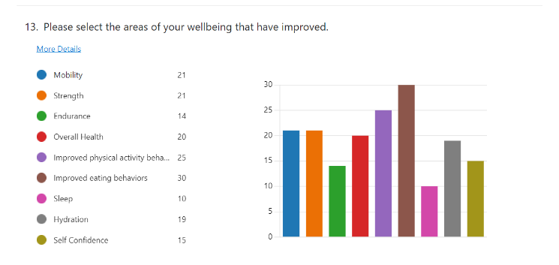

**Evaluation Method**

* Attendance of activities
* Pre-activity and post-activity evaluation questionnaire
* Verbal feedback
* Consultation with community on need

**Outcomes**

This project has:

* Led 40 health walks with 16 people
* Held 47 early exercise classes with 30 people, 24 kids' exercise classes with 13 children, and 11 family circuits training classes with 29 people
* Held six ‘Metafit’ exercise classes with 29 people
* Held nine cooking class sessions with 10 people
* Held two 1-to-1 cycling support training days with two people
* Supported 16 people through 1-to-1 wellbeing support consultations

**Learning**

* The project was able to adapt to feedback to better address community need. For example, the Metafit exercise classes did not function as they had hoped, so they introduced other activities such as tai chi, Zumba, and yoga which have been better received
* From their feedback, 12 people reported they felt very connected to others due to attending the group, and 17 felt connected
* The most common wellbeing areas that improved as a result of attending the group were improved physical activity, improved eating behaviours, mobility, strength, and overall health.

**Glenboig Development Trust – Mentoring Futures**

**Aim –** To support young people disengaged with education or employment to reconnect with their community and develop coping mechanisms

**Service/Activity –** 1-to-1 mentoring for 25 weeks and group activities

**Reach –** 30 young people

**Evaluation Method**

* Verbal feedback
* Written feedback
* WEMWBS

**Outcomes**

This project has:

* Supported 24 of the 30 young people to complete the 25-week programme
* Delivered 40 1-to-1 sessions with 24 young people and 30 group sessions with 26 young people, aimed at supporting young people to develop supportive relationships, improve social inclusion and connection, reduce isolation and loneliness, and give young people fulfilling and creative leisure and learning opportunities
* Engaged with young people via referrals, education pathways, health programmes, and voluntary organisations

**Learning**

The project allowed young people to direct and design their own interventions to encourage engagement.

Of the 24 young people who completed the programme:

* 22 reported an improvement in their wellbeing
* 21 reported that their home life improved
* 19 reported that they now had a road map to achieve their aspirations

**Glenboig Development Trust – Garden Project**

**Aim –** To provide a safe space to improve people’s health and wellbeing and encourage community spirit

**Service/Activity –** Community garden project

**Reach –** 334 people



**Evaluation Method**

* Written feedback via a Visitor’s Book and social media
* Verbal feedback
* Pictures

**Outcomes**

This project has:

* Had 300 drop-in visitors to the garden
* Worked with a local high school to support nine young people with additional support needs through planting and landscaping
* Incorporated a raised bed exclusively for children to support 10 children from a local nursery with planting
* Ran a sunflower-growing competition and a scarecrow-building competition to encourage families to engage in the activity together
* Developed the community garden including building a new slabbed path, a rockery, and three raised beds
* Been supported by 15 volunteers

**Learning**

* Other local organisations have begun to use the community garden for health and wellbeing-based services and support
* The project found that having a tool library encouraged people to visit regularly
* The project was asked by local people to ensure pathways were wheelchair accessible, and to build a fence to make the garden safer. The project was able to build a fence and pave the paths

**Glenboig Development Trust – Stop the World**

**Aim –** To connect with hard-to-reach young adults (particularly men) and their families with mental health issues to develop their understanding of negative behaviours

**Service/Activity –** 1-to-1 sessions with befrienders and mentors, and group activities

**Reach –** 30 people



**Evaluation Method**

* Self-assessment tools including goal setting
* WEMWBS
* Verbal feedback

**Outcomes**

This project has:

* Delivered 18 1-to-1 family sessions
* Delivered 25 weekly group activities with 29 people, including team building days out such as walk and talks, cycling, canoeing, water sport and orienteering
* Delivered 35 1-to-1 befriending and mentor sessions with 30 people
* Supported young people with resilience skills, mental health first aid, positive socialisation, and making health choices

**Learning**

* Four young men involved in the project returned to school. One young man began engaging with after-school activities
* An unexpected outcome of the project was that one of the project mentors was able to work with a young person undergoing assessment for autism to negotiate a timetable for returning to school which was accepted by the school. The young person was able to return to school following the new timetable
* The project found that building trust with the young people was vital. The young people were able to plan their own programme of support by identifying their aspirations and choosing their own activities

**Hope Community – Garden Project**

**Aim –** To provide a safe space for people to learn gardening skills and reduce social isolation

**Service/Activity –** Community garden and gardening skills

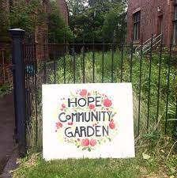**Evaluation Method**

* Verbal feedback

**Outcomes**

This project has:

* Provided a community garden space three days a week, where people could chat and connect with others to build supportive relationships
* Taught gardening skills to volunteers
* Hosted coffee mornings within the community garden

**Learning**

* The organisation had previously provided a horticultural course for the Cumbernauld Village assisted living care facility, which caters for people with dementia. Thanks to this funding, they were able to offer another course

**Kirkshaws Neighbourhood Centre – Health and Wellbeing Project**

**Aim –** To deliver an activity programme to support mental health and wellbeing improvement and post-pandemic recovery

**Service/Activity –** A programme of wellbeing activities including a healthy walking group, a chat café, healthy eating cooking programmes, and a craft group

**Reach –** 1480 people



**Evaluation Method**

* Attendance of activities
* Staff and volunteer feedback
* Written feedback from service users

**Outcomes**

This project has:

* Discussed with stakeholders which types of activities would benefit them most and shaped their project around this
* Employed a new member of staff for one year to support delivery of the project
* Delivered 190 healthy eating cooking classes
* Led 32 walking groups
* Held 48 adult art group sessions and 10 music sessions

**Learning**

* Members of the group were observed making new friendships and connecting with others in their community
* Service users felt they benefitted most from the cooking classes. The classes were the most popular activity

**Lanarkshire Association for Mental Health (LAMH) – Wishaw Wellbeing**

**Aim –** To provide a supportive environment for individuals to express needs and interests whilst participating in activities to improve health and wellbeing

**Service/Activity –** Wellbeing classes and food-related events

**Reach –** 3201 people

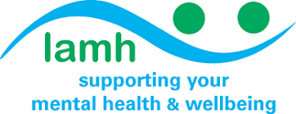

**Evaluation Method**

* Questionnaires
* Focus groups
* Ongoing verbal feedback

**Outcomes**

This project has:

* Delivered 415 wellbeing classes with 3120 people – topics were chosen by service users and include yoga, aerobics, pottery, mindfulness, colouring, container gardening, chat café, confidence and self-esteem, and drawing
* Held 12 food-related events with 81 people – the events targeted a specific marginalised group each event, invited them into the café to have a food event based on their own specific needs, and used the event to speak with them about their unique needs and challenges regarding mental health and wellbeing

**Learning**

* The project led to a new LGBTQIA+ support group being established offering peer support in relation to health and wellbeing

**LAMH Recycle – Personalised Community Supports with Peer Mentoring**

**Aim –** To engage with marginalised individuals in North Lanarkshire to provide individually person-centred tailored support and peer mentoring

**Service/Activity –** Tailored, person-centred support plans focused on learning and skills development and peer mentoring

**Reach –** 24 people



**Evaluation Method**

* Regular feedback sessions
* Testimonials from service users

**Outcomes**

This project has:

* Supported people with free-to-access taster sessions of work experience and business activities including IT waste management, computer sales and customer services, can recycling, general office duties, stores, warehousing and forklift operations, and driving, delivery, and collection
* Provided support, help, and advice to people who felt distressed
* Provided people with a safe, accessible and welcoming space for people to connect with others

**Learning**

* Service users were observed making new friends. The atmosphere at group events was fun. People reported feeling like they were not judged or isolated

**MADE4U IN ML2 – Wellbeing in ML2: Adults and Older People**

**Aim –** To provide physical and leisure wellbeing activities for vulnerable older adults, adults, and families

**Service/Activity –** Programme of daily wellbeing activities including dance classes, befriending, emergency food support, community café and meals, bingo, and more

**Reach –** 1450 people

**Evaluation Method**

* Focus groups
* 1-to-1 verbal feedback
* Attendance of activities

**Outcomes**

This project has:

* Delivered 10 mixed movement dance classes with 19 people, and made 1322 befriending calls to 255 people, by engaging with people with long-term health conditions or disabilities through referrals from local residential homes, social work, and word of mouth
* Held 23 older persons lunch clubs with 14 people
* Hosted 31 chatty cafes and seven ‘Welcome Wednesday’ drop-in sessions, providing a low-cost hot meal and a place for people to chat and attend mental health related talks from other organisations
* Provided 23 meal services to 84 people, providing low-cost meals to vulnerable people who were not eating or struggling to eat
* Supported 166 people to attend 47 walking groups, 11 men’s walking groups, 40 craft groups and two community trips
* Held a Christmas lunch which supported 55 people, a Christmas dinner for 212 people, and provided Christmas hampers to 95 people

**Learning**

* 80% of people who attended the lunch club said that it improved their health and wellbeing
* The community café was started as the organisation noticed that people from the walking group needed space to finish important and meaningful conversations, and to support people with social isolation
* The organisation did not expect to make home visits as part of their befriending activities, however they realised that it was a necessary service for them to provide to some of their most vulnerable service users

**Maggie’s Lanarkshire – Wellbeing Sessions**

**Aim –** To support people who have been diagnosed with cancer and/or a long-term health condition or disability to manage treatment and support themselves with the use of various relaxation techniques

**Service/Activity –** Delivery of psychological wellbeing workshops, courses and groups by a trained psychologist

**Reach –** 154 people with cancer and/or long-term condition diagnoses

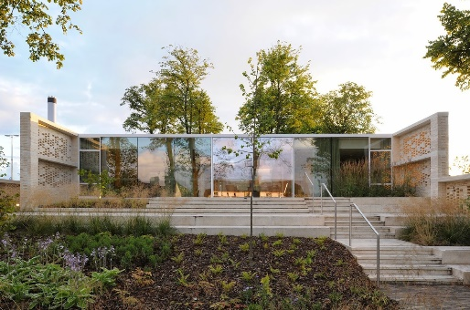

**Evaluation Method**

* Pre- and post-activity questionnaires
* Informal verbal feedback collected by staff from service users
* Attendance of activities

**Outcomes**

This project has:

* Supported 1505 total visits to the Maggie’s Lanarkshire Centre
* Delivered stress management courses to 29 people, totalling 91 visits to the centre
* Delivered the ‘Living Well When Cancer Can’t Be Cured’ course to three people, totalling 15 visits
* Held a bereavement support group with 15 people, totalling 96 visits to the centre
* Delivered cognitive rehab sessions with seven people, totalling 32 visits to the centre
* Taught meditation techniques to 15 people, totalling 229 visits to the centre

**Learning**

* Maggie’s found that people found the opportunity to connect with others face-to-face to be valuable
* Maggie’s held an annual audit in 2022 and found that, of the 68 people who responded, 100% said Maggie’s had helped improve their ability to reduce their stress and 98% said that Maggie’s helped them feel less alone

**Motherwell FC – The Well Hub**

**Aim –** To help people feel more connected, less isolated, and to provide regular opportunities for social interaction

**Service/Activity –** Employment of a Programmes Officer to deliver projects addressing mental health concerns

**Reach –** 101 people



**Evaluation Method**

* Verbal feedback

**Outcomes**

This project has:

* Been supplied with digital tablets and a big screen by club sponsor TCL – the tablets allowed service users to FaceTime with family to reduce social isolation, and the screens allowed the club to show the World Cup to service users who were struggling financially and would not have been able to watch it otherwise
* Provided a heat hub four times per week
* Delivered ‘the Changing Room’ project with SAMH, offering mental health support to 31 people
* Held 26 sessions of a women’s walking football group with 12 people, and 26 sessions of a men’s walking football group with 46 people

**Learning**

* Due to the cost-of-living crisis, the organisation was able to engage with more people than anticipated. They have therefore extended the work to ensure that people do not miss out on the support
* The organisation noted that their facilities were not accessible as they have a lot of stairs, this limited their ability to deliver some activities. However, they have now addressed this

**Motherwell Foodbank – Motherwell Foodbank @ Maranatha**

**Aim –** To provide food and toiletries to people in need

**Service/Activity –** Foodbank and free café

**Reach –** 6760 people

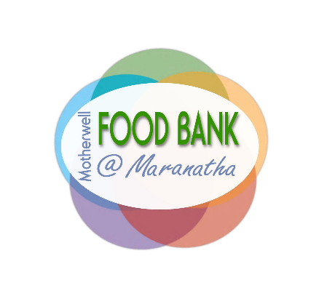

**Evaluation Method**

* Number of referrals and food parcels issued per week
* Record of family size for each referral

**Outcomes**

This project has:

* Processed around 15-20 referrals every week, which are fulfilled on a Monday and Thursday, or urgently out-of-hours collection is arranged if required
* Managed walk ins during Monday and Thursday opening hours
* Been supported by 18 volunteers per week

**Learning**

* At the start of the project, the foodbank was giving out around 30 food parcels per week. By the end, they were handing out around 110 food parcels per week. The number of volunteers and number of volunteering hours has had to increase to support this
* In one three-hour spell, the foodbank had 98 people drop in which is too many for the foodbank to cope with. They have now restricted service users to attending twice per calendar month without a referral.

**New Opportunities – New Opportunities Project**

**Aim –** To tackle inequalities, improve local people’s health and wellbeing, support family functioning, and strengthen community life by providing opportunities for local people to become involved in community-based activities

**Service/Activity –** Programme of weekly wellbeing activities including a community café, walk and talk group, women’s group, volunteering and skills development opportunities, and more

**Reach –** 361 people

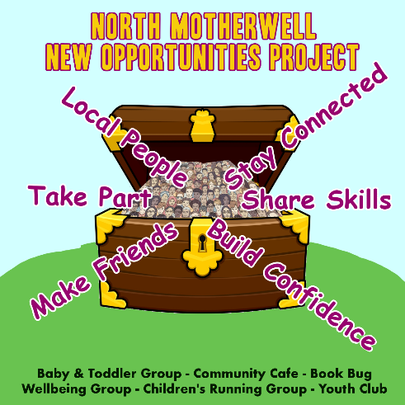**Evaluation Method**

* Informal verbal feedback
* Attendance of activities
* Formal feedback from groups and individuals

**Outcomes**

This project has:

* Held a twice-weekly community café supporting 98 on average, supported by nine volunteers
* Held a weekly health and wellbeing group with 22 regular attendees
* Held a twice-weekly parent, baby, and toddler group, with 47 families attending regularly
* Held a weekly ‘walk and talk for health’ session with 29 total adults
* Delivered volunteering and skills development opportunities, supported by 37 regular volunteers
* Held a women’s group for five families

**Learning**

* New Opportunities found that when one family member participated in the group, it was likely that other family members would become engaged with the organisation and participate in activities
* New Opportunities identified that local people have reported significantly higher levels of stress and increased anxiety due to financial hardship caused by the cost-of-living crisis. They have been able to work with local people, businesses, and other support organisations to provide emergency food and hygiene supplies to local people.
* The weekly ‘walk and talk for health’ session was developed following the success of a one-off social walk

**North Lanarkshire Recovery Community – Peace of Mind Therapies**

**Aim** – To support people struggling with addiction issues with their mental health, to enable them to address their addiction issues

**Service/Activity –** Holistic wellbeing activities (reiki, yoga, retreat, fishing)

**Reach –** 627 people

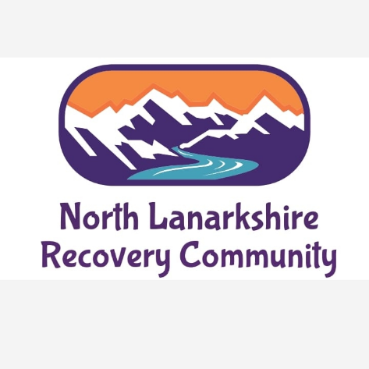

**Evaluation Method**

* Attendance of activities
* Verbal feedback

**Outcomes**

This project has:

* Hosted 20 reiki recovery café sessions in Airdrie for 60 people, 14 sessions in Motherwell for 39 people, and 21 sessions for 200 people in Cumbernauld
* Delivered yoga sessions in Airdrie for 180 people
* Provided a two-day recovery wellness retreat for 18 people
* Taken 16 people on two fishing excursions and 12 people on two camping fishing trips
* Hosted a Christmas party for 102 people

**Learning**

* The funding enabled the organisation to engage with some of the harder-to-reach members of the local community, providing them with the opportunity to be involved in activities they would not previously be able to access
* People have been able to seek alternative, holistic supports for their mental health and addiction issues
* The organisation initially thought that only people accessing the recovery cafés would benefit from yoga. However, as people became aware of the yoga, others are now attending regularly

**One Parent Families Scotland – Cumbernauld, Airdrie, Motherwell, and Bellshill**

**Aim –** To provide a range of family support interventions to support single parents who face barriers to accessing services

**Service/Activity –** 1-to-1 and group support work with single parents

**Reach –** 431 people



**Evaluation Method**

* Focus groups
* Individual needs analysis
* Verbal feedback

**Outcomes**

This project has:

* Provided 342 people with 1-to-1 support, involving an individual needs assessment, development of a personal action plan, and support with childcare advice, financial inclusion, crisis support, digital inclusion, a counselling service, and referral to specialist services
* Worked with 89 people through group work, delivering a scheduled programme of indoor and outdoor sessions focusing on confidentiality and boundaries, peer support, parenting, health and wellbeing, confidence and self-esteem, and signposting to other services and resources

**Learning**

* Parents were keen to have one week in the programme with a structured break in the group work, to allow parents to have time together with their children and other families during the school holidays to maximise peer support. One Parent Families organised a day for this to happen, where families could attend soft play or go to the park
* Many parents find group work challenging and do not like to attend, therefore, New Opportunities offers alternative 1-to-1 support

**PAMIS – Wellbeing Project**

**Aim –** To offer people with profound and multiple learning disabilities (PMLD) and their unpaid carers the opportunity to access activities to support their health and wellbeing

**Service/Activity –** 1-to-1 intensive support for carers and accessible wellbeing activities for people with PMLD

**Reach –** 307 people



**Evaluation Method**

* Verbal feedback

**Outcomes**

This project has:

* Provided 116 1-to-1 emotional support sessions for carers
* Delivered a range of activities for families including yoga (for 18 people), meditation (16 people), pottery (21 people), a canal trip (36), fishing (14), bikes and boats (22), and countryside access sessions with ponies (144)
* Helped families to access the PAMIS Family Support Service for additional support beyond this project

**Learning**

* PAMIS were able to support bereaved families who were struggling with their loss and caring role, and have included these families in the PAMIS Bereavement and Loss Project
* A parent requested cold water therapy: PAMIS were able to source a cold-water therapist who agreed to run a session for carers. This was well received, and participants requested this continue

**Parkinson’s Self-Help Group – Nurture, Develop, and Grow**

**Aim –** To support individuals with a neurological diagnosis and their carers

**Service/Activity –** Group wellbeing activities (crafts, music, tai chi, dancing) for people with a neurological diagnosis and advice and information for carers

**Reach –** 37 people

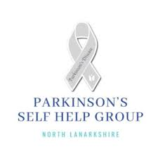

**Evaluation Method**

* Verbal feedback with groups and individuals
* Consultation with the board
* Anonymous written feedback

**Outcomes**

This project has:

* Provided a monthly newsletter led by what service users want
* Provided 37 people with activities such as a craft group, musical memories sessions, tai chi, and Bollywood dancing
* Provided carers with advice, information, and signposting to other relevant organisations
* Provided healthy eating advice and educational activities to 37 people
* Developed and encouraged people to make use of the green space attached to the centre

**Learning**

* The organisation found that when they suggested some of the activities, the initial reaction from some people was that they wouldn’t be able to do it. For example, people were apprehensive about the Bollywood dancing sessions. The group agreed to try one session, with no pressure on people to take part. There is now 14 people attending the monthly sessions

**Rivals School of Martial Arts – Food for Thought**

**Aim –** To provide support to families, older people, and people experiencing severe and multiple disadvantages struggling with food insecurityand social isolation

**Service/Activity –** Provision of a hot meal and space to chat within the Rivals School of Martial Arts gym

**Reach –** 300 meals per month



**Evaluation Method**

* Number of meals provided
* Verbal feedback

**Outcomes**

This project has:

* Provided 300 hot meals per month to people from disadvantaged backgrounds
* Provided people with a safe and comfortable environment to connect with others

**Learning**

* Due to the cost-of-living crisis, the project is increasingly receiving more requests than ever
* The organisation noticed an increase in the number of people looking for support with their mental health, social inclusion, and the reliance on foodbanks. The idea for the project came from consultation with local foodbanks which identified a significant increase in the number of food parcels being provided

**Scottish Huntington’s Association – National HD Specialist**

**Aim –** To provide practical and emotional support to people with a Huntington’s disease diagnosis and their carers

**Service/Activity –** Support coordinated by a National Huntington’s Disease specialist (dieticians, physiotherapy, speech and language therapy, financial planning, mental health support, youth specialist services)

**Reach –** 76 people

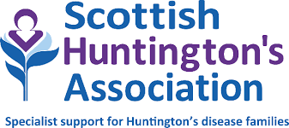

**Evaluation Method**

* Attendance of activities
* Verbal feedback

**Outcomes**

This project has:

* Supported 50 individuals who are symptomatic, 18 carers, five people who were at risk of inheriting the condition, and three individuals who had received a positive test but did not have symptoms
* Worked with individuals and their families on issues including employability, sensory loss, memory impairment, cognitive changes, poor mobility, isolation, depression, and financial matters
* Provided 18 carers with information on 227 occasions, around symptom management to avoid unnecessary hospitalisation and other topics
* Provided support and advice to 50 people with Huntington’s on 237 occasions
* Provided support and advice to 101 Health and Social Care professionals who attended training sessions on how to support people with Huntington’s

**Learning**

* The needs of families often change frequently due to the nature of the condition. The specialist therefore plays a vital role in coordinating the care the families receive, easing the stress placed on them
* With the recruitment of a new specialist, the service was able to re-establish face-to-face meetings with service users

**Social Track – Active Travel for Mental Health**

**Aim –** To support people with mental health issues to manage their mental health in a non-clinical setting

**Service/Activity –** A weekly bike ride on traffic-free routes guided by a qualified mountain bike and cycle leader

**Reach –** 134 people



**Evaluation Method**

* Verbal feedback
* Staff observations
* Attendance of activities

**Outcomes**

This project has:

* Supported 134 people through 25 weekly bike rides
* Hosted outreach sessions and attended community events to promote the project

**Learning**

* The project felt that they had underestimated the amount of support that service users would need with their mental health issues. The project has enrolled four members of staff on mental health support training offered by Scottish Cycling to develop their skillset, and hope to be able to offer this to all staff in the future
* The organisation moved locations throughout the project. The new location brought in new services users with different needs to their previous location, e.g., addiction issues were more prevalent in the new location. To develop their skills and offer appropriate support, the project is now working with Police Scotland to learn how to better support people with addiction issues

**Social Track – Free Your Inner Child**

**Aim –** To make people feel more mentally well and positive about their future by engaging with physical activity and skills-based learning

**Service/Activity –** Twice weekly group and individual sessions of action sports including BMX riding, skateboarding, and skating

**Reach –** 74 people



**Evaluation Method**

* Verbal feedback
* Staff observations
* Attendance of activities

**Outcomes**

This project has:

* Held 22 action sports group sessions with 69 people
* Held 5 1-to-1 sessions with five people
* Incorporated mindfulness techniques into their sessions

**Learning**

* The project found that people preferred riding the BMX bikes. The project was able to secure more bikes to accommodate this
* The biggest challenge the project found for delivering the sessions was the unpredictable weather, which deterred people from attending. The project is looking into indoor options for their activities in the future

**Street Soccer Scotland – Positive Change Through Football**

**Aim –** To provide support to people who are facing social isolation with personal development opportunities through football

**Service/Activity –** Free, weekly, non-competitive football sessions

**Reach –** 322 people



**Evaluation Method**

* Attendance of activities
* Verbal feedback
* A ‘player census’ written questionnaire gathered by volunteer students from Edinburgh Napier University

**Outcomes**

This project has:

* Provided football players with hot food at the start of each session
* Created an environment for players to chat and engage with each other to combat social isolation
* Partnered with other organisations to offer other supports to players such as Motherwell Football Club Community Trust and North Lanarkshire Recovery Community
* Held 84 football games

**Learning**

* From the questionnaire, 89% of service users felt their mental health had improved
* Players were asked to rate from one to four how they felt their life had improved due to joining Street Soccer Scotland (four being the most improvement). The average score was 3.5 out of four

**The Haven – Cumbernauld, Coatbridge, Airdrie**

**Aim –** To provide emotional, mental health and wellbeing, and complex bereavement support services

**Service/Activity –** Comprehensive emotional support session with a dedicated Haven Nurse, wellbeing support activities, and a wellbeing toolkit of resources

**Reach –** 12 individuals living with a diagnosis of illness

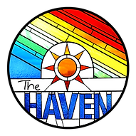

**Evaluation Method**

* Community Connections Consultation: an opportunity for local residents and organisations to provide feedback to inform The Haven communications
* Verbal feedback

**Outcomes**

This project has:

* Connected with 36 North Lanarkshire-based organisations to raise awareness of The Haven services
* Delivered 46 emotional and mental wellbeing support sessions, and provided therapeutic resources to support mental health and wellbeing to 12 people

**Learning**

* The Haven have been using ReciteMe, a website accessibility feature to help reduce inequalities as a result of being unable to access information. From the data report, The Haven have identified that people are increasingly using this feature. A total of 42 users have accessed the ReciteMe functions since its launch in December 2022. They also noted that the feature had been used to translate information into Arabic and Albanian

**The Haven – Wishaw and Shotts, Motherwell, Bellshill**

**Aim –** To provide emotional, mental health and wellbeing, and complex bereavement support services

**Service/Activity –** Comprehensive emotional support session with a dedicated Haven Nurse, wellbeing support activities, and a wellbeing toolkit of resources

**Reach –** 16 individuals living with a diagnosis of illness



**Evaluation Method**

* Community Connections Consultation: an opportunity for local residents and organisations to provide feedback to inform The Haven communications
* Verbal feedback

**Outcomes**

This project has:

* Connected with 36 North Lanarkshire-based organisations to raise awareness of The Haven services
* Delivered 69 emotional and mental wellbeing support sessions, and provided therapeutic resources to support mental health and wellbeing to 16 people

**Learning**

As in the section above

sss

**The Health and Wellness Hub – Transforming Lives**

**Aim –** To offer people training, coaching, and practical experiences that support personal, social, and vocational development

**Service/Activity –** Tailored training and coaching opportunities

**Reach –** 21 people

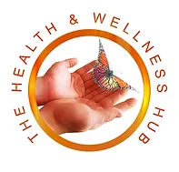**Evaluation Method**

* Individual needs assessment
* WEMWBS
* Verbal feedback

**Outcomes**

This project has:

* Worked with 21 volunteers to undertake a coaching programme tailored to their specific needs including goal setting, overcoming barriers, self-management, identifying and using strengths, and managing stress and anxiety
* Engaged with other organisations to provide advice and information for volunteers, e.g., Home Energy Scotland provided drop-in sessions giving advice on energy bills and funding during the cost-of-living crisis
* Provided 15 individuals with Wellness Recovery Action Planning Training
* Provided 16 individuals with mental health first aid training
* Provided training to volunteers in reiki, first aid, complementary therapies, and chair-based exercise training

**Learning**

* All 21 volunteers reported an improvement in their mental health and wellbeing as a result of being involved with the project
* The project struggled with people not turning up for activities or cancelling last minute, and communication was difficult as they were using a landline or email. The project invested in a mobile phone specifically for service users. This has enabled the project to contact service users more easily, and service users feel more comfortable as some were not comfortable calling the landline and leaving a voicemail. They can now text or call the project. Staff and service users are happier with this method of communication
* The mobile phone has also enabled the project to send reminders the day before any activities

**The Miracle Foundation – Encouraging Growth and Resilience Mental Health Workshops**

**Aim –** To help young people experiencing socio-economic disadvantages and those affected by bereavement and trauma (including adverse childhood experiences) to expand their knowledge on mental health and wellbeing

**Service/Activity –** 14 ‘Encouraging Growth and Resilience’ mental health workshops

**Reach –** 100 young people

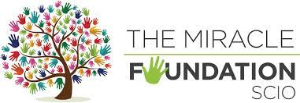

**Evaluation Method**

* Feedback questionnaire
* Facilitator observations
* Wellbeing [(SHANARRI)](https://www.gov.scot/policies/girfec/wellbeing-indicators-shanarri/) Indicators

**Outcomes**

This project has:

* Delivered 14 workshops aimed at improving the mental health and wellbeing of participants
* Engaged young people through group discussions, activities, and learning self-care practices
* Taught young people coping mechanisms such as breathing techniques, mindfulness, and self-care

**Learning**

* The organisation found it difficult to recruit participants for the workshops within local colleges. They had to revise their approach and held three canvassing days to increase engagement with college students. They found that college staff were reluctant to book programmes around class times despite interest from students. The organisation was able to work around this to continue delivering over the summer
* The project identified that some students with additional support needs (ASN) struggled in receiving appropriate support. The organisation entered talks with New College Lanarkshire’s ASN department, who have agreed to let them deliver more workshops over summer

**Venture Scotland**

**Aim –** To support young adults to improve their mental health

**Service/Activity –** 12 weeks of weekly outdoor activities and group sessions

**Reach –** 16 people

**Evaluation Method**

* 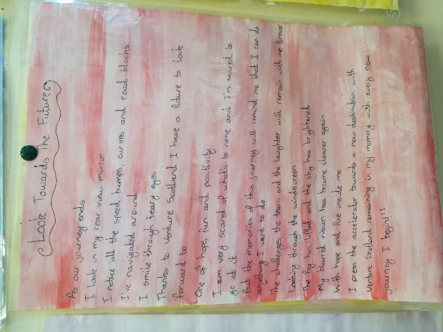Verbal feedback
* Written feedback
* Life skills questionnaire

**Outcomes**

This project has:

* Delivered a 12-week outdoor project, which took place on a weekly basis and focused on cultivating trusting relationships, promoting a safe and nurturing environment, and teaching practical and emotional skills to young people to improve their long-term wellbeing
* Hosted one camping trip and two bothy trips, held nine outdoor activity days, one team-building day, had eight life skills sessions, and offered 1-to-1 support for each young person
* Employed an Outreach and Support Worker

**Learning**

* Halfway through the project, the group said they wanted to take on more responsibility and gain confidence in planning and organising the activities. They were supported to do this through the camping trip and bothy trip
* The survey showed:
  + 75% improved their ability to “make their voice heard in a group setting”
  + 100% improved their ability to “trust in relationships”
  + 88% improved their belief in “making positive change” in their life
  + 88% felt less isolated since participating in the project

**Veterans Community Lanarkshire – Veterans Community**

**Aim –** To provide veterans and their families with a welcoming environment to access appropriate support

**Service/Activity –** Community hub (Monday-Thursday) and a weekly drop-in café for veterans (Friday)

**Reach –** 210 people

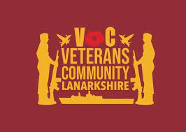

**Evaluation Method**

* Regular, in-person discussions with service users

**Outcomes**

This project has:

* Worked with other veteran support organisations (Fares4Free, Defence Medical Welfare Service, Legion Scotland, the Armed Services Advice Project) to ensure veterans are able to receive the most appropriate support
* Operated 50 sessions of a drop-in café every Friday for 70 people
* Operated a weekly community hub, open Monday to Friday, attended by 140 people

**Learning**

* The project was expanded from a once-a-week drop-in café to a community hub as service users wanted to be able to come together more often
* The project is led by what the veterans want. The hub has a suggestion box where veterans can make suggestions on how to improve services. For example, the hub was opened to the local community on Remembrance Day at the request of the veterans

**Viewpark Conversation Group – Mental Health and Greenspace Project**

**Aim –** To deliver a range of conservation, outdoor and gardening activities to members of the community affected by mental health related issues, with a focus on improving their mental health, physical health, and overall wellbeing

**Service/Activity –** A range of activities including conservation and ranger activities, guided nature and educational walks, tree planting, and wild gardening

**Reach –** 114 people

**Evaluation Method**

* Attendance of activities and returning service users
* Verbal feedback
* Feedback via social media and email
* Staff observations

**Outcomes**

This project has:

* Set up a volunteer hub on the greenspace
* Enabled 34 individuals to participate in conversation and ranger activities including hedgerow planting, educational talks, and litter-picking
* Taken 45 people on guided nature walks and exercise activities
* Enabled 35 people to participate in wild gardening and taught them tree-planting skills

**Learning**

* The project work carried out has significantly improved the greenspace. This has encouraged more people from the local community to visit and use the green space for walking, cycling, and jogging
* The organisation has learned that as most of the activities are outdoors, the weather has a significant impact on the success of activities, so they now plan for when activities need to be postponed or for lower attendance
* The organisation also learned that some of the activities (six-to-eight hours) were too long for people struggling with mental and physical health issues, so they reduced the time and introduced more frequent refreshment breaks. This has allowed more people to participate and has given the service users more time to network and connect with others

**Windmills – Connect@Windmills**

**Aim –** To bring together vulnerable young adults to give them the opportunity to connect with others

**Service/Activity –** Menu planning and cooking, socialisation, and group-led activities

**Reach –** Three groups of vulnerable young adults (an LGBTQIA+ group, a group committed to climate change, and a group with learning difficulties who are socially isolated),16-20 people each week

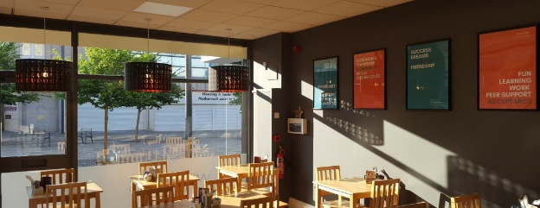

**Evaluation Method**

* Anecdotal verbal feedback
* Staff observations

**Outcomes**

This project has:

* Encouraged the groups to organise activities of their own choosing, e.g., quizzes, games, and a treasure hunt
* Planned a menu with a group, discussing dietary requirements and food preferences. Windmills’ chefs then made the menu and the group were responsible for either serving or setting out the food
* Held 52 social evenings with 50 people

**Learning**

* Staff observed an improvement in the group’s confidence and social anxiety. The young adults were observed engaging with each other and staff members, as well as participating in games
* The groups have made friendships outside of the activities

**Windmills – FamilyCook-In@Windmills**

**Aim –** To teach cooking skills to families experiencing financial difficulties, social isolation, and poor mental health

**Service/Activity –** Cook-along classes for families

**Reach –** 30 people



**Evaluation Method**

* Staff observations
* Anecdotal verbal feedback
* Photographs

**Outcomes**

This project has:

* Delivered 50 cook-along sessions with Windmills chefs for 25 people, teaching service users a range of health recipes, basic numeracy skills, portion sizes and budgeting
* Taught skills such as knife skills, food awareness, and food hygiene
* Taught mindfulness to five people

**Learning**

* The project was unexpectedly able to teach cooking skills and English to displaced Ukrainian refugees. The project listened to what they wanted to gain (which was friendship, understanding Scottish culture through cookery, and advice on living economically in Scotland)
* The project delivered some mindfulness sessions, however, some dropped out as they found this difficult

**g**

**Windmills – Skills@Windmills**

**Aim –** To teach young people coping strategies and resilience at work through cookery, kitchen, and front-of-house skills

**Service/Activity –** Cookery, front of house, health and wellbeing, and employability workshops

**Reach –** 46 young people



**Evaluation Method**

* Progress and performance indicators
* Attendance of activities
* Testimonies

**Outcomes**

This project has:

* Delivered 250 sessions of hospitality training including on health and wellbeing and employability
* Taught young people front of house skills such as barista training, cleaning, customer service, presentation skills and recipes for crepes, cakes, and smoothies
* Taught young people food hygiene, cleaning skills, and managing stock

**Learning**

* The project has been able to engage with 30 displaced Ukrainian refugees who were unable to secure employment, teaching them English and employability. Five of the Ukrainians have gone on to secure employment, one being with Windmills
* Five young people have also secured employment

**YMCA Bellshill and Mossend – Virtual Wellbeing Space**

**Aim –** To improve young people’s social connectedness and inclusion, self-confidence, and mindfulness

**Service/Activity –** Weekly virtual reality and games sessions, and hot food support service

**Reach –** 30 young people



**Evaluation Method**

* Written feedback
* Using coloured counters to evaluate the session
* Verbal feedback

**Outcomes**

This project has:

* Provided 30 young people with weekly sessions involving virtual reality resources, games consoles, arts and crafts, and a hot food support service
* Allowed young people to explore their mental health challenges through virtual reality
* Allowed young people to co-lead sessions and help to plan activities
* Created a safe environment for young people to talk freely about their experiences and provide an escape from their everyday lives through virtual reality headsets

**Learning**

* All young people involved reporting to their youth workers that they enjoyed the virtual reality experience
* The project received feedback that the young people liked the idea of chatting around a virtual campfire, and doing virtual nature treks and cooking simulators. The project was able to provide all of these virtual settings

**3. Case Studies**

This section provides six case studies from projects funded in Phase One. These case studies are illustrative of the range of great work that has been achieved by all organisations, and have been selected to highlight the variety of services provided.

**3.1 Airdrie Citizens Advice Bureau – Action Beyond Courage**

**Background**

The project received an enquiry from Client A. Client A is a single parent with two dependent children, living in a Local Authority property. Client A is a carer for one of her children who is disabled. Client A had been experiencing financial hardship due to cost-of-living crisis and the increase in fuel prices. Client A said she was struggling and didn’t know where to turn. She saw a posted advert for Airdrie Citizens Advice Bureau (CAB) and attended for advice.

**Intervention**

At her initial appointment, CAB staff discussed Client A’s current situation and provided her with a benefit check to ensure she was in receipt of all correct and appropriate benefits, which she was. They also advised Client A of the Scottish Government’s Home Heating Support Fund and completed an application for her to receive a grant. This would assist her with heating costs since one of her children is disabled.

At her follow-up appointment, CAB staff provided Client A with an income and expenditure form, which they provided assistance for her to complete. This form helps clients to budget and keep track of their spending and bill due dates. They also provided Client A with energy saving handy hints” to give her more knowledge about managing her energy consumption.

**Outcome**

Client A received a grant of £1400, which covered her fuel consumption during the winter months of fuel consumption. Client A fed back that she can manage her income better now she has her income and expenditure worksheet.

CAB staff also advised Client A of carer groups where she can meet with other carers or receive telephone/online support.  Client A fed back that she had contacted them.

**3.2 Forgewood Housing Cooperative – Taking Steps**

**Background**

During the winter months, W began attending the Community Centre. After using the facilities, W approached staff and declared that she was homeless and asked for help. Staff spoke with W and established that she had been walking around during the night seeking warmth and shelter. She told staff that she was cold and hungry. She had no access to a telephone, but needed to call the local council so they could assist with her housing situation.

**Intervention**

Staff provided W with a cup of tea and a biscuit, before they gave her access to an interview room within the centre. From there, staff assisted W to call the council and seek the support she needed. A member of staff also spoke to the council to establish what W needed to do next. The team at Forgewood Housing Cooperative provided W with directions and a bus fare so she could get to the council housing office.

**Outcome**

Since W attended the centre, she has been in contact with the centre again. W’s housing situation has been resolved and she is no longer homeless.

**3.3 Getting Better Together – The Parent Journey**



**3.4 FAMS – Moving Forward**

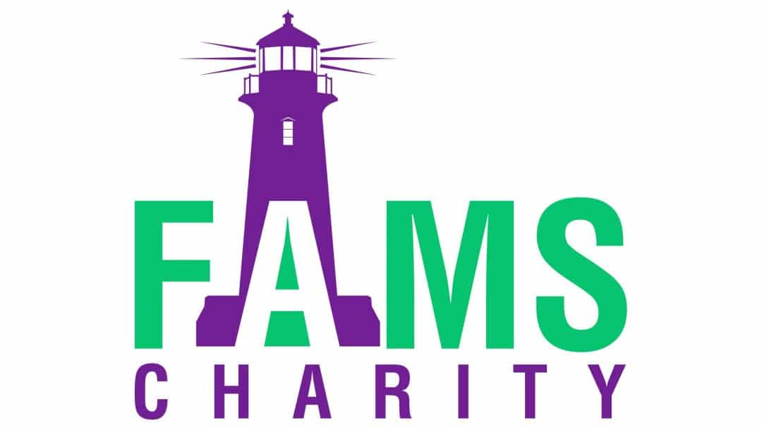**Background**

The family of a murdered man came to FAMS for support with trauma induced mental health and wellbeing issues. The family members were aged between 4 and 55. The murdered man, T, was 34 when we died. He left behind his parents, sister, nephew, his fiancé who was pregnant, and his daughter.

T’s family were struggling to process their complex grief. They were also dealing with a High Court case surrounding T’s death. This was impacting the mental health and wellbeing of the family.

**Intervention**

FAMS were able to offer support to each member of the family individually, and collectively as a group. Each family member was assigned to the sessions which best supported them.

**Outcome**

The family attended FAMS’ Friday Night Social Club. T’s mother and sister now volunteer with FAMS.

**3.5 Street Soccer Scotland – Positive Change through Football**

Street Soccer Scotland have [shared Brian’s story](https://streetsoccerscotland.org/my-team-mates-are-an-inspiration-brians-story-motherwell/), from Motherwell.

“I am a happy man now. I come here happy, I wake up happy. This has really improved my mental health and self-esteem.” – Brian

**3.6 Windmills – FamilyCook-In@Windmills**

**Background**

AM is a middle-aged woman with learning difficulties and mental health problems. She had recently left a bad relationship and felt lonely, isolated, and lacking purpose.

**Intervention**

AM became involved in the cooking class. She initially chose to work by herself with the chef, despite staff trying to encourage her to join the main group. However, this worked well for AM. Due to her needs and mental capacity, the chef was able to provide 1-to-1 support and worked around barriers to her learning.

**Outcome**

AM learned to cook a variety of dishes. Her favourite dish was lentil soup. AM fed back that she enjoyed the camaraderie with the chef, and they often had fun together. AM was often observed laughing with the chef. AM fed back to staff that she felt less lonely.

[document ends]