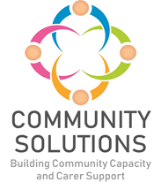

**Community Mental Health and Wellbeing Fund**

**Supplementary Impact and Learning Report –**

**Phase Two (2023-24)**

**Phase X (20XX-XX) - Impact and Learning Report**



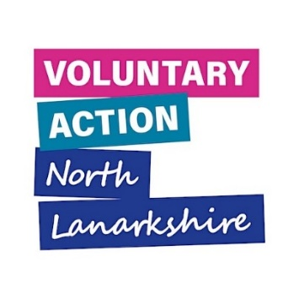



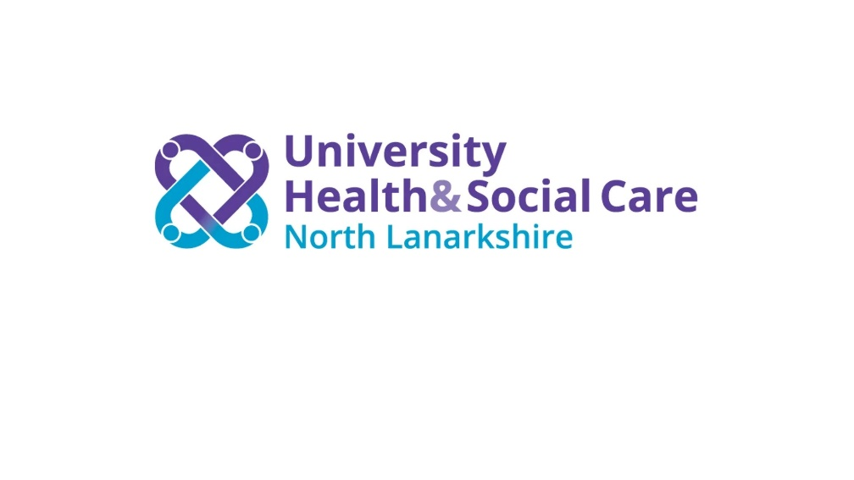

**Contents**

1. Introduction – Page 3

2. Summary of All Funded Projects – Page 4

3. Case Studies – Page 42

**1. Introduction**

**1.1 Background**

The purpose of this report is to supplement the Community Mental Health and Wellbeing Fund (CMHWB) Impact and Learning report for Phase Two. The full report includes an overview and background of the fund, and a summary of achievements, reach and impact data, whereas this supplementary report provides additional information about all projects funded through Phase Two of the Fund. This report provides a summary of the following for each funded project:

* The project aims
* The service/activity provided
* The project reach
* The evaluation method used to measure outcomes
* The achieved project outcomes
* The learning from each project

This report also includes case studies from six funded projects.

**2. Summary of All Funded Projects**

This section presents a project-by-project summary of the projects funded through Phase Two.

**Airdrie Citizens Advice Bureau – Action Beyond Courage Year 2**

**Aim –** To provide advice, support and assistance to the most vulnerable in the North Lanarkshire community

**Service/Activity –** 1-to-1 advice sessions and outreach surgeries

**Reach –** 234 people

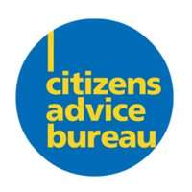

**Evaluation Method**

* Listening events for feedback
* Feedback questionnaires

**Outcomes**

This project has:

* Provided advice and support to 234 people across North Lanarkshire in 1-to-1 advice sessions
* Continued to work closely with partners such as Women’s Aid, Diamonds in the Community, Bear Necessities and Airdrie Action Partnership
* Been actively involved in North Lanarkshire Community Boards and received referrals from them
* Delivered Outreach Surgeries in Monklands Hospital, and at community groups, GPs and Women’s Aid. This was partly done in response to clients’ request to have more outreach surgeries in areas they live to minimise travel costs

**Learning**

* The project was able to increase applications for energy assistance/grants/emergency vouchers to respond to a need for energy advice during the Autumn and Winter months. This had an unexpectedly positive impact on service users to alleviate some of their financial worries
* The outreach surgeries are very well attended. Because of their success, the project is constantly having to manage the demand for the services
* Because of the close working relationship with all stakeholders, the project amended their service to align with stakeholders’ preferred outcomes. The stakeholders have provided positive feedback from their service users

**Bazooka Arts - Create and Connect Year 2: Community**

**Aim –** To provide mental health support through therapeutic arts, volunteering and transition support for clients in need of longer term or intensive therapeutic support

**Service/Activity –** Programme of weekly therapeutic arts sessions and online therapeutic arts provision

**Reach –** 45 people

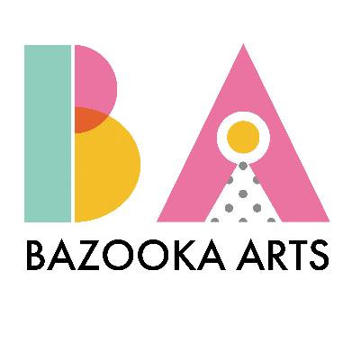

**Evaluation Method**

* Facilitator observation
* Documentation of creative work
* Feedback surveys when appropriate

**Outcomes**

This project has:

* Delivered 58 sessions through Movement, Drama, Visual Art, and Movement to Music therapeutic arts programmes
* Supported 20 participants of the therapeutic drama programme, all of whom have learning disabilities, to perform a show in Summerlee Museum to share their creativity with the wider community.

**Circle – Family Wellbeing Team**

**Learning**

* A second therapeutic movement class was set up in Coatbridge in response to demand to provide adults with complex support and mobility requirements with regular accessible therapeutic movement work. This has become a space for participants to rebuild and maintain mobility levels after Covid and strengthen social connections for both the participants and their carers
* Four participants who participated in the first part of the programme progressed to form their own arts project. They built a website and exhibited their art work at Summerlee Museum
* Reflection on learning from Year 1 highlighted partnership working as a key area to strengthen. The project has worked directly with partner organisation including Kirkshaws Neighbourhood Centre, NHS CMHT, Coatbridge Community Learning, Social Work and Culture NL to support this and develop a more robust two-way signposting and referral system. Additionally, the project’s partnership with Summerlee Heritage Museum has been a key success in inspiring creativity, increasing visibility of the project, and connecting participants to community-based sources and opportunities

i

**Aim –** To support and address health and social care needs experienced by parents due to experiences of poor mental health, domestic abuse, and trauma.

**Service/Activity –** 1-to-1 therapeutic support sessions and group work

**Reach –** 29 families, encompassing 30 parents/carers and 60 children

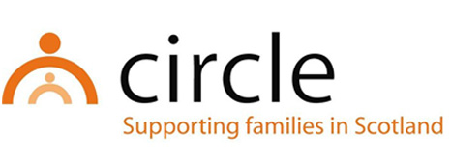**Evaluation Method**

* Wellbeing assessments with parents and families
* Feedback from parents and families

**Outcomes**

This project has:

* Provided 136 individual family wellbeing support sessions
* Supported 100% of 25 parents who reported on outcomes to improve their mental health and wellbeing, and reduce stigma around mental health and illness. It is expected that this also will have an indirect positive effect on the mental health and wellbeing of 44 children and young people in the families.

**Learning**

* The Family Wellbeing Team found the flexibility of the model of support has ensured families have accessed support that has been reflective of their needs and circumstances
* An unexpected positive outcome has been that families were able to get involved in wider Circle projects. This has involved parents and families participating in Christmas, half term and Easter activities. This has contributed towards reducing social isolation for families and improved opportunities to access community resources and meet other families.
* A significant number of referrals have been from Family Nurse Partnership for younger parents (late teenage years/early twenties). This will inform and influence ongoing and future support for this group of families.
* A third of supported families have expressed a need for group work. In response the project have set this up and collaborated with partner CVS organisations and health services. Attendance has been lower than anticipated. Understanding possible barriers to people accessing group work will be considered in any future development of group work.

**Cloudberry Communities – Natural Connections – Green Prescriptions and Health Walks in the Northern Corridor and beyond**

**Aim –** To provide advice, support and assistance to the most vulnerable in the North Lanarkshire community

**Service/Activity –** Health and wellbeing walks, peer support groups, workshops, 1-to-1 support, youth wellbeing sessions

**Reach –** 3886 people

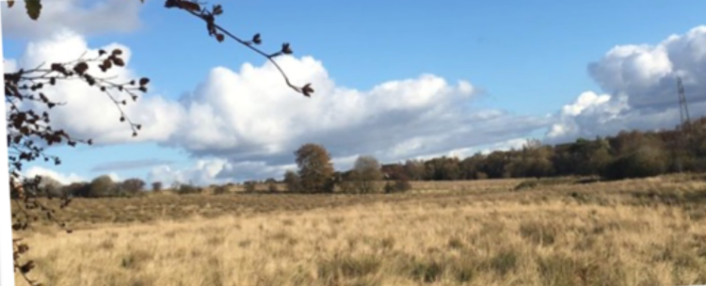

Cardowan landscape. c: Cloudberry Communities

**Evaluation Method**

* Surveys
* Participant and young people feedback

**Outcomes**

This project has:

* Supported 2667 people through health and wellbeing walks
* Supported 348 people through peer support groups and 1-to-1s
* Supported 426 people through wellbeing workshops and drop-ins
* Supported 445 young people in youth wellbeing sessions
* Developed a partnership with the charity Never Alone Depression support group to increase the level of support available in Moodiesburn

**Learning**

* An unexpected positive outcome of this project has been that a group of older session attendees who were experiencing isolation came together and developed a project around a long-term plan for the improvement of the old graveyard where the sessions have taken place. This has developed into a large-scale intergenerational heritage project with wider community involvement.
* The project supported a person who is now lead on a new project supporting volunteers
* The youth wellbeing sessions have informed a new project supporting transitions for those around school leaving age, who may not have a positive destination in mind or are non-attenders
* This project supported the Health and Wellbeing Group at Cardowan Community Meadow

**Cornerstone Community Care - Cornerstone Connects North Lanarkshire**

**Aim –** To provide social and creative activities to people with learning disabilities, autism, and complex care needs

**Service/Activity –** A programme of monthly activities

**Reach –** 33 people

**Evaluation Method**

* Survey in Easy Read format
* Verbal feedback from service users and carers
* Observations

**Outcomes**

This project has:

* Held 12 events, including two Movie afternoons, a Games afternoon, a Halloween-themed party, two Dance and Theatre groups, a Christmas lunch and party, a Valentines lunch and party, a Therapy Ponies visit, two Fitness and Dance groups, a Summer Connects closing party and lunch, all regularly attended by between 14 and 33 people#
* Enabled people to meet and make friends throughout the various events

**Learning**

* The project learned that reminding people of upcoming sessions helped to ensure the attendee numbers remained high
* The project felt that having face-to-face activities like this was very valuable in developing social connections, especially after lacking this during previous years due to the Covid-19 pandemic and cost-of-living crisis
* The project surveyed everyone who was interested in attending ahead of the project. Asking questions such as the best times for the sessions, dietary requirements, and activities they enjoy or they would like to try, made sure that settings were suitable for people’s needs and enabled the project to deliver activities and lunch that people enjoyed

**Families & Friends Against Murder and Suicide (FAMS) – Spring Ahead Year 2: Connection & Information**

**Aim –** To increase people’s awareness and knowledge of managing their mental health and wellbeing and how to access support

**Service/Activity –** Group activities and 1-to-1 support

**Reach –** 30 people

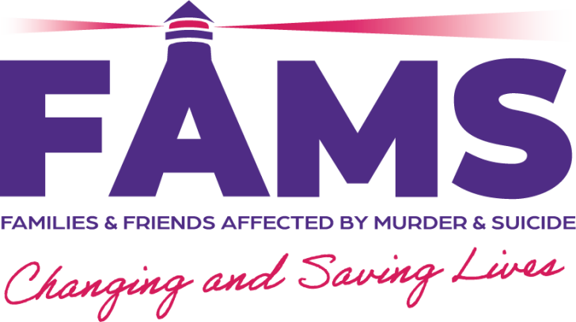

**Evaluation Method**

* Core-10 Measurement Tool
* Feedback
* Case studies

**Outcomes**

This project has:

* Ran 48 Lived Experience Peer Support Group sessions
* Ran 24 Stress-less Café sessions
* Ran 24 Wellbeing Wednesdays

**Learning**

* The project found a strength has been its flexibility. Having a range of support services, including 1-to-1 support, peer support groups, and recreational activities ensured individuals could access support in a style that suited them
* Another strength has been partnership working with local stakeholders. Partnerships with healthcare providers, social services, and grassroots organisations facilitated referrals and access to additional support
* In the future, the project would like to explore more innovative solutions to barriers to make the service more accessible, for example mobile outreach units or virtual support options
* Minority groups were underrepresented in the project, despite aims to be inclusive, and this was identified as an area of improvement for the future

**Forgewood Housing Cooperative - Forgewood & Gowkthrapple: Taking steps towards a happier and healthier life Year 2**

**Aim –** To engage the communities of Forgewood and Gowkthrapple and offer support to people with mental health issues

**Service/Activity –** A range of group activities

**Reach –** 736 people



**Evaluation Method**

* Informal conversations and feedback
* Interviews
* Observations

**Outcomes**

This project has:

* Led 9 community environment clean ups and ran 6 Community Art projects
* Held 37 Men’s group sessions and 20 Women’s group sessions
* Held 12 social history reminiscence sessions and a Health Issues in Community course
* Supported over 10 volunteers
* Organised 13 community events at Lawview sheltered accommodation to bring people together and learn digital skills

**Learning**

* The project highlighted the impact of weather on loneliness and isolation during the winter months as compared to warmer summer days. This led to a pilot of evening opportunities for informal drop in activities. This was particularly welcomed by individuals who live on their own
* As a result of this project the Men’s group themselves have organised and delivered additional activities, including community bingo nights enjoyed by 70 local people, and an overnight trip from 28 people from the local community
* The project found that while numbers in Gowkthrapple remain low due to change in community, impact is very high. They are now working with the Ukrainian community which brings additional challenges and rewards
* The project note that some evaluation methods could be a barrier to people first attending as some topics are stigmatised. The project found informal conversations and feedback struck the balance between capturing evidence while minimising barriers

**Person involved in Fresh Start NL - Let’s Talk project**

**“I can see a future for myself. The journey can still be a bit bumpy, but it is my journey to take”**

**Fresh Start NL - Let's Talk**

**Aim –** To support BAME and LGBTQ+ people to improve their wellbeing, enabling people to fulfil their potential, overcome difficulties and become more resilient

**Service/Activity –** 1-to-1 therapeutic support (1-hour weekly session for 10 weeks per person) and group work

**Reach –** 35 people

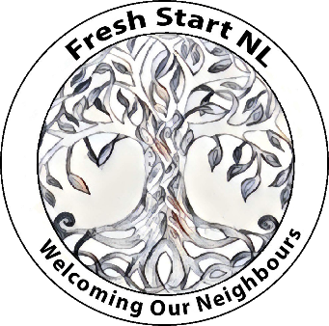

**Evaluation Method**

* CORE-34 Measurement Tool
* Warwick-Edinburgh Mental Wellbeing Scale

**Outcomes**

This project has:

* Supported 20 people through 1-to-1 therapeutic support, improving their mental health and wellbeing, and reducing mental health inequalities.
* Supported 15 people through two different groups that each met 10 times

**Learning**

* The project supported a bisexual person from a refugee background. Through 1-to-1 sessions with an Arabic-speaking therapist they were able to open up about and process their childhood trauma. They describe their experience as discovering the journey of themselves and finding out who they were and whom they want to be. They went from not being able to have contact with people to having a full placement in a college course

**Getting Better Together - Bump to Birth and Beyond Year 2**

**Aim –** To improve health and wellbeing by creating a positive and child-friendly environment and helping new/young, disadvantaged parents gain a better understanding around the importance of key infant priorities

**Service/Activity –** A range of activities and supports for families linked to a variety of antenatal and postnatal topics

**Reach –** 169 adults, 157 babies and children

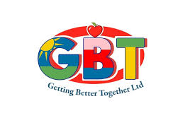

**Evaluation Method**

* Evaluation forms
* Informal feedback and observation from staff and participants
* Test of Change evaluation process and Outcome Star

**Outcomes**

This project has:

* Held 74 Bookbug sessions
* Held 36 Baby Massage sessions
* Held 42 Baby Sensory sessions
* Held 12 Mums Group sessions
* Enabled the development of positive social connections between the supported families

**Learning**

* The project demonstrated the importance of long-term engagement when working with families, to be able to develop trust and relationships. From this, families have a greater insight into the supports and services available to them, and staff have a better understanding of family circumstances, resulting in families being better supported overall
* An additional outcome the project saw was the creation and strengthening of positive relationships between families and their peers, families and staff, and within families themselves. The development of social connections will have an additional benefit for mental health and wellbeing

**Getting Better Together – Healthy and Active Lifestyles Project Year 2**

**Aim –** To improve the mental health and wellbeing of people facing socio-economic disadvantages through providing mental health improvement and physical activities

**Service/Activity –** Weekly group activities with focus on physical activity and social connection

**Reach –** 177 people

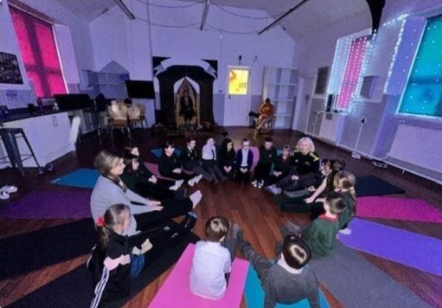

c: Getting Better Together

**Evaluation Method**

* Pre- and post-programme questionnaires
* Verbal feedback
* Instructor observations
* Consultation with community members

**Outcomes**

This project has:

* Delivered weekly session on Yoga, Easy Exercise, Mindfulness, Tai Chi, Open Gym, Walking Football, Line Dancing, Zumba, and Health Walks, with 482 sessions in total and 9 people attending each session on average
* Supported the development of peer relationships. 71% of people who completed the questionnaire responded “extremely well connected” to the question “How well connected do you feel with others as a result of attending the groups?”
* Employed instructors with lived experience of living in difficulty, which helped the members to feel comfortable and make connections

**Learning**

* The project based their timetable of activities on feedback from the previous year and on feedback at a community taster event. The project found this helped in maintaining attendance and delivering activities that the community had expressed interest in
* The project has identified a need for interventions such as this, providing community-based health improvement classes to those most in need, as they found an unwillingness from participants to attend mainstream services

**Glenboig Development Trust – Glenboig Community Garden Year 2**

**Aim –** To improve people’s mental health by supporting them to engage with nature and the environment through learning to grow and cook their own food

**Service/Activity –** 1-to-1 support and group activities in community garden

**Reach –** 724 people

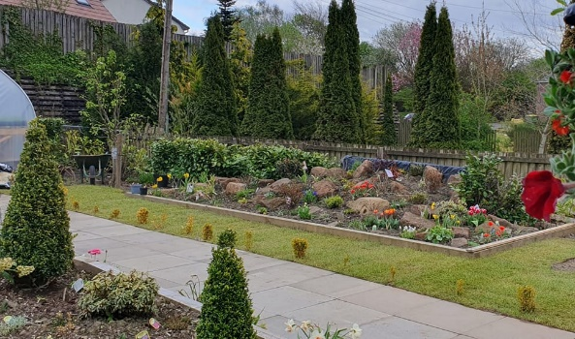**Evaluation Method**

* Surveys
* Observation
* Verbal feedback

**Outcomes**

This project has:

* Worked with local schools and nursery to support young people with additional support needs through planting and landscaping

c: Glenboig Development Trust

* Hosted two community events that were attended by 300 people each, including a harvest festival and a scarecrow competition run by the Community Garden participants, which many families throughout the community participated in
* Held 52 Men’s Shed and She Shed sessions
* Run a Tool Library, which supported 39 people to buy or borrow garden tools for their own gardening projects and to keep the village tidy

**Learning**

* An unexpected outcome of the project was that the participants of the community garden started a small vibrant garden shop to help generate a sustainable income through selling products, such as seedlings, bedding plants, and planters. The people involved in the Men’s Shed, the She Shed, and the young people all participated in making the products
* The garden group entered and won second place in the Beautiful Scotland competition New Comer category. This instilled a sense of achievement into participants, staff and volunteers and wider village residents
* The project supported a parent and young person who both got involved with the community garden in different ways, which over the course of several months improved both their mental health and wellbeing, confidence, and hope for the future

**Home-Start – Healthy Happy Families**

**Aim –** To promote positive mental health and wellbeing and increasing bonding and attachment between parents and their children

**Service/Activity –** 1-to-1 support and group activities

**Reach –** 820 people

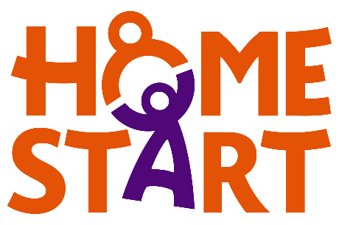

**Evaluation Method**

* Feedback
* Observations
* Case studies
* Visit- and volunteer-support reviews
* Surveys on specific aspects of the service such as Children’s Rights and the Promise

**Outcomes**

This project has:

* Trained group workers to deliver [Peep](https://www.peeple.org.uk/learning-together-training) and established new Peep groups
* Supported 120 people through a total of 1500 1-to-1 support sessions
* Supported 700 people through group sessions across 5 groups

**Learning**

* This project supported a six-month-old baby and Gran. Mum fled an abusive relationship and was seeking refuge in a woman’s shelter. The ongoing court case was having a serious impact on her mental and physical health and she was unable to attend the project herself. The Group Worker supported Mum through 1-to-1 support, supporting her into rented accommodation, and supporting her to give evidence at court, and now Mum accompanies her one-year old to the group
* This project has worked to become more accessible to families who have struggled to attend the group in Bellshill, by consulting with families and referrers and identifying areas where there are no other services, or where there is a higher population of families with young children

**Person involved in Lanarkshire Rape Crisis Centre Community Support Project**

**“I look forward to every day … I couldn’t be the person I am now without your help”**

**Lanarkshire Rape Crisis Centre – Community Support Project**

**Aim –** To support the mental health and wellbeing of survivors of sexual violence

**Service/Activity –** Awareness raising sessions, short term crisis support, 1-to-1 support

**Reach –** 220 people

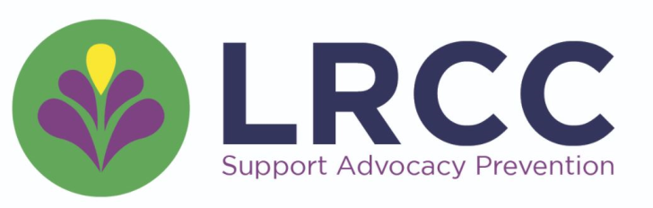

**Evaluation Method**

* Personal outcomes scale tracked by service users
* Written feedback from service users who have concluded their support

**Outcomes**

This project has:

* Held 19 awareness raising sessions on trauma from sexual violence and available services, attended by 102 people
* Delivered short term crisis support to 38 people, addressing immediate need for service users in North Lanarkshire
* Delivered 163 1-to-1 support and/or justice advocacy sessions to 80 people

**Learning**

* An unexpected outcome from this project has been that the delivery of work locally has led to unexpected links with individuals and organisations who wish to support the organisation
* This project found that while delivering local outreach sessions can be resource intensive, they have led to lasting results including, increased access to support services, increased referrals, partnerships with other services, and the recruitment of two new community volunteers
* The project supported a woman who struggled with self-blame, anxiety, regulation of emotions, and disordered eating. Through 1-to-1 support focussed on trauma-informed processing, she was able to explore various topics such as emotional regulation, unhealthy behaviour patterns, and healthy boundaries. She successfully exited the service after 12 support sessions, no longer feeling she was to blame for the sexual violence, feeling more confident to seek support for her disordered eating, and setting boundaries that serve her emotional safety

**Lanarkshire Community Food and Health Partnership – Food for Mood for Families**

**Aim –** To reduce health inequalities, supporting parents with young children facing socio-economic disadvantages, by increasing their knowledge of healthy nutrition, and other wellbeing topics like sleep, stress, and smoking

**Service/Activity –** Programmes of weekly group nutrition sessions and mental health activities in each of the localities

**Reach –** 45 people

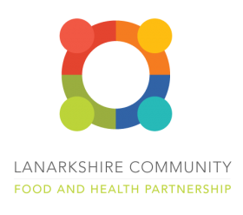

**Evaluation Method**

* Pre- and post-project surveys
* Partner feedback
* Nutritionist observations

**Outcomes**

This project has:

* Held 62 cooking and nutrition sessions
* Held 8 mental health activities outside of food and nutrition

**Learning**

* The participant numbers in one locality was smaller than anticipated due to staff illness and some partnership work had to be reduced. In the future the project would like to continue collaboration and partnership with CLD staff, possibly organising the project around this partnership to fully accommodate and prevent such issues
* The project supported a parent in poverty who had never cooked before and experienced great shame for not providing for their children. Throughout the project they discovered they thoroughly enjoyed cooking. With extra ingredients and donated food, they continued to cook with their children and share food with the community, improving both their family and community’s health
* The project supported a young single mother with learning difficulties and social anxiety, who struggled to read and understand recipes and measurements. Over the course of 9 weeks, with collaboration from the Sum It Up group, she was able to understand recipes, cook at home, become more vocal in the group and enjoy herself

**MADE4U IN ML2 - Wellbeing in ML2: Adults and Older People Year 2**

**Aim –** To provide physical and leisure wellbeing activities for vulnerable older adults, adults and families

**Service/Activity –** Programme of daily wellbeing activities including dance, befriending, emergency food support, community café and meals, crafting and more

**Reach –** 1339 people

**Evaluation Method**

* Feedback form
* Verbal feedback

**Outcomes**

This project has:

* Provided 2601 meals to the community, to people 217 who need food and/or struggle to cook. During Christmas, the project provided 273 three-course meals to families and individuals to bring joy and support during the holiday season
* Reached 207 people through 238 sessions of weekly and daily activities such as Mixed Movement, a Walking Group, Family Grub and Games, Community Craft/Roll Wae It, Seniors Bingo, and the Buzz Club
* Supported 55 people through a HouseHold Hardship session, and held 2 community trips
* Held 28 Community Cafes and Welcome Wednesdays, providing low-cost hot meals and a place for people to chat and attend mental health related talks

**Learning**

* The project was able to deliver more services and activities than initially anticipated. For example, they delivered a Christmas programme of activities, reaching 479 community members through Christmas lunch, a trip to Edinburgh, and provision of gift bags. They also delivered a summer programme, including Afternoon Tea, a Community BBQ and 2 community trips reaching a further 108 people
* In this phase the project reduced the number of Welcome Wednesdays from six to four. This adjustment allowed us to attract a larger attendance and allocate more time and attention to each event
* This phase saw an increase in participation within the craft group and expanding numbers of the family grub and games evenings. This might be due to a change in the space to an inviting versatile environment that can accommodate a range of activities

**Maggie’s Lanarkshire - Lanarkshire psychological wellbeing sessions and courses Year 2**

**Aim –** To support people who have been diagnosed with cancer and/or a long-term health condition or disability to manage treatment and support themselves with the use of various relaxation techniques

**Service/Activity –** A collection of courses and sessions, delivered by a trained psychologist

**Reach –** 321 people

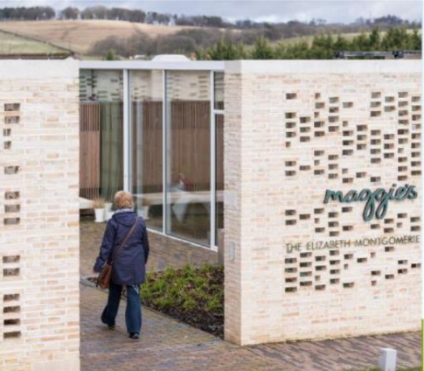**Evaluation Method**

* Verbal service user feedback during and after sessions
* Case studies

**Outcomes**

This project has:

c: Maggie's Lanarkshire

* Supported people in coping with stress and anxiety through 4 stress management courses reaching 64 people, 80 relaxation sessions reaching 270 people, and 48 Mindful Meditation sessions reaching 71 people
* Supported 29 people with advanced or secondary cancer through 4 “Living well when cancer can’t be cured” sessions
* Delivered 32 “Where Now?” sessions to 57 people finishing treatment, offering them skills and techniques at a time of transition
* Hosted a Bereavement Support Group to 12 people, meeting 24 times, providing a combination of therapeutic and peer support
* Delivered 2 cognitive rehab sessions to a total of 10 people, helping them build strategies to cope with for example short term memory loss and fatigue associated with cancer treatment
* Delivered 8 sleep workshops to support people struggling with insomnia associated with cancer diagnoses

**Learning**

* Using the HACT Social Value Bank Insight Tool, the project found that they generate four times the social value of its running costs through wider social, economic, and environmental benefits
* The project identifies various groups they would like to expand their support for in the future, including local ethnic minority communities, people affected by the cost of living crisis, carers, friends and family members, and men
* The project supported a husband who was recently bereaved from his wife. He found assurance and information about the grieving process in the Bereavement Support Group, and was supported with his sleep disturbances through the Sleep workshops. He comments on the significant improvement in quality of life due to the support

**Make and Create Arts - Positive Youth Connections**

**Aim –** To support the mental health, wellbeing and social integration of young people aged 16+ facing socio-economic disadvantage through creative learning opportunities and nutritious meals in a warm and safe space

**Service/Activity –** Weekly group activities

**Reach –** 17 young people

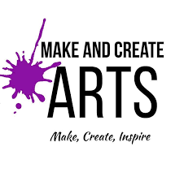

**Evaluation Method**

* Service User Feedback Survey
* Regular catch-up sessions with service users

**Outcomes**

This project has:

* Held 32 Friday Lunch Clubs
* Organised 32 Activity Corners, with guest tutors running creative projects such as sewing/knitting and song-writing
* Held 32 Creative Youth Group sessions
* Supported 100% of young people who reported on outcomes to “slightly” and “greatly” improve their mental health and wellbeing

**Learning**

* The project found that eating together is a much more valuable activity than anticipated. Sitting at a table eating together facilitated friendships and a feeling of wellbeing among the participants. Almost all participants who expressed an opinion on the project said the best thing about the project was something around the food provision
* The project found that their catch-up sessions with the young people helped allowing them to shape the sessions, enjoy them, and feel heard. For example, they expressed they wanted to play monopoly and the project made sure to provide dedicated time for this, completing the game in teams over the period of 5 weeks

**Motherwell and Wishaw Citizens Advice Bureau - Community Engagement Project**

**Aim –** To provide advice and support to target groups in the most deprived communities, and create opportunities for volunteering and employment

**Service/Activity –** 1-to-1 advice sessions

**Reach –** 980 people

**Evaluation Method**

* Impact surveys
* Case management tool CASTLE
* Warwick Edinburgh Mental Wellbeing Scale
* Feedback from clients and partners

**Outcomes**

This project has:

* Completed 72 crisis grants, and 323 benefit checks
* Distributed 399 shopping cards, and 329 energy vouchers
* Helped reschedule a total of £102,850 of debt
* Helped clients gain a total of £286,025.97
* Supported people interested in building confidence and skills to link in with the Employability Programme, which led to people gaining Employability Awards and IT skills, and the recruitment of new volunteers
* Held 143 weekly outreach clinics, reaching 429 people, providing awareness of CAB’s services in a stigma-free way

**Learning**

* Through continued promotion of the project’s services in several languages, aided by the Community Engagement Advisor who speaks Polish and Czech, the project saw an increase in ethnicity statistics of almost 20% from 2022/23 – 2023/24, highlighting the need of this targeted community project. This approach allowed people who had never accessed the service previously to feel comfortable to approach for advice and support
* The project supported a Polish national who is a single parent who originally accessed the service for help with an essential repair in her housing, but ended up being supported to receive Scottish Child Payment, budgeting, and energy advice. She felt more comfortable being able to speak her native language and felt empowered to take problems on in the future

**Motherwell Football Club Community Trust – The Well Hub Year 2**

**Aim –** To help people feel more connected, less isolated, and to provide regular opportunities for social interaction

**Service/Activity –** A programme of group activities and 1-to-1 support

**Reach –** 322 people

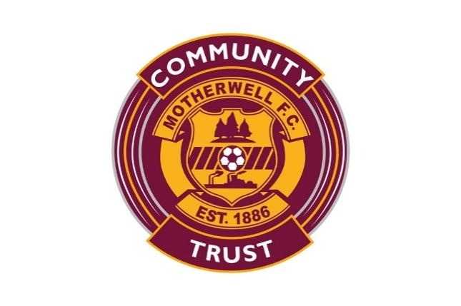

**Evaluation Method**

* Surveys
* Observation of individuals’ engagement and progression

**Outcomes**

This project has:

* Delivered 1-to-1 support to 32 people over 84 sessions
* Held 8 Women’s Group sessions, reaching 18 people
* Developed their work with people from ethnic minority backgrounds, holing 40 sessions that engaged 22 people
* Held 12 Menopause Group sessions, attended by 12 people
* Held 8 New Mums Group sessions, attended by 6 people
* Supported 75 Older People through 40 sessions
* Supported 54 people over 30 Money Management sessions
* Supported 37 people with grief over 8 sessions

**Learning**

* The project’s activities expanded from Phase 1 to include more beneficiary groups, including older people, people from ethnic minority backgrounds, people facing poverty due to the cost-of-living crisis, and more disabled people or people with chronic health conditions
* During the project, the Motherwell Football Club Community Trust opened a dedicated mental health facility in the stadium

**Person involved in New Opportunities Project**

**“Before I started volunteering here I felt anonymous. I feel more noticed now. I am proud of myself. I’m more confident and happier in myself.”**

**New Opportunities Project - New Opportunities Project Year 2**

**Aim –** To tackle inequalities, improve people’s health and wellbeing by providing opportunities for local people to become involved in community activities and form supportive relationships

**Service/Activity –** Programme of weekly wellbeing activities including a community café and volunteering opportunities

**Reach –** 253 people

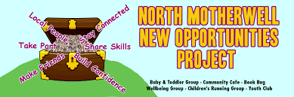**Evaluation Method**

* Questionnaires
* 1-to-1 discussions between service users and project coordinator
* Group feedback sessions
* Observations from group leader, peers, and friends/family

**Outcomes**

This project has:

* Held a twice-weekly Community Café, supporting a total of 112 people, a weekly Health and Wellbeing group, supporting 28 people and a weekly Women’s Group, supporting 15 people
* Held weekly Walk and Talk sessions for 28 people, supporting with people’s weight management and social connection
* Held twice-weekly Carer and Toddler sessions, attended regularly by over 40 families
* Developed a Garden Improvement Initiative, creating vegetable patches with crops distributed to local families and the community café, supported by people whose lives have been negatively impacted by addiction
* Held 29 weekly Social Clubs for 21 people whose lives have been directly/indirectly impacted by addiction
* Supported 24 people through crisis support

**Learning**

* The project found the Garden Initiative particularly successful. It has increased the self-esteem of participants, and other residents have a better understanding of the negative life experiences and stigma experienced by the participants
* The project supported a single parent with chronic pain, anxiety and depression, worried about her teenage child who is a school refuser. Volunteering at the café benefited her health and wellbeing and confidence, and enabled her to take on more volunteering hours. She reported feeling more able to support her teenager, who is now taking part in an LGBT youth group and started volunteering in the Community Café themselves

**North Lanarkshire Recovery Community - NLRC Recovery Therapies Year 2**

**Aim –** To support people across North Lanarkshire struggling with addiction issues with their mental health, to enable them to address their addiction issues and make positive social connections

**Service/Activity –** Holistic wellbeing activities, including reiki, yoga, fishing and more

**Reach –** 204 people

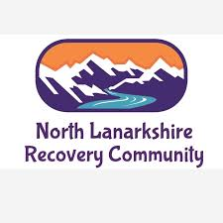

**Evaluation Method**

* Event attendance
* Service user feedback from regular meetings

**Outcomes**

This project has:

* Delivered 49 Qigong therapy sessions, supporting 55 people
* Delivered 49 Reiki sessions, supporting 40 people
* Delivered 49 Yoga sessions, supporting 60 people
* Hosted 1 holistic retreat for 21 people
* Facilitated 12 fishing and camping trips for a total of 28 people

**Learning**

* An unexpected outcome of the project is that 2 community members who attended Yoga and Qigong have went on to start training to become instructors in their own right
* The project gathers feedback from service users at monthly community meetings. These meetings are run by volunteers with minimal input from staff to ensure community members can speak freely and openly

**OutLET: Play Resource - Outdoors for Wellbeing – Transition Group**

**Aim –** To support the mental health and wellbeing of young adults aged 16+ with additional support needs during times of transition through an outdoor approach

**Service/Activity –** 3 programmes of small group outdoor sessions

**Reach –** 16 people

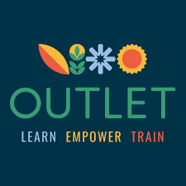

**Evaluation Method**

* Verbal feedback
* Observations

**Outcomes**

This project has:

* Delivered 32 outdoor sessions across 3 programmes
* Resulted in the young adults building friendships outside of the sessions, meeting up and supporting each other by going for cups of tea in a local café

**Learning**

* A positive unexpected outcome from this project has been that one of the young people now sees working outdoors as a possible career and is investigating college courses that could support this
* Two of the young people have used this project to support their independence in accessing public transport. They both reported that they feel more confident using busses for travel since the project
* The project was more difficult to get off the ground than expected because of a main point of contact leaving her role. The project was able to reach out to CVS organisations and schools, and was successful in getting school and parental/carer referrals

**Parent of person involved in PAMIS Lanarkshire Wellbeing Project**

**“My daughter loves being part of the group and getting to engage in one of her favourite activities – music. Not only is this a fun activity for her, it is an opportunity to be with peers which isn’t always easy to do within the local community.”**

**PAMIS Lanarkshire - PAMIS Well-being Project Year 2**

**Aim –** To offer people with profound and multiple learning disabilities (PMLD) and their unpaid carers the opportunity to access activities to support their health and wellbeing

**Service/Activity –** 1-to-1 intensive support for carers and accessible wellbeing activities for people with PMLD

**Reach –** 206 people

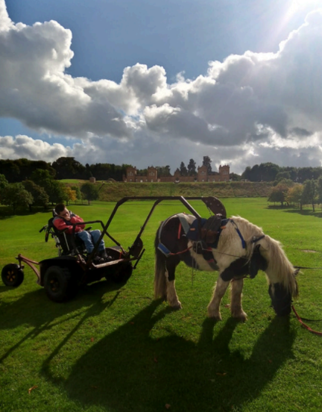**Evaluation Method**

* Verbal feedback
* Reflective conversations
* Collected recordings, quotes, and case studies

**Outcomes**

This project has:

* Provided 28 emotional 1-to-1 support sessions for carers
* Delivered a range of activities for families, including: 13 music Therapy sessions for 57 people; 20 Rebound Therapy sessions for 42 people; 9 Arts and Crafts sessions for 15 people; 4 Wake Up Shake Up sessions for 7 people; 1 Canal Cruise for 15 people; 2 Pony Axe S sessions for 32 people, using a pony to help people access places they could not access with their wheelchair alone; 6 Disco sessions for 10 people; 1 Outdoor adventure session for 12 people; and 4 Creative Writing sessions for 8 people

c: PAMIS

* Delivered a total of 60 activity sessions

**Learning**

* This project highlighted the inaccessibility of many public venues in North Lanarkshire, which hinders the ability of people with PMLD to join in with others in their community. For example, the hall that hosted a sensory pottery class had no Changing Places facilities, which meant that participants had to be changed in their vehicles or at another site with facilities.
* Family carers have received this project positively, expressing that they previously struggled to connect with others in similar circumstances in North Lanarkshire as many local leisure activities and facilities are not accessible. This project’s consistent activities have helped build friendships between families, and the project is noticing an increase in people booking to attend activities as people’s trust in the project increases

**Parkinson’s Self-Help Group - Nurture, Develop and Grow Year 2**

**Aim –** To support people with a neurological condition, and their carers, families and friends who experience negative mental health and emotional challenges and barriers due to the diagnosis

**Service/Activity –** Group wellbeing activities and provision of advice and information

**Reach –** 342 people



**Evaluation Method**

* Service User Feedback survey
* Verbal feedback
* Volunteer observations

**Outcomes**

This project has:

* Held 8 drop-in community events
* Delivered 223 Therapy sessions, attended by 5 people per session
* Held 48 Peer Support Groups, reaching 51 people in total
* Collaborated with St Dominic’s Nursery to host 6 Garden project sessions with 40 people attending in total
* Held 5 Physical Health activity sessions, 6 Positive Mental Health sessions, and 52 lunches for 43 people
* Facilitated 3 outings for 42 people

**Learning**

* An unexpected positive outcome from this project is the relationship that the project established with the libraries in North Lanarkshire. Conversations with the Health and Wellbeing Officer led to a digital session and the majority of service users signing up to the library’s digital catalogue, and the project arranged a dedicated area in each library in North Lanarkshire to display both Parkinson’s UK and Parkinson’s Self-Help Group leaflets and information
* Moving forward, the project intend to increase and wider interagency and intergenerational working, following on from joint projects with St Andrew’s Hospice, NL Libraries and St Dominic’s Nursery, raising further awareness of Parkinson’s and the local support available to the wider community

**Playlist for Life - Playlist for Life North Lanarkshire: Transforming the lives of those living with dementia through music**

**Aim –** To support the lives of people living with dementia and their carers through personally meaningful music playlists

**Service/Activity –** Establishment of community help points, delivery of training, provision of resources and information

**Reach –** 393 people

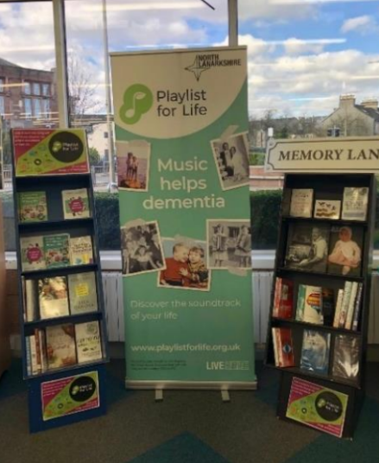

**Evaluation Method**

* Feedback from staff and volunteers on behalf of service users

**Outcomes**

This project has:

* Supported 21 existing community partners to be a Help Point and established 9 new Help Points, providing a range of 1-to-1 and group activities to support families to create and use personalised music playlists
* Shared 450 free resource packs with families through the Help Points
* Provided training to staff and volunteers at the Help Points, as well as Lanarkshire Carers

Bellshill Library Help Point Display

c: Playlist for Life North Lanarkshire

* Held 3 face to face and online networking and engagement sessions reaching 32 people
* Sent out 4 North Lanarkshire network newsletters to 31 people
* Created 55 individual playlists

**Learning**

* The project was able to connect with a wide range of groups beyond their standard Help Point partnerships, including the North Lanarkshire Council’s Assistive Technology Team who run the Technology Flat. The Technology Flat has been a valuable partner in supporting service users using tech to find the best solution for them to listen to a personal playlist
* The project found that reconnecting with existing Help Points in the area allowed the project to reinvigorate groups whose services had reduced during the pandemic, and learn how to improve support and resources for new Help Points joining the network. All Help Points surveyed said our support improved their staff and volunteers’ understanding of how music can help people with dementia

**Ponies Help Children - Volunteer Development Officer**

**Aim –** To improve the mental health and social skills of young people who are school leavers by supporting them to receive volunteer qualifications working with ponies

**Service/Activity –** Tailor-made training packages supported by the Volunteer Development Officer

**Reach –** 50 people

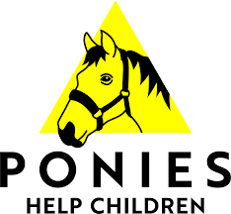

**Evaluation Method**

* Pre- and post-project evaluation forms
* Verbal feedback from service users and volunteers

**Outcomes**

This project has:

* Supported 10 young volunteers to accumulate 650 volunteer hours toward their Saltire Awards
* Supported 10 young people to work towards a Dynamic Youth Award, by helping them to achieving self-set targets
* Delivered 30 sessions of Yard and Equine training for 10 young people
* Supported 30 young people to receive a Ponies Help Children certificate for recognition of their work
* Hosted a Team Building day for 20 young people

**Learning**

* Due to the success of the volunteer development officer, the project is now looking at becoming an SQA accredited centre to bring more recognisable qualifications to young people in the future
* The project supported a young person who was referred by CAMHS. Their parent was worried about her being very withdrawn. Through this project the young person received equine training, which made her more talkative, confident, and open as she built up a bond with her horse. She has now gone on to volunteer with the organisation to help others, and the parent stated the project “has given [her] [her] child back”

**The Economic Forum for Women’s Empowerment - BAME women food festival and wellbeing project**

**Aim –** To promote a community of inclusiveness and healthy mental wellbeing through a BAME food project and Food Festival Exhibition

**Service/Activity –** 1-to-1 advice sessions

**Reach –** 525 people

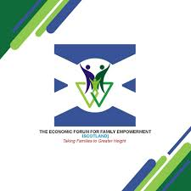**Evaluation Method**

* Social media interactions
* Observations
* Verbal feedback

**Outcomes**

This project has:

* Delivered 20 weekly cooking sessions focussing on the BAME Food Festival, reaching 50 people
* Delivered 7 cooking sessions for families with children, reaching 50 people
* Held 5 home/online cooking sessions with a family of 5
* Held a BAME Food Project event in July 2023 attended by approximately 200 people
* Held a BAME Food Festival Exhibition event in October 2023 attended by approximately 220 people

**Learning**

* The project events were attended by an overwhelming amount of people, which meant several individuals got involved to help out and manage the unexpectedly high numbers. The events were successful in bringing together people from different backgrounds and allowing them to learn, interact, share ideas and combat loneliness and social isolation.
* The project found that many of the people who participated in preparing and sharing the meals built self-confidence and positivity toward society and their own achievements in the future
* Founder and CEO Angela Nduka says: “This project is a confirmation that we can achieve and promote global peace and unionism through various mediums”

**The Health and Wellness Hub – Transforming Lives Year 2**

**Aim –** To offer people training, coaching, and practical experiences that support personal, social and vocational development

**Service/Activity –** Weekly group sessions and tailored volunteer training

**Reach –** 231 people

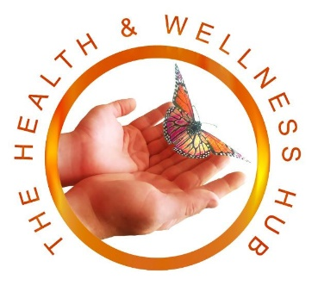

**Evaluation Method**

* Service User feedback survey
* Baseline and follow-up self-assessment
* Volunteer feedback

**Outcomes**

This project has:

* Engaged an additional 10 volunteers to the programme, and continued support of 19 continuing volunteers
* Supported 8 volunteers to receive a formal qualification in Swedish Massage, and 2 volunteers to receive a reiki qualification
* Delivered training, including WRAPS training and Mental Health First aid training to a total of 24 people
* Supported 190 service users to participate in weekly volunteer-led group activities, including a Natter and Chatter Peer Support Group, a Men’s Peer Support Group, an Arts N Crafts Peer Support Group and more

**Learning**

* The project supported a single parent who was referred by One Parent Family Scotland. She attended a group targeted at supporting single parents, and engaged in activities like yoga and meditation, which improved her mood and alleviated her anxiety. She now has completed Swedish Massage Training and has completed her first volunteering hours, which have increased her confidence and development of social connections
* The project supported a person dealing with bipolar disorders, PMSD, ADHD and sciatica. They were struggling to get out and into a routine. They attended the Hub’s Zumba class and have now also completed the 6-week introduction to volunteering and the holistic training. This has helped them gain confidence, a determination to improve and manage their illnesses, and a sense of purpose and pride

**The Miracle Foundation - Diverse Community Development & Engagement**

**Aim –** To provide safe spaces for those underrepresented in the community to come together as a group to discuss, explore and engage in matters affecting their mental health and wellbeing

**Service/Activity –** A range of activities and events and 1-to-1 support

**Reach –** 236 people

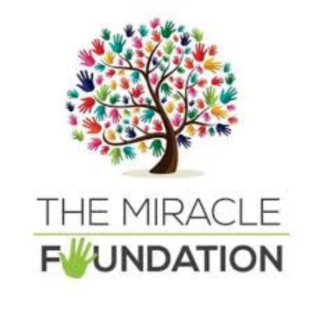

**Evaluation Method**

* Questionnaire
* Consultations with select individuals from BAME and underrepresented communities

**Outcomes**

This project has:

* Held 20 sessions, including coffee mornings, knitting groups, art sessions., and forum discussions
* Supported a range of people who are underrepresented in the community, including people from a minority ethnic background, refugees, older people, women, and LGBTQ+ people

**Learning**

* The project took various successful measures to ensure their questionnaire was accessible to service users. The questionnaire was written in consultation with individuals from underrepresented communities, which helped to develop questions around mental health and wellbeing, whilst remaining cultural and faith sensitive. The questionnaires were interpreted into 5 different languages (Urdu, Arabic, Polish, Mandarin, English), which reassured the service users and removed language barriers, and the service engagements were supported by interpreters
* An unexpected experience of this project was the openness of BAME community members to share their experiences around mental health and wellbeing. The appreciation for the extensive questionnaire indicated the strong need for more support and like initiatives. Having access to a safe environment has been crucial
* The project supported a young Ukrainian refugee, passionate about a future career in supporting mental health and wellbeing, to access counselling education. Through Miracle’s communication and collaboration with Grounded Learning, she was able to receive a fully funded place on a Counselling Skills course, and the project covered study materials and provided her with a space to study

**The Venture Trust - Outdoor Therapy**

**Aim –** To support people’s mental health and wellbeing by combining therapeutic support with time outdoors to allow participants to build a connection with local nature and community

**Service/Activity –** 1-to-1 outdoor therapy sessions

**Reach –** 17 people

**Evaluation Method**

* CORE Outcome Measure used pre- and post-project

**Outcomes**

This project has:

* Built connections and referral arrangements with local organisations in North Lanarkshire
* Delivered 121 1-to-1 outdoor therapy sessions to 12 people. For the 6 service users who had completed their sessions at the time of reporting, 5 had an overall improvement in their CORE score, meaning their mental wellbeing improved
* Assessed 5 additional people for future outdoor therapy sessions

**Learning**

* Through the project’s experience they have learnt where best to target referral generation, with good links now established with local NHS Community Link Workers
* Service users, most of whom had indicated a clinical therapy setting did not suit them, have provided positive feedback about the outdoor sessions, saying for example: “It really makes you more aware of how you are when you do go outdoors and walks really help stimulate the mindset of how you can reflect your thoughts and feelings across productively.” and: “… as someone who suffers with social anxiety, I feel that being outdoors really helps with mental health in general but when you’re outside walking, conversation and opening up just comes so freely and I think that’s what really helped me.”

**“I have to taste a culture to understand it. Cultural diversity brings a collective strength that can benefit all of humanity and community.”**

**Person involved in the Economic Forum for Women’s Empowerment BAME women food festival**

**The Well Foundation - The Well Foundation Community Sports Hub**

**Aim –** To provide sports opportunities for people of all ages from across the BAME community, including refugees, to use sports as a means to increase physical activity and integrate communities

**Service/Activity –** A programme of various weekly sports

**Reach –** 85 people

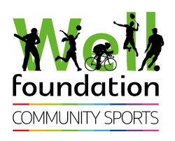

**Evaluation Method**

* Attendance
* Staff and volunteer observations
* Verbal feedback

**Outcomes**

This project has:

* Held 20 weekly football sessions for 35 men aged over 40
* Held 20 weekly badminton sessions for 8 people
* Held 20 weekly self-defence classes for 19 people
* Held 20 weekly fitness classes for 17 people
* Held 4 cycling classes for 6 people

**Learning**

* A positive unexpected outcome of this project was that a few refugees who joined the activities ended up inviting their friends to come along to sessions too
* Participants were able to build new friendships and fed back that they felt fitter because of the activities
* In the future the project would like to make more accommodations for disabled young people. A couple of disabled children came along but there were not enough volunteers to improve their experience

**Venture Scotland - Challenge Yourself, Discover Yourself Year 2**

**Aim –** To support young people between the ages of 16-30 who are experiencing poor mental health to build trusted relationships, build mental health awareness and resilience

**Service/Activity –** Multi-weekprogramme of outdoor activities, group activities and 1-to-1 support sessions

**Reach –** 31 people

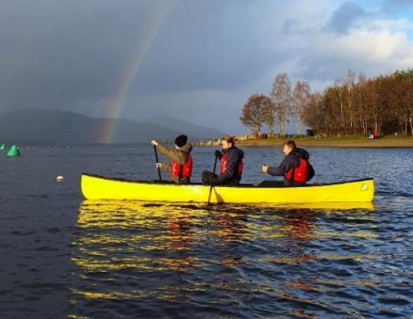**Evaluation Method**

c: Venture Scotland

* Feedback form
* Verbal feedback through 1-to-1 sessions
* Observations

**Outcomes**

This project has:

* Held 14 Outdoor Activity Days for 9 young people
* Held 11 Life Skill group work sessions for 8 young people
* Organised a 3-day Bothy trip for 8 young people
* Organised a 5-day Bothy trip for 6 young people

**Learning**

* The feedback form showed:
  + 8 out of 8 young people who completed the form said they “gained confidence and self-esteem”
  + 7 out of 8 young people “feel more confident about their future” and agree that their “mental and emotional health is better”
  + 6 out of 8 young people agree they are “more aware of things that affect my mental/emotional health and wellbeing since being on the project”
* The project supported a young person who came from a social care background and was experiencing poor mental health and isolation. The project’s Outdoor Programme Leader observed he struggled to show emotions and vulnerability. During sessions he often supported the rest of the team, he was able to relax, and reflect on his feelings. The young person said that his ability to understand and express emotions and maintain positive relationships with others went from Poor to Excellent by the end of the course, and he feels less isolated since participating

**YMCA Bellshill & Mossend - Y-Virtual Wellbeing Year 2**

**Aim –** To improve young people’s social connectedness, inclusion, self-confidence and mindfulness through use of a virtual wellbeing space

**Service/Activity –** Weekly virtual reality and games sessions, and hot food support service

**Reach –** 30 people



**Evaluation Method**

* Verbal feedback from young people, parents, and carers
* Feedback questionnaires
* Creative outputs from the project
* Regular staff reflection

**Outcomes**

This project has:

* Provided a space for 20-30 young people to access virtual reality resources, game consoles, arts and crafts and games on a weekly basis. The young people were actively involved in co-developing the project activities, building their confidence and social connections
* Provided hot food throughout the 48 total sessions

**Learning**

* The project found that Y-Virtual Reality offered an immersive and interactive experience that traditional programmes cannot provide. The VR environment provided unique learning opportunities that allowed the young people to explore new concepts and experiences
* A kinship carer of a young person accessing the virtual wellbeing space gave this feedback to the project staff: “You have no idea the impact this project has on our boy, his mental health and confidence. I can’t thank you enough”

**3. Case Studies and personal stories**

This section provides 6 case studies from projects funded in Phase Two. These case studies are illustrative of the range of great work that has been achieved by all organisations, and have been selected to highlight the variety of services provided. Some case studies have been edited for clarity and brevity.

**3.1 FAMS – Spring Ahead**

A FAMS service user gave feedback on the support they received:

**Background**

“I asked FAMS for help with my PTSD and mental health. These issues started the day my wee brother was murdered in 2000. I have been trying to deal with this for almost 24 years now. I had a psychiatrist and psychologist up to the pandemic, bereavement counselling and anger management. I felt rage, anger, depression, suicidal, great sadness, loss, emotionless and hardly having a sleep pattern. I was fuelled by revenge, so everything else in my life was put in the background. I started avoiding people and started drinking heavily.”

**Intervention**

“I was put in touch with FAMS holistic therapist Nicola by the Mental Health Practitioner at my GP’s surgery. I had an initial chat with her and started 1-to-1 support sessions.”

**Outcome**

“The support Nicola has given me has helped me with the rage that I carried for years. Before the rage controlled my actions, but now with the techniques I learnt I’m in control of the rage. I still get angry, but the rage never shows itself. I feel calmer inside myself for the first time in years. I now try to help people if they chat to me about mental health.”

**3.2 Glenboig Development Trust – Glenboig Community Garden**

**Background**

A young person was a school refuser due to bullying and left school at the first opportunity. His mother was worried about his mental health and about ‘letting him go’. She brought him to the garden to be doing something.

**Intervention**

Staff recognised that to build confidence in both the young person and the mother, they would be best both participating in the garden in separate ways. The young person’s mum agreed to volunteer at the centre, where she had distraction, someone else to talk to, and tasks to concentrate on while the young person volunteered in the garden, gaining a sense of independence from mum.

Both the young person and his mum volunteered at Glenboig Development Trust for 6 months. Mum was offered a short term paid cleaning position, and the young person was referred into an employment training programme and was accepted and placed within the community garden team.

**Outcome**

The young person has now developed coping mechanisms, has a place to go for a blether, and hope for his future. His mum reports he is not drinking the same and saving money for driving lessons. He wants to learn more about hard landscaping and has earned a trainee post.

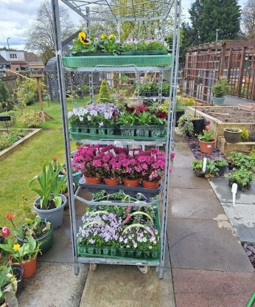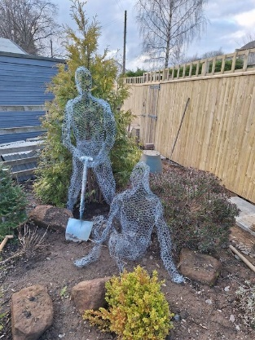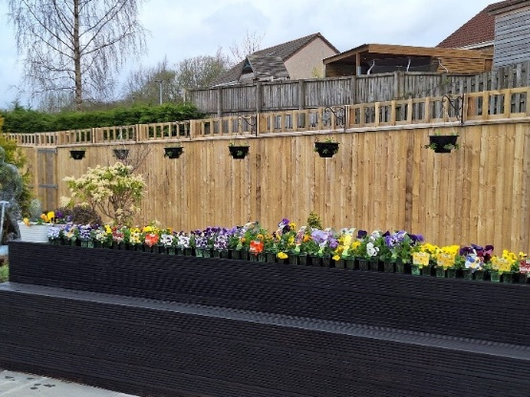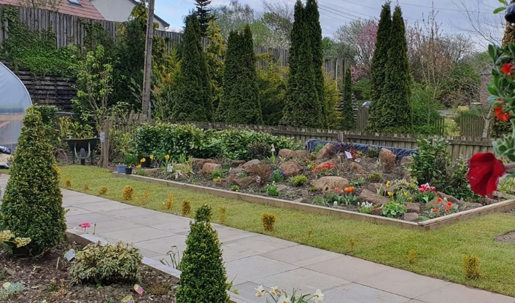His mum disclosed she and her son have become chattier with each other, bringing their experiences and stories back home. She says the community garden “has saved her son and given him a future to look forward to,” and her own mental health and confidence has improved as a result too.

**3.3 Motherwell and Wishaw Citizen’s Advice Bureau – Community Engagement Project**

A Motherwell CAB advisor wrote the following about the support they provided to one person during the project:

**Background**

Client is a Spanish citizen, single parent to two children. Client attended outreach clinic after being referred by a local councillor. Client came to the outreach clinic with a housing issue and financial difficulties. Client’s situation was complex also due to health issues experienced by her children.

**Intervention**

Benefit check carried out. Children have care and mobility needs - Child disability payment was discussed as they meet the eligibility criteria. Supported client with the claiming process.

Applied for a crisis grant for food and fuel. Whilst awaiting the decision, I offered client a fuel voucher and shopping card. Client did not wish to use the foodbank due to cultural difference, hence she was offered a dignified alternative to tackle immediate. food and fuel crisis

The housing issue required referral to a housing specialist who helped the client with a tribunal case.

I discussed with client how social work can help her with her children’s educational needs, and explained what responsibilities schools have in terms of providing support to pupils/students.

**Outcome**

The client appreciated a highly accessible clinic, which helped overcome the initial cost barrier related to travel costs, and engagement between the client and the adviser was helped by the fact that the adviser is of BME background and has lived experience.

The crisis situation was averted and a long-term financial solution identified. Client received the crisis grant of over £150 and has been supported to submit a strong application for Child Disability Payment, backed up with medical evidence, which would increase client’s household income by over £4000 per annum.

Client felt listened to, understood and reassured the help is there. Reported peace of mind and more confidence to deal with various agencies.

**3.4 PAMIS – PAMIS Well-being Project Year 2**

**Background**

C is a young woman who lives in North Lanarkshire. She is supported by carers to ensure her care needs are met. C has profound and multiple learning disabilities and extremely complex care needs, she is frequently admitted to hospital. C requires 2-1 care at all times. C is non-verbal and struggles with communication. Due to lack of opportunity she has limited social interaction with others her own age, C is mostly surrounded by paid staff but has some close family who she loves spending time with. C’s Mum oversees all of her care and support.

**Intervention**

With funding from The Community Mental Health and Wellbeing Fund, PAMIS have been able to offer C a space in our ongoing Music Therapy sessions alongside a regular slot at our Rebound Therapy class. PAMIS was able to adapt the activity to support C’s needs to help her engage, thrive and develop.

For example, PAMIS noticed among other things that C requires time to explore and settle into her surroundings, small groups and time to have 1-to-1 contact, proper equipment and hoist to leave her wheelchair, intensive interaction, emotional support, and choice to be fully involved in her sessions.

**Outcome**

C’s mum has commented on the benefit of the groups C attends:

“My daughter attends the Music sessions with her support workers and really enjoys them.  She loves being part of the group and getting to engage in one of her favourite activities – music.  Not only is this a fun activity for her, it is an opportunity to be with peers which isn’t always easy to do within the local community.  There are few inclusive activities which afford my daughter the opportunity to be with her peers and this is hugely important to reduce her isolation and to recognise herself within a peer group.”

“Physical activity is such a crucial part of my daughters’ weekly programme in order to promote health and wellbeing.  Having the opportunity to have fun while getting some physical activity is fabulous at any time but has been particularly beneficial for my daughter once it was permitted as part of a rehabilitation programme following surgery. In addition to the physical benefits, she can develop her communication skills; self-confidence and self-esteem by using her voice and gestures to control the pace of the session.”

**3.5 The Miracle Foundation**

A Miracle Foundation staff member reflected on the support they provided for a young refugee: 

**Background**

I had a 1-to-1 interview with Y, a 17-year-old female Ukrainian refugee. I could feel the frustration for Y as she is trying to break down the barriers within her own community and has a passion for a future career in supporting mental health and wellbeing through talking therapies. The Miracle Foundation Operations Manager and I agreed that we wanted to support Y to achieve her dreams.

**Intervention**

I coordinated with my management team, our own counsellors, local colleges and completed some online research to identify requirements for this career and support the girl to access education. I kept regular contact with the girl and provided her with all the information we had found and helped her to make some applications. I also worked with Grounded Learning, an organisation that provides a variety of COSCA accredited counselling training and courses, including a programme that offers evening and weekend, online only, and blended learning options. Grounded Learning also provide one fully funded space for nominated volunteers of OSCAR registered Scottish Charities that would benefit from this training. I coordinated with one of their course leads and I nominated Y for the COSCA Certificate in Counselling Skills SCQF Level 8. The team at Grounded Learning got back to me very quickly to offer Y a fully funded place. The Miracle Foundation SCIO supported this by funding Y’s course books and materials and providing her with a quiet office space to do her online coursework and study. By providing this space to Y, The Miracle Foundation SCIO can also support Y with any language barriers, or any other support required to facilitate her learning.

**Outcome**

Y will begin her coursework in September and is very much looking forward to this. She thanked me for all of our support and invited me to attend an event that her community were holding for Ukrainian Independence Day. I felt very honoured and humbled to be invited to a celebration that means so much to the community. Y herself was translating into English for the audience throughout the celebration. Y continues to volunteer weekly with the organisation, supporting us to break down barriers and developing her own professional experience.

**3.6 Venture Scotland – Challenge Yourself, Discover Yourself Project**

**Background**

Venture Scotland’s Challenge Yourself, Discover Yourself project worked with 8 young adults in North Lanarkshire who needed support to improve their mental health, gain connections and make positive changes to their lives.

**Intervention**

The project allowed young adults to take part in weekly outdoor activity days, group sessions, and remote bothy trips, all of which were underpinned by self-awareness, mindfulness and personal growth. The project focussed on immersing young adults in the outdoors, cultivating trusting relationships, creating a safe and nurturing environment, and supporting them to learn and maintain practical and emotional skills to improve their wellbeing long-term.

Over 12 weeks, young adults took part in activities from canoeing, indoor climbing, hillwalking, abseiling, paddleboarding and weaselling, to life skill group sessions focussing on mindfulness, positive self-talk, needs, perceptions, emotions and relationships. The group took part in 2 remote bothy residentials, which allow young adults to learn how to make and invest in basic lifestyle changes, such as the importance of sleep, routine, shelter, eating nourishing food, and drinking lots of water, alongside cultivating an environment of trust, communication and community. Every spark of confidence the young people gain is a form of learning which can be channelled into their daily life.

**Outcome**

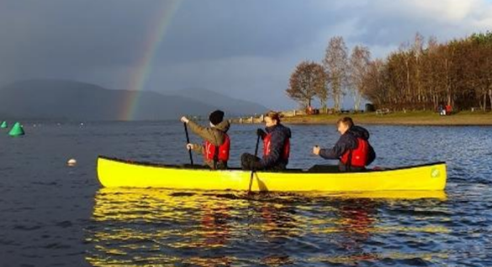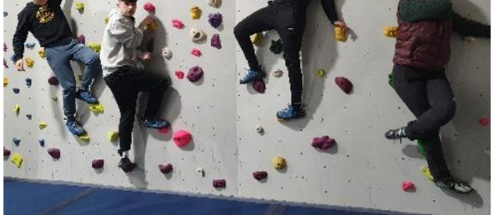At the end of the project the majority of young people reported that their mental and emotional health was better and they are move capable of dealing with the ups and downs of everyday life. All young people said they have gained confidence and self-esteem, and that they feel confident about the future.

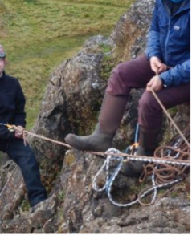

[end of document]