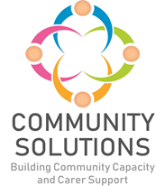

**Community Mental Health and Wellbeing Fund**

**Impact and Learning Report - Phase Two (2023-24)**

**Phase X (20XX-XX) - Impact and Learning Report**



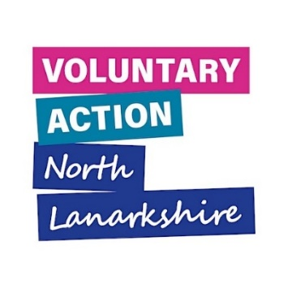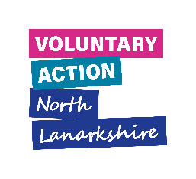

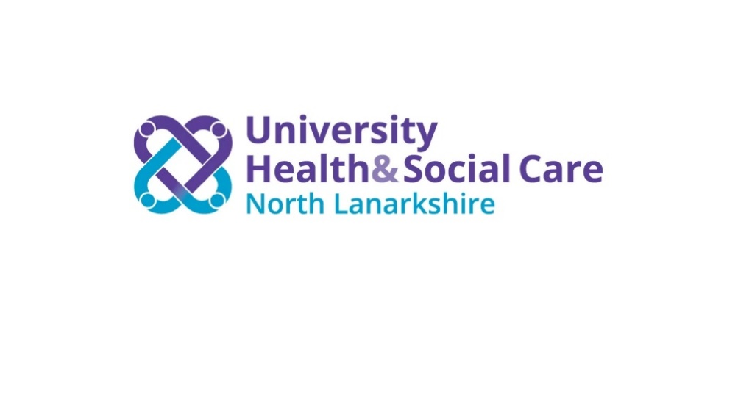

# Contents

1. Introduction – Page 3

2. Fund Overview – Reach and Impact – Page 8

3. Learning – Page 10

4. Future Phases – Page 17

**Appendices – Page**

Appendix A: Highlights from Six Funded Projects* – Page 19

Appendix B: Summary of All Funded Projects – Page 26

*A complementary report with more information on all funded projects is available.

**1. Introduction**

**1.1 Purpose**

The purpose of this report is to share the impact and learning from projects funded in Phase Two of the Community Mental Health and Wellbeing Fund (CMHWB).

**1.2 Fund Phases**

Phase One of the CMHWB Fund was established in late 2021. Given the success of Phase One, additional funding was agreed for Phase Two which completes in spring 2024.

|  |  |  |  |
| --- | --- | --- | --- |
| Phase | Date | Total Custodian Funding | Total Funding |
| Phase One | Nov 2021 – Mar 2023 | £1,670,000 | £1,741,000 |
| Phase Two | Apr 2023 – Mar 2024 | £955,000 | £1,026,000 |
| TOTAL | | **£2,625,000** | **£2,767,000** |

Custodian funding is the total amount of funding distributed to funded projects. Total funding includes custodian funding and the management costs for the programme.

**1.3 Aims**

The CMHWB Fund is a funding initiative aimed at supporting “at risk” groups in North Lanarkshire through community-based mental health and wellbeing support for adults provided by the community and voluntary sector (CVS).

Phase One of the Fund had a particular focus on:

* Tackling priority issues within the Scottish Government’s [COVID-19 Mental Health](https://www.gov.scot/publications/mental-health-scotlands-transition-recovery/) [Transition and Recovery Plan](https://www.gov.scot/publications/mental-health-scotlands-transition-recovery/) such as suicide prevention, social isolation and loneliness, prevention and early intervention
* Addressing the mental health **inequalities exacerbated by the pandemic** and the needs of a range of ‘at risk’ groups locally
* Supporting **small ‘grass roots’ community groups** and organisations to deliver such activities
* Providing **opportunities for people to connect** with each other, build trusted relationships, and revitalise communities
* Supporting **recovery and creativity** locally by building on what is already there, what was achieved through the pandemic, and by investing in creative solutions

**1.3.1 Outcomes**

The Fund seeks to contribute to the four key areas of focus from the Scottish Government’s COVID-19 [Mental Health Transition and Recovery Plan](https://www.gov.scot/publications/mental-health-scotlands-transition-recovery/):

* Promoting and supporting the conditions for good mental health and wellbeing at population level
* Providing accessible signposting to help, advise and support
* Providing a rapid and easily accessible response to those in distress
* Ensuring safe, effective treatment and care of people living with mental illness

The Fund also supports the Community Solutions outcomes for adults:

* Improved mental health and wellbeing
* Reduction in mental health inequalities
* Reduction in stigma around mental health and illness

**1.3.2 Objectives**

* To develop a culture of mental wellbeing and prevention within North Lanarkshire and across Scotland with improved awareness of how we can stay well and help ourselves and others
* To promote and support the conditions for good mental health and wellbeing at population level
* To provide accessible signposting to help, advice and support
* To provide a rapid and easily accessible response to those in distress
* To ensuring safe, effective treatment and care of people living with mental illness

**1.4 Funding and Fund Management**

In response to the mental health need arising from the COVID-19 pandemic, the Scottish Government launched a national fund – the [Communities Mental Health and Wellbeing Fund](https://www.gov.scot/publications/communities-mental-health-wellbeing-fund-year-1-2021-22-national-fund-guidance/). The Scottish Government asked the 32 Third Sector Interfaces (TSIs) in Scotland – of which Voluntary Action North Lanarkshire (VANL) is the interface for North Lanarkshire – to manage the funding on their behalf. VANL manage distribution of the Fund through the Community Solutions Programme

VANL supports this Fund as part of the wider Community Solutions Programme, which VANL hosts and manages on behalf of [University Health and Social Care North Lanarkshire (UHSCNL).](https://hscnl.org.uk/)

**1.4.1 Funding Awards Process**

An open call for applications was issued to the sector. Applications were then submitted to Voluntary Action North Lanarkshire (VANL) and assessed against eligibility criteria by a funding panel consisting of representatives from VANL, NHS Lanarkshire staff, and North Lanarkshire Council (NLC).

Funding was awarded to 33 organisations for 33 projects. Please see Appendix B for a full list of funded CVS projects for Phase Two.

**1.5 Evaluation, Learning and Improvement**

**1.5.1 Approach**

The Fund’s approach to evaluation, learning, and improvement is guided by the Community Solutions Performance Management, Evaluation, Learning and Improvement Framework (PMELI). The Framework sets out the Community Solutions Programme’s approach to performance management, evaluation, learning, and improvement to support funded projects and the programme as a whole. The Framework also sets out standardised measures and relevant supports to help funded projects make the most of their findings.

In line with the Framework, funded CVS organisations are required to assess the reach and impact/outcomes of their work, and capture and share learning to inform improvements to their service and/or activities, and where possible to other funded projects, the wider CVS, and the Health and Social Care system. Using the framework, VANL staff support funded projects to undertake ongoing evaluation to facilitate learning and improvement both during and at the end of project delivery.

**1.5.2 Performance Data and Method**

Funded projects are required to capture and share with VANL key information on the following:

* Type of support provided – activities
* Numbers of unique individuals supported – reach
* The difference this support made to those receiving support – outcomes.

Funded projects are also asked to measure their project outcomes using the Community Solutions outcomes outlined in Section 1.3.1.

Funded projects collect this data at points prior to, during, and post project delivery using a range of different methods, including:

* Written surveys; online or via the phone
* Verbal feedback
* Observations
* Self-assessment methods such as the [Warwick-Edinburgh Mental Wellbeing Scale](https://warwick.ac.uk/fac/sci/med/research/platform/wemwbs/)
* ‘What’s Important Now’ (WIN) holistic needs-analysis

Funded projects use this data to complete evaluation forms which are submitted to VANL at the three, six- and twelve-month mark of the projects. Three-month progress reports were introduced in Phase One as this was a new Fund, and was continued into Phase Two as they were beneficial. The purpose of the three-month form was to allow funded projects to identify any issues with project delivery at the earliest possible opportunity, so VANL could appropriately support them to resolve any issues and plan the next steps together.

VANL also hosted two Learning and Improvement events for representatives from funded projects in 2023-24. The purpose of these events is to collect feedback from funded projects on their experience of the Fund. This feedback informs the delivery of future fund phases and service delivery for projects.

Data from evaluation forms and Learning and Improvement events is used to prepare Impact and Learning reports for each phase.

**Many thanks to the funded projects which provided information and to the VANL staff who prepared this report.**

**2. Overview of Phase Two Reach and Impact**

**2.1 Funded Projects and People Supported – Figure One**

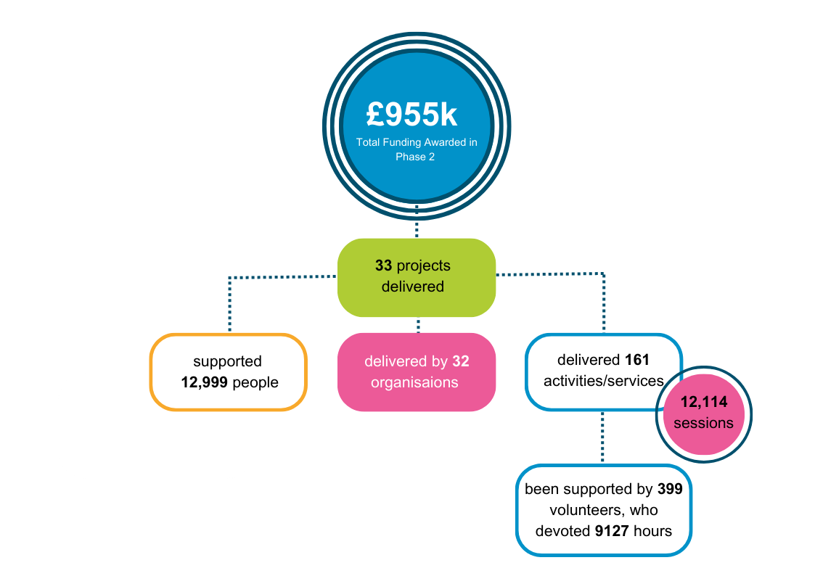[1]

**2.2 Summary of Reported Community Solutions Outcomes**

This information is collected by funded projects using self-assessment from the people their projects support, through methods such as written pre- and post-support surveys, and verbal feedback.

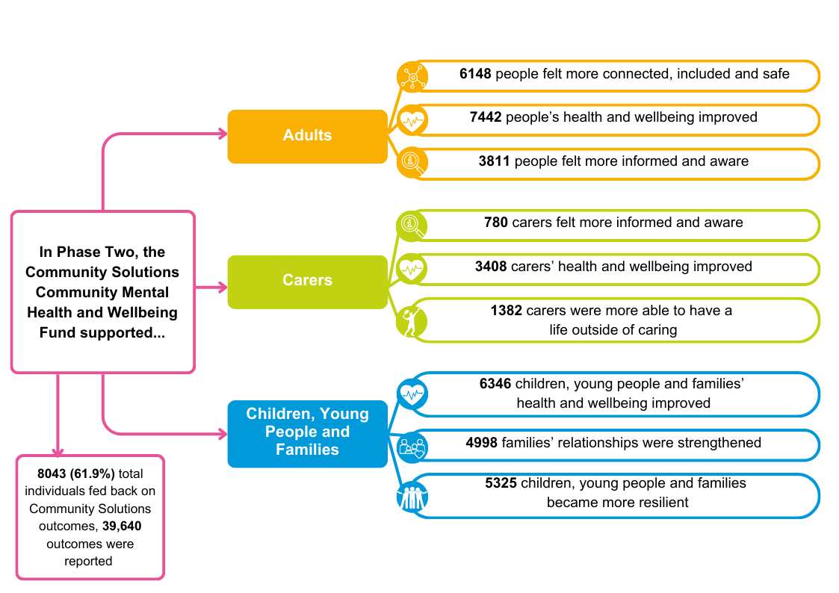

**3. Learning**

**3.1 Phase Two Learning and Improvement Event**

VANL hosted two Learning and Improvements event during Phase Two for funded organisations – one in September 2023, and one in April 2024. A total of 16 out of 33 organisations participated. The purpose of the events was to:

* Facilitate open discussion to promote and support learning and improvements, both to collaboration and the management of the fund, and current and future services
* Focus on solutions to identified challenges
* Inform planning for Phase Three

The event structure involved a group discussion using the following prompts:

* What, if any, benefits/successes have you noticed from longer term funding?
* How have you found the new online evaluation process?
* Any achievements to date that you are particularly proud of?
* Some projects identified early issues with uptake of the projects, was this something you experienced and is this issue resolved?
* Any challenges you encountered that slowed the progress/stopped the outcomes from happening, and is there any VANL could change to help with this?

Feedback from these discussions was analysed by VANL staff, with a summary of key themes presented below:

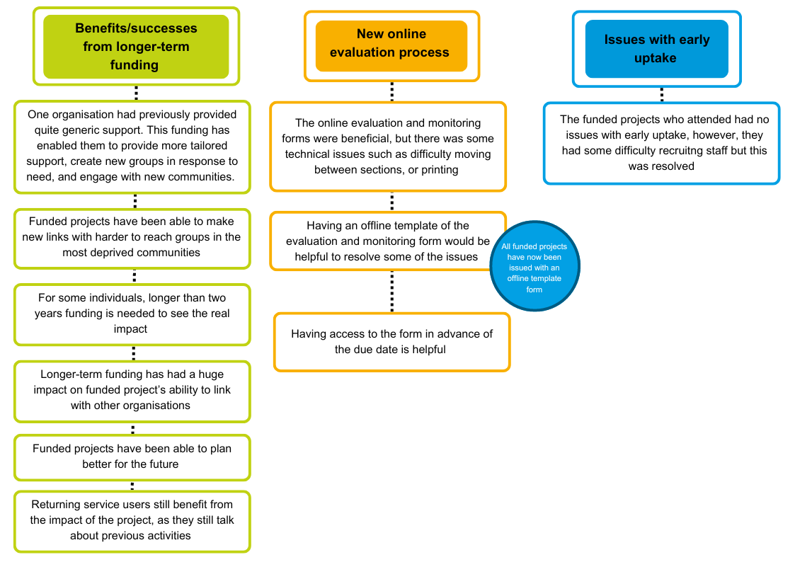

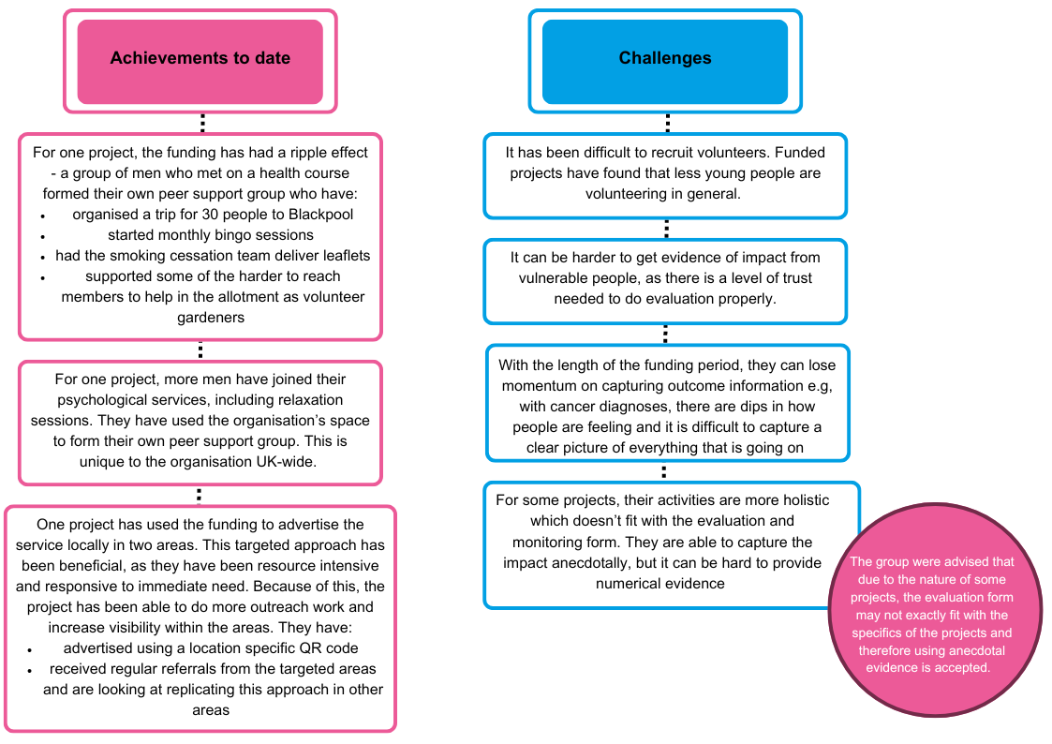

**3.2 Unexpected Positive Outcomes**

In addition to their planned outcomes, funded projects were asked to identify positive but unexpected outcomes.

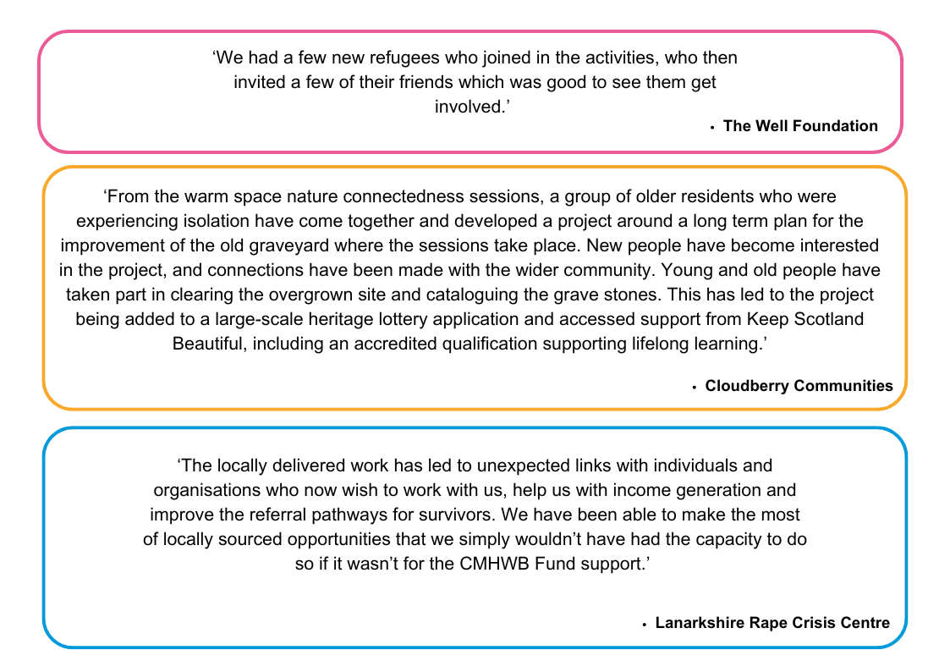

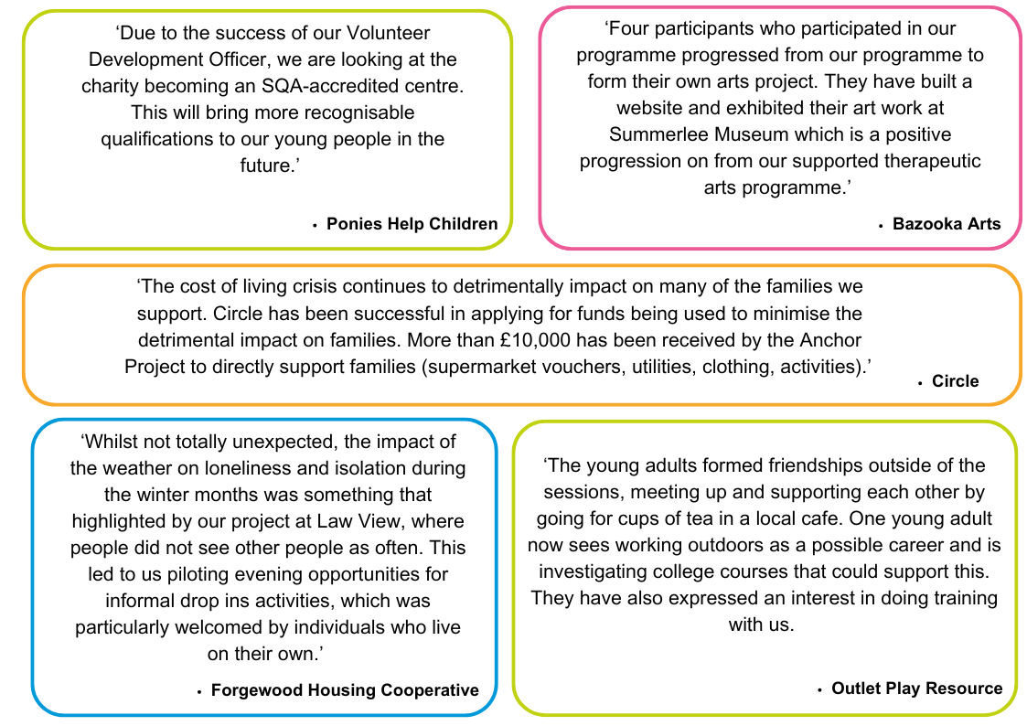 **3.3 Other Feedback from Funded Projects**

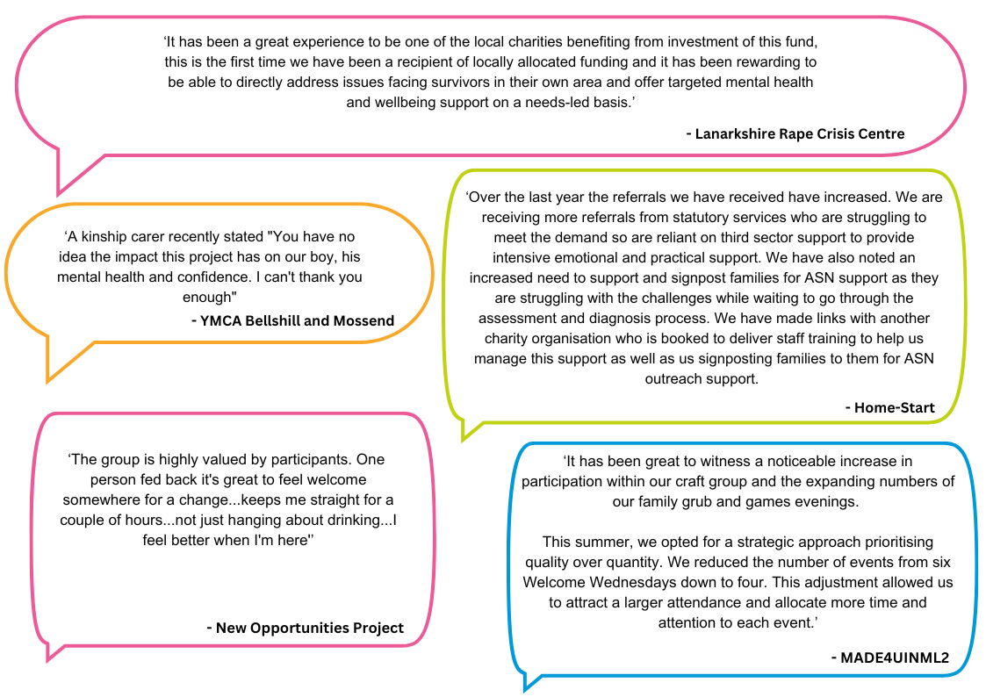Below is highlighted additional selected feedback from funded projects, which was provided in the monitoring and evaluation reports submitted to VANL.

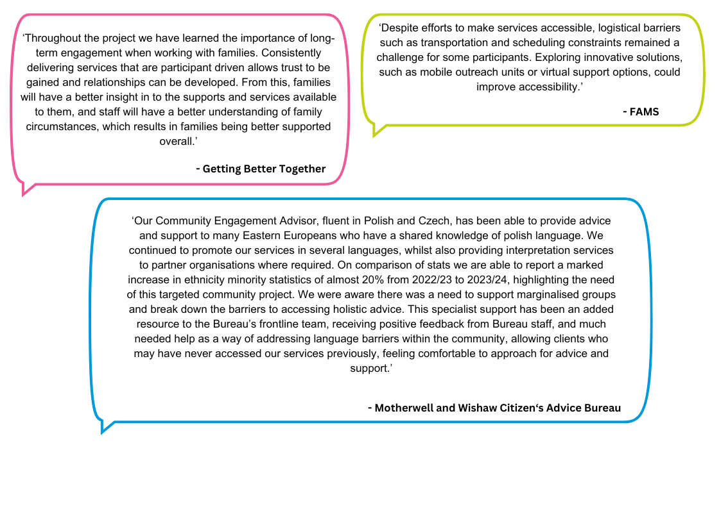

**4. Future Phases**

**4.1 Phase Three**

Informed by the learning of Phase One and Two, plans for Phase Three were announced in Summer 2023. During late 2023, applications were sought from eligible CVS organisations, for launch in April 2024. The schedule for Phase Three is as follows:

|  |  |
| --- | --- |
| **Action** | **Date** |
| **Application Launch** | September 2023 |
| **Application Closing Date** | November 2023 |
| **Award Decision Date** | January-February 2024 |
| **Award Letters Issued** | March 2024 |
| **Projects Delivered** | April 2024 – March 2025 |
| **Mid-project Evaluation Report** | October 2024 |
| **End-of-project Evaluation Report** | June 2025 |
| **Total Funding** | £1,011,000 |
| **Total Custodian Funding** | £955,000 |

**5. Appendices**

**Appendix A - Highlights from Six Funded Projects**

All Phase Two funded projects completed and returned monitoring and evaluation forms to VANL, which were analysed to demonstrate the impact their services/activities achieved with the people supported. Summaries from six funded projects’ evaluation reports are provided below, with summaries for all funded projects provided in a supplementary report.

**Bazooka Arts - Create and Connect Year 2: Community**

**Aim –** To provide mental health support through therapeutic arts, volunteering and transition support for clients in need of longer term or intensive therapeutic support

**Service/Activity –** Programme of weekly therapeutic arts sessions and online therapeutic arts provision

**Reach –** 45 people

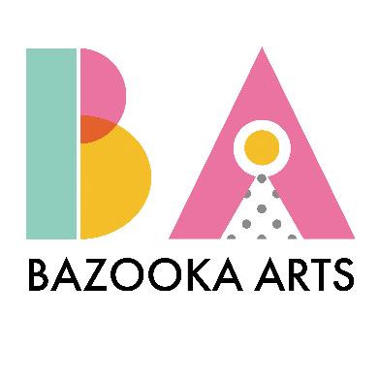

**Evaluation Method**

* Facilitator observation
* Documentation of creative work
* Feedback surveys when appropriate

**Outcomes**

This project has:

* Delivered 58 sessions through Movement, Drama, Visual Art, and Movement to Music therapeutic arts programmes
* Supported 20 participants of the therapeutic drama programme, all of whom have learning disabilities, to perform a show in Summerlee Museum to share their creativity with the wider community.

**Learning**

* A second therapeutic movement class was set up in Coatbridge in response to demand to provide adults with complex support and mobility requirements with regular accessible therapeutic movement work. This has become a space for participants to rebuild and maintain mobility levels after Covid and strengthen social connections for both the participants and their carers
* Four participants who participated in the first part of the programme progressed to form their own arts project. They built a website and exhibited their art work at Summerlee Museum
* Reflection on learning from Year 1 highlighted partnership working as a key area to strengthen. The project has worked directly with partner organisation including Kirkshaws Neighbourhood Centre, NHS CMHT, Coatbridge Community Learning, Social Work and Culture NL to support this and develop a more robust two-way signposting and referral system. Additionally, the project’s partnership with Summerlee Heritage Museum has been a key success in inspiring creativity, increasing visibility of the project, and connecting participants to community-based sources and opportunities

i

**Circle – Family Wellbeing Team**

**Aim –** To support and address health and social care needs experienced by parents due to experiences of poor mental health, domestic abuse, and trauma.

**Service/Activity –** 1-to-1 therapeutic support sessions and group work

**Reach –** 29 families, encompassing 30 parents/carers and 60 children

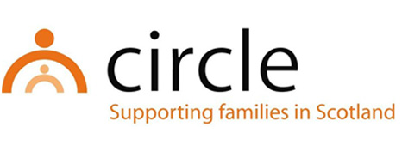**Evaluation Method**

* Wellbeing assessments with parents and families
* Feedback from parents and families

**Outcomes**

This project has:

* Provided 136 individual family wellbeing support sessions
* Supported 100% of 25 parents who reported on outcomes to improve their mental health and wellbeing, and reduce stigma around mental health and illness. It is expected that this also will have an indirect positive effect on the mental health and wellbeing of 44 children and young people in the families.

**Learning**

* The Family Wellbeing Team found the flexibility of the model of support has ensured families have accessed support that has been reflective of their needs and circumstances
* An unexpected positive outcome has been that families were able to get involved in wider Circle projects. This has involved parents and families participating in Christmas, half term and Easter activities. This has contributed towards reducing social isolation for families and improved opportunities to access community resources and meet other families.
* A significant number of referrals have been from Family Nurse Partnership for younger parents (late teenage years/early twenties). This will inform and influence ongoing and future support for this group of families.
* A third of supported families have expressed a need for group work. In response the project have set this up and collaborated with partner CVS organisations and health services. Attendance has been lower than anticipated. Understanding possible barriers to people accessing group work will be considered in any future development of group work.

**Cloudberry Communities – Natural Connections – Green Prescriptions and Health Walks in the Northern Corridor and beyond**

**Aim –** To provide advice, support and assistance to the most vulnerable in the North Lanarkshire community

**Service/Activity –** Health and wellbeing walks, peer support groups, workshops, 1-to-1 support, youth wellbeing sessions

**Reach –** 3886 people

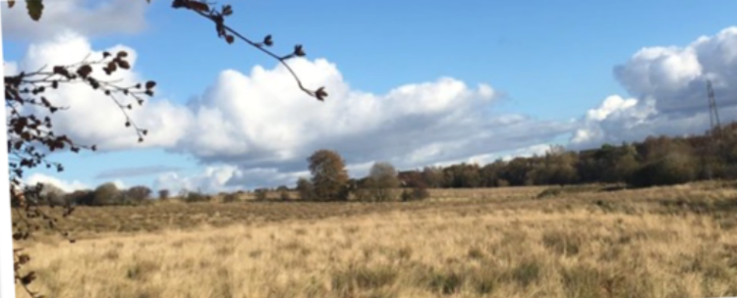

Cardowan landscape. c: Cloudberry Communities

**Evaluation Method**

* Surveys
* Participant and young people feedback

**Outcomes**

This project has:

* Supported 2667 people through health and wellbeing walks
* Supported 348 people through peer support groups and 1-to-1s
* Supported 426 people through wellbeing workshops and drop-ins
* Supported 445 young people in youth wellbeing sessions
* Developed a partnership with the charity Never Alone Depression support group to increase the level of support available in Moodiesburn

**Learning**

* An unexpected positive outcome of this project has been that a group of older session attendees who were experiencing isolation came together and developed a project around a long-term plan for the improvement of the old graveyard where the sessions have taken place. This has developed into a large-scale intergenerational heritage project with wider community involvement.
* The project supported a person who is now lead on a new project supporting volunteers
* The youth wellbeing sessions have informed a new project supporting transitions for those around school leaving age, who may not have a positive destination in mind or are non-attenders
* This project supported the Health and Wellbeing Group at Cardowan Community Meadow

**Forgewood Housing Cooperative - Forgewood & Gowkthrapple: Taking steps towards a happier and healthier life Year 2**

**Aim –** To engage the communities of Forgewood and Gowkthrapple and offer support to people with mental health issues

**Service/Activity –** A range of group activities

**Reach –** 736 people

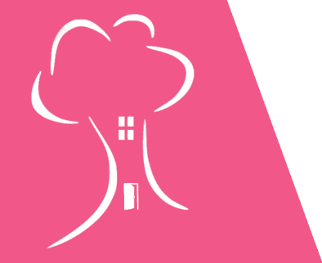

**Evaluation Method**

* Informal conversations and feedback
* Interviews
* Observations

**Outcomes**

This project has:

* Led 9 community environment clean ups and ran 6 Community Art projects
* Held 37 Men’s group sessions and 20 Women’s group sessions
* Held 12 social history reminiscence sessions and a Health Issues in Community course
* Supported over 10 volunteers

Organised 13 community events at Lawview sheltered accommodation to bring people together and

**Learning**

* The project highlighted the impact of weather on loneliness and isolation during the winter months as compared to warmer summer days. This led to a pilot of evening opportunities for informal drop in activities. This was particularly welcomed by individuals who live on their own
* As a result of this project the Men’s group themselves have organised and delivered additional activities, including community bingo nights enjoyed by 70 local people, and an overnight trip from 28 people from the local community
* The project found that while numbers in Gowkthrapple remain low due to change in community, impact is very high. They are now working with the Ukrainian community which brings additional challenges and rewards
* The project note that some evaluation methods could be a barrier to people first attending as some topics are stigmatised. The project found informal conversations and feedback struck the balance between capturing evidence while minimising barriers

**MADE4U IN ML2 - Wellbeing in ML2: Adults and Older People Year 2**

**Aim –** To provide physical and leisure wellbeing activities for vulnerable older adults, adults and families

**Service/Activity –** Programme of daily wellbeing activities including dance, befriending, emergency food support, community café and meals, crafting and more

**Reach –** 1339 people

**Evaluation Method**

* Feedback form
* Verbal feedback

**Outcomes**

This project has:

* Provided 2601 meals to the community, to people 217 who need food and/or struggle to cook. During Christmas, the project provided 273 three-course meals to families and individuals to bring joy and support during the holiday season
* Reached 207 people through 238 sessions of weekly and daily activities such as Mixed Movement, a Walking Group, Family Grub and Games, Community Craft/Roll Wae It, Seniors Bingo, and the Buzz Club
* Supported 55 people through a HouseHold Hardship session, and held 2 community trips
* Held 28 Community Cafes and Welcome Wednesdays, providing low-cost hot meals and a place for people to chat and attend mental health related talks

**Learning**

* The project was able to deliver more services and activities than initially anticipated. For example, they delivered a Christmas programme of activities, reaching 479 community members through Christmas lunch, a trip to Edinburgh, and provision of gift bags. They also delivered a summer programme, including Afternoon Tea, a Community BBQ and 2 community trips reaching a further 108 people
* In this phase the project reduced the number of Welcome Wednesdays from six to four. This adjustment allowed us to attract a larger attendance and allocate more time and attention to each event
* This phase saw an increase in participation within the craft group and expanding numbers of the family grub and games evenings. This might be due to a change in the space to an inviting versatile environment that can accommodate a range of activities

**PAMIS Lanarkshire - PAMIS Well-being Project Year 2**

**Aim –** To offer people with profound and multiple learning disabilities (PMLD) and their unpaid carers the opportunity to access activities to support their health and wellbeing

**Service/Activity –** 1-to-1 intensive support for carers and accessible wellbeing activities for people with PMLD

**Reach –** 206 people

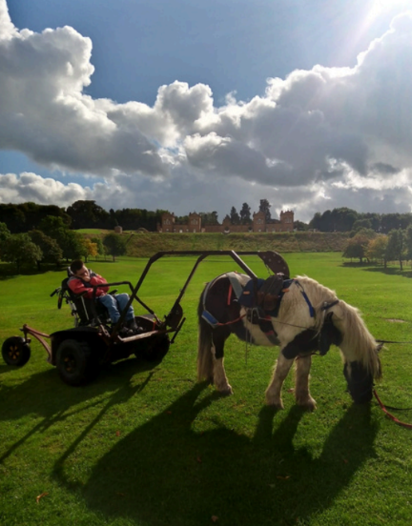**Evaluation Method**

* Verbal feedback
* Reflective conversations
* Collected recordings, quotes, and case studies

**Outcomes**

This project has:

* Provided 28 emotional 1-to-1 support sessions for carers
* Delivered a range of activities for families, including: 13 music Therapy sessions for 57 people; 20 Rebound Therapy sessions for 42 people; 9 Arts and Crafts sessions for 15 people; 4 Wake Up Shake Up sessions for 7 people; 1 Canal Cruise for 15 people; 2 Pony Axe S sessions for 32 people, using a pony to help people access places they could not access with their wheelchair alone; 6 Disco sessions for 10 people; 1 Outdoor adventure session for 12 people; and 4 Creative Writing sessions for 8 people

c: PAMIS

* Delivered a total of 60 activity sessions

**Learning**

* This project highlighted the inaccessibility of many public venues in North Lanarkshire, which hinders the ability of people with PMLD to join in with others in their community. For example, the hall that hosted a sensory pottery class had no Changing Places facilities, which meant that participants had to be changed in their vehicles or at another site with facilities.
* Family carers have received this project positively, expressing that they previously struggled to connect with others in similar circumstances in North Lanarkshire as many local leisure activities and facilities are not accessible. This project’s consistent activities have helped build friendships between families, and the project is noticing an increase in people booking to attend activities as people’s trust in the project increases

**Appendix B – Summary of All Funded Projects**

Across the funded projects, there is variation in the number of unique individuals supported when compared to the total funding award. This is due to the diverse nature of projects funded - projects varied in the intensity of support, and number of sessions delivered to each unique individual.

|  |  |  |  |
| --- | --- | --- | --- |
| **Organisation** | **Project** | **Total Funding Award**  **(£)** | **Number of Unique Individuals Supported** |
| B.1 Airdrie Citizens Advice Bureau | Action Beyond Courage (ABC) | 40,311 | 234 |
| B.2 Bazooka Arts | Create & Connect Year 2: Community | 34,900 | 45 |
| B.3 Circle | Family Wellbeing Team | 50,987 | 90 |
| B.4 Cloudberry Communities | Natural Connections | 43,600 | 3886 |
| B.5 Cornerstone Community Care | Cornerstone Connects North Lanarkshire | 10,714 | 33 |
| B.6 FAMS | Spring Ahead – Connection & Information | 38,640 | 30 |
| B.7 Forgewood Housing Cooperative | Forgewood & Gowkthrapple: Taking steps towards a happier and healthier life | 44,739 | 736 |
| B.8 Fresh Start NL | Let's talk | 9,400 | 35 |
| B.9 Getting Better Together | Bump to Birth and Beyond | 27,482 | 326 |
| **Organisation** | **Project** | **Total Funding Award**  **(£)** | **Number of Unique Individuals Supported** |
|  | Healthy & Active Lifestyles Project | 30,660 | 177 |
| B.10 Glenboig Development Trust | Glenboig Community Garden | 48,551 | 724 |
| B.11 Home-Start | Healthy Happy Families | 35,671 | 820 |
| B.12 Lanarkshire Rape Crisis Centre | Community Support Project | 16,774 | 220 |
| B.13 Lanarkshire Community Food and Health Partnership | Food for Mood for Families | 27,862 | 45 |
| B.14 MADE4UINML2 | Wellbeing in ML2: Adults and Older People | 49,846 | 1339 |
| B.15 Maggie’s Lanarkshire | Lanarkshire psychological wellbeing sessions and courses | 21,771 | 321 |
| B.16 Make and Create Arts | Positive Youth Connections | 13,293 | 17 |
| B.17 Motherwell and Wishaw Citizens Advice Bureau | Community Engagement Project | 41,450 | 980 |
| B.18 Motherwell Football Club Community Trust | The Well Hub | 30,300 | 322 |
| **Organisation** | **Project** | **Total Funding Award**  **(£)** | **Number of Unique Individuals Supported** |
| B.19 New Opportunities Project | New Opportunities Project | 23,122 | 253 |
| B.20 North Lanarkshire Recovery  Community | NLRC Recovery Therapies | 18,400 | 204 |
| B.21 OutLET: Play Resource | Outdoors for Wellbeing | 18,393 | 16 |
| B.22 PAMIS Lanarkshire | PAMIS Well-being Project | 21,139 | 206 |
| B.23 Parkinson’s Self-Help Group | Nurture, Develop and Grow | 26,972 | 342 |
| B.24 Playlist for Life | Playlist for Life North Lanarkshire | 21,625 | 393 |
| B.25 Ponies Help Children | Volunteer Development Officer | 18,500 | 50 |
| B.26 The Economic Forum for Women’s Empowerment | BAME women food festival and wellbeing project | 10,000 | 525 |
| B.27 The Health and Wellness Hub | BAME Engagement Focus and Support Project | 30,212 | 231 |
| B.28 The Miracle Foundation | Diverse Community Development & Engagement | 43,765 | 236 |
| **Organisation** | **Project** | **Total Funding Award**  **(£)** | **Number of Unique Individuals Supported** |
| B.29 The Venture Trust | Outdoor Therapy | 35,020 | 17 |
| B.30 The Well Foundation | The Well Foundation Community Sports Hub | 33,760 | 85 |
| B.31 Venture Scotland | Challenge Yourself, Discover Yourself Phase 2 | 19,965 | 31 |
| B.32 YMCA Bellshill & Mossend | Y-Virtual Wellbeing | 16,427 | 30 |
|  | **TOTAL** | **954,251** | **12,999** |

[document ends]

1. In Phase Two, to allow more organisations to receive funding, one project per organisation was suggested, excluding Getting Better Together who received funding for two projects. From Phase Three, one project per organisation will be enforced to allow more organisations to be supported by the fund.