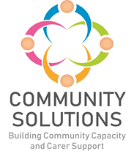

**A Successful Example of Co-Production: The Community Solutions Programme – A Case Study**

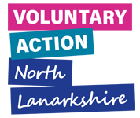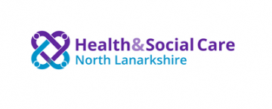

**1. Community Solutions and Co-production**

The [Community Solutions](http://www.voluntaryactionnorthlanarkshire.org/article/about-community-solutions) Programme is an example of a successful, cross-sector initiative in North Lanarkshire which is founded and delivered through ‘co-production’ approaches.

Community Solutions, established in 2012, is a health and social care investment and improvement programme for North Lanarkshire, which aims to improve people’s health, wellbeing, quality of life and equality by investing in community-led initiatives which build community, family and individual strengths and resources - with a focus on prevention and early intervention.

## Co-production is defined by the [Scottish Co-production Network](https://www.coproductionscotland.org.uk/what-is-copro) as being “about combining everyone’s strengths so that we can work together to achieve positive change.”

Community Solutions supports co-production with key stakeholders as set out in Diagram 1, including:

* people who use services - including unpaid carers
* people who provide services in both the public sector and community and voluntary sector (CVS).

The above stakeholders support co-production of the programme in several, complementary areas as set out in Diagram 2, including:

* programme strategy development and governance
* fund design, management, and decisions
* preparation of funding applications to the programme
* performance management, evaluation, learning, and improvement (PMELI)

**Diagram One: Overview of Community Solutions Stakeholders**



**Diagram Two: Community Solutions Co-production Approach**



**2. Community Solutions Co-production Overview**

**2.1 Strategy Development**

A new strategy for the Community Solutions Programme was developed and agreed in 2021/22 using a co-production approach, involving all stakeholders. This included:

* learning from the Health and Social Care North Lanarkshire (HSCNL) Community Profiles and needs data
* learning from the Community Solution’s Programme evaluation up to 2021
* focus groups with key stakeholders at local and NL-wide levels to discuss their views on the new strategy.
* discussion of a draft strategy with the Community Solutions Governance Group, which includes representatives from stakeholder groups
* approval by the Integrated Joint Board (IJB)
  1. **Programme Governance**

Community Solutions is governed through a ‘triple-lock’ approach and supported and managed at both locality and North Lanarkshire-wide levels as set out in Diagram 3.

**Diagram 3: Community Solutions Programme Governance**

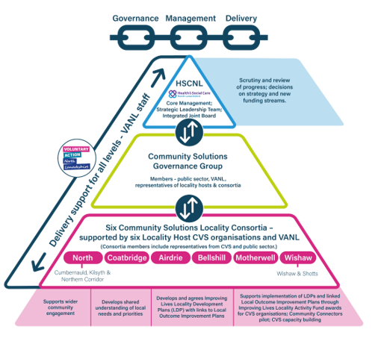

**2.3 Fund Design, Management and Decisions**

The Programme manages a number of funds which are invested strategically to increase CVS capacity to provide local support and services. These funds are co-designed by VANL and the funder/s. CVS organisations are expected to develop their funding applications informed by resident, service user and carers’ needs and views.

**2.3.1 Local Activity Fund**. (See Diagram 4)

There are six Community Solutions Locality Activity Funds (LAF) covering six different localities in North Lanarkshire. These localities are supported by a “Locality Host” which is a locally-based CVS organisation, commissioned to fulfil this role. The Locality Host convenes and supports a Locality Consortia involving representatives from CVS organisations, NHS and the council. CVS organisations can apply to one or more of these LAFs for funding to deliver services and support in the locality covered by the LAF. LAF funding awards decisions are taken by the Community Solutions Locality Consortia.

**Diagram 4: Community Solutions Locality Level Support**



* + 1. **NL-wide thematic funding**

Community Solutions manages a number of NL-wide “thematic” funds.

* Mental health and wellbeing – with one fund for adults and one for children and young people

Funding award decisions for the Adult mental health and wellbeing fund are taken by a cross-sector panel. Decisions regarding funding awards for the children and young people’s Mental Health and Wellbeing Fund are taken by schools, informed by analysis of local needs.

* Carers’ Breather Fund – award decisions are taken by a cross-sector panel.

Community Solutions also manages a series of thematic funds on a range of issues such as:

* anticipatory care
* befriending
* community transport
* food and health
* hospital discharge support

These funds were awarded to a number of organisations some years ago and a review of this funding is underway supported by a number of “stakeholder review groups”.

* 1. **Performance management, evaluation, learning, and improvement**

Community Solution’s approach to Performance Management, Evaluation, Learning, and Improvement Framework (PMELI) also involves all stakeholder groups in several ways.

* service users are supported to provide feedback on their experience and outcomes through surveys, personal stories and [Care Opinion](https://www.careopinion.org.uk/)
* funded projects are supported to provide performance information on their delivery of the funded work and the support provided by VANL
* funded projects and other stakeholders are invited to participate in Learning and Improvement events to share learning and identify and support improvements to their own service and more widely.

**3.1 Complementary Approaches**

The Community Solutions co-production approach is informed and supported by:

* the [Ladder of Participation](https://organizingengagement.org/models/ladder-of-citizen-participation/) which supports different types of participation by citizens
* [National Community Engagement Standards](https://www.scdc.org.uk/what/national-standards).
* a Human Learning Systems (HLS) approach, which was adopted by [Health and Social Care North Lanarkshire](https://www.voluntaryactionnorthlanarkshire.org/index.php/health-and-social-care-north-lanarkshire/) (HSCNL) in 2023 to support delivery of their Commissioning Plan.

Both the Community Solution’s PMELI Framework and the HLS approach encourage use a co-production approach to ongoing cyclical learning, drawing from prior knowledge to inform future interventions and sharing any new learning with stakeholders.

Please see here for a briefing paper which sets out how the HLS approach relates to the Community Solutions Programme’s integrated approach to PMELI.

**4. Community Solutions Achievements Using a Co-production Approach**

In 2022-23, the Community Solutions Programme distributed **£3.1m** in funding to **233** projects, delivered by **98** CVS organisations.

With this funding, the Programme has delivered the following in 2022-23.

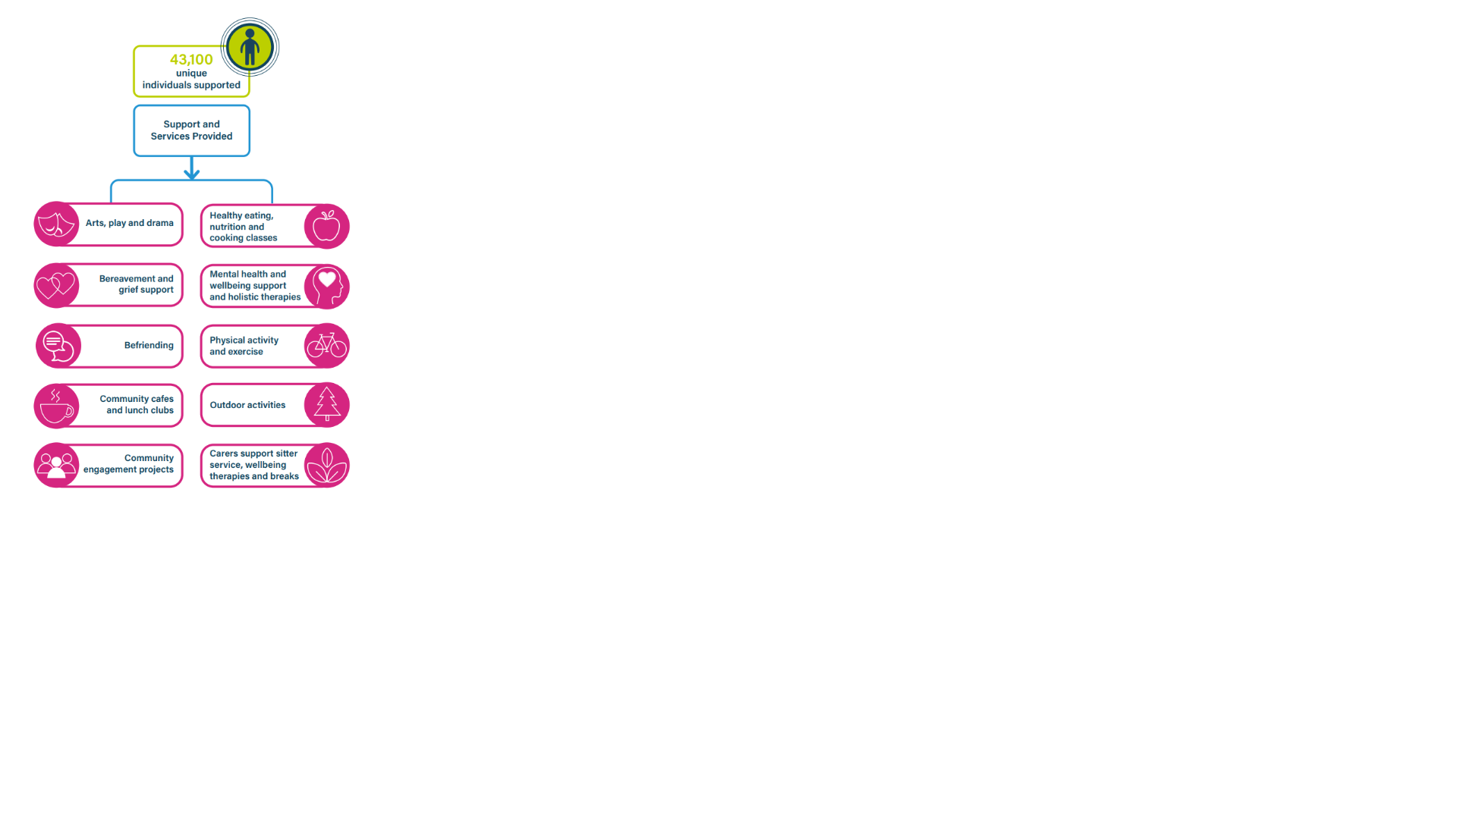**4.1 Summary of Unique Individuals Supported and Services Provided through the Community Solutions Programme 22-23**

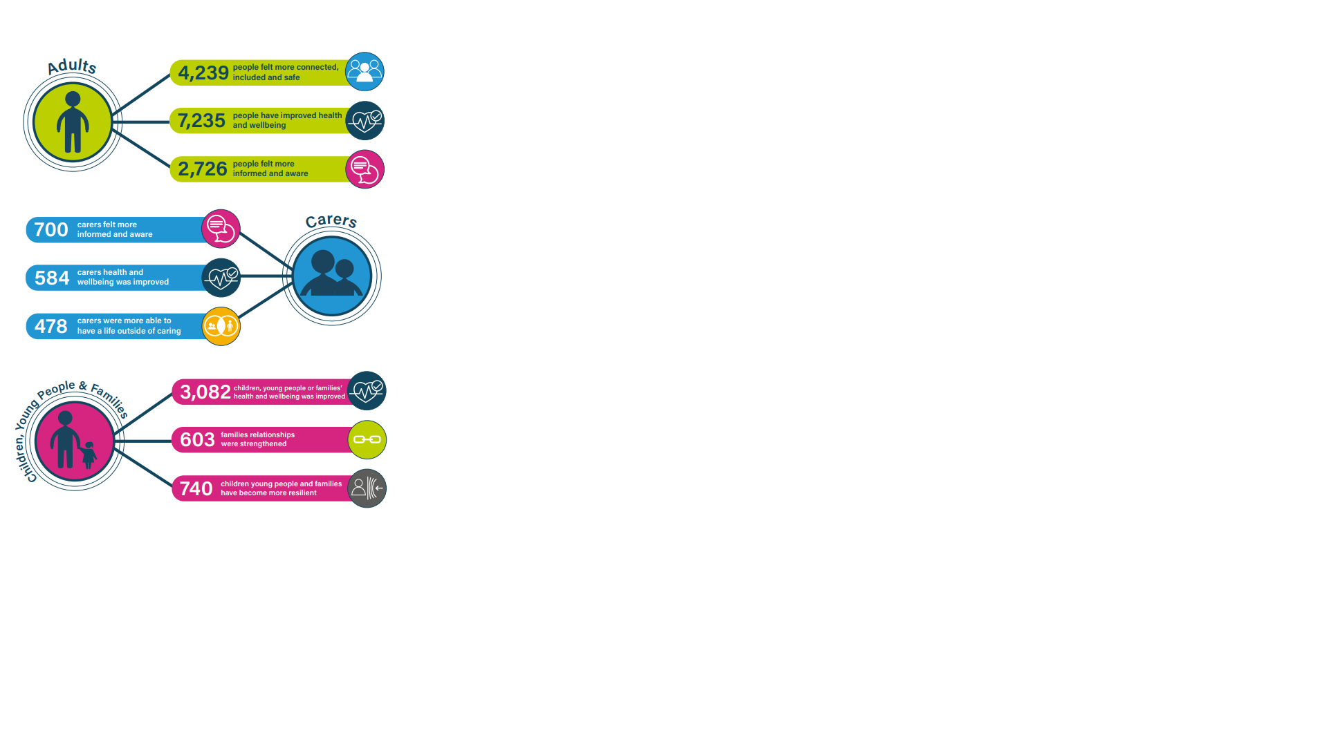**4.2 Summary of Reported Outcomes for Services Provided Through the Community Solutions Programme 2022-23**

[document ends]